A GUIDE TO REALITY

The Universe,
Actually
What humanity currently understands
about reality
Lothar J. Musiol
A guide to what is known

A Note on This Book
This book is written for the reader of the great one-volume guides to science: an intelligent person who is not a specialist, and who would rather be told what is known than be flattered with wonder.
The model is a classic one-volume guide to science from the 1980s, together with the shorter guides to physics, chemistry, and biology that preceded it. Those books offered a single account of the natural sciences, updated as the account changed. The present book follows that ambition in two ascending arcs. The first runs from the rules of motion and the quantum world through particles and atoms to space and time, planets, stars, galaxies and the universe as a whole. The second runs from the first living chemistry through the body and mind and the living planet to technology and the way knowledge itself is made.
Compared with a guide finished in the 1980s, entire subjects had to be added: CRISPR and gene editing, mRNA medicine, the human microbiome, gravitational waves as something heard and not merely predicted, exoplanets as a catalog, dark energy, quantum information, artificial intelligence in the form of learned systems, climate science as a body of measurement, and synthetic biology. Those chapters are here because a guide that omitted them would no longer be a guide to the present.
The voice of the opening pages is kept throughout: short claims, the evidence named, and the uncertainty named beside it. Nothing in this book is offered as a final truth. It is offered as the picture a careful reader can hold in 2026, actually.

Preface
Every child is born a scientist.
The evidence for this is plain enough. Children ask questions with a persistence that adults often find exhausting. Why is the sky blue? Why does rain fall? Why do people age? Why do stars shine? Why is there a Moon?
The questions arise naturally.
The answers do not.
Human history can be viewed as a series of attempts to answer such questions. Some answers were beautiful. Some were clever. Many were comforting.
Most were wrong.
This should not be taken as a criticism of our ancestors. The universe was under no obligation to make itself easy to understand. A species that evolved on a small world around an ordinary star could scarcely expect to discover the workings of atoms, galaxies, life, and time itself.
Yet that is exactly what happened.
Slowly, over thousands of years, humanity assembled a picture of reality.
The Earth was shown to be a planet, the stars to be suns, life to have evolved, and matter to consist of atoms. Space and time themselves were shown to be parts of a larger structure called spacetime.
Each discovery displaced an older certainty. Each expanded the horizon of ignorance. For every mystery solved, ten new mysteries appeared.
Today we know more than all previous generations combined. We know the age of the universe to remarkable precision. We can watch galaxies billions of light-years away. We can read the genetic instructions that build living organisms. We can alter those instructions, we have observed black holes, and we have detected gravitational waves. We have constructed machines capable of performing tasks once believed to require uniquely human intelligence.
And yet.
We do not know what dark matter is. We do not know what dark energy is. We do not know how life began. We do not know how consciousness arises. We do not know whether we are alone.
Science is not a monument of certainty. It is a process of reducing uncertainty.
The purpose of this book is therefore not to present final truths. No such book can be written.
Its purpose is simpler. To describe, as clearly as possible, what humanity currently understands about reality.
Actually.

Contents
An introduction, eleven parts and the back matter. Select a title to jump to it.
A Note on This Book
Preface
Introduction: Why Any of This Matters
Part I: The Rules of Motion and Energy
1. Motion, Force and Energy
2. Heat and Disorder
3. Waves, Sound and Light
4. Electricity, Magnetism and Fields
Part II: The Quantum World
5. Quantum Rules and Quantum Matter
6. Measurement, Decoherence and Interpretations
7. Entanglement and Bell’s Theorem
8. Quantum Information and Computation
9. Quantum Field Theory and Electrodynamics
Part III: Particles, Nuclei and Atoms
10. The Standard Model of Particle Physics
11. Beyond the Standard Model
12. Dense Matter and the Strong Force
13. Nuclei, Fission and Fusion
14. Neutrinos
15. Atoms and the Periodic Table
16. The Chemistry of Bonds and Reactions
17. Solids, Soft Matter and Plasma
Part IV: Space, Time and Gravity
18. The Speed of Light and Special Relativity
19. Gravity and Curved Spacetime
20. Relativity at Work: GPS and Beyond
21. Gravitational Waves
22. Black Holes
23. Hawking Radiation and the Vacuum
24. The Black-Hole Information Question
Part V: Planets, Stars and Galaxies
25. The Solar System
26. Small Bodies and Visitors
27. Planets Around Other Stars
28. Stars and Stellar Remnants
29. Fast Radio Bursts and High-Energy Messengers
30. Galaxies and the Large-Scale Universe
Part VI: The Universe as a Whole
31. The Expanding Universe
32. A Universe With a Birthday
33. Dark Matter and Dark Energy
34. Quantum Gravity, Strings and the Multiverse
35. The Arrow of Time
36. What Is Time?
Part VII: Life
37. The Origin of Life
38. The Cell
39. Evolution and Genetics
40. Quantum Biology
41. The Human Genome
42. CRISPR and Gene Editing
43. Synthetic Biology
44. Life Through Deep Time
45. Life at the Extremes
46. The Search for Life Elsewhere
47. Human Evolution
Part VIII: The Human Body and Mind
48. The Human Body
49. Disease, Microbes and Resistance
50. The Microbiome
51. Precision Medicine
52. Aging and Longevity
53. The Brain and Nervous System
54. Consciousness
55. Minds That Are Not Ours
Part IX: Earth, the Living Planet
56. The Structure of the Earth
57. Climate Science
58. Ecology and the Living Planet
59. Biodiversity
60. Oceans and Ecosystems
61. Renewable Energy
62. Sustainability
Part X: Technology
63. Information Theory
64. Secrets and Codes
65. Artificial Intelligence
66. Robotics
67. Biotechnology
68. Space Exploration
Part XI: How We Know, and What Comes Next
69. A History of Scientific Thought
70. Four Maxes
71. The Scientific Method
72. Mathematics, Humanity’s Language
73. Knowing, Doubting and Correcting
74. Future Challenges
75. Possible Futures
76. What Would Change in the Guides
Epilogue: Actually
A Note on Sources
Bibliography
External Resources
About the Author
Also by Lothar J. Musiol

Introduction: Why Any of This Matters
You are a collection of atoms that has become temporarily organized enough to ask what atoms are. The atoms themselves are indifferent. They were forged in stars that died before the Sun existed, scattered, and later gathered into a planet where, after several billion years of chemistry, some of them began to copy themselves. Those copies eventually produced a nervous system capable of noticing the copying.
The noticing is recent: written records cover a few thousand years, and science as a systematic method is younger still. In that short interval the same atoms have measured the age of the universe, the size of the electron, and the sequence of bases in their own genome. They have also built devices that can destroy the biosphere that sustains them and devices that can leave the planet. Both facts are consequences of the same understanding.
Nothing in the laws requires that understanding to continue. The laws are compatible with a universe that never produces observers, or with observers that appear and then vanish. The present moment is one in which observers exist and have begun to reconstruct the history that produced them. How long that reconstruction continues is not written in the equations. It is written, if anywhere, in what those observers choose to do with the knowledge they have acquired.
The chapters that follow are the current state of that reconstruction. They are incomplete. They will be revised. They are nevertheless the most reliable map yet drawn of the territory in which any such choice must be made.

What the Sky Is Doing While You Read This
While you read this sentence the Earth has moved roughly 30 kilometers in its orbit. The Solar System has moved roughly 220 kilometers around the Galactic center. The Galaxy has moved several hundred kilometers relative to the cosmic microwave background. None of these motions is felt. All of them are real.
The photons striking your retina left their sources long ago. Some left the Sun eight minutes ago. Some left distant galaxies when the Earth was young. A few, if you are looking at the microwave background, left when the universe was 380 000 years old. Their journey does not pause while you turn the page.
The calculations that describe these motions and these journeys are the same calculations that describe the fall of an apple and the swing of a pendulum. The scales differ but the laws do not, and the recognition is ordinary once it is made. It is still capable of producing a slight shift in the way the next sentence is read.

A Brief Interlude on Scales
Consider a bacterium. It is roughly a micrometer across. Enlarge it ten thousand times, to the size of a grape, and its genome, a single loop of DNA, would unspool to more than ten meters, packed inside that grape. The bacterium copies all of it before every division, as its ancestors have done for several billion years.
Now consider the opposite direction. The observable universe is about 10²⁷ meters across. Shrink it to the size of the Earth, and the Earth itself would end up less than a hundredth of the width of an atom. On a globe of that universe, everything humans have ever built is a speck far below the reach of any microscope. The speck is recent, local and, so far, unique.
Both comparisons are accurate. Neither is especially comforting. They do, however, explain why the same physical laws can feel remote when written as equations and intimate when written as the difference between a bacterium and a person. This book follows that range in order, from the rules of motion and the quantum world, through particles and atoms, up to planets, stars and the universe as a whole. It then climbs a second ladder, from the first cells through bodies, minds and the living planet to technology and the way we know anything at all. The laws do not change. The number of zeros does.
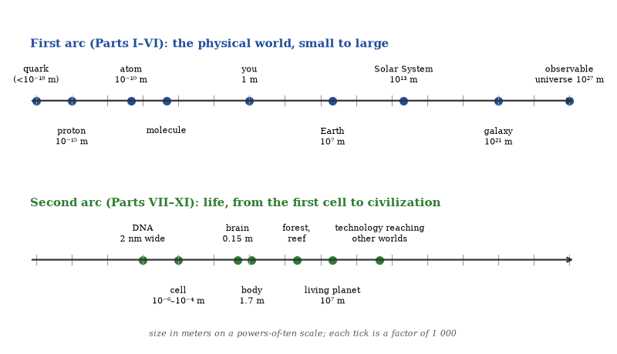
Figure 1. The two arcs of this book: the physical world from quarks to the observable universe, then life from the cell to civilization.

The Cosmic Calendar
Compress the 13.8 billion years since the Big Bang into a single calendar year, as Carl Sagan did in his television series Cosmos, and the proportions become vivid. The Big Bang is midnight on 1 January. Galaxies begin to assemble within weeks. Our Sun and its planets do not form until the first day of September, and the earliest life on Earth appears in the last days of that month.
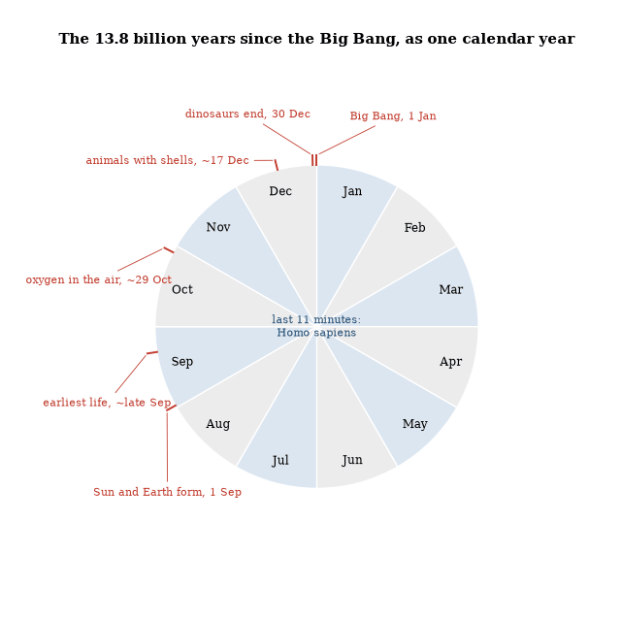
Figure 2. The cosmic calendar: 13.8 billion years squeezed into one year, so that one day is about 38 million years. Dates are approximate. Our species appears about eleven minutes before midnight on 31 December, and all of recorded history fits into the final twelve seconds or so.
Oxygen builds up in the air in late October. Animals with hard parts arrive in the middle of December, and the dinosaurs vanish on the morning of 30 December. Our species appears about eleven minutes before the year ends. All of written history occupies the last twelve seconds or so, and the four centuries since Galileo turned a telescope on Jupiter take less than a second.
The calendar is a device, not a measurement, and its dates move as the science improves. Its use is the sense of scale it gives. Almost everything in this book happened before there was anyone to notice it, and almost everything we know about it was learned in the final sliver of the last day.

A Remark on Numbers
Large numbers are best approached with caution, because a billion is a thousand million while a trillion is a thousand billion. The difference is the difference between a modest public building and the annual budget of a medium-sized country. Both are finite. Neither is easy to visualize.
The same caution applies in the opposite direction. A nanometer is a billionth of a meter and a femtometer is a millionth of a nanometer; atoms are measured in the former and atomic nuclei in the latter. The fact that both can be manipulated with instruments built by people who occasionally lose their car keys is one of the more surprising achievements of the species. The achievement does not make the numbers less large or less small. It merely shows that careful counting can be done even by creatures whose native range is meters and years.

Part I: The Rules of Motion and Energy
The everyday laws of motion, heat, waves and fields that every later part relies on

1. Motion, Force and Energy
A skater pulls in her arms and spins faster. A satellite circles for decades without fuel. A pendulum clock keeps time through a recession. Behind these three ordinary facts stand the ideas that carry the rest of this book: motion needs no push to continue, forces change motion, and energy keeps its books to the last decimal.

Motion and Newton’s Laws
Aristotle held that every kind of matter has a natural place. Earthy things seek the center and fire seeks the heights, so an object out of its place moves toward it. Heavier objects, being more eager, fall faster. Forced motion requires a continuous push, and rest is the natural state.
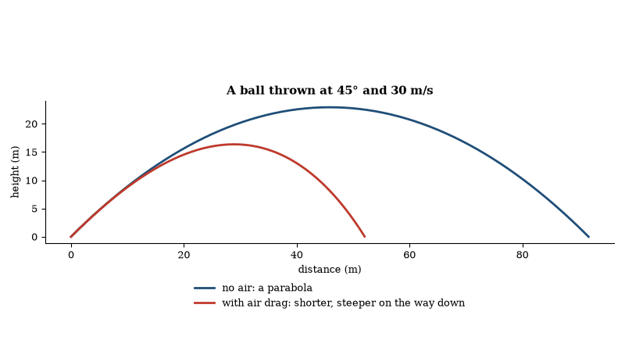
Figure 3. Newton’s second law at work. Without air a thrown ball follows a parabola; with air resistance the same throw falls short and descends more steeply.
The view lasted nearly two thousand years because it matched ordinary observation. Feathers fall slower than stones. A thrown stone eventually stops. The heavens move in circles while earthly things fall straight.
Galileo tested the claim about falling. He used inclined planes to slow the motion enough to measure with the tools he had. Balls of different weight rolled down the same plane in the same time. The distance covered increased with the square of the time. The acceleration was constant. In a vacuum, a feather and a metal ball fall together. Air resistance, not weight, explains the everyday difference.
Newton put the results into three laws. An object at rest stays at rest, and an object in motion continues in a straight line at constant speed, unless a force acts on it. Force equals mass times acceleration. For every action there is an equal and opposite reaction. Mass is the measure of inertia, the resistance to change in motion. Weight is the force of gravity on that mass. The two are proportional on Earth, but they are not the same thing. On the Moon the mass is unchanged and the weight is less.
Momentum is mass times velocity. In an isolated system it is conserved. When two objects collide, the total momentum before equals the total momentum after. Angular momentum is conserved in rotation. A spinning skater who pulls in her arms spins faster. The product of moment of inertia and angular speed stays constant.
Work is force times distance in the direction of the force. Energy is the capacity to do work, kinetic energy being the energy of motion and potential energy the energy of position. In the absence of friction and other losses, mechanical energy is conserved. A pendulum converts kinetic to potential and back. Friction converts mechanical energy into heat. The first law of thermodynamics says that energy is never created or destroyed, only converted.
These laws are the foundation of classical mechanics. They describe the motion of planets, the flight of a baseball, and the structure of a bridge. They fail only at very high speeds, very strong gravity, or very small scales. In those regimes, relativity and quantum mechanics take over. For everything in between, Newton’s laws remain the working tools.

The Principle of Stationary Action
Classical mechanics can be written in more than one way. Newton’s laws describe how forces change momentum from moment to moment. An equivalent description uses the principle of stationary action.
The action of a path is a quantity calculated from the kinetic energy and the potential energy along that path. For a particle moving from one point to another in a given time, the actual path is the one for which the action is stationary—usually a minimum. Nearby paths have nearly the same action. The path nature takes is the one that does not change the action to first order when the path is varied slightly.
This is not a statement that nature calculates. It is a mathematical fact about the equations. The path that satisfies Newton’s second law is the same path that makes the action stationary. The two descriptions are equivalent. One is local: the force at each point determines the acceleration at that point. The other is global: the entire path is the one that satisfies the stationary condition.
The principle extends to fields and to more complicated systems. In Lagrangian mechanics the action is the integral of the Lagrangian. The Euler-Lagrange equations that follow from the stationary condition are the equations of motion. In quantum mechanics the path-integral formulation assigns a phase to every path and sums them. The classical path is the one where the phases reinforce. The stationary-action principle is the classical limit of that sum.
The formulation is useful because it makes symmetries transparent. If the Lagrangian does not depend on a coordinate, the corresponding momentum is conserved. Time translation symmetry gives energy conservation, spatial translation symmetry gives momentum conservation, and rotational symmetry gives angular-momentum conservation, all as cases of Noether’s theorem, which connects continuous symmetries to conservation laws. The connection is clearer in the action formulation than in the force formulation.

The Principle of Least Action
The principle of least action states that the actual path taken by a system between two configurations is the path that makes the action stationary. In symbols:
S = ∫ L dt, L = T − V.
For a particle the Lagrangian is kinetic energy minus potential energy. The condition δ S = 0 yields the Euler–Lagrange equations, which are equivalent to Newton’s laws. The same variational statement works for fields. The action for the electromagnetic field or for the metric of general relativity produces Maxwell’s equations or the Einstein equation when it is required to be stationary.
Feynman regarded the principle as the most fundamental formulation of classical mechanics. It makes no reference to forces. It refers only to the comparison of entire paths.
The principle does not require the action to be a minimum. It requires it to be stationary. In some cases the stationary path is a maximum or a saddle. The terminology “least action” is traditional and slightly inaccurate. The content is the stationarity condition. That condition is sufficient to generate the equations of motion for every fundamental theory now in use.

Least Action in Light and Everyday Motion
The same idea governs light. In a medium whose refractive index varies, light takes the path of stationary travel time. That is Fermat’s principle, the optical form of the action principle. The parabola of a thrown stone, the bending of light at an interface and the minimal surface of a soap film are all cases in which the observed shape makes a simple integral stationary. No separate force law is needed: the force law follows from the variational statement.

Worked Examples: Least Action and Optics
Example 1. Light travels from air into glass (n = 1.5). The angle of incidence is 30°. What is the angle of refraction?
Snell’s law: n₁sin θ₁ = n₂sin θ₂. sin θ₂ = sin 30° / 1.5 = 1/3. θ₂ ≈ 19.5°.
Example 2. Show that the optical path length is stationary for the actual ray in a plane mirror.
The geometric path that reflects with equal angles is the shortest path that touches the mirror (image method). Any other path is longer. The action (travel time) is therefore stationary.
Example 3. A soap film adjusts its shape. Why is the surface a minimal surface?
The surface energy is proportional to area. The equilibrium shape minimizes area subject to the boundary conditions—the definition of a minimal surface. The same variational principle governs the film and the light ray.

Conservation Laws
Energy, momentum, and angular momentum are conserved in every isolated system. The conservation laws follow from symmetries of the underlying action, as Noether’s theorem shows.
In mechanics the statements are elementary. The total energy of a collection of particles interacting through forces that derive from a potential is constant. The total momentum is constant when no external force acts. The total angular momentum about any fixed point is constant when no external torque acts. The same statements hold, with the appropriate field expressions, for the electromagnetic field and for the gravitational field.
Apparent violations are always the result of an incomplete accounting. Heat is disordered kinetic energy and radiation carries both energy and momentum, so when those contributions are included the balances close. No experiment has shown a violation of any of the three laws in an isolated system.
The laws define the quantities they conserve. Energy is the quantity that is constant because the laws do not depend on the absolute time. Momentum is conserved for the parallel reason that the laws do not care where in space they are applied. The definitions are operational and have been confirmed from the scale of elementary particles to the scale of galaxy clusters.

Energy Is Only a Number
Richard Feynman introduced the conservation of energy with a parable. A child owns a number of indestructible blocks, and a watchful parent counts them each evening. One evening a block is missing. It turns out to be in a toy chest. Another evening the count is off again, and the missing block is found under the bath water, whose level has risen by a measurable amount. The parent invents rules for the hiding places and keeps the books balanced.
Energy is like that. Nothing in nature is labeled energy. It is a quantity we calculate from other things, such as speeds, heights, temperatures and fields, and it has the remarkable property that the total, correctly calculated, never changes. When the sum seems to fail, physicists look for a hiding place: a new form of energy. Sometimes they find one. The neutrino was proposed in just this way, to account for energy that seemed to vanish in beta decay.
The parable is also honest about a limit. It tells us how to keep the accounts and not what is being accounted. That the number is constant is a fact, tied by Noether’s theorem to the sameness of the laws from one moment to the next.

Conservation of Energy from Time-Translation Invariance
Noether’s theorem associates a conservation law with every continuous symmetry. Invariance of the action under time translation implies conservation of energy. If the Lagrangian does not depend explicitly on time, the quantity E = ∑_{i} q̇_{i}(∂ L)/(∂q̇_{i}) − L is constant along the motion. For the standard mechanical Lagrangian this quantity is T + V.
The same reasoning applies to fields. Invariance under time translation yields a conserved energy-momentum tensor. The integral of its time-time component over a spatial volume is the total energy. Apparent non-conservation always signals that the system under consideration is not isolated or that the Lagrangian has an explicit time dependence.
The link between time-translation symmetry and energy conservation is exact within the domain of the variational principle. It supplies the deepest reason that energy is conserved.

The Motions of the Earth
The Earth rotates on its axis once every sidereal day (86 164 s). It revolves about the Sun once every sidereal year (365.256 days). The axis is tilted 23.4° to the orbital plane; the tilt varies between 22.1° and 24.5° with a 41 000-year period. The axis itself precesses with a 25 800-year period and nutates with an 18.6-year period of 19 arc-seconds. These three astronomical cycles—obliquity, precession, and eccentricity—modulate the seasonal distribution of sunlight and have produced the succession of ice ages recorded in ice cores and marine sediments.
The Earth’s orbit is an ellipse of eccentricity 0.017. The semi-major axis is one astronomical unit, 149.6 million kilometers. The orbital speed is 29.8 km/s. The Sun itself orbits the galactic center at 220 km/s, completing one revolution in about 225 million years. The Solar System oscillates above and below the galactic plane with a period of roughly 62 million years.
Relative to the cosmic microwave background the Solar System moves at 370 km/s. All of these motions are unfelt. Uniform velocity produces no local effect; only accelerations are detectable, and most of the accelerations associated with the larger motions lie below the threshold of human sensation. The principle that uniform motion is equivalent to rest was stated by Galileo and remains the foundation of both Newtonian and relativistic mechanics.

The Rotation of Rigid Bodies
A rigid body has six degrees of freedom: three of translation and three of rotation. The rotational motion is governed by the angular-momentum equation. The moment of inertia tensor relates angular velocity to angular momentum. For a principal-axis rotation the relation is scalar. For a general rotation the angular-velocity vector and the angular-momentum vector are not parallel.
Euler’s equations describe the free rotation of a rigid body. They predict that rotation about the axis of intermediate moment of inertia is unstable. A book tossed into the air rotates stably about its longest or shortest axis and tumbles about the intermediate axis. The instability is geometric. It follows from the conservation of energy and angular momentum alone.
Precession occurs when a torque acts on a spinning body. The angular-momentum vector moves perpendicular to the torque. The result is the slow conical motion of a spinning top or of the Earth’s axis under the gravitational torque of the Sun and Moon. The same mathematics describes the motion of a gyroscope and the stabilization of a bicycle wheel.
The kinetic energy of rotation is 1/2 Iω². It is independent of the translational kinetic energy. Both are conserved separately when no external torque or force acts. The separation is a consequence of the rigidity constraint.

Oscillations
An oscillation is a periodic motion about an equilibrium. For small amplitudes the restoring force is proportional to the displacement. The motion is then simple harmonic. The period is independent of amplitude and is given by 2π√(m/k) for a mass on a spring and by 2π√(l/g) for a simple pendulum.
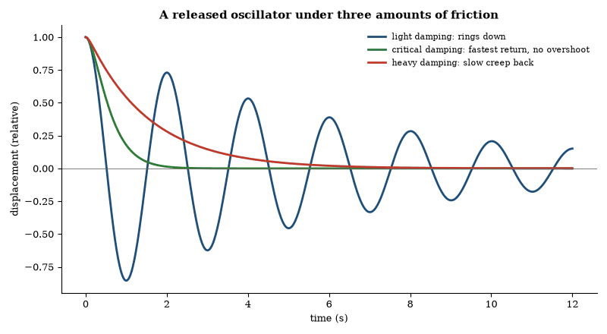
Figure 4. The three regimes of damped oscillation. Shock absorbers and door closers are tuned to the green curve.
When friction is present the oscillation is damped. The amplitude decays exponentially. When the damping is light the frequency is nearly unchanged. When the damping is critical the system returns to equilibrium as quickly as possible without oscillating. When the damping is heavier the return is slower and monotonic.
A driven oscillator responds most strongly when the driving frequency matches the natural frequency. The response is resonance. The amplitude at resonance is limited by the damping. The phase of the response shifts from in-phase below resonance to out-of-phase above resonance. The same behavior appears in electrical circuits, in atoms driven by light, and in mechanical structures driven by wind or earthquakes.
Coupled oscillators exchange energy. Two pendulums connected by a weak spring exhibit beats. The energy flows back and forth at a frequency set by the coupling strength. The normal modes of the system are the patterns in which every part oscillates at the same frequency. Any motion can be written as a superposition of normal modes.

The Flow of Fluids
A fluid is a substance that cannot support a static shear stress. It flows. The motion is described by the Navier–Stokes equation, which expresses the conservation of momentum for a continuous medium. The equation contains a term for pressure gradients, a term for viscous stresses, and a term for external forces such as gravity.
At low speeds and high viscosities the flow is laminar. Layers slide past one another with little mixing. At high speeds or low viscosities the flow becomes turbulent. Turbulence is characterized by eddies on many scales and by an enhanced rate of mixing and dissipation. The transition is governed by the Reynolds number, the ratio of inertial forces to viscous forces. Above a critical value the laminar solution is unstable.
Bernoulli’s principle follows from the steady, inviscid limit of the momentum equation. Along a streamline the sum of pressure and kinetic-energy density is constant when gravity is neglected. The principle explains the lift of an airfoil, the curve of a spinning ball, and the operation of a carburetor. It is an energy statement for an idealized fluid. Real fluids always dissipate some energy through viscosity.
The same equations describe the flow of air, of water, of blood, and of the molten rock in the Earth’s mantle. The mathematics is universal. The observed patterns differ only because the Reynolds numbers and the boundary conditions differ.

Worked Examples: Fluid Flow and Bernoulli
Example 1. Water flows through a pipe that narrows from 10 cm to 5 cm diameter. The speed in the wide section is 2 m s⁻¹. What is the speed in the narrow section?
Continuity: A₁ v₁ = A₂ v₂. Area ratio = 4. v₂ = 8 m s⁻¹.
Example 2. Use Bernoulli’s equation to find the pressure drop.
P₁ + 1/2ρ v₁² = P₂ + 1/2ρ v₂². Δ P = 1/2ρ(v₂² − v₁²) = 30 kPa (taking ρ = 10³ kg m⁻³).
Example 3. An airfoil has flow speed 50 m s⁻¹ over the upper surface and 40 m s⁻¹ over the lower surface. Estimate the pressure difference.
Δ P ≈ 1/2ρ(v_{u}² − v_{l}²) ≈ 550 Pa. For a wing of area 20 m² the lift is about 11 kN—sufficient to support a light aircraft.
The calculations assume incompressible, inviscid flow. They nevertheless give the correct order of magnitude for many practical devices.

Worked Examples: Orders of Magnitude
Verbal A ball thrown upward slows, stops, and falls. The same acceleration that slows it is the acceleration that speeds it on the way down. The direction of the acceleration never changes. Only the direction of the velocity changes.
Calculation A 2 kg mass falls 5 m. Potential energy lost = mgh = 2 × 9.8 × 5 = 98 J. If the energy appears as kinetic energy, v = √(2 × 98/2) = 9.9 m s⁻¹.
Verbal Two slits produce a pattern of bright and dark bands. Closing one slit removes the bands, so the bands require both paths, and that requirement is not classical.
Calculation Light of wavelength 500 nm passes through slits 0.1 mm apart. On a screen 2 m away the fringe spacing is λ D/d = 5 × 10⁻⁷ × 2 / 10⁻⁴ = 10 mm.
Verbal A star more massive than about eight solar masses ends as a neutron star or a black hole. The choice depends on the mass of the core that remains after mass loss. The dependence is observed in the remnant masses.
Calculation The Schwarzschild radius of the Sun is 2GM/c² ≈ 3 km. A solar-mass black hole is therefore smaller than a city. A billion-solar-mass black hole has a radius of order 3 × 10⁹ km—roughly the size of the Solar System.
Verbal Across the whole sky the microwave background varies by only about one part in 10⁵. The small non-uniformities are the seeds of galaxies: the seeds are visible, and the galaxies are the grown plants.
Calculation A temperature fluctuation of 100 µK on a 2.7 K background is a fractional perturbation of 100 × 10⁻⁶/2.7 ≈ 3.7 × 10⁻⁵. The same fraction appears in the density perturbations that later collapse.
The first pair uses this chapter; the others draw on light and interference (Chapter 3), black holes (Chapter 22) and the microwave background (Chapter 32). They recover the orders of magnitude that appear in nature.
Questions to Keep Asking
How do we know that heavy and light objects fall together? Think of what Galileo could measure with a ramp and a water clock, and of the astronaut who dropped a hammer and a feather on the Moon in 1971.
What observation would show that energy is not conserved? When beta decay seemed to break the rule, physicists proposed a new particle instead of abandoning it. Why was that a reasonable bet?
Try it yourself. Drop a coin and a sheet of paper together, then drop the paper crumpled into a ball. What changed, and what did not?

2. Heat and Disorder
A cup of coffee cools, and never warms itself from the air around it. Nothing in the laws of motion forbids that, yet no one has ever seen it happen. The reason, which took the nineteenth century to find, is the most statistical law in physics.

Heat and Thermodynamics
Heat is the transfer of energy that raises the temperature of a body or changes its state. Temperature is a measure of the average kinetic energy of the molecules. The two are related but distinct. A large cold object can contain more thermal energy than a small hot one.
The kinetic theory of gases treats a gas as a collection of molecules in random motion. Pressure is the force from molecules striking the walls. Boyle’s law (pressure times volume is constant at fixed temperature) and Charles’s law (volume is proportional to absolute temperature at fixed pressure) follow from the model. Absolute zero, about −273 degrees Celsius, is the temperature at which molecular motion would reach its minimum. It cannot be reached, but it can be approached.
Specific heat is the energy needed to raise the temperature of a given mass by one degree. Latent heat is the energy needed to change state without changing temperature—melting ice or boiling water. Water has a high specific heat and high latent heats. That is why it moderates climate and why sweating cools the body.
The first law of thermodynamics is the conservation of energy. Heat and work are both forms of energy transfer. The second law says that heat does not spontaneously flow from a colder body to a hotter one. Equivalently, an isolated system never loses entropy. Entropy is often called disorder; more precisely it counts the microscopic arrangements consistent with the macroscopic state. A gas expands into a vacuum because there are more ways for the molecules to be spread out than confined. The reverse is not impossible in principle, but it is so improbable that it is never observed.
Heat engines convert heat into work. They require a temperature difference. The efficiency is limited by the temperatures of the hot and cold reservoirs. No engine can convert all the heat into work, and that limit is not a matter of engineering but a consequence of the second law.
The same laws govern the cooling of a cup of coffee, the operation of a refrigerator, and the evolution of the universe. In an expanding universe, the total entropy increases. Local decreases are possible when energy is supplied from elsewhere. Life is such a local decrease. It maintains order by exporting disorder to its surroundings.

Temperature, Gas Laws and Phases
Temperature is the quantity that is equal when two systems are in thermal equilibrium. It is proportional to the average kinetic energy per degree of freedom in an ideal gas. The proportionality constant is Boltzmann’s constant. Heat is energy transferred by virtue of a temperature difference.
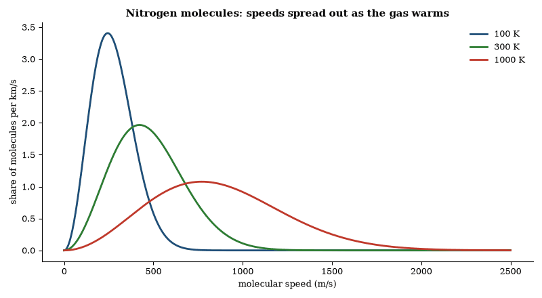
Figure 5. Temperature is a statement about a distribution. Hotter gas has a lower, broader hump of molecular speeds and a long tail of very fast molecules. At 300 K the most common nitrogen speed is about 420 m/s.
In quantitative form the first law says that the change in internal energy of a system equals the heat added minus the work done by the system. Taken together with the second law, it forbids perpetual-motion machines of both the first and the second kind.
The ideal-gas law, PV = NkT, follows from the kinetic theory once the temperature is identified with the average kinetic energy. Real gases deviate from the law at high densities or low temperatures because of intermolecular forces and finite molecular volume. The deviations are described by the van der Waals equation and by more elaborate equations of state.
Phase transitions occur when the free energy of two different arrangements of the same molecules becomes equal. Melting, boiling, and sublimation are first-order transitions marked by latent heat and by a discontinuous change in density. The critical point is the end of the boiling curve, where the distinction between liquid and gas disappears.

Worked Examples: Thermodynamics
Example 1. An ideal gas expands isothermally from 2 L to 4 L at 300 K. How much work is done by one mole?
W = RTln (V₂/V₁) = 1 730 J.
Example 2. A Carnot engine operates between 600 K and 300 K. What is its maximum efficiency?
η = 1 − T_{C}/T_{H} = 0.5 (50 percent).
Example 3. 1 kg of water is heated from 20 °C to 100 °C. How much heat is required? (Specific heat 4 180 J kg⁻¹ K⁻¹.)
Q = mcΔ T = 334 kJ. The same quantity of heat is released when the water cools.
These results follow directly from the first and second laws and from the definition of the ideal-gas temperature scale.
Example. One mole of a monatomic ideal gas is heated at constant volume from 300 K to 400 K. How much heat is absorbed, and how much work is done?
No work is done at constant volume, so Q = Δ U = 3/2R Δ T = 1.5 × 8.314 × 100 ≈ 1 250 J.
Example. A Carnot engine operates between 400 K and 300 K. Find its efficiency and the work produced per kilojoule of heat absorbed from the hot reservoir.
η = 1 − T_{C}/T_{H} = 0.25. Work = 250 J per kilojoule absorbed.
The results follow directly from the first law and from the definition of the Carnot efficiency. They are the upper bounds realized by no real engine.
Example. A heat engine absorbs 500 J from a hot reservoir and rejects 300 J to a cold reservoir. What is its efficiency? What is the maximum possible efficiency if the reservoirs are at 600 K and 300 K?
Efficiency = W/Q_{H} = 200/500 = 0.4. Carnot efficiency = 1 − 300/600 = 0.5. The engine is irreversible.
Example. One mole of ideal gas is compressed adiabatically from 300 K and 10 L to 5 L. γ = 1.4. Find the final temperature.
T₂ = T₁(V₁/V₂)^{γ−1} = 300 × 2^{0.4} ≈ 396 K.
The results follow from the definition of efficiency and from the adiabatic condition for an ideal gas.

Chaos
A system can be deterministic and still be unpredictable in practice. Deterministic means that the future state is fixed by the present state and the laws. Unpredictable means that a small uncertainty in the present state grows so rapidly that the future cannot be calculated usefully beyond a limited time.
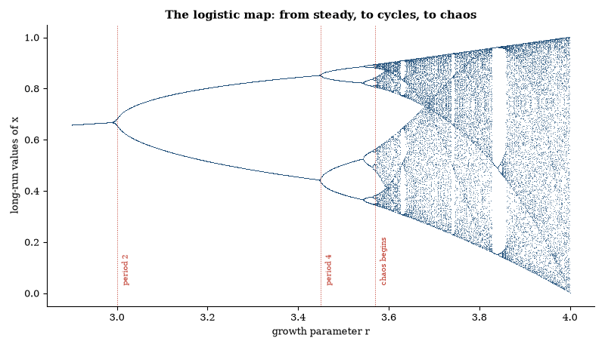
Figure 6. The logistic map, x → r x (1 − x), computed for 1,100 values of r. Each vertical slice shows where the sequence settles. Doubling of the period leads to chaos near r = 3.57, with a window of order near r = 3.83.
The classic example is the logistic map, x_{n+1} = r x_{n} (1 − x_{n}). For some values of the parameter r the sequence is periodic. For others it is chaotic. Nearby starting points diverge exponentially. The rate of divergence is measured by the Lyapunov exponent. When the exponent is positive, the system is chaotic.
The same behavior appears in continuous systems. Edward Lorenz studied a simplified model of atmospheric convection whose equations are deterministic but whose solutions are sensitive to initial conditions. Two trajectories that begin close together separate until they bear no useful relation. The atmosphere is such a system. Weather forecasts lose skill after about two weeks because the initial uncertainties, however small, grow to the size of the weather itself. Climate, which is the statistics of the weather, remains predictable on longer scales.
Chaos is not randomness. The trajectory is unique. It is confined to a strange attractor of lower dimension than the full phase space. The attractor has structure, which is fractal, and the motion on it is aperiodic. Small changes in parameters can move the system from periodic to chaotic behavior through a sequence of period doublings. The ratios of the parameter intervals approach a universal constant.
Most real systems are neither purely regular nor purely chaotic. The solar system is stable on human timescales and chaotic for the inner planets on timescales of a few million years and more. Turbulence in fluids is chaotic. The heart and the brain show both regular and chaotic dynamics. The existence of chaos shows that exact laws do not guarantee practical predictability. The distinction is quantitative. It depends on the Lyapunov time and on the precision of the initial data.

Lyapunov Exponents and Predictability
A chaotic system has at least one positive Lyapunov exponent, and the exponents obey a bookkeeping rule: their sum equals the average rate at which phase-space volume contracts. In a dissipative system that sum is negative, so the attractor has zero volume and a non-integer dimension.
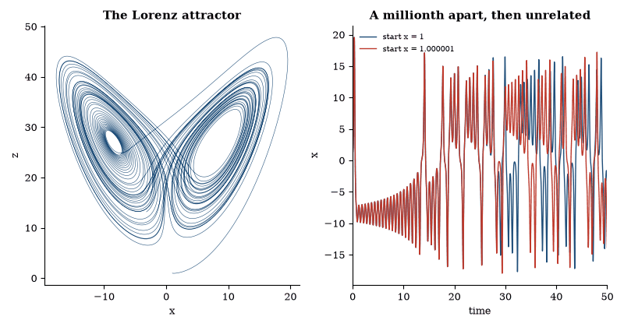
Figure 7. Left: the path of Lorenz’s convection model, a strange attractor. Right: two runs that start one part in a million apart agree for a while, then diverge completely. That is the practical meaning of a positive Lyapunov exponent.
Chaos needs nonlinearity and, for continuous-time systems, at least three dynamical degrees of freedom. It appears in low-dimensional systems such as the logistic map at parameter value 4, the Lorenz equations, double pendulums and driven oscillators, and also in high-dimensional ones such as turbulence, climate and neural networks. The limit on prediction is practical, not fundamental. Statistical properties such as invariant measures and correlation functions remain well defined, and forecasts succeed inside the predictability horizon.

Solitons
A soliton is a localized wave that propagates without changing shape and that survives collisions with other solitons intact. The classic example is the solitary wave observed by John Scott Russell in a canal in 1834: a single elevation of water that traveled for miles without dispersing. The mathematical model is the Korteweg–de Vries equation
∂_{t} A + A∂_{x} A + b∂_{x}³ A = 0.
Its solutions interpenetrate and emerge unchanged. The same behavior appears in optical fibers, in plasmas, and in certain magnetic materials.
A soliton is intermediate between a particle and a wave. It is localized like a particle and extended like a wave. It carries energy, momentum, and, in some cases, topological charge. Because the shape is preserved by a balance between nonlinearity and dispersion, the soliton is stable against small perturbations.
Solitons have been used to transmit data over long optical links and to model domain walls, dislocations, and certain elementary excitations in condensed matter. They remain classical solutions of nonlinear wave equations. Their quantum counterparts appear as stable particles or as topological defects in quantum field theory. No fundamental soliton has been observed that is not already accounted for by the Standard Model or by general relativity.
Questions to Keep Asking
How do we know that heat is the motion of molecules? Brownian jiggling of pollen grains and Joule’s paddle wheel, which turned falling weights into warmth in water, both point to it.
What would a genuine violation of the second law look like, and why do physicists still bet heavily against it?
Try it yourself. Put a drop of food coloring in a glass of cold water and another in a glass of warm water. Time how long each takes to spread evenly, and ask what the difference says about molecular motion.

3. Waves, Sound and Light
You can hear a conversation around a corner without seeing the speakers. Sound bends around obstacles and light mostly does not. The difference is wavelength, and it is the first clue to what a wave is.

Waves and Their Distinguishing Properties
A wave is a traveling disturbance that carries energy and momentum without a net transport of matter. Sound, water waves, light, and gravitational waves all satisfy the definition. Six properties distinguish wave motion from the motion of rigid bodies.
Superposition: linear waves add and can cancel. The result is interference. Diffraction is the consequence of interference that allows waves to spread around obstacles. Refraction is the change of direction at an interface where the propagation speed changes. Dispersion is the dependence of speed on frequency; it separates colors in a rainbow and stretches distant thunder. Damping is the progressive loss of amplitude. Polarization is the restriction of the oscillation direction for transverse waves.
None of these six effects occurs for the center-of-mass motion of ordinary rigid bodies. Their presence is therefore diagnostic of wave motion. Light exhibits all six. Gravitational waves have so far shown superposition and polarization; searches for their lensing and dispersion have found neither.
Every sinusoidal wave obeys λ f = c, where λ is the wavelength, f the frequency, and c the phase speed. When c depends on λ, the wave is dispersive. Sound in air is nearly non-dispersive, which is why speech remains intelligible at a distance. Water waves are strongly dispersive.
The energy density of a harmonic wave is proportional to the square of the time and space derivatives of the displacement. The momentum density is proportional to the product of those derivatives. Reflection from a fixed obstacle reverses the component of momentum normal to the surface, producing equal angles of incidence and reflection.

Huygens’ Principle and the Dimensionality of Space
In three spatial dimensions a wave front may be reconstructed by treating every point on the front as the source of a secondary spherical wavelet. The envelope of the wavelets gives the position of the front at a later time. The construction, due to Huygens, correctly describes reflection, refraction, and, with Fresnel’s addition of interference, diffraction. It is a direct consequence of the wave equation in an odd number of dimensions greater than or equal to three.
The principle fails in two dimensions. A circular pulse leaves a wake; the interior never returns to rest. The mathematical reason is that the delta-function solution of the wave equation that propagates outward and leaves no residual amplitude exists only when the dimension is odd and at least three. In even dimensions the response to a sharp pulse keeps a lingering tail inside the wave front, so the pulse cannot stay sharp.
The practical consequence is that a room becomes dark when the light is switched off, and that speech ends when the speaker stops. Both facts depend on our living in a three-dimensional space. In a two-dimensional world the same signals would continue indefinitely.

Worked Examples: Waves and Superposition
Example 1. Two sound waves of equal amplitude and frequencies 440 Hz and 442 Hz interfere. What is the beat frequency?
Beat frequency = |f₁ − f₂| = 2 Hz. The intensity rises and falls twice per second.
Example 2. A wave on a string has wavelength 0.5 m and frequency 200 Hz. What is its speed?
v = fλ = 100 m s⁻¹.
Example 3. In a double-slit experiment the slits are 0.2 mm apart and the screen is 2 m away. Light of wavelength 600 nm is used. What is the fringe spacing?
Δ y = λ L/d = 6 mm.
The same relations govern interference in water waves, sound, light and electron diffraction.
Example. A string fixed at both ends vibrates in its third harmonic. The length is 1.2 m and the wave speed is 240 m s⁻¹. Find the frequency.
Wavelength of the third harmonic = 2L/3 = 0.8 m. Frequency = v/λ = 300 Hz.
Example. Two loudspeakers 2 m apart emit the same 340 Hz tone. An observer walks along the line joining them. At what distances from the midpoint is the sound loudest?
Path difference must be an integer number of wavelengths. λ = v/f = 1 m. At a distance x from the midpoint the path difference is 2x, so the sound is loudest at the midpoint and 0.5 m on either side of it (and again at the speakers).
These calculations use only the relations v = fλ and the interference condition. They recover the standing-wave and two-source patterns observed in ordinary acoustics.
Example. A standing wave on a string has nodes 0.25 m apart. The wave speed is 200 m s⁻¹. What is the frequency of the fifth harmonic?
Distance between nodes = λ/2 = 0.25 m, so λ = 0.5 m. Fundamental wavelength for a string of length L = nλ/2 with n = 5 gives L = 1.25 m. Frequency of fifth harmonic = 5v/(2L) = 400 Hz.
Example. Two coherent sources 3 m apart emit 600 Hz sound in air (v = 340 m s⁻¹). How many interference maxima lie along the line joining the sources?
λ = 340/600 ≈ 0.567 m. Maximum path difference = 3 m. Number of maxima = 2 × (3/0.567) + 1 ≈ 11.
The calculations use only wavelength, path difference and the standing-wave condition.

Sound and the Human Voice
Sound in air is a longitudinal pressure wave. Its speed is √(γ P/ρ), approximately 340 m/s at room temperature. The speed is nearly independent of frequency, so speech remains intelligible over distance. Dispersion is weak; an echo reproduces the original waveform with only minor distortion.
The human voice is produced by the vibration of the vocal folds. Air from the lungs passes through the glottis. The Bernoulli effect lowers the pressure when the folds approach, drawing them together; the pressure then rises and the folds separate. The cycle repeats at the fundamental frequency of the note. The vocal tract acts as a resonator that filters the harmonic spectrum, producing the formants that distinguish vowels.
The intensity range of the voice exceeds 80 dB. The frequency range of a trained singer can span three octaves or more. The same physical elements—energy source, oscillator, resonator, and radiator—appear in every musical instrument. The voice is distinguished by the continuous control the singer exerts over tension, airflow, and cavity shape.
The ear also makes sound of its own. Outer hair cells in the cochlea amplify incoming sound mechanically, and in many people they emit faint tones spontaneously. Evoked emissions, picked up by a sensitive microphone in the ear canal, are used to screen the hearing of newborns without invasive procedures.

Light
Light travels in straight lines in a uniform medium. It reflects from a smooth surface so that the angle of incidence equals the angle of reflection. It refracts when it passes from one medium to another. The change in direction is described by Snell’s law. Lenses use refraction to focus light, convex lenses converging rays and concave lenses diverging them. The eye, the camera, the microscope, and the telescope are all applications of these rules.
White light is a mixture of wavelengths, which a prism spreads into a spectrum. Each element, heated or with light passing through its vapor, produces a characteristic set of spectral lines, the fingerprints used to identify elements in the laboratory and in stars. The Doppler shift of those lines measures how fast a source is approaching or receding.
Light turns out to be an electromagnetic wave, and it does not need a medium. The speed in vacuum is a constant, about 299,792 kilometers per second. Experiments designed to detect motion through a supposed ether, most famously the Michelson-Morley experiment, found no such effect. Special relativity took the constant speed of light as a postulate. Time and length are relative, and mass and energy are equivalent, by the relation E = mc².
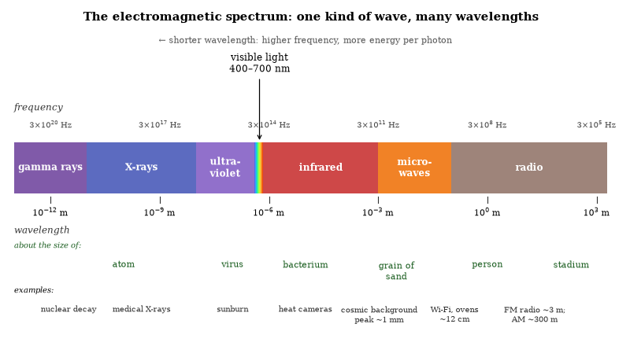
Figure 8. The electromagnetic spectrum. Visible light is a narrow band in a single family of waves that runs from gamma rays to radio.
Light also behaves as particles, called photons. Each photon carries energy in proportion to its frequency. The photoelectric effect, in which light ejects electrons from a metal, is explained by that particle nature. The wave and particle pictures live together in the single framework of quantum mechanics.
Polarization, interference, and diffraction are wave effects. They are used in sunglasses, in holography, and in the measurement of molecular structure. The same light that carries information from distant galaxies also carries the signals in optical fibers. The physics is the same. The applications differ.

Optics and Quantum Mechanics
Classical optics treats light as a wave, so interference, diffraction, and polarization follow from the wave equation, and the speed in vacuum is c. In a medium it is c/n, where n is the refractive index. Lenses and mirrors redirect rays according to the law of reflection and Snell’s law of refraction. These rules are exact in the geometric-optics limit and are recovered as the short-wavelength limit of the wave theory.
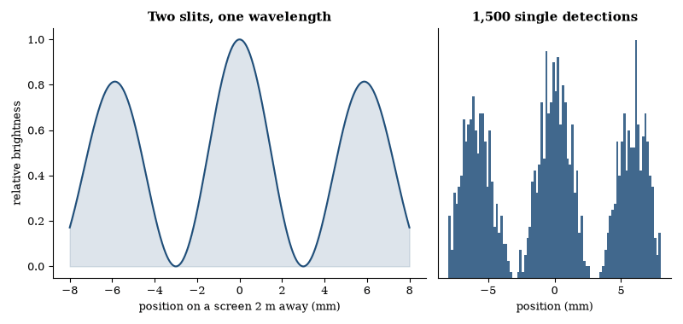
Figure 9. Interference from two slits 0.2 mm apart with light of wavelength 600 nm, on a screen 2 m away. Right: the same pattern builds up when particles arrive one at a time, shown as a simulated tally of detections.
Quantum mechanics assigns an amplitude to each path a photon can take. The probability is the square of the sum of the amplitudes. The same rule produces the interference pattern in a double-slit experiment when single photons are sent one at a time. The photon is detected at one place and the pattern builds from many detections, with no trajectory observed between source and detector, yet the calculation uses every path.
The photoelectric effect and Compton scattering show that light delivers energy and momentum in discrete quanta. The energy of a photon is E = hν. The momentum is E/c. These relations are confirmed by the threshold frequencies of photoemission and by the wavelength shift in Compton scattering. The wave and particle descriptions are complementary: each is exact in its domain and neither is complete alone.
Quantum electrodynamics unifies the two. The electromagnetic field is quantized, photons are its quanta, and electrons interact by exchanging virtual photons. The theory reproduces classical optics in the appropriate limit and adds the quantum corrections measured in the Lamb shift and the anomalous magnetic moment. Optics is the classical limit; the underlying rules are quantum.
Questions to Keep Asking
How do we know that light is a wave? In 1801 Thomas Young showed that light from two narrow slits makes bright and dark bands, a result that only waves can produce.
What would it mean if light showed no diffraction at any scale? Why does the size of an obstacle, compared with the wavelength, decide whether you see bending?
Try it yourself. Look at a bright lamp through the narrow gap between two fingers held almost touching, or through the fine barbs of a feather. The dark lines you see are interference.

4. Electricity, Magnetism and Fields
Rub a balloon on your hair and it clings to the wall. A compass needle swings near a wire carrying current. In 1865 four equations tied these curiosities to one another and to light itself, and predicted radio before anyone had built a transmitter.

Electricity and Magnetism
Electric charge comes in two kinds, called positive and negative. Like charges repel and opposite charges attract, with a force that follows an inverse-square law, Coulomb’s law. Charge is both conserved and quantized. The elementary unit is the charge of the electron or the proton.
A current is a flow of charge, carried in a metal wire by electrons. Ohm’s law relates voltage, current and resistance; resistance turns electrical energy into heat, and power is voltage times current. Batteries convert chemical energy into electrical energy, and generators convert mechanical energy into it by moving conductors through magnetic fields.
Magnetism and electricity are two aspects of the same interaction. A moving charge produces a magnetic field, and a changing magnetic field drives an electric one. Oersted showed that a current deflects a compass needle. Faraday showed that a changing magnetic field induces a current. Maxwell unified the two in a set of equations. Those equations predict that a changing electric field produces a changing magnetic field, and vice versa, and that the disturbance propagates as a wave at the speed of light. Light is that wave.
The Earth is a magnet. Its field is generated by motions in the liquid outer core. Over geological time it flips polarity at irregular intervals. It deflects much of the solar wind away from the surface. Compasses align with it. Birds and other animals use it for navigation.
Transformers change voltage by electromagnetic induction, motors convert electrical energy into mechanical energy, and the entire electrical grid rests on these principles. Alternating current is used for transmission because transformers can step the voltage up for long distances and down for use. Direct current is used in electronics and in some long-distance lines. The underlying physics is the same.
Semiconductors control the flow of charge with small signals. Transistors, diodes, and integrated circuits are built from them. The electronics of a computer and the power system of a city are different scales of the same electromagnetic interaction.

Maxwell’s Equations
James Clerk Maxwell unified electricity and magnetism in 1865. He did this without the aid of a committee, which may explain why it worked. The four equations that bear his name describe all classical electromagnetic phenomena. They also predict that light is an electromagnetic wave, a result that was considered rather sporting of them.
The first equation, Gauss’s law, says that the flux of the electric field through any closed surface equals the enclosed charge divided by the permittivity of free space; in differential form, the divergence of the field is proportional to the charge density, so charge is the source of the electric field. The second says that the magnetic flux through any closed surface is zero. There are no magnetic monopoles, and magnetic field lines close on themselves.
Faraday’s law states that a changing magnetic flux through a circuit induces an electromotive force. In differential form the curl of the electric field equals the negative of the rate of change of the magnetic field. A changing magnetic field produces an electric field. The direction is given by Lenz’s law: the induced field opposes the change that produces it.
Ampère’s law, as corrected by Maxwell, states that the curl of the magnetic field is proportional to the total current density plus the displacement current. The displacement current is the term Maxwell added: the rate of change of the electric field. The reverse also holds: a changing electric field produces a magnetic field. The two fields can sustain each other.
In free space, with no charges or currents, the equations combine to give wave equations for both fields. The waves travel at the speed c = 1/√(μ₀ ε₀). That speed matches the measured speed of light. Light is an electromagnetic wave. The same equations describe radio waves, infrared, ultraviolet, X-rays, and gamma rays. They differ from one another only in frequency.
The equations are linear, so solutions can be superposed, and they are also Lorentz invariant. The same equations hold in every inertial frame when the fields are transformed correctly. That invariance was one of the clues that led to special relativity. The classical theory is complete within its domain. It fails at the quantum level, where the field is quantized and the photon appears, and it fails at the Planck scale, where gravity cannot be ignored. Within the domain of classical electromagnetism the equations remain exact.

The Electromagnetic Field
In the field picture the electromagnetic interaction is carried by two vector fields, the electric field E and the magnetic field B, defined at every point of space and time. Charges are their sources, and Maxwell’s equations tie the fields to the charges and to each other.
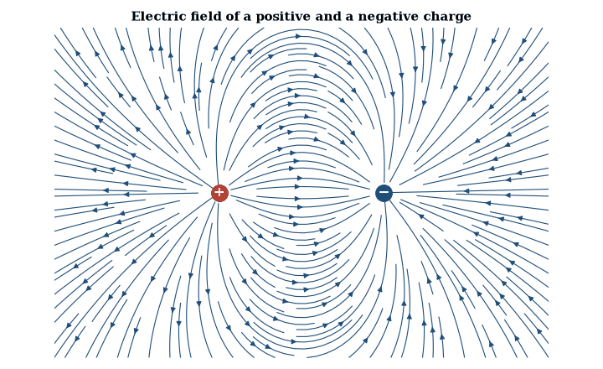
Figure 10. Field lines leave positive charge and end on negative charge. The lines are densest where the field is strongest, near the charges.
The energy density of the field is proportional to E² + c² B². The momentum density is proportional to the Poynting vector E × B. Both quantities are conserved when the field interacts with charges, provided the mechanical energy and momentum of the charges are included. The field therefore carries energy and momentum exactly as a wave must.
The Lorentz force law gives the force on a charge moving in the field. Together with Maxwell’s equations it constitutes the classical theory of electromagnetism. The theory is accurate from the scale of atoms to the scale of galaxies whenever quantum effects and gravitational curvature can be neglected.

Collective Electrodynamics
Carver Mead has argued that the electromagnetic field can be understood as a consequence of the quantum phase of charged particles rather than as an independent entity. In this view the vector potential is the fundamental object. It sets the phase standard for the electrons. The electric and magnetic fields are derived quantities.
The starting point is the phase of the electron wave function. A charged particle moving in a potential acquires a phase proportional to the line integral of the vector potential. When many electrons share a common phase, as they do in a superconductor, the collective phase is a macroscopic observable. The supercurrent is proportional to the gradient of that phase. The magnetic field is related to the curl of the potential, and the quantization of flux follows from the requirement that the phase be single-valued around a closed loop.
From the collective behavior one can recover Maxwell’s equations. The electric field appears as the force that changes the momentum, and the magnetic field appears as the quantity whose flux is quantized. The energy and momentum stored in the fields can be expressed in terms of the potentials and the charges. The classical fields are the large-scale description of the underlying phase relationships.
The approach does not replace quantum electrodynamics. It offers a different route to the same classical limit, beginning from the quantum mechanics of the charges rather than from the fields. It makes the Aharonov–Bohm effect and the Josephson effect natural rather than surprising, because both are direct statements about phase. It also clarifies why the potentials, which are gauge-dependent, can still have physical consequences: the gauge-invariant phase differences are what the charges measure.
The account is consistent with experiment. It does not alter any tested prediction of classical electromagnetism or of QED. It changes the order of explanation. The fields are what the charges do, collectively, when their phases are taken into account. Whether this order is more fundamental is a question of interpretation. The mathematics and the measurements remain the same.

The Aharonov–Bohm Effect
A magnetic field can affect an electron that never enters the region where the field is nonzero. In the Aharonov–Bohm effect an electron beam is split, passed on either side of a long solenoid, and recombined. The magnetic field is confined inside the solenoid and is zero outside, but the vector potential is not zero. The relative phase between the two paths depends on the magnetic flux through the solenoid. The interference pattern shifts when the flux is changed. The shift has been measured with the field completely shielded from the electrons.
The effect shows that the vector potential has physical consequences in quantum mechanics even where the field vanishes. In classical mechanics only the fields appear in the force law. In quantum mechanics the phase of the wave function depends on the line integral of the potential. The phase is gauge-dependent, but the phase difference around a closed loop is gauge-invariant and equal to the enclosed flux in appropriate units. The effect is topological. It depends on the flux, not on the local field along the path.
The same principle appears in superconducting rings. A superconducting loop encloses flux in discrete quanta. The quantization follows from the requirement that the macroscopic wave function be single-valued. The Aharonov–Bohm phase is the underlying mechanism. The effect has been observed with electrons, with neutrons, and in solid-state devices. It is a direct demonstration that the electromagnetic potentials are not merely a mathematical convenience.

The Vacuum
Empty space is not empty. Quantum field theory assigns a zero-point energy to every mode of every field. The energy of a harmonic oscillator in its ground state is 1/2 ħ ω. Summing over all modes gives a formally infinite vacuum energy. A cutoff at the Planck scale produces a density many orders of magnitude larger than the observed cosmological constant.
The Casimir effect, taken up below, shows that vacuum energy has measurable consequences. What it measures is a difference in vacuum energy between two arrangements, not the absolute value, which no experiment of this kind can reach.
Measured from the acceleration of the cosmic expansion, the vacuum energy density is about 10⁻⁹ joules per cubic meter. The naive quantum-field estimate exceeds it by up to 120 orders of magnitude. That mismatch is the cosmological-constant problem of Chapter 33.
The vacuum also fluctuates. Virtual particle pairs appear and disappear. They contribute to the Lamb shift, to the anomalous magnetic moment of the electron, and to the running of coupling constants. Those effects are calculated and measured to high precision. The vacuum is therefore both the source of the most precise predictions in physics and the source of the largest discrepancy between theory and observation. The two facts coexist. The resolution is not yet known.

The Casimir Effect
The Casimir effect is a force between uncharged conducting plates that arises from the modification of the vacuum modes of the electromagnetic field. Between the plates the boundary conditions exclude modes whose wavelengths do not fit. The resulting difference in zero-point energy produces an attractive force per unit area F/A = -(π²ħ c)/(240 d⁴) for perfect conductors separated by distance d.
The effect is a macroscopic manifestation of vacuum fluctuations. The same mode-modification principle appears in other geometries and for other fields. The Casimir effect confirms that boundary conditions alter the vacuum energy of quantum fields.
The Casimir force has been measured between a sphere and a plate and between two plates. The force is attractive for perfect conductors. For real metals it is reduced by finite conductivity and by surface roughness. Temperature corrections become important at separations greater than a micrometer. The measurements agree with theory once these corrections are included.
The effect can be repulsive for certain combinations of materials and intervening fluids. The repulsion has been observed. It does not permit extraction of energy from the vacuum. The plates must still be separated by external work. The force is a consequence of the change in vacuum mode density. It is not a source of free energy.
Questions to Keep Asking
How do we know that light is an electromagnetic wave? Maxwell calculated its speed from electrical and magnetic constants, and the answer matched the measured speed of light.
Magnetic monopoles would change one of Maxwell’s four equations. Searches have found none. What would a single detection mean for the theory?
Try it yourself. Hold a compass beside a wire and touch the wire briefly across the ends of a flashlight battery (only for a moment, since the wire heats). Reverse the battery. What does the needle do?
Further reading for Part I. The Feynman Lectures on Physics, Volume I, is free online and is the natural next step; read the chapters on energy and on the kinetic theory of gases first. Schiller’s Motion Mountain covers the same ground with a modern eye, and Asimov’s Understanding Physics tells how the ideas were found.

Part II: The Quantum World
The rules of the very small, and what they let us build

5. Quantum Rules and Quantum Matter
A glowing stove coil, an LED, and a lump of metal cooled until it carries current forever are all quantum facts you can see or build without a laboratory. This chapter and the next four lay out the rules behind them.
Quantum mechanics is the rule book for atoms, light and everything built from them. Its rules are few, strange, and better tested than any others in science. This chapter states them, then shows them at work in matter that is cold enough, or clean enough, for quantum behavior to become visible on a large scale.
Energy comes in lumps. In 1900 Max Planck explained the spectrum of glowing bodies by assuming that light is emitted in packets of energy E = hν, where ν is the frequency and h is Planck’s constant, about 6.6 × 10⁻³⁴ joule-seconds. In 1905 Einstein showed that light also arrives in such packets, photons, which is why the photoelectric effect has a sharp frequency threshold.
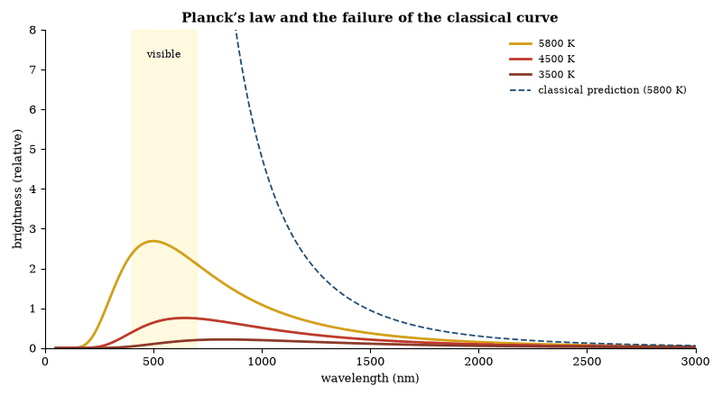
Figure 11. Thermal radiation computed from Planck’s law (solid) against the classical prediction for 5800 K (dashed), which rises without limit toward short wavelengths. Planck’s assumption that energy comes in quanta removes the divergence and fits the observed curve.
Matter has waves too. In 1924 Louis de Broglie proposed that a particle of momentum p has a wavelength h/p, and electron beams were soon seen to diffract from crystals. In a double-slit experiment, electrons or photons sent one at a time each arrive at a single spot, yet the spots build up an interference pattern. Neither “particle” nor “wave” alone describes that behavior.
The theory describes a system by a wave function: a set of complex numbers, called amplitudes, one for each possible outcome. The Schrödinger equation fixes how the wave function changes in time, smoothly and deterministically. When a measurement is made, the probability of an outcome is the squared magnitude of its amplitude (the Born rule). Amplitudes add before they are squared, and that is where interference comes from.
A system can be in a superposition of states that would exclude each other in classical physics, and two or more systems can share a joint state that cannot be split into separate descriptions. That is entanglement, the subject of Chapter 7. Some pairs of quantities cannot both be sharp at once. For position and momentum the limit is Heisenberg’s uncertainty relation, Δx Δp ≥ ħ/2, with ħ = h/2π. It is a property of waves, not a defect of instruments, and it sets the size of atoms (Chapter 15).
Particles also carry spin, an intrinsic angular momentum that comes in whole or half multiples of ħ. Fermions, with half-integer spin, obey the Pauli exclusion principle: no two can share a state, which gives atoms their shells and makes matter solid. Bosons, with integer spin, crowd into the same state. The sections below follow that crowding into Bose–Einstein condensates, superconductors and lasers, and then into newer quantum phases. What a measurement actually is, and how the classical world emerges, is left to Chapter 6.

Bose–Einstein Condensates
A Bose–Einstein condensate is a state of matter in which a macroscopic number of bosons occupy the same quantum state. It forms when a dilute gas of bosonic atoms is cooled below a critical temperature, typically a few hundred nanokelvin. The transition is marked by the appearance of a macroscopic wave function and by a peak in the momentum distribution at zero momentum.
The condensate is described by the Gross–Pitaevskii equation, a nonlinear Schrödinger equation that includes the mean-field interaction. Experiments have demonstrated matter-wave interference, quantized vortices, superfluidity and the suppression of inelastic collisions. Condensates of photons, polaritons and magnons have also been realized. The state provides a controllable macroscopic quantum system. It is used to simulate condensed-matter models, to perform precision interferometry and to study the crossover between quantum and classical behavior.
The critical temperature for Bose–Einstein condensation in a dilute gas scales as the density to the two-thirds power and as the inverse of the atomic mass. Evaporative cooling in magnetic or optical traps reaches that range. The condensate fraction grows as the temperature is lowered further.
Interactions are characterized by the s-wave scattering length. The scattering length can be tuned with magnetic Feshbach resonances. Attractive interactions produce collapse above a critical atom number. Repulsive interactions stabilize the condensate and permit the observation of sound waves, solitons and quantized vortices. The same systems realize analog models of black-hole horizons and of cosmological particle creation. The laboratory control is precise. The underlying quantum statistics are those of ideal bosons modified by weak interactions.

Superconductivity
Below a critical temperature some materials conduct electricity with zero resistance. A current in a superconducting loop persists for years without measurable decay. The material also expels magnetic fields, the Meissner effect, and the transition is a sharp phase transition.
The microscopic theory is BCS theory. Electrons near the Fermi surface form Cooper pairs, bound by an attraction mediated by lattice vibrations. The pairs behave as bosons and condense into a single macroscopic quantum state whose phase is coherent across the sample. Scattering that would cause resistance in a normal metal cannot happen without breaking pairs, which costs a finite energy, so the resistance is zero.
A junction between two superconductors separated by a thin insulator allows a supercurrent to flow with no voltage, the Josephson effect. The current depends on the phase difference across the junction. An applied voltage produces an alternating current at a frequency proportional to the voltage. The constant of proportionality is 2e/h. The relation is exact and is used to define the volt. Magnetic flux through a superconducting ring is quantized in units of h/2e, the factor of 2 reflecting that the carriers are pairs. The quantization is observed.
High-temperature superconductors, discovered in 1986, become superconducting at temperatures above the boiling point of liquid nitrogen. Their mechanism is not fully understood. The conventional BCS theory does not account for them. They are used in magnets, in sensors, and in some power applications. The zero-resistance state and the flux quantization remain the defining experimental signatures. Both follow from the existence of a macroscopic coherent phase.
The Meissner effect is the expulsion of magnetic flux from the interior of a superconductor. It is distinct from perfect conductivity. A perfect conductor would freeze in the flux present when it became resistanceless. A superconductor actively expels flux. The expulsion is a thermodynamic equilibrium property.
Type-I superconductors expel flux completely below a critical field and then revert to the normal state. Type-II superconductors allow flux to penetrate in quantized vortices above a lower critical field. The vortices form a lattice, and the mixed state persists until an upper critical field. High-temperature superconductors are extreme type-II materials with high upper critical fields. The vortex lattice and its pinning determine the critical current. Both the Meissner effect and the vortex state are macroscopic quantum phenomena.

Time Crystals
A time crystal is a quantum system that spontaneously breaks time-translation symmetry. In its simplest realization a periodically driven many-body system develops a response that oscillates at a subharmonic of the drive frequency. The subharmonic motion persists indefinitely in the idealized limit and is protected by many-body localization or by other mechanisms that prevent heating to infinite temperature.
Laboratory realizations have been achieved with trapped ions, nitrogen-vacancy centers in diamond, and superconducting qubits. The observed oscillations match the predicted subharmonic response and are robust against small perturbations. The systems are not perpetual-motion machines. They are driven. The novelty is the spontaneous breaking of the discrete time symmetry of the drive.
Time crystals enlarge the catalog of possible phases of matter. They demonstrate that quantum systems can exhibit order in the time domain analogous to spatial crystallinity. Their practical utility is still exploratory. Their existence shows that the symmetry principles governing phases of matter extend to the temporal domain.

Topological Phases of Matter
Topological phases are quantum states of matter whose distinguishing properties are invariant under continuous deformations of the Hamiltonian. The integer quantum Hall effect is the classic example. The Hall conductance is quantized in units of e²/h and is determined by a topological invariant—the Chern number—rather than by material details.
Topological insulators possess conducting surface states that are protected by time-reversal symmetry. The surface states are helical: spin and momentum are locked. Backscattering is suppressed. Superconducting analogs—topological superconductors—can host Majorana zero modes at defects. The modes obey non-Abelian statistics and are candidates for fault-tolerant qubits.
The classification of topological phases uses symmetry and dimensionality. Interactions and disorder modify but do not erase the topological distinction in the simplest cases. Experimental realizations include quantum-Hall systems, topological insulators, and engineered superconducting structures. The phases enlarge the set of possible electronic states beyond the conventional band-insulator and metal dichotomy. Their protected boundary modes are robust against local perturbations.
The Chern number is an integer topological invariant of a filled band. The invariant is unchanged by continuous deformations of the Hamiltonian that do not close the gap. Disorder that preserves the gap does not destroy the quantization. The robustness is topological.
Time-reversal-invariant topological insulators are characterized by a Z₂ invariant. The invariant protects an odd number of helical surface states. Magnetic impurities that break time-reversal symmetry can gap the surface. Non-magnetic disorder cannot. The protection has been observed in transport and in photoemission. The same topological classification extends to superconductors and to interacting systems. The invariants organize the phases. They do not by themselves determine the material realization.

Quantum Optics
Quantum optics studies the quantum properties of light and its interaction with matter at the level of individual photons and atoms. A single-photon source emits one photon at a time. A single-photon detector registers that photon with high efficiency. Interference of single photons in a Mach–Zehnder interferometer demonstrates that the photon takes both paths when no which-path information is available.
Cavity quantum electrodynamics couples an atom to a high-finesse optical cavity. The coupling strength can exceed the decay rates, producing reversible exchange of excitation—vacuum Rabi oscillations. The same regime allows deterministic generation of entangled atom–photon states and the realization of quantum gates between distant atoms mediated by photons.
Squeezed light has reduced noise in one quadrature at the expense of increased noise in the conjugate quadrature. It improves the sensitivity of interferometers beyond the standard quantum limit and is used in gravitational-wave detectors. Photon antibunching and Bell tests with photons are routine. Quantum optics supplies both the experimental foundation of quantum information and a precision tool for metrology.
The Hong–Ou–Mandel effect is the interference of two identical photons at a beam splitter. When the photons arrive simultaneously they exit together in the same output port. The coincidence rate drops to zero. The dip is a direct signature of bosonic exchange symmetry. It is used to characterize single-photon sources and to implement linear-optical quantum gates.
Light comes in kinds that differ in their photon statistics. A coherent state from a laser has Poissonian photon counts. A single-photon Fock state has exactly one photon. Squeezed vacuum emits photons in correlated pairs. Photon counting and homodyne detection tell them apart, and each kind has its use, from quantum cryptography to the quantum-noise reduction in gravitational-wave detectors mentioned above.
Questions to Keep Asking
How do we know that energy comes in quanta? Black-body spectra, the threshold frequencies of the photoelectric effect, and the sharp lines of atomic spectra all point the same way.
What would you expect to see if energy were not quantized? Compare the dashed classical curve in the figure with the glow of a hot object.
Try it yourself. Look at a compact fluorescent bulb or an LED through a compact disc held at an angle. You will see separate colored lines, not a smooth rainbow. What do the lines tell you about the atoms inside?

6. Measurement, Decoherence and Interpretations
Ask ten physicists what happens when a quantum measurement is made and you will hear several answers, all agreeing on every experiment ever done. This chapter sets out the answers and why choosing among them is hard.

The Measurement Problem
The measurement problem is the question of how a definite outcome emerges from a quantum superposition. The Schrödinger equation is linear and deterministic, so it never picks a single result on its own. The Born rule gives probabilities. It does not describe the occurrence of a single result. Collapse postulates add the selection by hand. They are not derived from the unitary dynamics.
Decoherence explains why interference is suppressed, but not why one outcome occurs rather than another. Many-worlds interpretations deny that any selection occurs, Bohmian mechanics adds particle positions, and objective-collapse models modify the equation; none is established. The problem is the gap between the unitary formalism and the definite events of experience, and it remains open.

Decoherence
A quantum system that interacts with its environment becomes entangled with the environment. The reduced state of the system, obtained by tracing over the environmental degrees of freedom, loses the off-diagonal terms that encode interference. The process is decoherence. It occurs rapidly for macroscopic objects. A dust grain in air decoheres in a time far shorter than any practical observation. Interference between macroscopically distinct positions becomes unobservable. The basis in which interference disappears, the pointer basis, is selected by the form of the interaction, and for macroscopic objects it is approximately the position basis. The resulting diagonal density matrix looks like ignorance about which outcome occurred, but it is an improper mixture, not a definite result.
Decoherence does not destroy the global superposition. The full state of system plus environment remains pure if it began pure. The local description of the system alone becomes mixed. Interference terms are still present in the global state. They are dispersed into correlations with the environment and cannot be recovered without measuring the environment in a precisely controlled way. For ordinary environments that control is impossible.
The process explains why macroscopic superpositions are not seen, though it does not by itself select one outcome. The global state still contains every branch; decoherence makes the branches effectively independent. It supplies the physical reason that the measurement problem is invisible in practice. It does not solve the problem of why one branch is experienced. That question remains interpretation-dependent.
Decoherence rates have been calculated and measured for systems ranging from single ions to superconducting circuits. The agreement is quantitative. The phenomenon is established. Its implications for the ontology of quantum mechanics are not.

The Quantum-to-Classical Transition
The quantum-to-classical transition is the emergence of classical behavior from quantum mechanics. Treating the decohered state as a classical mixture is adequate for prediction and incomplete for ontology.
The transition is continuous. Mesoscopic systems display partial coherence. The degree of classicality increases with the separation of the components and with the strength of the environmental interaction. No sharp boundary exists. The transition is well-described by decoherence for all practical purposes. The residual conceptual questions are those of the measurement problem. They are not resolved by the practical success.

Worked Examples: Quantum Measurement
Example 1. A spin-1/2 particle is prepared in the state (|↑⟩ + |↓⟩)/√2. What are the probabilities of measuring spin up or spin down along the z-axis?
Each probability is |1/√2|² = 1/2.
Example 2. The same particle is measured and found to be up. It is then measured again immediately along the same axis. What is the outcome?
The second measurement yields up with certainty. The state has collapsed to |↑⟩.
Example 3. An electron is confined to a one-dimensional box of width 0.1 nm. What is the minimum uncertainty in its momentum? What kinetic energy does that imply?
Δ x ≈ 0.1 nm. Δ p ≥ ħ/(2Δ x) ≈ 5 × 10⁻²⁵ kg m s⁻¹. E ≥ (Δ p)²/(2m) ≈ 1 eV. The estimate matches the order of magnitude of atomic energy levels.
Example 4. A radioactive nucleus has a half-life of 1 hour. What is the probability that it decays in the next minute?
Decay constant λ = ln 2 / T_{1/2}. Probability in time t ≪ T_{1/2} is ≈ λ t = 0.0115.
The calculations illustrate the Born rule, state reduction, the uncertainty principle and exponential decay—the operational content of quantum measurement.

Many-Worlds Interpretation
As an answer to the measurement problem, many-worlds says that nothing needs answering. The universal wave function never collapses; apparent collapse is the branching of the wave function into components that no longer interfere, and observers are branched along with everything else.
The full account, with its difficulty over the origin of probabilities, appears in the discussion of the multiverse. What matters here is the comparison with the other options. This interpretation adds no postulates and no new dynamics, it makes the same predictions as textbook quantum mechanics with collapse, because the branches no longer interfere, and its price is ontological: the reality of every unobserved branch.

Bohmian Mechanics
Bohmian mechanics supplements the wave function with particle positions. The positions evolve according to a guidance equation determined by the wave function. The wave function itself evolves by the Schrödinger equation. The particles have definite positions at all times. The apparent randomness arises from ignorance of the initial positions.
The theory reproduces the Born-rule statistics for a particular distribution of initial positions. The distribution is preserved by the dynamics. The theory is deterministic and non-local, with a non-locality that Bell’s theorem requires and that does not permit signaling, and it is empirically equivalent to standard quantum mechanics. Its advantage is ontological clarity. Its cost is the addition of unobservable trajectories and the explicit non-locality.

Objective Collapse Models
Objective collapse models modify the Schrödinger equation so that superpositions of macroscopically distinct states decay spontaneously. The collapse is a physical process. It occurs with a rate that increases with the number of particles. Microscopic systems are essentially unaffected. Macroscopic superpositions collapse rapidly.
The models predict small deviations from standard quantum mechanics, constrained by matter-wave interferometry and by the absence of anomalous heating; none has been observed. They solve the measurement problem by altering the dynamics, at the price of new parameters, which are bounded but not excluded, so the models remain possible extensions.

Quantum Darwinism
Quantum Darwinism proposes that the classical world emerges through the redundant encoding of information in the environment. Pointer states are those that survive decoherence and proliferate their information. Observers who access fragments of the environment obtain the same information. The redundancy defines objectivity.
The proposal accounts for the preferred basis and for the agreement among observers. It does not select a single outcome. All pointer states are encoded. The appearance of a single outcome still requires an interpretation of the branching or an additional postulate. The framework is consistent with decoherence. It extends it by emphasizing redundancy. It remains an account of classicality, not a solution to the measurement problem.

Consistent Histories
The consistent-histories approach assigns probabilities to sets of histories that satisfy a consistency condition. The condition ensures that the probabilities obey the classical sum rules. Inconsistent sets do not receive probabilities. The approach avoids explicit collapse but requires the selection of a consistent set, and the selection is not given by the formalism.
Different consistent sets can be incompatible. The approach does not privilege one. It therefore does not explain why one set of events is experienced. It supplies a framework in which classical reasoning can be applied to quantum systems. The framework is mathematically precise. The physical interpretation of the multiplicity of sets remains open.

Relational Quantum Mechanics
Relational quantum mechanics asserts that the quantum state of a system is relative to another system. There is no absolute state. Events are interactions. The state is the information that one system has about another. The approach dissolves the measurement problem by denying the existence of an observer-independent state.
The approach is consistent with the predictions of quantum mechanics. It requires care in the treatment of sequences of measurements. It does not add dynamical postulates. Its cost is the abandonment of an absolute quantum state. The cost is accepted by its proponents as the price of consistency. The approach remains a minority interpretation.

Quantum Bayesianism
Quantum Bayesianism interprets the quantum state as an agent’s information or degrees of belief. The state is not a property of the system but of the agent, and measurement updates the agent’s beliefs. The approach avoids ontological questions about collapse by relocating the state to the agent.
The approach reproduces the operational predictions. It must explain why agents who communicate agree. The explanation relies on the common information acquired through interaction. The approach is operationally clear, and its metaphysical claim—that the state is not ontic—is disputed. The dispute does not affect the calculations; it affects the interpretation of what the calculations describe.
Questions to Keep Asking
How do we know that superpositions are real and not just ignorance? Interference experiments with large molecules, built from hundreds of atoms, show wave behavior that a mere lack of knowledge could not produce.
Collapse models predict a tiny extra heating of matter. What result from a sensitive experiment would favor one of them over the others?
Try it yourself. Hold two polarizing lenses, such as a pair of sunglass lenses, so that they block the light when crossed. Slide a third between them at 45 degrees. Why does light reappear?

7. Entanglement and Bell’s Theorem
In 2022 the Nobel Prize in Physics went to three experimenters who showed that nature breaks a rule Einstein thought it had to obey, the rule that what happens here depends only on what is here. No signal travels faster than light, and yet the rule fails.

The Inequality That Cannot Be Satisfied
In 1964 John Bell wrote an inequality that any local hidden-variable theory must obey. Quantum mechanics predicts that the inequality can be violated, and when the prediction was tested it was: the violation has been confirmed with photons, atoms, ions and superconducting circuits, and the loopholes have been closed. The inequality is not satisfied.
The result does not permit faster-than-light signaling, but it does rule out outcomes fixed in advance by local variables. The correlations are stronger than any local mechanism can produce. The first tests were delicate; the latest are conclusive, and versions of them are now teaching-laboratory demonstrations. Local realism, the joint assumption that outcomes are predetermined and that no influence travels faster than light, is false, and the falsity is measured.

Bell’s Theorem and the Experiments
In 1935 Einstein, Podolsky, and Rosen argued that quantum mechanics is incomplete. They considered two particles that have interacted and then separated. A measurement on one instantly determines the result of a corresponding measurement on the other. If the particles have definite properties all along, the correlation is ordinary. If they do not, the theory appears to require a nonlocal influence. Einstein called the second possibility spooky.
Experiments beginning in the 1970s and culminating in the work of Aspect, Dalibard, and Roger in 1982 measured the correlations with polarizers whose settings were changed while the particles were in flight. The results matched the quantum prediction and violated the Bell inequality. Later experiments closed the main loopholes: the detection loophole, the locality loophole, and the freedom-of-choice loophole. Three loophole-free tests in 2015 settled the matter, and Alain Aspect, John Clauser and Anton Zeilinger shared the 2022 Nobel Prize in Physics for the experiments.
The experiments rule out local hidden-variable theories but do not select among the remaining interpretations (Chapter 6). Each side’s outcomes stay random; only the joint statistics show the violation, which is why no signal can be sent. The same resource drives quantum teleportation (Chapter 8).
The theorem and the experiments fix one boundary. Any complete account of the correlations must abandon either locality or the assumption that the outcomes are determined by preexisting local variables, or both. The boundary is experimental.

How the Inequality Works
Two particles are prepared in an entangled state and sent to distant observers. Each observer chooses a measurement setting and records a binary outcome. A local hidden-variable theory assumes that the outcomes are predetermined by variables carried with the particles and that each observer’s result depends only on the local setting and on those shared variables. Under this assumption the correlations obey an inequality. One standard form (CHSH) states that a certain combination of four correlation functions cannot exceed 2 in absolute value.
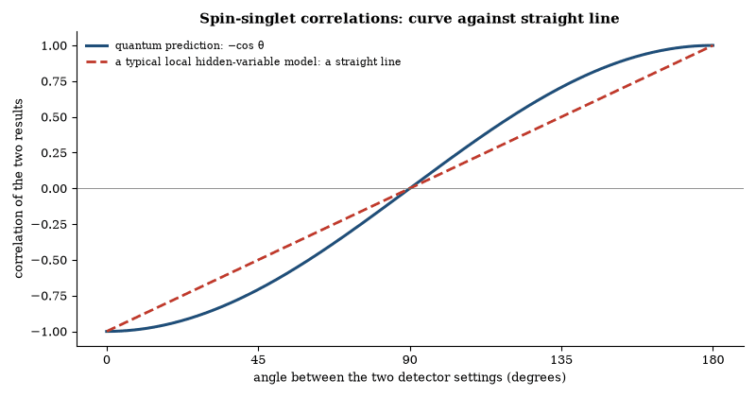
Figure 12. The quantum correlation for two entangled spins is a cosine, which bows beyond the straight line that local hidden-variable models of this kind can give. At the best angles the combination used in the CHSH inequality reaches 2√2 ≈ 2.83, above the local limit of 2.
Quantum mechanics predicts a larger value. For the spin singlet the correlation is minus the cosine of the angle between the analyzers. Suitable choices of angle yield 2√2 ≈ 2.828. The quantum prediction therefore lies outside the bound required by local hidden variables.

Entanglement as a Resource
Quantum entanglement is a correlation between subsystems that no assignment of pre-existing local properties can reproduce. For two spin-1/2 particles in the singlet state, spin measurements along the same axis are perfectly anti-correlated; along axes at an angle θ the correlation is −cos θ. The same resource powers quantum teleportation, super-dense coding and device-independent cryptography, so entanglement is both a foundational feature of quantum mechanics and a practical tool.
Entanglement is monogamous. A system maximally entangled with one partner cannot be entangled with a third. The monogamy relation is quantitative. It bounds the sum of the squared concurrences. The bound is saturated by the singlet and by GHZ states in appropriate limits.
Entanglement can be distilled. From many weakly entangled pairs one can extract a smaller number of nearly maximally entangled pairs by local operations and classical communication. The reverse process—entanglement dilution—converts maximally entangled pairs into a larger number of weakly entangled pairs. The two processes define the entanglement of formation and the distillable entanglement. For pure bipartite states the two measures coincide. For mixed states they may differ. The difference is a signature of bound entanglement that cannot be distilled.

Worked Examples: Quantum Entanglement
Example 1. The singlet state of two spin-1/2 particles is |ψ⟩ = 1/(√2)(|↑↓⟩ − |↓↑⟩). What is the probability that both particles give the same result when measured along the same axis?
The probability is zero. The outcomes are perfectly anti-correlated.
Example 2. The same state is measured with the two analyzers at a relative angle θ. What is the probability that the outcomes differ?
The probability is cos ²(θ/2). For θ = 0 the probability is 1 (always different). For θ = 120° the probability is 1/4. Combined at suitable angles, correlations of this form violate the Bell inequality that any local hidden-variable theory must satisfy.
Example 3. An entangled photon pair is produced in the state 1/(√2)(|HH⟩ + |VV⟩). One photon is measured in the diagonal basis and found to be D. What is the state of the other photon?
The other photon is immediately in the state D. The measurement has projected the joint state.
Example 4. Two parties share a singlet. Alice measures her spin along z and obtains ↑. She tells Bob the result by ordinary communication. What can Bob conclude about his own spin?
Bob knows his spin is ↓ along z. He cannot use the information to send a signal faster than light, because Alice’s outcome is random. The correlations appear only after the results are compared.
These examples recover the perfect anti-correlations, the angular dependence that violates Bell inequalities, the instantaneous update of the joint state, and the no-communication theorem—the operational content of entanglement.

The Free Will Theorem
The free will theorem of Conway and Kochen states that if experimenters have freedom in the choice of measurement settings, then the responses of entangled particles are not determined by prior information. The theorem assumes the quantum predictions and a locality condition. It concludes that the particles’ responses are not functions of the past.
The theorem is a variant of Bell’s theorem. It emphasizes the freedom of the experimenter. The freedom is the assumption that the settings are not correlated with the hidden variables. The assumption is necessary for the derivation. It is not proven. The theorem sharpens the conflict between determinism, locality and the quantum predictions. It does not resolve it.

Leggett–Garg Inequalities
Leggett–Garg inequalities bound the correlations of measurements performed on a single system at different times. They assume macroscopic realism and non-invasive measurability. Quantum mechanics violates the inequalities. The violations have been observed in superconducting qubits, photons and other systems.
The inequalities test the applicability of classical realism to macroscopic objects. Their violation shows that the systems do not possess pre-existing values that are merely revealed by measurement. The tests are complementary to Bell tests. They probe temporal rather than spatial correlations. The violations confirm the quantum predictions for the systems examined. They do not yet extend to everyday macroscopic objects.

Contextuality
Contextuality is the dependence of measurement outcomes on the set of compatible measurements performed together. The Kochen–Specker theorem shows that no non-contextual hidden-variable theory can reproduce the predictions of quantum mechanics in Hilbert spaces of dimension greater than two. The theorem is state-independent.
Contextuality is a feature of the quantum formalism. It has been demonstrated in experiments with photons, neutrons and ions. It is a resource for quantum computation, since certain computational advantages require it. The phenomenon is distinct from non-locality because it appears in single systems. It is a fundamental obstruction to classical simulations of quantum mechanics.

Quantum Steering
Quantum steering is the ability of one party to influence the state of a distant party by choice of measurement. It is intermediate between entanglement and Bell non-locality: not all entangled states are steerable, but all Bell-nonlocal states are. Steering can be verified with one trusted and one untrusted party.
The phenomenon has been demonstrated experimentally. It is a resource for one-sided device-independent cryptography. The hierarchy—entanglement, steering, Bell non-locality—organizes the strengths of quantum correlation. Each level excludes a larger set of classical models, and steering, the intermediate level, is both theoretically sharp and experimentally accessible.

Device-Independent Quantum Information
Device-independent protocols rely only on the observed correlations. They do not require characterization of the devices. Security is certified by the violation of a Bell inequality. The certification is independent of the internal workings of the apparatus. Quantum key distribution and random-number generation have been implemented in the device-independent setting.
The implementations require high-efficiency detection and space-like separation. Both have been achieved, though the rates are low; the principle is established, and practical deployment awaits higher rates and longer distances. The approach eliminates side-channel attacks that exploit imperfect device characterization. It replaces them with the requirement of a loophole-free Bell violation.
Questions to Keep Asking
How do we know that the loopholes are closed? Experiments in 2015 set the detectors far enough apart, and chose settings fast enough, that no signal could connect them.
If the CHSH combination were found never to exceed 2 in a carefully closed experiment, what would that say about quantum mechanics?
Try it yourself. Try to invent a strategy for a two-player game in which each player sees one private bit and must give an answer without talking. You will find that you cannot win more than 75 percent of rounds on average, while entangled players can reach about 85 percent.

8. Quantum Information and Computation
A message sent as quantum states reveals eavesdroppers by the disturbance they cause, and a machine with enough perfect qubits could factor numbers that stump every classical computer. Neither idea is science fiction. Both are held back by noise.
A classical computer stores bits, each a zero or a one. A quantum computer stores qubits, which can be placed in combinations of zero and one, and entangled with one another. The point is not that a qubit holds both values in a way you can read out. A measurement still yields a zero or a one. The point is that the computation can explore amplitudes, and amplitudes can cancel.
The advantage of a quantum computer is interference: amplitudes for wrong answers cancel and amplitudes for right answers add. For this to help, the problem must have a structure that an algorithm can exploit. Factoring has such a structure, which is why Shor’s algorithm matters to cryptography. Searching an unstructured list has less, which is why Grover’s algorithm offers only a square-root speedup. Simulating a quantum system has the structure by definition, which is why chemistry and materials are the applications scientists emphasize.

No-Cloning and Quantum Information
An unknown quantum state cannot be copied. Suppose a machine takes a system in an arbitrary state and produces two systems in that same state, while leaving the original unchanged. The linearity of quantum mechanics forbids it. If the machine works for two orthogonal states, it fails for their superposition. The proof is short, and the result is called the no-cloning theorem.
The theorem has practical consequences. It prevents the use of quantum states as ordinary classical bits that can be duplicated and checked. It is the reason quantum key distribution can detect eavesdropping. Any attempt to measure or copy the quantum signals disturbs them in a way that the legitimate parties can observe. It also limits what a quantum computer can do with an unknown state. The state can be teleported if the original is destroyed, but it cannot be cloned.
The theorem does not forbid copying known states or classical information; it forbids only the perfect copying of unknown quantum states. Approximate cloning is possible, with a fidelity that is bounded and too low to evade the security proofs of key distribution. The restriction is both a limitation and a resource.
Quantum information is carried by qubits. A qubit can be in a superposition of two states. Two qubits can be entangled. The joint state cannot be written as a product of individual states. Measurement of one qubit instantly correlates with the measurement of the other, regardless of distance. The correlation does not allow faster-than-light signaling. The outcomes are random. Only when the results are compared does the correlation appear. Entanglement is a resource for computation and communication; the measurement problem it sharpens is the subject of Chapter 6.
The no-cloning theorem, entanglement, and the limits on signaling are established. They follow from the linearity and the tensor-product structure of quantum mechanics. They constrain every interpretation and every proposed application.

Quantum Key Distribution
Quantum key distribution allows two parties to generate a shared secret key. Security rests on the no-cloning theorem and on the disturbance caused by measurement. The BB84 protocol uses four polarization states. The E91 protocol uses entangled pairs and Bell violation. Both have been implemented over optical fiber and free space.
The secret-key rate falls with distance because of loss and noise, so global distances need quantum repeaters, which exist as prototypes but are not yet practical; satellites offer another route. The security proofs either assume ideal devices or are device-independent, and real devices introduce side channels, for which countermeasures exist. The protocols are information-theoretically secure under their stated assumptions, and those assumptions must be enforced in practice.

Quantum Teleportation
Quantum teleportation transfers an unknown quantum state from one system to another using a shared entangled pair and classical communication. The sender performs a joint measurement. The receiver applies a correction conditioned on the classical result. The state is destroyed at the sender and recreated at the receiver. No information is transmitted faster than light.
Teleportation has been demonstrated with photons, atoms, ions and superconducting circuits. It is a primitive for quantum networks and for measurement-based computation. The fidelity is limited by the quality of the entanglement and by the accuracy of the operations. High-fidelity teleportation over laboratory distances is routine. Extension to long distances requires quantum repeaters. The protocol is both a fundamental demonstration and a practical tool.

Quantum Networks
A quantum network distributes entanglement and transmits quantum states among multiple nodes. The nodes are quantum processors or memories. The links are photonic channels. Quantum repeaters extend the range by entanglement swapping and purification. The network enables distributed quantum computation, blind quantum computation and long-distance key distribution.
Prototype networks with a few nodes exist and have demonstrated entanglement distribution and teleportation. Scaling to many nodes needs memories with long coherence times, efficient interfaces and error correction; these are engineering challenges, and the architectural principles are established. The network would be the quantum counterpart of the classical internet, but nothing yet exists at comparable scale.

Quantum Computing
A quantum computer stores information in qubits. A qubit is a two-level quantum system that can exist in a superposition of its basis states. An n-qubit register can therefore occupy a superposition of all 2^{n} classical bit strings simultaneously.
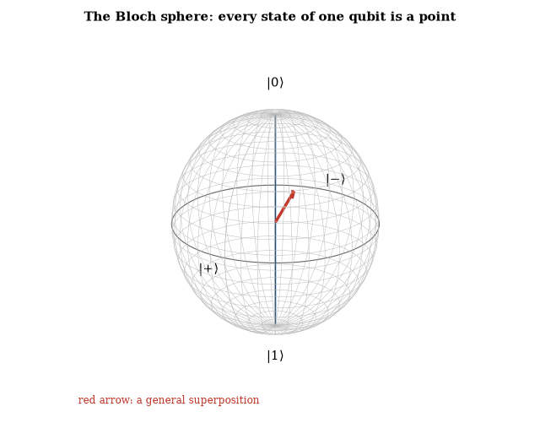
Figure 13. A single qubit’s state is a point on a sphere. The poles are the ordinary bit values 0 and 1; every other point is a superposition, with the angle around the equator giving the relative phase. Gates are rotations of the sphere.
Entanglement and interference allow certain algorithms to extract global properties of a function with fewer queries than any classical algorithm. Shor’s algorithm factors large integers in polynomial time by finding the period of a modular exponential function. Grover’s algorithm searches an unstructured database of N items in roughly √N steps. Both rely on the coherent evolution of superpositions and on a final measurement that yields the desired result with high probability.
The practical obstacles are decoherence and gate errors. Interaction with the environment destroys the relative phases that encode the computation. Quantum error-correcting codes spread the logical information across many physical qubits so that local errors can be detected and reversed without measuring the logical state. Fault-tolerant thresholds exist: if the physical error rate lies below a few parts in 10³ to 10⁴, arbitrarily long computations are possible in principle.
Present devices contain from tens to more than a thousand physical qubits and run circuits of limited depth. They have demonstrated small instances of quantum advantage on specially chosen sampling tasks. They have not yet run Shor’s algorithm on integers large enough to threaten cryptographic systems. The gap between the theoretical algorithms and large-scale, error-corrected machines remains the central engineering problem.
The computational model does not violate the Church–Turing thesis in its modern form. It supplies a different complexity scaling for particular problems. The scaling originates in the same interference of amplitudes that appears in every other quantum experiment.

Quantum Error Correction
Quantum error correction protects quantum information against decoherence and gate errors. A logical qubit is encoded in a subspace of several physical qubits. The code detects errors by measuring stabilizer operators that commute with the logical operators. The measurement reveals the error without revealing the logical state. A recovery operation then restores the state.
The surface code is a leading candidate. It requires only nearest-neighbor interactions on a two-dimensional lattice, and its threshold is approximately 1 percent. Below the threshold, increasing the code distance suppresses the logical error rate exponentially. Above the threshold, adding qubits makes the error worse. Present devices operate near or below the threshold for small distances; in 2024 Google showed the logical error rate falling as the code distance grew from 3 to 7. Scaling to the distances required for useful algorithms remains an engineering challenge. The existence of the threshold shows that fault-tolerant quantum computation is possible in principle.
The threshold theorem states that if the physical error rate lies below a constant threshold, then arbitrarily long quantum computations can be performed with only polylogarithmic overhead. The theorem requires that errors are local and that fresh ancilla qubits can be supplied. It does not require that the errors are independent, only that their correlations decay sufficiently fast.
Magic-state distillation converts noisy non-Clifford states into purer ones. It is the leading method for implementing the non-Clifford gates required for universality. The overhead in qubits is steep, and reducing it is an active research area. Concatenated codes and topological codes both achieve thresholds. Topological codes are preferred for their higher thresholds and for their compatibility with two-dimensional architectures. The theorem guarantees that fault tolerance is possible. It does not guarantee that it is easy.

Topological Quantum Computation
Topological quantum computation encodes information in non-Abelian anyons, storing it in their fusion space and performing gates by braiding them around one another. Because braiding is topological, it is insensitive to local disturbances, so the protection is built in rather than actively maintained. Error correction is still needed for the non-topological operations and for leakage.
Ising anyons are expected in the fractional quantum Hall state at filling factor 5/2 and in certain superconducting nanowires, but conclusive evidence for them is still lacking. On their own they are not universal and need extra, unprotected gates. Fibonacci anyons would be universal; so far they have only been simulated on conventional quantum processors, and Microsoft’s 2025 claim of a topological qubit remains disputed. The theory is mature; the hardware is not.

Measurement-Based Quantum Computation
Measurement-based quantum computation performs the computation by a sequence of single-qubit measurements on a pre-entangled resource state. The resource is a cluster state or a graph state. The measurements are adaptive. The basis of each measurement depends on previous outcomes.
The approach separates the creation of entanglement, which can be prepared in advance, from the computation, which consists only of measurements. That separation suits photonic hardware, where photon loss is the main error and error correction is possible. The scheme has the same computing power as the circuit model and has been demonstrated on small scales; scaling it requires high-fidelity resource states and fast feed-forward of measurement results.

Adiabatic Quantum Computation
Adiabatic quantum computation encodes the solution of a problem in the ground state of a final Hamiltonian. The system is prepared in the ground state of an initial Hamiltonian and evolved slowly to the final Hamiltonian. The adiabatic theorem guarantees that the system remains in the ground state if the evolution is slow enough. The runtime scales with the inverse square of the minimum gap.
The model is universal, equivalent to the circuit model, but practical implementations are limited by the size of the energy gap and by thermal excitations. Quantum annealing is a related heuristic that does not guarantee reaching the ground state. Both approaches are studied for optimization problems, where speed-ups over classical algorithms are possible for some instances but not guaranteed for all.

Quantum Annealing
Quantum annealing is a heuristic for finding the ground state of an Ising Hamiltonian. A transverse field is applied and slowly reduced, and tunneling lets the system escape local minima. The method does not guarantee the optimal solution; it can beat simulated annealing on some instances and lose on others.
Commercial devices implement quantum annealing with thousands of qubits, but the qubits are noisy and their connectivity limited. Advantages over classical algorithms have been claimed for specific classes of problem, and the claims are contested while benchmarking continues. The devices are useful for studying quantum dynamics; their advantage for practical optimization remains unproven.

Variational Quantum Algorithms
Variational quantum algorithms use a parameterized quantum circuit and a classical optimizer. The circuit prepares a trial state. The classical optimizer adjusts the parameters to minimize a cost function. The approach is hybrid. It is suitable for noisy intermediate-scale devices. The quantum approximate optimization algorithm and the variational quantum eigensolver are examples.
The algorithms do not require fault tolerance. Their performance is limited by noise and by the difficulty of the classical optimization. Barren plateaus—regions of exponentially small gradients—impede training for some circuits. Mitigation strategies exist, and the algorithms are a practical approach for present hardware, but their asymptotic advantage is not established.

Blind Quantum Computation
Blind quantum computation allows a client to delegate a computation to a server without revealing the input, the output or the algorithm. The client prepares single qubits and sends them to the server. The server entangles them and measures according to instructions. The instructions are chosen so that the server learns nothing about the computation. The client obtains the result.
A photonic demonstration has been carried out. Security rests on the no-signaling principle and on the client’s ability to prepare states from a restricted set. The protocol enables private computation on a remote quantum computer. It does not require the client to possess a universal quantum computer. The client needs only to prepare and measure single qubits. The capability is a distinctive feature of quantum networks.

Building One, and What It Is For
Building the machine is a fight with noise. A qubit is a physical system, and physical systems interact with their surroundings. The interaction leaks information and destroys the amplitudes. Error correction encodes one logical qubit in many physical qubits so that errors can be detected and fixed faster than they occur. The overhead is large. A useful error-corrected machine requires many physical qubits per logical qubit, with error rates below a threshold. Recent experiments have demonstrated error correction that improves as the code grows, which is the necessary direction. They have not yet produced a machine that runs Shor’s algorithm on cryptographically relevant numbers.
Cryptography has not waited. Public-key systems based on factoring or on related problems are vulnerable in principle to a large quantum computer. New systems, based on problems believed to resist quantum attack, have been standardized and are being adopted. The migration is slow because it touches everything that authenticates and encrypts. It is underway because data recorded today can be stored and decrypted later. The correct engineering response precedes the machine.
The phrase “quantum supremacy” or “quantum advantage” has been used for demonstrations in which a quantum device performed a particular task faster than a classical computer. The tasks were chosen to suit the device. They were real comparisons and not, by themselves, useful computations. The useful threshold is a calculation that someone wanted for an independent reason, done better than by any classical method. That threshold has not been clearly passed for a commercially relevant problem. It is the threshold that matters.
Quantum computing is therefore best understood as a new kind of instrument, powerful where interference helps and irrelevant where it does not. If the engineering succeeds, the first deep scientific returns are likely to be in the simulation of molecules, materials, and perhaps nuclear physics. Those are returns worth having. They are not a general replacement of classical computing. Most of what computers do will remain classical, because most of what computers do does not need amplitudes.
The classical competition should not be underestimated. Algorithms and hardware for classical simulation of quantum systems improve. A claimed quantum advantage has to beat the best classical method, not a naive one. Several early claims were later matched or approached classically. The race is real. It is a reason to be precise about what has been shown. It is also a reason the useful applications, when they come, will be in problems where the quantum structure is essential and the classical simulation is genuinely hard, not in problems where a cleverer classical programr had not yet looked.
The variety of qubits is the sign of an early technology. Superconducting circuits, trapped ions, neutral atoms, photons and spins in solids are all in use, each stronger in speed, connectivity or stability, and none has won. Mature technologies usually settle on one or two platforms. Until quantum computing does, parallel investment makes sense, and no single company’s roadmap should be mistaken for the field’s. Roadmaps are plans; the platforms are the evidence.
People are part of the timeline too. A technology that needs specialists in physics, engineering and algorithms is limited by how many such people exist, so training them is part of the investment. A hardware roadmap that ignores the workforce describes a laboratory success; a field is a laboratory plus a community that can reproduce and extend it.
Questions to Keep Asking
How do we know that a quantum computer has done something a classical one cannot? Look at how such claims are checked, and how some have been matched later by cleverer classical algorithms.
What size of error-corrected machine, and what task, would make you conclude that a useful quantum advantage has arrived?
Try it yourself. Two bits have four possible states, and ten qubits are described by 1,024 amplitudes. Roughly how many amplitudes describe 300 qubits, and how does that compare with the number of atoms in the observable universe?

9. Quantum Field Theory and Electrodynamics
The electron’s magnetism has been measured to about twelve digits, and quantum electrodynamics predicts the same number. Measure the distance from New York to San Francisco as precisely and you would be right to within a few millionths of a meter.

Quantum Field Theory
Quantum field theory is the framework that combines quantum mechanics with special relativity. The fundamental objects are fields defined at every point of spacetime. Particles appear as quanta of those fields. The theory is formulated so that the laws take the same form in every inertial frame and so that no signal propagates faster than light. It predicts the existence of antiparticles, the spin-statistics connection and the CPT theorem.
Interactions are local. The Lagrangian density at each point depends only on the fields and their derivatives at that point. The resulting S-matrix elements are computed by Feynman diagrams. Each diagram corresponds to a possible sequence of emissions and absorptions. The sum of diagrams yields the probability amplitude for a given process. Renormalization absorbs the infinite contributions of high-energy virtual particles into a finite number of measured parameters. After renormalization the predictions are finite and accurate.
The Standard Model is a quantum field theory. Its gauge symmetries dictate the interactions of quarks, leptons and the Higgs field. Quantum electrodynamics, the oldest and simplest part, predicts the anomalous magnetic moment of the electron to more than ten significant figures. Quantum chromodynamics accounts for the spectrum and scattering of hadrons once confinement is accepted. The electroweak theory unifies the electromagnetic and weak interactions and predicted the W, Z and Higgs bosons before they were observed.
The framework fails when gravity becomes strong: attempts to quantize gravity perturbatively fail because the theory is non-renormalizable, and no consistent quantum field theory of the metric itself is known. At accessible energies, however, quantum field theory is the most precise description of nature that exists. Every confirmed particle-physics experiment is a test of it.

Quantum Electrodynamics
Quantum electrodynamics is the quantum field theory of the electromagnetic interaction. It describes electrons, positrons and photons. The interaction is local and gauge-invariant. The coupling constant is the fine-structure constant α ≈ 1/137.
Feynman diagrams organize the perturbative expansion, and renormalization absorbs the divergences into the measured values of the electron mass and charge. The sections that follow describe both in detail.
The theory is the most precise in physics. The anomalous magnetic moment of the electron agrees with experiment to more than ten significant figures. The Lamb shift, the hyperfine structure of hydrogen and the scattering of electrons and positrons are likewise predicted to high accuracy. Quantum electrodynamics is the unbroken U(1) sector of the Standard Model. It is the prototype of a successful quantum field theory.

The Precision of Quantum Electrodynamics
Quantum electrodynamics is the theory of electrons, positrons, and photons. It is the most precisely tested theory in physics. The magnetic moment of the electron is predicted and measured to more than ten significant figures. The agreement holds.
The Dirac equation gives the electron a g-factor of exactly 2. Quantum corrections change it. The leading correction, calculated by Schwinger in 1948, is a = (g-2)/2 = α/(2π), where α is the fine-structure constant. Higher-order terms in powers of α have been calculated. The experimental value of the anomaly is a_{e} = 0.00115965218059(13). The theoretical value, limited by the precision of α itself, matches within the uncertainties.
The Lamb shift is the splitting between the 2s_{1/2} and 2p_{1/2} levels of hydrogen. In the Dirac theory they are degenerate. The measured interval is about 1057 MHz. The dominant contribution comes from the electron’s interaction with the fluctuating electromagnetic field. A smaller contribution, about −27 MHz, comes from vacuum polarization, the Uehling effect. The full calculation, including higher orders, matches the measurement.
The fine-structure constant is not, in fact, constant: it runs with the energy scale. Vacuum polarization screens charge at long distances, so at shorter distances the effective charge is larger. The running is logarithmic, and at the mass of the Z boson 1/α is about 128.9 rather than 137.0, as measured in scattering experiments and consistent with the calculation.
Renormalization is the procedure that makes these predictions finite, as the technical section below explains. It is not an arbitrary subtraction. It is required by the structure of the theory and constrained by gauge invariance, and the Ward identity ensures that the renormalization of the vertex and of the electron field are related, so that the charge remains universal.
The precision is possible because the expansion parameter α is small. Each additional loop is suppressed by another factor of α/π. The same methods applied to the strong force do not converge in the same way at low energy. QED is both a working computational tool and a demonstration that a quantum field theory can be defined, renormalized, and tested to extraordinary accuracy. Its success fixes the standard against which other theories are judged.

Feynman’s Account of Quantum Electrodynamics
Richard Feynman presented quantum electrodynamics in a form that begins with amplitudes rather than with fields. Every photon carries a complex amplitude, which can be drawn as an arrow. The arrow has a length and a direction. The probability that an event occurs is the square of the length of the final arrow. When an event can happen in more than one way, the arrows for the different ways are added before the square is taken. Interference is the result of that addition. Nature, it seems, prefers to do the arithmetic first and the squaring later, which is the opposite of the order most of us learned in school and have been regretting ever since.
Light is partially reflected from a surface of glass. The probability depends on the thickness of the glass. The calculation sums the amplitudes for reflection from the front surface and from the back surface. The relative phase depends on the extra distance traveled. The same rule accounts for the reflection from a mirror, the focusing of a lens, and the diffraction by a grating. In each case every possible path contributes an amplitude. Paths near the classical path have nearly the same phase and add constructively. Paths far from the classical path cancel.
An electron also carries an amplitude for going from one point to another. The amplitude depends on the proper time along the path. An electron can emit or absorb a photon. Those three processes—the photon going from place to place, the electron going from place to place, and the electron emitting or absorbing a photon—are the only ingredients. Every electromagnetic process is a combination of them, and the combinations are drawn as diagrams, each of which corresponds to a term in the calculation. The terms are added, and the square of the sum is the probability.
The theory is approximate. Higher-order diagrams contain loops and produce large intermediate numbers. Those numbers are absorbed into the measured mass and charge of the electron. Once that is done, the remaining predictions are finite. The magnetic moment of the electron, the Lamb shift, and the scattering of light by light have all been calculated and checked against experiment. The agreement is the strongest quantitative success in physics.
The account does not eliminate the mathematics. It shows what the mathematics is doing. Amplitudes are added for every way an event can happen. The classical path is the path that survives the addition. The photon is the quantum of the electromagnetic field. The same rules govern the emission of light by an atom, the reflection of light by a mirror, and the forces between charges. The strangeness is not removed. It is located in the rule that the arrows must be added before they are squared.

The Technical Structure of Quantum Electrodynamics
Feynman’s formulation of quantum electrodynamics supplies a set of rules for calculating any electromagnetic process. The amplitude for a particle to go from one point to another is given by a propagator. For the electron the propagator is the Green function of the Dirac equation. For the photon it is the Green function of the wave equation. Both are known in closed form.
An interaction occurs when an electron emits or absorbs a photon. The vertex contributes a factor proportional to the charge and to the Dirac matrix γ^{μ}. Momentum is conserved at every vertex. The full amplitude for a process is the sum of the amplitudes for every diagram that connects the initial state to the final state. Each internal line is a propagator. Each closed loop is integrated over the momentum that circulates in it.
The path-integral version of the same theory states that the amplitude is the sum over all field histories of e^{iS/ħ}, where S is the classical action. The Feynman rules are the perturbative expansion of that sum. The two formulations are equivalent. The diagrams are a bookkeeping device for the expansion, not pictures of trajectories.
Ultraviolet divergences appear in the loop integrals and are handled by renormalization. The bare mass and charge in the Lagrangian are not the measured ones, and the difference absorbs the divergent parts, so that after renormalization every physical prediction is finite. Infrared divergences appear when massless photons are emitted with vanishing energy; they cancel in any observable that sums over the soft photons that cannot be resolved, a cancellation guaranteed by the structure of the theory.
The same rules give the anomalous magnetic moment, the Lamb shift, the running of the charge, and the cross sections for scattering and pair production. Each additional loop is suppressed by a power of the fine-structure constant. The expansion is therefore practical. The theory remains the prototype of a renormalizable quantum field theory. Its rules are specific to electrons and photons. The same diagrammatic method, with different vertices and propagators, is used for the other forces.

Path Integrals
The path-integral formulation expresses the quantum amplitude for a process as a sum over all possible histories. Each history contributes a phase e^{iS/ħ}, where S is the classical action of that history. The dominant contributions come from paths near the classical path, where the phase is stationary. Quantum corrections arise from the fluctuations around it.
The formulation is equivalent to the operator formalism. It makes Lorentz invariance and the connection to classical mechanics manifest. It is the natural language for gauge theories and for the quantization of constrained systems. In statistical mechanics the same integral, continued to imaginary time, yields the partition function.
Feynman introduced the path integral for non-relativistic quantum mechanics and later extended it to quantum electrodynamics. It remains the standard starting point for perturbative calculations in the Standard Model and for many non-perturbative approaches. The classical limit ħ → 0 recovers the principle of least action. The path integral therefore unifies the classical and quantum descriptions within a single expression.

Feynman Diagrams
Feynman diagrams are graphical representations of the terms in the perturbative expansion of a quantum field theory. External lines denote incoming and outgoing particles, internal lines denote virtual particles, and vertices denote interactions. Each diagram corresponds to an integral over the momenta of the virtual particles. The integral is weighted by the coupling constants and by the propagators of the internal lines.
The diagrams automatically incorporate particle creation and annihilation, crossing symmetry and the correct combinatorial factors. They make the order of a calculation visible: loop diagrams represent quantum corrections, while tree diagrams are classical. Renormalization subtracts the divergent parts of the loop integrals and replaces them with measured parameters.
The same diagrams are used in condensed-matter theory and in statistical mechanics. Their utility is practical. They convert an abstract expansion into a set of concrete integrals that can be evaluated. Every precision test of quantum electrodynamics and of the electroweak theory has been performed with Feynman diagrams. They are the computational language of perturbative quantum field theory.

Renormalization
Renormalization absorbs the divergences of loop integrals into a finite number of measured parameters. In a renormalizable theory the number of such parameters does not increase with the order of perturbation theory. Quantum electrodynamics and the Standard Model are renormalizable. Gravity is not. Higher-dimension operators in an effective theory are suppressed by powers of a high scale. They become important only near that scale.
The renormalization group describes how the parameters change with scale. Couplings that grow in the ultraviolet indicate new physics or a Landau pole. Couplings that grow in the infrared indicate confinement or the generation of a mass gap. The group organizes the relation between physics at different energies. It does not remove the need for experimental input. It determines how that input is extrapolated.

Anomalies in Quantum Field Theory
Anomalies are symmetries of the classical action that are broken by quantum effects. The chiral anomaly is the non-conservation of the axial current in the presence of gauge fields. It is required for the decay of the neutral pion and for the resolution of the U(1) problem in QCD. Gauge anomalies must cancel for consistency. In the Standard Model they cancel between quarks and leptons.
The cancellation is a constraint on the particle content, and it is satisfied by the observed fermions. Gravitational anomalies impose further constraints. Anomalies are not defects but calculable quantum effects that have observable consequences, and their cancellation or non-cancellation determines which theories are consistent.

Instantons
Instantons are classical solutions of the Euclidean field equations. They describe tunneling between topologically distinct vacua. In QCD they contribute to the mass of the eta-prime and to the violation of U(1) axial symmetry. Their density is suppressed at high temperature. The suppression is observed in the restoration of the symmetry above the deconfinement transition.
In the electroweak theory instantons violate baryon and lepton number. The rate is negligible at zero temperature. At temperatures above the electroweak scale, the related sphaleron processes make it fast. The process is the basis of electroweak baryogenesis and of leptogenesis scenarios that rely on sphalerons. Instantons are non-perturbative. They are not captured by Feynman diagrams. They are required for a complete description of the vacuum structure.

Symmetry Breaking
Spontaneous symmetry breaking occurs when the ground state of a system does not share the symmetry of the Lagrangian. The symmetry is not absent. It is realized non-linearly. Goldstone’s theorem states that each broken continuous generator produces a massless boson. In a gauge theory the Goldstone bosons are absorbed by the gauge fields, which become massive. The Higgs mechanism is the relativistic realization of this process.
Explicit breaking by a small term in the Lagrangian gives the would-be Goldstone bosons a small mass. Pions are the approximate Goldstone bosons of chiral symmetry. Their mass is small compared with the scale of chiral symmetry breaking. The same pattern appears in condensed-matter systems. Superconductors, magnets and liquid crystals all break symmetries spontaneously. The resulting collective modes are the analogs of Goldstone bosons. The phenomenon is general.
Questions to Keep Asking
How do we know that renormalization is not just a trick to hide infinities? It makes predictions that experiments check to many digits, and effective-field-theory ideas explain why it works.
A long-running disagreement over the muon’s magnetic moment was settled largely in the Standard Model’s favor by better calculations. What kind of disagreement would be harder to explain away?
Try it yourself. Draw the simplest Feynman diagram in which two electrons repel each other. Label the lines and say which one is virtual.
Further reading for Part II. Feynman’s QED is four short lectures on how light and electrons really behave, written for anyone. Carroll’s Something Deeply Hidden argues for the many-worlds reading of quantum mechanics, and Everett’s original 1957 paper is short enough to read. Mead’s Collective Electrodynamics rebuilds electromagnetism from quantum ideas.

Part III: Particles, Nuclei and Atoms
From quarks and the Standard Model up through nuclei and atoms to chemistry and materials

10. The Standard Model of Particle Physics
Every ordinary thing is built from three kinds of particle: up quarks, down quarks and electrons. The Standard Model needs seventeen to account for everything accelerators have produced, and no experiment has shown it to be wrong within its domain.

The Particle That Should Not Have Been Found
In 2012 two experiments at the Large Hadron Collider announced the discovery of a particle with a mass of 125 GeV. The particle decayed in the ways predicted for the Higgs boson. The decays were rare. The background was large. The signal emerged only after years of data and after the application of every available discrimination technique. The emergence was gradual. It was also unambiguous.
The particle completes the Standard Model without explaining it. Its mass is not predicted, and its couplings are measured rather than derived. They agree with the theory, which is a triumph, but an incomplete one: the theory that predicted the particle cannot say why it has the mass it has. The mass is an input, now known. The reason for it is not.

The Standard Model in Brief
The Standard Model is a renormalizable quantum field theory based on SU(3)_{c} × SU(2)_{L} × U(1)_{Y}. It contains three generations of quarks and leptons and a single Higgs doublet. Nineteen parameters, most of them Yukawa couplings that set the fermion masses, remain free. They are measured, not predicted; grand unification and supersymmetry would reduce the count under assumptions not yet confirmed.
Precision tests confirm the model to high accuracy. The electron magnetic moment, the W and Z masses and the Higgs couplings agree with the predictions after radiative corrections. Neutrino masses require an extension. Dark matter and the baryon asymmetry lie outside the model.
The theory is the most successful description of the non-gravitational interactions. Its incompleteness is quantitative: no contradiction with existing data has been established, but no complete ultraviolet completion is known.

Particles and Forces
The Standard Model describes the electromagnetic, weak, and strong interactions. It contains twelve fermions—six quarks and six leptons—and the gauge bosons that mediate the forces. The Higgs boson generates the masses of the W and Z bosons and of the fermions through the Yukawa couplings.
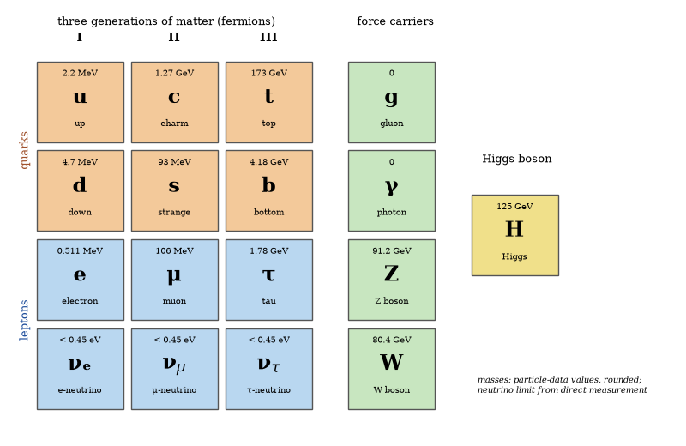
Figure 14. The particles of the Standard Model, with rounded masses.
The electromagnetic and weak interactions are unified in the electroweak theory. At energies above the electroweak scale the distinction disappears. The strong interaction is described by quantum chromodynamics, in which quarks carry color charge and are confined, so free quarks are never observed and the observed hadrons are color-neutral combinations of quarks.
Every particle the model predicts has been found, and the measured masses and couplings agree with it to high precision. It still leaves out gravity and says nothing about why its parameters have the values they do.

Symmetries of the Standard Model
The Standard Model is defined by its gauge symmetry group SU(3)_{c} × SU(2)_{L} × U(1)_{Y}. The factor SU(3)_{c} is the color group of the strong interaction. Quarks transform as triplets; gluons as an octet. The group remains unbroken. Its coupling grows at low energy and confines quarks and gluons into color-singlet hadrons.
The factor SU(2)_{L} × U(1)_{Y} is the electroweak group. Left-handed fermions transform as doublets under SU(2)_{L}; right-handed fermions are singlets. The Higgs field is a doublet. Its vacuum expectation value breaks SU(2)_{L} × U(1)_{Y} to the electromagnetic U(1)_{em}. Three of the four gauge bosons acquire mass and become the W± and Z. The unbroken generator is the photon. The same vacuum expectation value generates fermion masses through Yukawa couplings.
The gauge symmetries dictate the form of every interaction vertex. They forbid proton decay at the renormalizable level and guarantee the cancellation of anomalies once the observed fermion content is included. Global symmetries are fewer. Baryon number and lepton number are accidental consequences of the gauge structure and the particle content. They are conserved by all renormalizable terms. Neutrino masses, if Majorana, violate lepton number by two units and lie outside the minimal Standard Model.
Discrete symmetries (charge conjugation, parity, time reversal) are violated by the weak interaction. Their observed pattern is reproduced by the complex phases in the Yukawa matrices. The gauge symmetry group, together with the representation content of the fermions and the Higgs, constitutes the entire defining structure of the Standard Model.

The Higgs Mechanism
The Higgs mechanism generates masses for the W and Z bosons and for the fermions. A complex scalar doublet acquires a vacuum expectation value. Three of its four degrees of freedom become the longitudinal polarizations of the W and Z. The fourth remains as the Higgs boson. The vacuum expectation value is fixed by the Fermi constant. The Higgs mass is fixed by the self-coupling. Both are measured.
Fermion masses arise from Yukawa couplings to the same vacuum expectation value. The couplings are free parameters spanning about six orders of magnitude, from the electron to the top quark, and nothing in the model fixes them. Why the Higgs mass sits so far below the Planck scale is the hierarchy problem of Chapter 11. The mechanism works; its deeper origin is unknown.

The Higgs Boson Since 2012
The Higgs boson was discovered in 2012 at a mass of approximately 125 GeV. Its couplings to the W, Z and to the heavy fermions agree with Standard Model predictions within present uncertainties. The self-coupling has not yet been measured. The width is narrow, consistent with the expected decay channels. No deviation that requires new physics has been established.
The vacuum is metastable in the Standard Model. The Higgs self-coupling runs negative at high scales. The lifetime of the vacuum exceeds the age of the universe for the measured masses. New physics below the instability scale can stabilize the vacuum. Its absence so far leaves the metastability intact. The observation confirms the mechanism. It does not reveal the origin of the potential or the reason for the particular mass.

The Core Theory and Everyday Life
The physicist Sean Carroll has given the name Core Theory to the combination of the Standard Model of particle physics with general relativity, treated as a quantum field theory at ordinary energies. The claim made for it is bold and well founded. Everything in daily experience, from chemistry and the shapes of molecules to living cells, brains and the weather, is governed by the fields and forces already in the Core Theory.
The argument is that any new particle or force strong enough to affect atoms and molecules at ordinary energies would long ago have shown itself in accelerators and precision experiments. The room for new physics at these scales is almost gone. The exceptions are on cosmic scales, dark matter and dark energy among them, and they do not touch daily life.
This is not a claim that everything is predictable or that the Core Theory explains everything. It cannot predict the weather a month ahead, and it says nothing about why the fields are what they are. The claim is narrower: what remains unknown lies at extreme energies, tiny distances or huge scales, and the laws that run ordinary life are known.
Questions to Keep Asking
How do we know that quarks exist if none has ever been seen alone? Scattering experiments, jets of particles in collisions and the pattern of known particles all require them.
Proton decay or a new particle at the Large Hadron Collider would each demand more than the Standard Model. Which one would you expect to see first, and why?
Try it yourself. Count the quarks and electrons in one water molecule. (Answer: 28 up quarks, 26 down quarks and 10 electrons.)

11. Beyond the Standard Model
The Standard Model cannot say what most matter is, why there is any matter at all, or why neutrinos weigh anything. This chapter is a list of those holes and of the best ideas for filling them.

Grand Unified Theories
Grand unified theories embed the Standard Model gauge group in a single simple group. The smallest example is SU(5). Larger groups such as SO(10) and E₆ are also studied. At energies far above the electroweak scale the unified symmetry is unbroken. Quarks and leptons occupy common multiplets. The strong, weak and electromagnetic couplings are different low-energy manifestations of a single coupling.
Unification predicts that the three Standard Model couplings meet at a single high scale when evolved with the renormalization-group equations. In the minimal non-supersymmetric SU(5) model they miss. In the minimal supersymmetric extension they meet near 10¹⁶ GeV. The same scale suppresses the rate of proton decay. Present experimental limits on the proton lifetime already exclude the simplest non-supersymmetric models and constrain the supersymmetric ones.
The theories also relate quark and lepton masses and, in SO(10), naturally accommodate a right-handed neutrino, supplying a seesaw mechanism for the observed neutrino masses. They do not explain the number of generations or the hierarchy of Yukawa couplings. Supersymmetric versions introduce new particles that have not been observed. The minimal non-supersymmetric version is already ruled out; others survive with intermediate symmetry-breaking scales.
No direct evidence for grand unification exists. The ideas remain the most economical framework that links the three non-gravitational forces and that relates the matter content of the Standard Model. Their confirmation or exclusion will require either the discovery of proton decay, the observation of supersymmetric partners, or a decisive mismatch in the high-scale extrapolation of the couplings.

The Seesaw Mechanism
The seesaw mechanism accounts for the extreme smallness of neutrino masses. In the Standard Model the left-handed neutrinos are massless. The introduction of a right-handed neutrino that is a singlet under the Standard Model gauge group permits two additional mass terms: a Dirac mass m_{D} that couples the left-handed neutrino to the right-handed neutrino, and a Majorana mass M for the right-handed neutrino alone.
Because no gauge symmetry forbids the Majorana term, M may lie near the grand-unification or Planck scale. Diagonalization of the resulting mass matrix yields a light eigenvalue m_{ν} ≈ m_{D}²/M and a heavy eigenvalue approximately equal to M. A large M therefore forces m_{ν} to be tiny. The ordinary neutrino mass is suppressed by the ratio of the electroweak scale to the high scale.
The construction also breaks lepton number, by two units. It thereby permits neutrinoless double-beta decay. In SO(10) grand unified theories the right-handed neutrino is required to complete the spinor representation that contains one generation; the seesaw appears automatically. The mechanism remains the most economical explanation of the observed neutrino masses within a grand-unified framework. Direct evidence for the heavy right-handed states is absent.

The Hierarchy Problem
The hierarchy problem is the sensitivity of the Higgs mass to ultraviolet physics. Quadratic divergences require fine-tuning if the cutoff lies far above the electroweak scale. The fine-tuning is of order (v/Λ)². For a Planck-scale cutoff it is of order one part in 10³⁴. No symmetry of the Standard Model protects the mass.
Supersymmetry cancels the quadratic divergences. Composite Higgs models replace the elementary scalar with a bound state. Extra dimensions lower the cutoff. None of these solutions has been confirmed. The absence of superpartners below a TeV increases the residual tuning. The problem is conceptual. It is not a contradiction with data. It is a reason to expect new physics near the electroweak scale. That expectation has not yet been fulfilled.

Naturalness
Naturalness is the expectation that dimensionless parameters of order one are typical and that large hierarchies require explanation. The expectation is aesthetic and historical. It has been successful in some cases—the charm quark was predicted by the absence of flavor-changing neutral currents. It has failed in others—the cosmological constant is unnaturally small.
The failure does not invalidate the criterion. It shows that the criterion is not infallible. Anthropic selection or environmental scanning can produce apparently unnatural values. The criterion remains a guide for model building. It is not a theorem. Its continued use is justified by its past successes and tempered by its known failures.

Supersymmetry
Supersymmetry relates bosons and fermions. Each particle has a superpartner whose spin differs by one-half. The symmetry cancels quadratic divergences and unifies the gauge couplings at a high scale. It supplies a dark-matter candidate if R-parity is conserved. The lightest superpartner is stable.
No superpartners have been observed, and collider limits now exceed a TeV for many strongly interacting states, which increases the leftover fine-tuning. The symmetry may be broken at a higher scale, or absent altogether. Its motivations, the hierarchy problem, unification and dark matter, remain, but experimental support does not: supersymmetry is a well-motivated extension that has not been confirmed.

The Theta Term and the Strong CP Problem
The QCD Lagrangian admits a term proportional to the topological charge. The coefficient is an angle θ. The term violates CP. Experimental limits on the neutron electric dipole moment require θ to be smaller than 10⁻¹⁰. No symmetry of the Standard Model sets θ to zero. The smallness is the strong CP problem.
The Peccei–Quinn mechanism promotes θ to a dynamical field that relaxes to zero; its excitation is the axion, also a candidate for dark matter. Laboratory and astrophysical searches constrain the axion’s mass and coupling, but none has confirmed a detection. The mechanism solves the strong CP problem if the axion exists, and that is not yet established.

Axions
Axions are hypothetical particles that solve the strong CP problem. They are light, weakly interacting, and can constitute the dark matter. The mass is inversely proportional to the decay constant. Astrophysical bounds require the decay constant to be large, so the mass is small—microelectronvolts or below for the dark-matter window.
Searches use resonant cavities in magnetic fields, nuclear magnetic resonance, and broadband techniques. The cavity experiments scan the mass range by tuning the frequency. No signal has been found in the ranges examined. The remaining parameter space is large. A detection would solve both the strong CP problem and the dark-matter problem. The absence of a detection so far constrains but does not exclude the particle.

Sterile Neutrinos
Sterile neutrinos are singlets under the Standard Model gauge group. They interact only through mixing with the active neutrinos or through gravity. They are required in the seesaw mechanism. Their masses can range from sub-electronvolt to the grand-unification scale. Light sterile neutrinos have been invoked to explain anomalies in short-baseline oscillation experiments. The anomalies are not confirmed by all experiments.
Cosmological bounds limit the contribution of light sterile neutrinos to the energy density in the early universe. The bounds are in tension with the parameter space preferred by some anomalies. Heavy sterile neutrinos are constrained by the non-observation of their decay products and by the success of Big Bang nucleosynthesis. The particles remain hypothetical. They are a minimal extension that can generate neutrino masses.

Leptogenesis
Leptogenesis generates the baryon asymmetry from a lepton asymmetry: heavy right-handed neutrinos decay out of equilibrium, and the decays violate CP. The resulting lepton asymmetry is partially converted into a baryon asymmetry by electroweak sphalerons. The mechanism operates naturally within the seesaw framework.
The required right-handed neutrino masses lie above 10⁹ GeV in the simplest versions. Lower scales are possible with resonant enhancement or with additional fields. The mechanism links the baryon asymmetry to the origin of neutrino masses. It has not been experimentally confirmed. It remains the most economical explanation that connects two otherwise separate facts—the smallness of neutrino masses and the existence of the baryon asymmetry.

Electroweak Baryogenesis
Electroweak baryogenesis generates the baryon asymmetry during the electroweak phase transition. A strongly first-order transition provides the departure from equilibrium. CP violation in the bubble walls generates a chiral asymmetry. Sphalerons convert it into a baryon asymmetry outside the bubbles. Inside the bubbles the sphalerons are suppressed and the asymmetry is frozen.
In the Standard Model the transition is a smooth crossover, not first-order, so the mechanism needs extensions, such as extra scalar fields or supersymmetry, that strengthen it, and these are constrained by the Higgs mass and by the absence of new particles. The mechanism is testable, predicting electric dipole moments and changes to the Higgs potential, neither yet observed at the required level. It survives in limited regions of parameter space.
Questions to Keep Asking
How do we know that new physics is needed? Neutrino masses, dark matter and the excess of matter over antimatter are each firmly observed and absent from the model.
Many arguments of naturalness predicted new particles that the Large Hadron Collider did not find. Does that weaken the arguments, or only the particular models?
Try it yourself. Naturalness predicted the charm quark correctly and failed for the cosmological constant. Find one other case in this book where an elegance argument succeeded or failed.

12. Dense Matter and the Strong Force
A teaspoon of neutron-star material would weigh billions of metric tons, and nothing like it can be made on Earth. What the stuff is made of is being answered with gravitational waves and X-ray telescopes.

The Equation of State of Dense Matter
The equation of state of matter at supranuclear density is unknown. It is constrained by nuclear theory at low density, by the maximum mass of neutron stars, and by the tidal deformability measured in gravitational-wave events. A maximum mass above two solar masses requires a relatively stiff equation of state. The tidal deformability of GW170817 requires that the equation of state not be too stiff at 1–2 times nuclear density.
Hyperons, deconfined quarks or Bose condensates may appear at high density. Each softens the equation of state. Their presence is limited by the maximum-mass constraint. Laboratory heavy-ion collisions probe the equation of state at high temperature and moderate density. They do not reach the cold, high-density conditions of neutron-star cores. The core composition remains an open question. The constraints from astrophysics are now quantitative.

Inside a Neutron Star
A neutron star is about twenty-five kilometers across and heavier than the Sun, and it has layers. A thin atmosphere and an ocean of ordinary plasma cover a crust, where atomic nuclei form a rigid crystal lattice permeated by free neutrons. Deeper, where the density approaches that of an atomic nucleus, nuclei are predicted to merge into strange shapes called nuclear pasta, in rods and sheets. Beneath lies a core of neutron-rich matter, probably superfluid and, in the case of the protons, superconducting.
What lies at the center is not known. It may be neutrons alone, or neutrons with heavier particles, or quark matter, and the answer fixes the maximum mass a neutron star can have. Observations constrain it from three directions: the heaviest known stars have about two solar masses, the gravitational waves of colliding stars show how readily they deform, and X-ray timing from the NICER telescope has measured the radii of nearby pulsars at about 11 to 13 kilometers.
Because no laboratory can make matter so dense and cold, neutron stars are the only way to test what nuclear forces do under such pressures. Each new measurement rules out a family of models.

Little Bangs: Heavy-Ion Collisions
To make quark matter in the laboratory, physicists collide heavy nuclei at nearly the speed of light, gold at the Relativistic Heavy Ion Collider in New York and lead at the Large Hadron Collider in Geneva. For an instant, a region the size of a nucleus reaches a temperature of several trillion kelvin, about as hot as the whole universe was a few microseconds after the Big Bang. Protons and neutrons melt, and quarks and gluons move freely.
The surprise of the first results was that the new state did not behave like a gas. It flowed like a nearly perfect liquid, with almost no internal friction. The ratio of its viscosity to its entropy is close to a value that string-theory calculations had suggested as a lower bound, a link between particle collisions and the black-hole holography of Chapter 24.
The fireball lives for about 10⁻²³ seconds, and the quark-gluon plasma cannot be observed directly. Its properties are inferred from the pattern of particles that fly out, and the fireball’s expansion is modeled with relativistic fluid dynamics. These experiments probe matter at high temperature and low density. The cold, dense matter inside neutron stars remains out of reach.

Quark Matter
Quark matter is the phase in which quarks are deconfined. It is expected at densities several times nuclear density or at temperatures above approximately 150 MeV. Lattice QCD calculations show a crossover at zero chemical potential. At high chemical potential the transition may be first-order. The critical point, if it exists, has not been located.
Neutron-star cores may contain deconfined quarks, a possibility constrained by the maximum mass of neutron stars and by their tidal deformability. For some equations of state, hybrid stars with quark cores fit present data, while pure quark stars are disfavored. Heavy-ion collisions create a quark-gluon plasma at high temperature and low density, a nearly perfect fluid whose properties are measured; the cold, dense phase remains out of experimental reach.

Color Superconductivity
Color superconductivity is the pairing of quarks at high density and low temperature. The pairing is analogous to ordinary superconductivity: it gaps the quark spectrum and breaks color symmetry, and several phases are possible. The color-flavor-locked phase pairs all three colors and flavors. It is electrically neutral and may form the ground state of cold quark matter.
The gap is estimated to be tens of MeV. It affects the cooling and the transport properties of a quark core. No observational signature has been confirmed. The phase is a prediction of QCD at high density. Its realization in neutron stars depends on the density reached in the core and on the strange-quark mass. Both are uncertain. The phase remains a theoretical possibility whose astrophysical consequences are under study.

The Chiral Magnetic Effect
The chiral magnetic effect is the generation of an electric current along a magnetic field in a medium with chiral imbalance. It is a macroscopic manifestation of the chiral anomaly. In heavy-ion collisions the effect may produce a charge separation across the reaction plane. Early searches reported hints, but a dedicated 2021 run at RHIC comparing two isobar nuclei found no clear signal beyond the expected backgrounds.
The effect is also predicted in Weyl and Dirac semimetals. It has been observed in those materials, which confirms the theoretical mechanism in condensed matter, while the heavy-ion realization remains under debate. The effect illustrates how a quantum anomaly can produce a macroscopic transport phenomenon. Its cosmological consequences, if any, are speculative.
Questions to Keep Asking
How do we know the size of a neutron star? Pulsar X-ray timing and the deformation of merging stars in gravitational waves each give radii of about 11 to 13 kilometers.
What would a neutron star heavier than about 2.3 solar masses tell us about the matter inside it?
Try it yourself. Atomic nuclei have a density of about 2 × 10¹⁷ kilograms per cubic meter. Estimate the radius of a ball of such matter with the Sun’s mass. (Answer: about 13 km.)

13. Nuclei, Fission and Fusion
A kilogram of uranium-235, completely fissioned, would release as much energy as about three thousand metric tons of coal. A kilogram of hydrogen fused to helium releases roughly eight times more again. The gulf between a chemical fire and a nuclear one is a factor of millions, and it comes from one curve.

Nuclear Binding Energy
The mass of a nucleus is less than the mass of its separated protons and neutrons. The difference is the binding energy. For helium-4 the difference is about 0.75 percent of the mass. That corresponds to about 28 MeV, whereas a chemical bond is a few electron-volts, so nuclear binding is millions of times stronger.
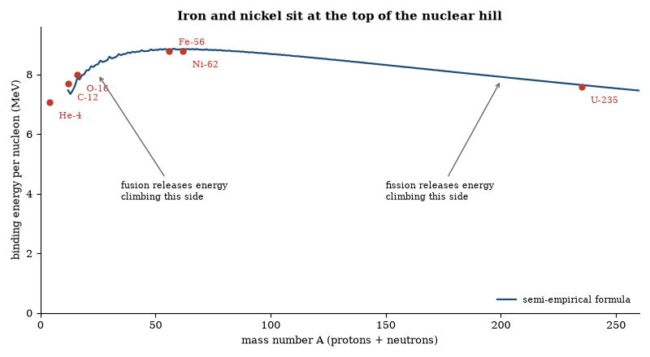
Figure 15. Binding energy per nucleon against mass number. The curve is computed from the liquid-drop (semi-empirical) mass formula; red points are measured values for selected nuclei. Nuclei near iron-56 and nickel-62 are the most tightly bound, so fusion of light nuclei and fission of heavy ones both release energy.
When the binding energy per nucleon is plotted against mass number, the curve rises from hydrogen, peaks near iron and nickel at about 8.8 MeV per nucleon, and then declines slowly toward uranium. Light nuclei release energy by fusing toward the peak and heavy nuclei by fissioning toward it, with iron at the top. A star that has built an iron core has no further nuclear source of energy.
The shape of the curve comes from a competition between the strong and electromagnetic forces. The strong force is short-range: a nucleon inside a large nucleus is bound to all its neighbors, one on the surface to fewer, and since small nuclei are mostly surface, adding nucleons helps. The electrical repulsion between protons is long-range and grows faster with the number of protons, so in large nuclei it begins to win. Extra neutrons add strong-force binding without adding charge, but beyond lead and bismuth no stable combination exists.
Fusion in the Sun requires protons to approach within the range of the strong force. At the temperature of the solar core the typical kinetic energy is far below the Coulomb barrier. Fusion occurs by quantum tunneling. The probability is low. A given proton in the core waits billions of years before it fuses. The Sun’s power density is only a few hundred watts per cubic meter. It shines because it is large and well insulated, not because the reactions are rapid.
Fission of a heavy nucleus such as uranium-235, triggered by a neutron, releases about 200 MeV and two or three additional neutrons. If, on average, one of those neutrons causes another fission, the reaction is sustained. A small fraction of the neutrons are delayed by the decay of fission products. That delay allows a reactor to be controlled. In a bomb the multiplication is rapid and uncontrolled. Natural reactors operated at Oklo in Gabon about two billion years ago, when the uranium-235 abundance was higher and groundwater moderated the neutrons.
Radioactive decay follows an exponential law. After one half-life half the nuclei remain. Carbon-14 has a half-life of about 5,730 years and is used to date organic material up to about 50,000 years. Uranium-238 has a half-life of about 4.5 billion years and is used to date the solar system. The range of half-lives is explained by tunneling through the nuclear barrier. A small change in the barrier height or width changes the lifetime by many orders of magnitude.

Nuclear Stability and the Valley of Stability
Stable nuclei lie in a narrow band on the plot of proton number versus neutron number. For light nuclei the band follows N ≈ Z. For heavier nuclei the band bends toward neutron excess because of the increasing Coulomb repulsion among protons. The band is the valley of stability.
Nuclei outside the valley decay toward it: neutron-rich nuclei by beta emission, and proton-rich nuclei by positron emission or electron capture. The most stable nuclei near iron have the highest binding energy per nucleon. Fusion below iron and fission above it therefore both release energy.
Magic numbers—2, 8, 20, 28, 50, 82, 126—mark closed nuclear shells. Nuclei with magic proton or neutron numbers are especially stable. The shell model of the nucleus accounts for the magic numbers in the same way that the atomic shell model accounts for the noble gases. The existence of superheavy islands of stability beyond the known elements is a prediction of the same model. No such island has yet been reached by experiment.
The valley of stability and the shell closures together determine which isotopes exist long enough to be studied and which can be used as fuels, tracers, or chronological markers. The nuclear landscape is as structured as the electronic periodic table.

Worked Examples: Binding Energy and Fission
Example 1. Calculate the energy released in the fission of one ²³⁵U nucleus into typical fragments of mass 95 and 138, plus two neutrons.
Mass of ²³⁵U = 235.044 u. Mass of fragments + neutrons ≈ 234.846 u. Defect = 0.198 u. Energy = 0.198 × 931.5 MeV ≈ 184 MeV. (The accepted average is ~200 MeV when all products are included.)
Example 2. How many fissions per second are required to produce 3 GW of thermal power?
Energy per fission ≈ 200 MeV = 3.2 × 10⁻¹¹ J. Rate = 3 × 10⁹ / 3.2 × 10⁻¹¹ ≈ 9.4 × 10¹⁹ fissions s⁻¹.
Example 3. A reactor operates for one year at that power. What mass of ²³⁵U is consumed?
Number of fissions = 9.4 × 10¹⁹ × 3.16 × 10⁷ ≈ 3.0 × 10²⁷. Mass = 3.0 × 10²⁷ × 235 u ≈ 1 200 kg. (Actual fuel loading is larger because of incomplete burn-up.)
The same arithmetic fixes the fuel requirements and the waste inventory of every power reactor.

Nuclear Fission
Fission is the splitting of a heavy nucleus into two lighter fragments. The fragments lie closer to the iron peak and therefore possess higher binding energy per nucleon. The difference appears as kinetic energy of the fragments, neutrons, and gamma rays. Each fission of uranium-235 or plutonium-239 releases roughly 200 MeV, tens of millions of times the energy of a chemical bond.
A chain reaction occurs when the neutrons emitted by one fission induce further fissions. In a reactor the reaction is controlled by moderators and control rods so that exactly one neutron per fission continues the chain. In a weapon the reaction is uncontrolled and multiplies rapidly. Both devices rely on the same nuclear process.
The fuel is limited to a few fissile or fertile isotopes. Uranium-235 is the only naturally occurring fissile nuclide. Plutonium-239 and uranium-233 are produced by neutron capture in reactors. Spent fuel contains a mixture of fission products, many of them radioactive with half-lives from seconds to millions of years. The long-lived components dominate the waste-management problem.
Fission supplies about 10 percent of the world’s electricity. The energy density is roughly a million times higher than that of chemical fuels. The engineering constraints are heat removal, neutron economy, and containment of radioactive material.

Nuclear Fusion
Fusion is the joining of light nuclei to form a heavier nucleus closer to the iron peak. The energy release per nucleon is larger than in fission for the lightest fuels. The most accessible reaction on Earth is the fusion of deuterium and tritium:
²H + ³H → ⁴He + n + 17.6 MeV.
The Coulomb barrier must be overcome. In stars the barrier is penetrated by quantum tunneling at temperatures of tens of millions of kelvin. On Earth the same temperatures must be reached and the plasma confined long enough for the reaction rate to exceed the energy losses. Magnetic confinement and inertial confinement are the two principal approaches.
No terrestrial device has yet produced sustained net electrical power. Experimental reactors have achieved brief periods in which the fusion energy exceeded the energy delivered to the plasma. The engineering requirements—materials that withstand intense neutron fluxes, tritium breeding, and continuous heat extraction—remain unsolved at industrial scale.
Fusion fuels are abundant: deuterium is extracted from water and tritium can be bred from lithium. The reaction products are not long-lived radioactive wastes, and the practical obstacles are technical, not fundamental.

Cold Fusion
Cold fusion is the claim that nuclear fusion can occur at ordinary temperatures in condensed matter. The original reports involved electrolysis of heavy water with palladium electrodes. Excess heat and occasional nuclear signatures were announced. Subsequent attempts to reproduce the results under controlled conditions have failed.
The Coulomb barrier between two deuterons at room temperature is many orders of magnitude too high for an appreciable tunneling rate. No known solid-state effect lowers the barrier sufficiently. Claims of anomalous heat have not been accompanied by the neutron or gamma-ray fluxes required by the proposed fusion reactions. When nuclear products are reported they appear at levels inconsistent with the claimed energy release.
The scientific consensus is that cold fusion, as originally described, does not occur. Research into low-energy nuclear reactions continues in a few laboratories. No verified, reproducible demonstration of net energy gain from such reactions has been published in the peer-reviewed literature. The energy-release mechanisms that are known to work remain the high-temperature processes of stellar fusion and of thermonuclear weapons, and the neutron-induced fission of heavy nuclei.

Nuclear Power
A nuclear power reactor maintains a controlled fission chain reaction. The heat is transferred to a working fluid that drives turbines. Light-water reactors use ordinary water as both moderator and coolant. Heavy-water, graphite-moderated, and fast-neutron reactors employ different combinations of fuel, moderator, and coolant.
The thermal efficiency is limited by the Carnot factor and by the temperature the fuel cladding and coolant can tolerate. Typical efficiencies are 30–35 percent. The remainder of the fission energy appears as waste heat. Capacity factors of operating reactors commonly exceed 90 percent. The fuel lasts years before it must be replaced.
Safety systems are designed to shut the reactor down and remove decay heat even if external power is lost. Accidents have occurred when those systems failed or were overwhelmed. The radiological consequences depend on the inventory of fission products released and on the effectiveness of containment. Waste remains radioactive for times that range from decades to hundreds of thousands of years. Geological disposal is the method adopted or planned by every country that operates reactors.
Nuclear power produces no carbon dioxide during operation. The life-cycle emissions are comparable to those of wind and lower than those of solar photovoltaics when construction and fuel-cycle energy are included. The constraints are cost, waste, proliferation risk, and public acceptance.

Nuclear Weapons
A fission weapon assembles a supercritical mass of uranium-235 or plutonium-239 so rapidly that the chain reaction multiplies before the device disassembles. The yield is measured in kilotons of TNT equivalent; the first weapons produced yields of tens of kilotons, and later designs reached hundreds of kilotons.
A thermonuclear weapon uses the energy of a fission primary to compress and heat a secondary containing lithium deuteride. The high temperature and density ignite fusion. Additional fission of a uranium tamper can increase the yield further. Yields of tested devices have exceeded 50 megatons. The design is limited by engineering practicality rather than by nuclear physics.
The effects are blast, thermal radiation, prompt ionizing radiation, and residual fallout. The relative importance of each depends on the yield, the altitude of detonation, and the environment. No shielding short of massive earth or concrete protects against a close burst. The long-term radiological hazard is dominated by a few fission products, notably strontium-90 and caesium-137, and by any unfissioned plutonium.
The existence of the weapons follows directly from the energy release of fission and fusion. Their non-use in war since 1945 is a political fact, not a physical one. The physics that makes them possible is the same physics that powers the stars and that can power reactors.

The Origin of the Elements
Hydrogen and most of the helium were produced in the first three minutes. The remaining elements were produced in stars. Helium burning yields carbon and oxygen. Carbon burning and oxygen burning yield neon, magnesium, silicon, and sulfur. Silicon burning yields iron-group nuclei. Beyond iron, neutron-capture processes produce the heavier elements.
The slow neutron-capture process operates in asymptotic-giant-branch stars. The rapid process operates in neutron-star mergers and possibly in some supernovae. The observed abundance patterns of the heavy elements match the predictions of these two processes once the neutron fluxes and the seed nuclei are specified.
Supernovae and stellar winds return the newly synthesized nuclei to the interstellar medium. Subsequent generations of stars form from the enriched gas. The Sun formed from gas already enriched by earlier generations of stars. The Earth and its inhabitants are made of nuclei that were forged in earlier stars and ejected in their deaths.
The abundances measured in the solar system, in other stars, and in the interstellar medium are consistent with this history. Nuclear astrophysics therefore accounts for the chemical composition of ordinary matter.

The Reaction That Should Not Have Been Possible
In 1938 Bethe calculated the carbon-nitrogen-oxygen cycle. The cycle allows stars more massive than the Sun to fuse hydrogen into helium. The calculation solved the problem of how stars shine. It also predicted that the Sun’s energy source is the proton-proton chain, not the CNO cycle. The prediction was confirmed decades later by the detection of solar neutrinos.
The neutrinos arrived in fewer numbers than expected, and the deficit lasted thirty years before the resolution, neutrino oscillation, arrived. The neutrinos changed flavor on the way from the Sun to the Earth. The change required that neutrinos have mass. The mass is small but real. The non-zero mass is the first confirmed physics beyond the original Standard Model.
The chain of inference runs from a calculation of stellar energy to a modification of particle physics. The chain is unbroken. It began with the question of why the Sun is hot. It ended with the discovery that the lightest known particles have mass. The ending was not anticipated. It was required by the data.
Questions to Keep Asking
How do we know that the Sun runs on fusion? Neutrinos from the Sun’s core, including those from the carbon–nitrogen–oxygen cycle, have been detected in underground experiments.
If solar neutrinos had come out at a tenth of the predicted rate and no oscillation had been found, what would that have said about the Sun’s core?
Try it yourself. Use E = mc² to find how much mass the Sun converts to radiation every second, given its power of 3.8 × 10²⁶ watts. (Answer: about four million metric tons.)

14. Neutrinos
Right now about sixty billion neutrinos from the Sun pass through your thumbnail every second, and almost none interact. That they exist at all was proposed in desperation, to rescue the conservation of energy.
In beta decay the energy of the emitted electron is not fixed. It forms a continuous spectrum. If the nucleus simply emitted an electron, energy and momentum would not be conserved. Wolfgang Pauli proposed in 1930 that a light, neutral particle carries away the missing energy and momentum. Enrico Fermi named it the neutrino and built a theory of beta decay around it. The particle was detected in 1956 by Cowan and Reines using a reactor as the source.
Neutrinos interact only through the weak force and gravity. A typical solar neutrino can pass through a light-year of lead with a substantial probability of no interaction. About 65 billion solar neutrinos pass through each square centimeter of the Earth every second. Over a human lifetime only a few interact with atoms in the body.
There are three flavors, electron, muon, and tau, with small but nonzero masses, and the mass eigenstates are mixtures of the flavor eigenstates. A neutrino produced as one flavor can be detected as another after traveling a distance. This is neutrino oscillation. It was confirmed by experiments with solar neutrinos, atmospheric neutrinos, and reactor neutrinos. The oscillation data determine the mass-squared differences and the mixing angles. The absolute mass scale is not yet known. It is below about 0.1 eV.
Neutrinos are produced in the Sun by the fusion reactions, in supernovae, in the atmosphere by cosmic-ray interactions, in reactors, and in the early universe. They carry information from regions that light cannot leave. The detection of neutrinos from supernova 1987A confirmed that the core collapse releases most of its energy in neutrinos. Neutrino telescopes now observe high-energy neutrinos from distant sources.
The existence of three light neutrino species was established by the width of the Z boson. The Standard Model accommodates the oscillations by giving the neutrinos small masses, either as Dirac particles or as Majorana particles. Which possibility is realized is not yet known. The neutrinos are the lightest known massive particles. They are also the most numerous, after the photons of the cosmic microwave background.

Neutrino Mass and Mixing
Neutrino oscillation experiments measure two mass-squared differences and three mixing angles. The atmospheric difference is approximately 2.5 × 10⁻³ eV² and the solar difference approximately 7.5 × 10⁻⁵ eV². The mixing angles are large, one of them near maximal, while the CP-violating phase is only weakly constrained. The mass ordering—normal or inverted—remains unknown.
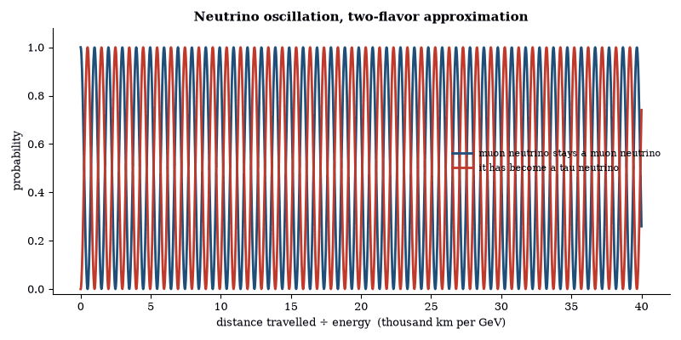
Figure 16. A neutrino produced as one flavor is a mixture of mass states that drift out of step as it travels, so it can be detected as another flavor. Computed from the two-flavor formula with the atmospheric mass splitting 2.5 × 10⁻³ eV² and maximal mixing.
The absolute mass scale is bounded by the endpoint of tritium beta decay, by the rate of neutrinoless double-beta decay if neutrinos are Majorana, and by the effect of neutrino mass on the cosmic microwave background and on large-scale structure. Cosmology bounds the sum of the masses below about 0.07 to 0.12 eV, depending on which data sets are combined. The bounds are consistent. They do not yet determine the individual masses. The seesaw mechanism remains the most economical explanation of the smallness of the masses.
The Majorana or Dirac nature of the neutrino is undecided. Neutrinoless double-beta decay is possible only if neutrinos are Majorana. The decay violates lepton number by two units. Current experiments set lower limits on the half-life of order 10²⁶ years. The limits translate into upper bounds on the effective Majorana mass. The bounds do not yet exclude the inverted ordering. They constrain the normal ordering only in part of the parameter space.
Cosmological bounds on the sum of neutrino masses come from the suppression of small-scale structure: free-streaming neutrinos erase density perturbations smaller than the distance they travel, an effect measured in the microwave background and in galaxy surveys. These bounds assume the standard thermal history and can be relaxed in non-standard cosmologies, whereas laboratory bounds from beta decay are model-independent. Both keep improving, and the cosmological bounds are now pressing against the lower limit set by the oscillation data.

Catching the Ghost Particle
A neutrino interacts so rarely that detecting one needs a huge detector, a very low background and a great deal of patience. The Super-Kamiokande detector in Japan holds 50 000 metric tons of ultrapure water in a mine, surrounded by thousands of light sensors that catch the faint flash when a neutrino strikes a nucleus. Its observation that atmospheric neutrinos change flavor, and the Sudbury Neutrino Observatory’s demonstration that solar neutrinos do the same, earned the 2015 Nobel Prize for Takaaki Kajita and Arthur McDonald.
The IceCube observatory instruments a cubic kilometer of Antarctic ice with sensors. In 2013 it detected neutrinos with energies of a thousand trillion electronvolts, and in 2018 it traced one to a blazar, a first identification of a source of high-energy neutrinos. The burst from supernova 1987A, about two dozen neutrinos in all, showed that a collapsing star releases most of its energy this way.
Their mass is measured by the energy spectrum in tritium decay, where the KATRIN experiment in Germany has set an upper limit below one electronvolt, and by cosmology. The relic neutrinos left from the Big Bang, about a hundred per cubic centimeter for each type, have been predicted but never detected. The future experiments DUNE in the United States and Hyper-Kamiokande in Japan aim to measure the mass ordering and any difference between neutrinos and antineutrinos.
Questions to Keep Asking
How do we know that neutrinos have mass? A neutrino produced as one flavor is found later as another, and that can happen only if the flavors are mixtures of states with different masses.
The absolute mass scale is still unknown. What measurement of tritium decay or of the cosmic microwave background would surprise current expectations?
Try it yourself. If 65 billion solar neutrinos cross each square centimeter every second, roughly how many cross your body, about 0.7 square meters in cross-section, each second? (Answer: about 5 × 10¹⁴.)

15. Atoms and the Periodic Table
Mendeleev left gaps in his table of 1869 and predicted what would fill them. Within two decades gallium, scandium and germanium turned up with nearly the properties he had foretold. A chart built from chemistry turned out to be a map of electron shells.

The Afternoon the Atom Became Real
In 1905 Einstein published a paper on Brownian motion. He calculated how far a pollen grain should wander if it were being struck by invisible molecules. The calculation matched the observations quantitatively, and atoms were no longer a useful fiction: they were real, and they had a size.
The paper was short. It did not require a new apparatus. It required only the recognition that the random walk of a visible particle is the visible signature of invisible collisions. Once the signature was calculated, the invisible became measurable. Perrin confirmed the numbers a few years later. The confirmation ended a debate that had lasted a century.
The same paper also gave a value for Avogadro’s number. The value was close to the modern one. The closeness was not an accident. It was the result of treating the molecular hypothesis as a quantitative claim rather than a philosophical preference. The preference had been optional. The claim was not.

The Atomic Hypothesis
Richard Feynman once asked what single sentence would carry the most scientific knowledge to a civilization that had lost everything else. His answer was the atomic hypothesis: all things are made of atoms, small particles in perpetual motion that attract one another a little way apart and repel when pressed together. In that sentence, he said, there is an enormous amount of information about the world, if only a little imagination and thinking are applied.
The sizes are the first surprise. An atom is to an apple as an apple is to the Earth. A glass of water holds more molecules than a glass could hold grains of sand if the sand filled the oceans many times over. The picture also explains the everyday behavior of water. At the surface, molecules leave the liquid and return to it. When the departures and returns balance, the water is in equilibrium with its vapor, and the glass stops getting emptier. Warm it and the departures win.
The hypothesis was a respectable idea for two thousand years and a settled fact for little more than a century. Einstein’s analysis of Brownian motion, described above, and Perrin’s measurements made it hard to doubt.

The Development of Chemistry
Chemistry began as practical craft. Fire, metals, dyes, and medicines were used long before they were understood. The Greeks proposed that matter was made of four elements—earth, water, air, and fire—or of atoms. Neither account was tested by measurement.
Alchemy mixed the practical with the mystical. It sought the transformation of metals and the elixir of life. It developed laboratory techniques—distillation, sublimation, crystallization—that later chemistry kept. It did not develop a quantitative theory.
The transition came with measurement. Robert Boyle defined an element as a substance that could not be broken down further by chemical means. He studied the behavior of gases. The phlogiston theory explained combustion as the release of a substance called phlogiston. The theory was useful until the weights were measured carefully. When a metal burns it gains weight, yet if it loses phlogiston it should lose weight, and the contradiction was fatal.
Antoine Lavoisier established the modern account: combustion is combination with oxygen, and mass is conserved. He introduced a systematic nomenclature, and chemistry became quantitative. The gases were isolated—carbon dioxide, nitrogen, hydrogen, oxygen—and the composition of air and of water was established.
John Dalton’s atomic theory explained the fixed proportions in which elements combine. Each element has atoms of a characteristic weight. Compounds are combinations of atoms in simple ratios. Avogadro’s hypothesis—that equal volumes of gases at the same temperature and pressure contain equal numbers of particles—resolved the confusion over atomic weights. Berzelius determined accurate atomic weights and introduced the modern symbols.
Organic chemistry was long thought to require a vital force. Friedrich Wöhler’s synthesis of urea from inorganic materials in 1828 undermined the claim. Organic compounds are carbon compounds. They follow the same rules as inorganic compounds. Structural formulas, valence, and the three-dimensional arrangement of atoms followed. Isomers have the same composition and different structures. Optical isomers differ in the arrangement of atoms in space.
The periodic table organized the elements by atomic weight and by property. Mendeleev left gaps and predicted the properties of the missing elements. The predictions were confirmed. The modern table, ordered by atomic number, is described below.
Physical chemistry applied thermodynamics and kinetics to reactions. Catalysis speeds reactions without being consumed. Ionic dissociation explained the behavior of acids, bases, and salts in solution. Synthetic organic chemistry produced dyes, drugs, and polymers. The same principles that explain a laboratory reaction explain the chemistry of a cell and the chemistry of an industry. The history is the progressive replacement of qualitative ideas by quantitative ones.

The Atom and the Nucleus
Matter is made of atoms, an idea that is ancient; the modern form began with chemistry, where elements combine in fixed proportions and Dalton’s atomic theory explained the proportions.
Atoms are mostly empty space. The nucleus, containing protons and neutrons, is tiny and dense. The electrons occupy the outer regions. Rutherford’s scattering experiments showed the nuclear structure, and Bohr’s model placed electrons in discrete energy levels. Quantum mechanics replaced the orbits with orbitals, regions of probability. The spectra of atoms are the transitions between those levels.
Radioactivity is the spontaneous decay of unstable nuclei, emitting alpha particles (helium nuclei), beta particles (electrons or positrons), or gamma rays (high-energy photons). The half-life is the time for half of a sample to decay. It is characteristic of the isotope and independent of temperature or chemical form. Radioactive dating uses those clocks. Carbon-14 serves for organic material younger than about 50,000 years. Uranium-lead dates rocks billions of years old.
Isotopes of an element have the same number of protons and different numbers of neutrons. Some are stable and some are radioactive, and artificial isotopes are produced in reactors and accelerators. They are used as tracers in medicine and in research.
Nuclear fission splits a heavy nucleus into lighter ones, releasing energy. It powers reactors and was used in the first nuclear weapons. Nuclear fusion joins light nuclei into heavier ones, and it powers the Sun and the stars. The physics of controlled fusion for power is understood, and what remains is an engineering challenge. The sustained, net-energy reaction on Earth is not yet routine.
The binding energy of the nucleus comes from the strong force. A nucleus weighs less than its protons and neutrons weigh apart. The difference appears as energy, by E = mc². That is the source of nuclear energy. It is also the source of the energy released in the Sun. The same relation that appears in relativity governs the power of a star and the energy of a reactor.

The Size of Atoms and the Binding of Nuclei
The sizes of atoms are set by the balance between the electrostatic attraction of the nucleus and the kinetic energy required by the uncertainty principle. Typical atomic radii are a few tenths of a nanometer. Typical nuclear radii are a few femtometers, so the emptiness of the atom is extreme: if a nucleus were the size of a pea, its atom would fill a large concert hall.
The nucleus contains protons and neutrons bound by the strong interaction. The binding energy per nucleon reaches a maximum near iron. Lighter nuclei can release energy by fusion; heavier nuclei can release energy by fission. Both processes are observed in nature and in technology.

The Periodic Table
The periodic table arranges the elements by atomic number. The atomic number is the number of protons in the nucleus and the number of electrons in the neutral atom. The arrangement reveals the periodic recurrence of chemical properties. Elements in the same column share the same number of valence electrons and therefore similar chemistry.
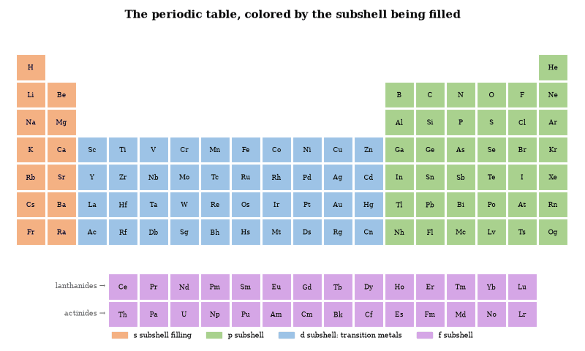
Figure 17. The shape of the periodic table is the shape of the electron shells: two columns where an s subshell fills, six for p, ten for d and fourteen for f. Rows are periods; columns are groups with similar chemistry. (Helium, with a filled 1s shell, sits with the noble gases.)
The modern table is the consequence of the quantum structure of the atom. Electrons occupy orbitals labeled by the principal quantum number n, the angular-momentum quantum number l, and the magnetic and spin quantum numbers. The Pauli principle limits each orbital to two electrons. The order of filling—1s, 2s, 2p, 3s, 3p, 4s, 3d, and so on—produces the observed periods and the transition metals, lanthanides, and actinides.
The table is predictive. The existence and properties of missing elements were forecast before their discovery. The same quantum rules that generate the table also generate the spectra, the ionization energies, and the ionic radii. The periodic table is therefore not an empirical chart. It is the display of the allowed electronic configurations of the elements.

Electron Shells
The principal quantum number n defines the shell. Shells are labeled K, L, M, … or simply by n = 1, 2, 3, …. The maximum number of electrons in a shell is 2n². Within a shell the orbitals are s, p, d, f, corresponding to l = 0, 1, 2, 3.
The energy of an orbital depends primarily on n and secondarily on l. In multi-electron atoms the dependence on l produces the familiar order of filling. The 4s orbital lies below the 3d orbital, so potassium and calcium fill 4s before the transition metals fill 3d. The same inversion occurs for 5s–4d and 6s–5d–4f.
Closed shells are chemically inert. The noble gases have filled shells and high ionization energies. Atoms with one electron outside a closed shell are alkali metals. Atoms with one vacancy in a shell are halogens. The shell structure therefore accounts for the principal chemical families and for the stability of the octet.
The radial probability density of an s orbital has maxima whose number equals n. Higher shells are larger. The increase in size down a group and the decrease across a period follow from the changing effective nuclear charge and from the successive filling of shells. The shells are the spatial expression of the quantum numbers.

Isotopes
Isotopes are atoms of the same element that differ in neutron number. They have the same atomic number and therefore the same electron configuration and the same chemistry. They differ in mass and in nuclear stability.
Most elements have more than one stable isotope. Tin has ten. The mass number A is the sum of protons and neutrons. The atomic mass of an element is the weighted average of the masses of its naturally occurring isotopes. High-resolution mass spectrometry separates the isotopes and measures their abundances.
Unstable isotopes decay by emission of alpha particles, beta particles, or gamma rays, or by electron capture or spontaneous fission. The half-life is characteristic of each nuclide. Half-lives range from fractions of a second to billions of years. The decay chains of the heavy elements and the production of cosmogenic isotopes supply clocks for geology and archaeology.
Isotopic fractionation occurs in physical and chemical processes because of the mass difference. Light isotopes diffuse and react slightly faster. The resulting variations in isotope ratios record temperature, diet, and provenance. The same mass difference is negligible for the chemistry of the outer electrons. Isotopes are therefore chemically almost identical and nuclearly distinct.

Worked Examples: Electron Shells and Isotopes
Example 1. How many electrons can occupy the n = 3 shell?
Maximum = 2n² = 18. (The shell contains 3s, 3p and 3d orbitals.)
Example 2. Natural chlorine is 75.8 percent ³⁵Cl and 24.2 percent ³⁷Cl. What is its atomic mass?
0.758 × 35 + 0.242 × 37 = 35.48 u. (The accepted value is 35.45 u; the difference is experimental rounding.)
Example 3. The half-life of ¹⁴C is 5 730 years. What fraction remains after 10 000 years?
N/N₀ = 2^{−10000/5730} ≈ 0.30. About 30 percent remains. The same calculation dates organic samples.
These exercises recover the structure of the periodic table and the practical use of isotopic clocks from the underlying quantum and nuclear rules.
Example. Write the ground-state electron configuration of iron (Z = 26).
1s² 2s² 2p⁶ 3s² 3p⁶ 4s² 3d⁶. (The 4s orbitals fill before 3d; the configuration is the observed ground state.)
Example. How many unpaired electrons does the Fe³⁺ ion possess in a high-spin octahedral complex?
Fe³⁺ is d⁵. High-spin places one electron in each of the five d orbitals. Five unpaired electrons.
The configurations follow from the Pauli principle and from the relative energies of the orbitals. They organize the chemistry of the transition metals.

Quantum Mechanics of the Atom
The electrons in an atom are described by the Schrödinger equation. The solutions are stationary states labeled by quantum numbers. The energy levels of hydrogen are E_{n} = -13.6 eV/n². Transitions between levels emit or absorb photons whose frequencies match the observed spectral lines.
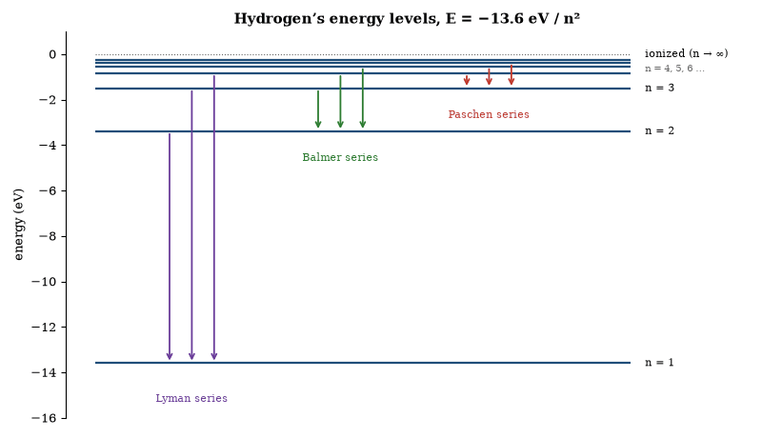
Figure 18. The energy levels of hydrogen and the three best-known series of spectral lines. Each arrow is one photon, with energy equal to the drop between levels. The Balmer series, ending on n = 2, is the visible one: 656, 486 and 434 nm.
The Pauli exclusion principle requires that no two electrons occupy the same state. The principle, together with the Coulomb interaction, produces the shell structure of the periodic table. Chemical bonding arises when atoms share or transfer electrons so as to fill or empty outer shells.
The uncertainty principle limits the simultaneous knowledge of position and momentum. An electron confined to an atomic volume must possess a minimum kinetic energy. That kinetic energy balances the electrostatic attraction and sets the size of the atom. The same balance determines the sizes of molecules and the lattice spacings of solids.
Measurement collapses the wave function onto an eigenstate of the measured observable. The probability of each outcome is the squared modulus of the corresponding amplitude. The rule has been confirmed in every tested system. The interpretation of the collapse remains open, but the predictive content does not.

Worked Examples: Atomic Spectra and the Bohr Model
Example 1. Calculate the wavelength of the photon emitted when a hydrogen atom falls from n = 3 to n = 2.
1/λ = R(1/2² − 1/3²). R = 1.097 × 10⁷ m⁻¹. λ = 656 nm (the red Balmer line).
Example 2. What is the ionization energy of hydrogen from the ground state?
E = 13.6 eV.
Example 3. A muon (mass 207 m_{e}) replaces the electron in hydrogen. By what factor does the Bohr radius shrink?
The radius scales inversely with the reduced mass, which for a muon bound to a proton is about 186 m_{e}. The muonic atom is therefore roughly 190 times smaller. Its X-ray transitions are correspondingly higher in energy and are used to measure nuclear charge radii.
The formulae recover the observed hydrogen spectrum and the scaling that appears in exotic atoms.
Questions to Keep Asking
How do we know that atoms are mostly empty space? Rutherford’s students fired alpha particles at gold foil, and nearly all passed straight through, with a few bouncing back from a tiny, dense nucleus.
What would change if a new element beyond the current table were found to sit in the wrong column, with chemistry that breaks the pattern?
Try it yourself. An element has 2 electrons in its first shell, 8 in its second and 1 in its third. What is it? (Answer: sodium.)

16. The Chemistry of Bonds and Reactions
Why does iron rust, bread rise, vinegar sting and a battery run down? Each is a rearrangement of electrons, shared, transferred or promoted, and the rules for it fit on a page.

Electronegativity and the Periodic Table
Electronegativity increases from left to right across a period and decreases down a group. Fluorine is the most electronegative element. The alkali metals are the least. The trend follows from the effective nuclear charge felt by the valence electrons and from the distance of those electrons from the nucleus.
The difference in electronegativity between two bonded atoms estimates the percentage of ionic character. A difference of 1.7 corresponds roughly to a bond that is 50 percent ionic. The estimate is approximate. It nevertheless correctly predicts that sodium chloride is ionic, that hydrogen chloride is polar covalent, and that the carbon–hydrogen bond is nearly non-polar.
The same scale explains the acid–base behavior of the oxides and the hydrides. Elements of high electronegativity form acidic oxides, elements of low electronegativity form basic oxides, and the amphoteric oxides lie in between. The pattern is a direct consequence of the electron-attracting power of the central atom.
Electronegativity is not a quantum-mechanical observable but a useful parameter derived from thermochemical data. More rigorous calculations replace it with computed charge distributions, though the qualitative ordering it provides remains intact.

The Chemical Bond
The chemical bond is the attractive interaction that holds atoms together in molecules and solids. Pauling showed that the bond can be understood as a resonance hybrid of ionic and covalent contributions. The covalent contribution arises when electrons are shared between atoms. The ionic contribution arises when electrons are transferred. The actual bond is a quantum-mechanical mixture of the two.
The strength of the bond is measured by the energy required to separate the atoms. Typical covalent bond energies range from about 1 eV for weak bonds to several eV for strong bonds. The length of the bond is the average distance between the nuclei. Both quantities are determined by the balance between the electrostatic attraction of the electrons to the nuclei and the kinetic energy and mutual repulsion of the electrons.
Electronegativity, described in the preceding section, supplies the bookkeeping. It organizes the periodic table and predicts the polarity of molecules, and it remains a useful semi-empirical tool even though more precise quantum calculations are now routine.
The same framework accounts for the tetrahedral carbon atom, the structure of the peptide bond, and the hydrogen bond that stabilizes water and biological macromolecules. The chemical bond is therefore the link between atomic physics and the structures of ordinary matter.

Resonance and Molecular Structure
Many molecules cannot be represented by a single Lewis structure. Benzene is the classic example. The two Kekulé structures differ only in the placement of the double bonds. The actual molecule is a resonance hybrid in which the electrons are delocalized around the ring. The hybrid has a lower energy than either classical structure. The difference is the resonance energy.
The same description applies to the carbonate ion, the nitrate ion, and the peptide bond. In each case the observed bond lengths are intermediate between single and double bonds, and the molecule is more stable than any single Lewis structure would predict. Resonance is the classical language for what molecular-orbital theory describes as delocalized electrons occupying bonding orbitals that extend over several atoms.
The concept does not imply that the molecule oscillates between structures. It implies that the true wave function is a superposition. The superposition is stationary. The measured properties are those of the hybrid. The language of resonance remains useful for qualitative reasoning even when full quantum calculations are available.

The Hydrogen Bond
A hydrogen bond is the attractive interaction between a hydrogen atom bonded to an electronegative atom and another electronegative atom. The typical strength is 0.1–0.4 eV, weaker than a covalent bond and stronger than a van der Waals interaction. The bond is directional. The hydrogen atom lies approximately on the line joining the two electronegative atoms.
Water is liquid at room temperature because of hydrogen bonds. Each molecule can form up to four. The resulting network gives ice its open structure and its lower density than liquid water. The same bonds stabilize the secondary structure of proteins and the base pairing of nucleic acids. The double helix of DNA is held together by hydrogen bonds between complementary bases.
The bond is largely electrostatic, with a smaller covalent contribution arising from charge transfer. Its strength and directionality make it the principal organizing force in aqueous chemistry and in molecular biology. Without it, the structures of liquid water, of proteins, and of DNA would not exist in their observed forms.

Oxidation and Reduction
Oxidation is the loss of electrons and reduction the gain of them, and the two always occur together: the substance that loses electrons is oxidized, the one that gains them is reduced, and the pair makes up a redox reaction.
The tendency of a half-reaction to occur is measured by its standard reduction potential. The potential is the voltage of a cell in which the half-reaction is coupled to the standard hydrogen electrode. A positive potential means the half-reaction proceeds spontaneously as a reduction under standard conditions. The difference in potential between two half-reactions gives the voltage of the corresponding galvanic cell and, through the relation Δ G = -nFE, the free-energy change.
The same scale organizes the chemistry of the elements: metals with negative reduction potentials dissolve in acid, and metals with positive potentials do not. The potentials also determine the products of electrolysis and the feasibility of industrial redox processes. They remain the practical measure of electron-transfer tendency.

Acids and Bases
An acid is a proton donor. A base is a proton acceptor. The definition, due to Brønsted and Lowry, covers aqueous and non-aqueous chemistry. The strength of an acid is measured by the equilibrium constant of its dissociation. The negative logarithm of that constant is the pKa; strong acids have negative pKa values and weak acids have positive values.
The pH of a solution is the negative logarithm of the hydrogen-ion activity. In pure water at 25 °C the pH is 7. The product of the hydrogen-ion and hydroxide-ion concentrations is the ion-product constant K_{w} = 10⁻¹⁴. The relation fixes the pH once either concentration is known.
Buffer solutions resist changes in pH. They contain a weak acid and its conjugate base in comparable amounts. Addition of strong acid or base shifts the ratio but leaves the pH nearly constant until one component is exhausted. The same principle operates in blood, where the carbonic-acid–bicarbonate system maintains the pH near 7.4.
The concepts of acidity and basicity extend to Lewis acids and bases, in which the acid accepts an electron pair and the base donates one. The extension includes coordination chemistry and many catalytic processes. The proton definition remains the most useful for aqueous solution chemistry.

Chemical Kinetics
Chemical kinetics is the study of reaction rates. The rate of an elementary reaction is proportional to the product of the concentrations of the reactants, each raised to the power of its stoichiometric coefficient in the rate-determining step. The proportionality constant is the rate constant k.
The temperature dependence of k is given by the Arrhenius equation k = A e^{−E}_{a}^{/RT}, where E_{a} is the activation energy. Only collisions that supply at least E_{a} produce products. Catalysts lower E_{a} by providing an alternative path, though they do not change the equilibrium constant.
Integrated rate laws give the concentration as a function of time. First-order reactions decay exponentially. Second-order reactions follow a different algebraic form. The half-life is independent of concentration only for first-order processes. Radioactive decay is the classic example.
The same formalism describes enzyme kinetics once the Michaelis–Menten mechanism is adopted. At low substrate concentration the rate is first-order in substrate. At high concentration the enzyme is saturated and the rate is zero-order. The framework therefore covers both ordinary chemical reactions and the catalytic steps of biochemistry.

Chemical Equilibrium
Chemical equilibrium is the state in which the forward and reverse rates of a reaction are equal. The equilibrium constant K is the ratio of the rate constants and is related to the standard free-energy change by Δ G° = -RTln K. When Δ G° is negative, K > 1 and products are favored. When Δ G° is positive, reactants are favored.
Le Chatelier’s principle states that a system at equilibrium responds to a disturbance by shifting in the direction that reduces the disturbance. Addition of a reactant, increase of pressure for a reaction that reduces the number of gas molecules, or removal of a product all drive the reaction forward. Temperature changes shift the equilibrium according to the sign of Δ H.
The equilibrium constant is independent of the path and of the presence of a catalyst. It depends only on temperature. The approach to equilibrium, by contrast, is accelerated by catalysts. The distinction between thermodynamics and kinetics is therefore sharp: equilibrium fixes the final composition and kinetics fixes the time required to reach it.

Electrochemistry
Electrochemistry is the coupling of chemical reactions to the flow of electric charge. In a galvanic cell a spontaneous redox reaction generates a potential difference. The cell potential under standard conditions is the difference of the standard reduction potentials of the two half-reactions. The relation to free energy is Δ G = -nFE, where n is the number of moles of electrons transferred and F is Faraday’s constant.
The Nernst equation corrects the potential for non-standard concentrations: E = E° − RT/nFln Q. At equilibrium E = 0 and the equation reduces to the expression for K.
Electrolytic cells reverse the process, since an external voltage drives a non-spontaneous reaction through the same half-reactions in the opposite direction. Industrial production of aluminum, chlorine and many organic compounds relies on electrolysis. Corrosion is an uncontrolled galvanic process in which a metal is oxidized by atmospheric oxygen. All of these phenomena are governed by the same thermodynamic and kinetic relations.

Organic Chemistry and Functional Groups
Organic chemistry is the chemistry of carbon compounds. Carbon forms stable chains and rings because the C–C bond is strong and because carbon can form four covalent bonds. The resulting molecular diversity is organized by functional groups—local arrangements of atoms that confer characteristic reactivity.
Hydrocarbons contain only carbon and hydrogen. Alkanes are saturated, alkenes and alkynes contain multiple bonds and undergo addition, and aromatic rings exhibit special stability due to delocalization. Substitution of heteroatoms produces alcohols, ethers, aldehydes, ketones, carboxylic acids, esters, amines and amides. Each class displays a limited set of typical reactions.
The same functional-group logic governs biochemistry. Proteins are polyamides, carbohydrates are polyhydroxy aldehydes or ketones, lipids are largely hydrocarbon chains with polar head groups, and nucleic acids are phosphate-linked sugars bearing heterocyclic bases. The reactions of metabolism are the reactions of these functional groups, catalyzed by enzymes and regulated by the cell.
Stereochemistry adds a further layer: carbon atoms bearing four different substituents are chiral, and biological systems almost invariably use one enantiomer. The preference is a historical fact of terrestrial evolution, not a chemical necessity. The functional-group classification nevertheless remains the organizing principle of both laboratory and biological organic chemistry.

Polymers and Macromolecules
A polymer is a large molecule built by the repetition of smaller units. Synthetic polymers are produced by chain-growth or step-growth polymerization. The degree of polymerization, the architecture (linear, branched, cross-linked) and the tacticity determine the mechanical properties. Thermoplastics soften on heating and thermosets do not, while elastomers return to their original shape after large deformations.
Biological macromolecules are polymers of defined sequence. Proteins are linear polypeptides that fold into specific three-dimensional structures. Nucleic acids are linear polynucleotides that store and transmit information. Polysaccharides serve structural and storage roles. In each case the covalent backbone is formed by condensation reactions. Non-covalent interactions—hydrogen bonds, hydrophobic contacts, ionic pairs—stabilize the higher-order structure.
The physical chemistry of polymer solutions and melts is described by scaling laws. The radius of a flexible chain grows as a power of its length. Entanglements dominate the viscoelasticity of concentrated solutions and melts. The same concepts apply, with modifications, to the crowded interior of a cell. Polymer science therefore links synthetic materials to the macromolecules of life.

Surface Chemistry and Catalysis
Surface chemistry studies reactions that occur at interfaces. Adsorption may be physical (van der Waals) or chemical (covalent or ionic). The Langmuir isotherm describes monolayer adsorption when sites are equivalent and non-interacting. Real surfaces are heterogeneous. Coverage depends on temperature and on the partial pressure or concentration of the adsorbate.
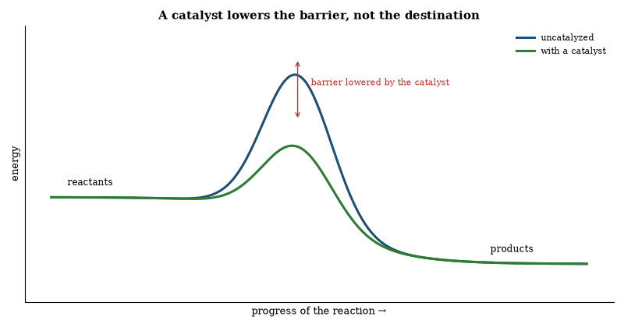
Figure 19. A catalyst offers a lower-energy route over the barrier. The starting and finishing energies, and therefore the equilibrium, are unchanged; the reaction simply gets there faster.
Heterogeneous catalysis occurs when a reactant adsorbs, reacts on the surface, and the product desorbs. Metals, metal oxides and zeolites are common catalysts. The surface lowers the activation energy by stabilizing the transition state. Industrial processes—ammonia synthesis, petroleum cracking, catalytic converters—rely on such surfaces. Homogeneous catalysis uses soluble complexes, and the distinction is practical rather than fundamental, since both accelerate attainment of equilibrium without shifting its position.
Enzyme catalysis is the biological counterpart. The active site binds the substrate, stabilizes the transition state, and releases the product. Rate enhancements of 10⁶ to 10¹⁷ are common. The underlying physical chemistry—adsorption, activation-energy reduction, and product release—is the same as in industrial catalysis. Surfaces and active sites are therefore central to both technology and metabolism.
Questions to Keep Asking
How do we know that a chemical bond is a sharing of electrons? X-ray diffraction maps the distribution of electron density in molecules and shows it piled between bonded atoms.
What measurement would show that a reaction is faster because of a catalyst and not merely because of heating?
Try it yourself. Stir baking soda into vinegar in a cup and feel the cup. The reaction absorbs heat. How does the temperature change relate to the bubbling?

17. Solids, Soft Matter and Plasma
A silicon chip holds tens of billions of switches, each a few dozen atoms across. A soap film, a rubber band and a lightning bolt belong to the same chapter. What unites them is that large numbers of particles do things no single one can.

Semiconductors
A semiconductor is a material whose electrical conductivity lies between that of a conductor and an insulator and can be controlled. Silicon is the most common. In a pure crystal the valence band is full and the conduction band is empty. The energy gap between them is about 1.1 electron-volts. At room temperature a few electrons have enough thermal energy to cross the gap. The conductivity is low but not zero.
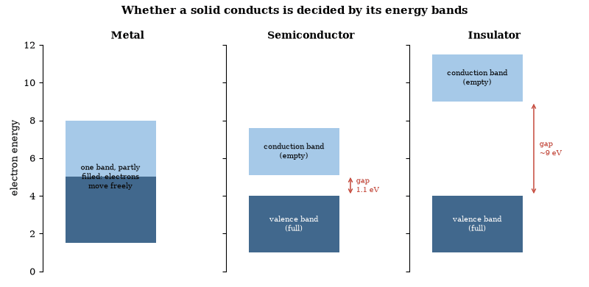
Figure 20. Energy bands in solids. A metal has a partly filled band. A semiconductor has a full band separated from an empty one by a small gap (about 1.1 eV in silicon) that heat, light or doping can bridge. An insulator’s gap is too wide to cross.
Doping changes the conductivity by many orders of magnitude. Adding a small fraction of phosphorus or arsenic introduces extra electrons. The material is n-type. Adding boron introduces holes—missing electrons that behave as positive carriers. The material is p-type. A junction between p-type and n-type material forms a diode. Current flows easily in one direction and is blocked in the other. The junction also separates charge and produces a voltage when light falls on it. That is the basis of a solar cell.
A transistor uses a small current or voltage to control a larger current. In a bipolar transistor a small base current controls a larger collector current. In a field-effect transistor a voltage on the gate controls the current between source and drain. Both act as switches and as amplifiers. A modern integrated circuit contains billions of transistors on a single chip. The transistors are formed by doping selected regions of a silicon wafer and depositing insulating and conducting layers. Manufacturing generations are now named after a few nanometers, though the smallest physical features are closer to ten to twenty.
The same quantum mechanics that explains the band gap explains the operation of the devices. Electrons in the crystal occupy energy bands. The exclusion principle prevents them from all occupying the lowest states. The gap, the doping, and the junctions are applications of those rules. The technology that processes information is built from the same physics that describes the atom.

The Structure of Solids
In a crystalline solid the atoms occupy the sites of a regular lattice. The lattice may be simple cubic, face-centered cubic, body-centered cubic, hexagonal, or one of the less symmetric Bravais types. The repeating unit is the unit cell. X-ray diffraction measures the spacing and the symmetry of the cell.
Electrons in a solid form energy bands. When a band is partially filled the solid is a metal and conducts electricity. When a band is full and separated by a gap from the next empty band the solid is an insulator or a semiconductor. The size of the gap determines the electrical behavior. Silicon and germanium are semiconductors because their gaps are about an electron-volt or less (1.1 eV for silicon, 0.67 eV for germanium). Diamond is an insulator because its gap is several electron-volts.
Defects control many properties. Vacancies, interstitials, and dislocations allow plastic deformation. Impurity atoms donate or accept electrons and thereby dope a semiconductor. Grain boundaries in a polycrystalline material scatter electrons and phonons and raise the electrical and thermal resistance.
The same band structure that determines conductivity also determines optical absorption, magnetism, and superconductivity. The macroscopic properties of a solid are therefore the collective consequence of the quantum states of its electrons and of the geometry of its lattice.

Materials Science
Materials science studies the relationship between the structure of a material and its properties. Structure is examined at successive scales: electronic, atomic, crystalline, microstructural and macroscopic. Properties include mechanical strength, electrical conductivity, thermal conductivity, optical response and chemical reactivity. The link between structure and property is the central organizing principle.
Crystalline metals conduct electricity because their valence electrons are delocalized. Semiconductors conduct only when electrons are excited across a band gap; the gap can be engineered by doping. Ceramics are hard and brittle because their bonding is ionic or covalent and dislocation motion is difficult. Polymers range from rigid thermosets to elastomers according to chain architecture and cross-linking. Composite materials combine phases to obtain properties unavailable in any single constituent.
Processing determines microstructure. Casting, deformation, heat treatment, thin-film deposition and additive manufacturing each produce characteristic defect populations and grain sizes. Those features control strength, toughness and functional performance. The same principles govern both traditional alloys and modern nanomaterials. Materials science is the discipline that turns the periodic table and the laws of solid-state physics into objects that can be manufactured and used.
The mechanical behavior of materials is governed by defects. Dislocations allow plastic deformation in metals at stresses far below the theoretical strength of a perfect crystal. Grain boundaries impede dislocation motion; smaller grains therefore raise the yield strength (Hall–Petch relation). Alloying, work hardening and precipitation hardening are practical methods of increasing dislocation density or of placing obstacles in their path.
Optical properties follow from the same band structure. Photons with energy greater than the gap are absorbed, doping introduces carriers and shifts the Fermi level, and the framework describes LEDs, photovoltaic cells and transistors.
Soft matter—polymers, colloids, liquid crystals—responds strongly to small forces, a subject taken up below. Biological materials are soft matter under genetic control, with the extra constraint that the structure must be grown, not merely fabricated.

Soft Matter
Soft matter comprises materials whose mechanical response is dominated by energies comparable to thermal energy. Polymers, colloids, liquid crystals, foams and biological tissues belong to the class. Entropic forces, self-assembly and large fluctuations are characteristic: a polymer chain in solution adopts a random-walk configuration, and the free energy cost of stretching it is entropic. Colloidal particles interact through van der Waals, electrostatic and depletion forces. The interactions can be tuned to produce crystals, glasses or gels.
Liquid crystals possess orientational order without full positional order. They flow like liquids and respond to electric fields like crystals. The combination is the basis of display technology. Biological soft matter—cytoskeletal networks, membranes, extracellular matrix—is under active, energy-consuming control. The same physical principles operate. The additional feature is continuous energy input that maintains the system far from equilibrium. Soft matter therefore links polymer physics, colloid science and cell biology.
Polymer solutions exhibit scaling regimes: in a good solvent the chain is swollen, and in a poor solvent it collapses. At the theta point the excluded-volume interaction vanishes and the chain is ideal. The osmotic pressure and the viscosity follow power laws of concentration whose exponents are predicted by scaling and confirmed by experiment.
Colloidal glasses form when the volume fraction is high enough that particles are caged by their neighbors. The glass transition is kinetic. Crystallization is thermodynamically preferred but may be suppressed by polydispersity or by rapid concentration increase. Active colloids consume energy and display collective motion absent in equilibrium systems. The same crowding and activity govern the cytoplasm. Soft-matter concepts therefore describe both synthetic materials and the interior of the cell.

Plasma Physics
A plasma is an ionized gas in which the charged particles exhibit collective behavior. The Debye length is the distance over which electric fields are screened. When the system size greatly exceeds the Debye length the plasma description applies. Magnetic fields confine plasmas because charged particles gyrate around field lines. The gyro-radius decreases with field strength and increases with particle energy.
Fusion plasmas are confined in tokamaks and stellarators. The goal is to maintain temperatures and densities at which the fusion power exceeds the power required for heating and confinement. Instabilities—kink, ballooning, turbulence—limit the achievable parameters. In December 2022 the laser-driven National Ignition Facility released more fusion energy than its lasers delivered to the target, but no device has yet produced net electrical power. The same plasma physics governs the solar corona, the interstellar medium and laboratory discharges. The equations are those of magnetohydrodynamics supplemented by kinetic theory where collisions are rare.
Magnetohydrodynamics treats the plasma as a conducting fluid. The magnetic field is frozen into the fluid in the limit of perfect conductivity. Field lines are advected with the flow. Magnetic reconnection violates the frozen-in condition in localized regions where resistivity or kinetic effects become important. Reconnection converts magnetic energy into kinetic and thermal energy. It powers solar flares and permits changes in magnetic topology.
In fusion devices turbulence driven by temperature and density gradients transports heat and particles outward. The transport exceeds collisional predictions by orders of magnitude. Suppression of the turbulence by sheared flows or by magnetic shear is an active research goal. The same turbulent transport operates in accretion disks and in the interstellar medium. The equations are shared. The boundary conditions differ.
Questions to Keep Asking
How do we know a material’s band gap? Light of lower energy than the gap passes through, and light above it is absorbed, so the color and the onset of absorption reveal it.
A new material is claimed to be a superconductor at room temperature. What measurements would you demand before accepting it?
Try it yourself. The gap in electron-volts is about 1240 divided by the longest wavelength in nanometers that the material absorbs or emits. What gap does a 620 nm red LED have? (Answer: about 2 eV.)
Further reading for Part III. Weinberg’s The First Three Minutes is the classic account of how the lightest nuclei were made. The Particle Data Group’s Review of Particle Physics is where the numbers in this Part are kept, and Asimov’s A Short History of Chemistry shows how the periodic table was assembled.

Part IV: Space, Time and Gravity
Relativity, gravitational waves and black holes

18. The Speed of Light and Special Relativity
Light leaves a flashlight at the same speed whether you stand still or chase it. That single fact, believed before it was understood, bends time and length, and the muons raining down from the upper atmosphere show that it does.

The Moment the Rules Changed
In 1905 a patent clerk in Bern published a remarkable run of papers within a single year. One showed that light comes in packets. One showed that atoms are real. One showed that time and space are not what they seem. None required a laboratory. Together they dismantled the classical picture of the world.
The clerk was not trying to be revolutionary; he was trying to remove inconsistencies that would not go away. Maxwell’s equations would not tolerate a preferred frame, the photoelectric effect would not tolerate continuous energy, and Brownian motion would not tolerate a continuum without atoms. Once stated, the resolutions were simple. Accepting them took years, and the old rules never came back.
The episode is the clearest modern example of a quiet calculation overturning an entire ontology. It has not been the last. It remains the standard against which later revolutions are measured. Most of them have been louder. None has been cleaner.

The Speed of Light as a Conversion Factor
The speed of light in vacuum is defined to be exactly 299 792 458 m/s. The meter is the distance light travels in 1/299 792 458 of a second. The definition makes c a conversion factor between the units of length and time rather than a quantity to be measured.
The invariance of c is a physical fact. The numerical value is a convention. Once the value is fixed, measurements of length become measurements of time and vice versa. The same convention appears in the natural units used in particle physics, where c = 1 and energies are quoted in electron-volts.
The definition does not alter any prediction of relativity. It merely chooses the units in which the invariant speed has the value 1. All measurable ratios remain unchanged. The practical advantage is that length standards can be realized by time standards, which are more stable.

The Speed of Light and the Structure of Spacetime
The invariance of the speed of light forces the replacement of Galilean spacetime by Minkowski spacetime. The interval ds² = c²dt² − dx² − dy² − dz² is the same for every inertial observer. Surfaces of constant interval are hyperboloids. The light cone, ds = 0, bounds the causal future and past of every event.
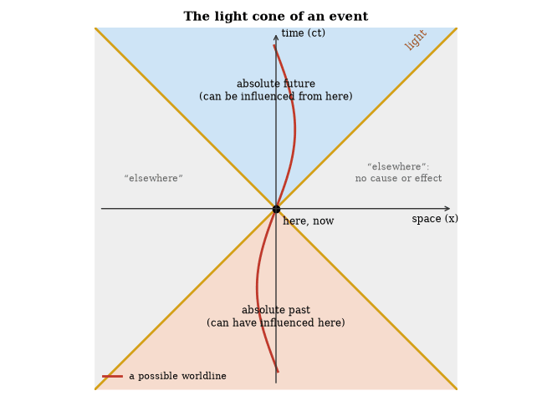
Figure 21. The light cone divides spacetime around an event into the future and past that can be causally connected to it and the “elsewhere” that cannot. Any possible worldline stays inside the cone.
Coordinates of different inertial frames are related by Lorentz transformations. These transformations mix space and time and leave the interval unchanged. The classical notions of absolute simultaneity and absolute time are thereby eliminated. All observable relativistic effects—time dilation, length contraction, the relativistic velocity addition law—follow from the geometry of the light cone and from the invariance of ds.
The same geometry persists locally in the presence of gravity. Global curvature modifies the relation between neighboring light cones but does not alter the local limiting speed. The invariance of c remains the structural foundation of both special and general relativity.

The Doppler Effect
The Doppler effect is the change in observed frequency caused by relative motion between source and observer. For sound the shift depends on whether the source or the observer is moving, because sound propagates in a medium. For light in vacuum the shift depends only on the relative velocity.
In the low-speed limit the fractional frequency change is v/c for both cases. At relativistic speeds the formula becomes
f = f₀√((1-β)/(1+β)),
where β = v/c and the velocity is the component along the line of sight. Recession lowers the frequency; approach raises it.
The effect is measured in the spectra of stars and galaxies, in radar speed guns, and in the precise timing of pulsars. It also appears in the transverse Doppler shift, a purely relativistic time-dilation effect that has been confirmed with fast ions. The same principle underlies the cosmological redshift once the expansion of space is taken into account.
No experiment has shown a dependence of the vacuum speed of light on the speed of the source. The Doppler formula for light is therefore a direct consequence of the invariance of c.

Aberration of Light
Aberration is the apparent displacement of a star’s position caused by the motion of the observer. The Earth moves at 30 km/s around the Sun. A telescope must therefore be tilted by an angle θ ≈ v/c in the direction of motion in order to keep the star centered. The annual change in the required tilt is the aberration ellipse.
Bradley measured the effect in 1728 and thereby determined the speed of light to within a few percent of the modern value. The same measurement demonstrated that the Earth moves. The classical formula is sufficient for the Earth’s orbital speed. At higher speeds the relativistic expression
tan θ = (sin θ′)/(γ(cos θ′+β))
must be used. The formula has been confirmed with particle beams and with precise astrometry.
Aberration is distinct from parallax. Parallax is a change in direction caused by a change in the observer’s position. Aberration is a change caused by the observer’s velocity. Both effects are present in stellar observations and must be separated.

The Michelson–Morley Experiment
The Michelson–Morley experiment compared the speed of light in two perpendicular directions. An interferometer was floated on mercury and rotated. No shift of the interference fringes was observed at the level of sensitivity corresponding to the Earth’s orbital speed.
The null result is explained by the invariance of c. Every inertial observer measures the same speed. There is no preferred frame in which light travels at a different speed. Subsequent experiments with lasers, cryogenic resonators, and particle beams have confirmed the isotropy to better than one part in 10¹⁷.
The experiment did not disprove the existence of a medium. It showed that if a medium exists, it does not define a rest frame that can be detected by measuring the two-way speed of light. The one-way speed is fixed by convention once the two-way speed is known to be isotropic. The result remains one of the foundations of special relativity.

The Experiment That Should Not Have Worked
In 1887 Michelson and Morley measured the speed of light in two perpendicular directions. Because the Earth moves, they expected light to take longer along the direction of motion. The difference was not there, and it was still not there when the experiment was repeated.
The null result eliminated the luminiferous aether but did not immediately suggest the correct replacement; Lorentz and FitzGerald proposed length contraction as a patch. Einstein proposed that the speed of light is the same in every inertial frame and that simultaneity is relative. The proposal was not a patch but a replacement, and the replacement survived every subsequent test.
The experiment is still cited because it is simple, decisive, and historically pivotal. Modern versions are many orders of magnitude more sensitive than the original, and the null result remains. The aether has not returned. The lesson is that a sufficiently clean null result can remove an entire theoretical structure. The structure does not always notice at once.

Length Contraction and Time Dilation
A rod moving lengthwise relative to an observer is measured to be shorter than its proper length by the factor √(1-v²/c²). A clock moving relative to an observer is measured to run slow by the same factor. Both effects follow from the invariance of the speed of light and from the definition of simultaneity.
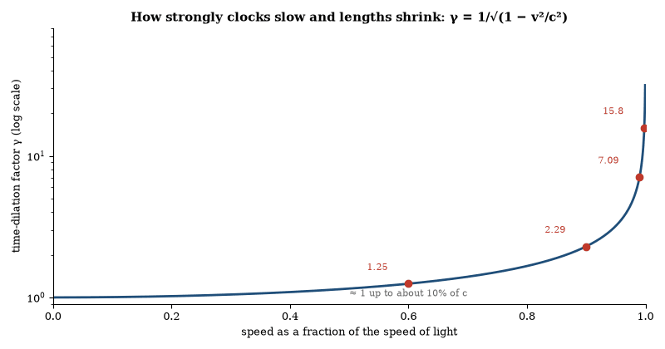
Figure 22. The Lorentz factor γ against speed. It is negligible in everyday life and climbs without limit as v approaches c. At 0.6c a moving clock runs 25 percent slow; at 0.998c, the speed of the muons in the worked example, γ ≈ 16.
The proper length is the length measured in the frame in which the rod is at rest. The proper time is the time measured by a clock that travels with the object. Coordinate length and coordinate time differ from these invariants once relative motion is present. The differences have been confirmed by the extended lifetimes of fast muons, by the operation of particle accelerators, and by the frequency shifts of clocks flown in aircraft.
The effects are reciprocal. Each observer finds the other’s rods contracted and the other’s clocks slow. There is no contradiction because the observers disagree on which events are simultaneous. The invariant is the spacetime interval. All measured contractions and dilations are projections of that interval onto different axes.

The Twin Paradox
Two twins separate. One remains on Earth. The other travels at high speed to a distant point and returns. The traveling twin ages less. The difference is the difference in proper time along the two world-lines. The stay-at-home twin follows a straight path in spacetime and the traveler a bent one, and along the bent path less proper time passes.
The acceleration that reverses the traveler’s velocity is not the source of the asymmetry. The asymmetry exists between any two paths that begin and end at the same events. Acceleration is needed only to make the paths meet again. Once the paths are fixed, the proper-time difference is fixed by the geometry.
The effect has been measured with atomic clocks flown around the world and with unstable particles circulating in storage rings. In every case the moving clock records less proper time. The result is a direct consequence of the invariance of the spacetime interval. It does not require general relativity.

Mass, Energy and Momentum in Relativity
The energy and momentum of a particle form a four-vector. Its magnitude is the rest energy mc². The relations are
E = γ mc², p = γ mv, E² = p²c² + m²c⁴.
At low speeds the expressions reduce to the Newtonian kinetic energy and momentum plus the constant rest energy. At high speeds the energy grows without bound as v approaches c. No finite energy can accelerate a massive particle to the speed of light.
The same relations hold for systems of particles and for fields once the appropriate total four-momentum is used. Mass can be converted into other forms of energy and vice versa. The conversion is observed in particle–antiparticle annihilation, in nuclear reactions, and in the mass defect of bound systems. The factor c² is large, so macroscopic mass changes are minute except in nuclear and particle processes.
The invariant mass of a system is not the sum of the rest masses of its parts. Binding energy and relative kinetic energy contribute. The invariant mass is the magnitude of the total four-momentum. It is the quantity that is conserved in every inertial frame.

Worked Examples: Time Dilation and Length Contraction
Example 1. A muon is created 10 km above the Earth’s surface with speed 0.998c. Its proper lifetime is 2.2 µs. Does it reach the ground?
Proper lifetime τ = 2.2 × 10⁻⁶ s. Lorentz factor γ = 1/√(1-0.998²) ≈ 15.8. Lifetime in the Earth frame t = γτ ≈ 35 µs. Distance traveled = 0.998c × 35 × 10⁻⁶ ≈ 10.4 km. The muon reaches the ground.
Example 2. A rod of proper length 1 m moves at 0.6c relative to an observer. What length does the observer measure?
γ = 1.25. Contracted length L = L₀/γ = 0.8 m.
Example 3. Two events occur 3 m apart and 10 ns apart in the laboratory. Is the interval time-like or space-like?
cΔ t = 3 m. Δ x = 3 m. c²Δ t² − Δ x² = 0. The interval is null (light-like).
These calculations use only the definitions of γ and of the invariant interval. They reproduce the results measured in cosmic-ray and accelerator experiments.

Faster than Light
Special relativity requires that no signal or causal influence travel faster than light in vacuum. The requirement follows from the invariance of the speed of light and from the demand that cause precede effect in every inertial frame. A signal that outruns light in one frame arrives before it is sent in another frame. The reversal permits closed causal loops. No consistent physics of such loops is known.
Quantum mechanics does not evade the limit: entanglement correlates measurement outcomes but does not transmit controllable information. The no-communication theorem shows that local operations on one subsystem cannot alter the reduced state of the other. Any protocol that appears to signal faster than light either fails when the statistics are computed correctly or relies on a classical channel that itself respects the light-speed limit.
Tachyonic fields—fields whose quanta have imaginary mass—appear in some unstable theories. They signal an instability, not a usable faster-than-light particle. The instability is removed by shifting to the true vacuum. No stable tachyon has been observed.
Group velocities greater than c occur in regions of anomalous dispersion. The signal velocity, defined by the front of a sharp pulse, remains at or below c. The apparent superluminal group velocity does not carry information outside the light cone. Experiments confirm the distinction.
No confirmed observation has shown a causal influence propagating faster than light. The light-cone structure of spacetime and the no-communication theorem remain intact. Claims to the contrary have not survived scrutiny.

Everything Moves at the Speed of Light in Spacetime
In special relativity the four-velocity of any massive particle has constant magnitude c. The particle’s path through spacetime is parameterized by proper time. The components of the four-velocity satisfy
u^{μ} u_{μ} = c², in the sign convention of the interval above.
When the particle is at rest in a given frame, the entire four-velocity points in the time direction. When the particle moves, part of the four-velocity is spatial. The spatial speed can never reach c because the time component would then vanish and the magnitude condition would fail. The trade-off is exact. Motion through space reduces the rate at which the particle advances through coordinate time, which is the observed time dilation.
Massless particles travel on null geodesics. Their four-velocity is undefined in the same sense, but their world-lines satisfy ds = 0. They move at c through space and do not advance in proper time. The same geometric fact covers both cases: every causal trajectory is limited by the light cone, and every massive trajectory maintains a four-velocity of fixed magnitude c.
The statement is therefore not that every object races through space at light speed. It is that every object moves through spacetime at light speed. The division between the time part and the space part depends on the frame. The magnitude does not. The geometry enforces the division. Nothing massive can convert its entire motion into spatial motion. The conversion would require the time component to disappear, which the invariant interval forbids.

Relativity Visualized
Lewis Carroll Epstein presented special relativity through diagrams in which every object moves at the speed of light through spacetime. A vertical axis is proper time and a horizontal axis is space, so a particle at rest traces a vertical line and a moving particle traces a diagonal line. The length of the spacetime path between two events is the same for every traveler. Tilting a path toward the horizontal trades vertical progress for horizontal progress. The diagrams make time dilation and length contraction geometric facts rather than algebraic surprises.
In the diagram a light ray runs at 45 degrees. Any massive particle’s world-line lies inside that angle. The faster the particle moves through space, the less proper time it accumulates between two coordinate-time slices. The slowing of clocks is the reduced vertical progress. Length contraction appears when one asks for the simultaneous positions of the two ends of a moving rod. Simultaneity is a horizontal slice in the rod’s rest frame and a tilted slice in the laboratory frame. The tilted slice intersects a shorter segment of the rod’s world-tube. The contraction is the difference in the slices.
In these pictures the traveling twin’s bent path accumulates less vertical length than the straight path of the stay-at-home twin. The difference is visible as a shorter vertical projection. No acceleration is required for the comparison once both twins are reunited; the acceleration merely allows the paths to meet again. The diagram shows the result without coordinates.
Epstein’s construction does not alter the predictions of special relativity. It supplies a geometric reading in which the invariance of the spacetime interval is primary and the familiar effects are projections. The reading is pedagogically effective. It is fully equivalent to the standard algebraic treatment.

Einstein’s Contributions
In 1905 Einstein published four papers that altered physics. The first explained the photoelectric effect by treating light as quanta of energy hν. The second gave the theory of Brownian motion and thereby a direct estimate of atomic size. The third presented the special theory of relativity. The fourth showed that mass and energy are related by E = mc².
Special relativity rests on two postulates: the laws of physics are the same in every inertial frame, and the speed of light in vacuum is the same in every inertial frame. The consequences are the relativity of simultaneity, time dilation, length contraction, and the invariance of the spacetime interval. The theory has been confirmed by particle lifetimes, by the operation of the Global Positioning System, and by every high-energy experiment.
In 1915 Einstein completed the general theory. Gravity became the curvature of spacetime itself. The Einstein field equation relates that curvature to the distribution of energy and momentum. The theory predicts the deflection of light by the Sun, the precession of Mercury’s perihelion, gravitational redshift, and gravitational waves. All have been observed. The same equation, applied to the cosmos, yields the expanding universe and the existence of black holes.
Einstein also introduced the cosmological constant, later set to zero, then restored by observation as the simplest model of dark energy. He contributed to the foundations of quantum statistics (Bose–Einstein condensation) and, with Podolsky and Rosen, formulated the argument that quantum mechanics appears incomplete. The argument led to Bell’s theorem and to experiments that confirmed the quantum predictions.
The body of work therefore spans the photoelectric effect, the atomic hypothesis, special and general relativity, the mass–energy relation, and the early critique of quantum completeness. Each part has been tested. Each remains in use.

The Maximum Force
General relativity implies a maximum force. The value is c⁴ / 4G, about 3 × 10⁴³ newtons. No larger force can be exerted. The same limit appears as a maximum power c⁵ / 4G. Both follow from the requirement that the horizon of a black hole cannot be crossed by a signal and from the definition of the horizon itself.
The limit is local. It applies to the flow of energy or momentum through a surface. Distant objects can recede faster than light because the intervening space expands. The force limit does not constrain that recession. It constrains what can be done at a single place.
The limit is not an extra postulate. It is a rewriting of the content of the Einstein equation in the language of force and power. Experimental tests are indirect. They consist of the confirmed predictions of general relativity itself. No violation has been observed.
The bound is easiest to read through the hoop conjecture: a system whose energy is squeezed inside its own Schwarzschild radius forms a horizon. Try to deliver more than c⁴/4G through a surface and the stress-energy gathered there would already have formed one. The limit is, in effect, saturated during the last moments of black-hole mergers.
The matching bound on power is the force limit multiplied by c, about 10⁵² W. Both limits are classical statements. Quantum corrections are expected near the Planck scale, but nothing suggests that they would remove the existence of an upper bound.

A Table of Limits
Several of the great constants of physics can be read as limits. The speed of light is the greatest speed at which any signal or influence can travel. Planck’s constant is the smallest quantum of action, so that no process can involve less than a fixed amount of it. Boltzmann’s constant sets a smallest unit of entropy. The maximum force and maximum power of general relativity, met in the preceding sections, are limits of the same kind. Christoph Schiller’s free textbook Motion Mountain organizes a whole course in physics around this idea.
The limits come from different theories, and they are claims about what can be measured, not necessarily about the grain of nature itself. Together they give the Planck units, the natural scales of length, time and mass at which quantum theory and gravity must be combined. Every limit on the table has so far survived every test. A confirmed violation of any one of them would be among the most important results in the history of physics.
Questions to Keep Asking
How do we know that time dilation is real? Cosmic-ray muons live far longer in our frame than at rest, atomic clocks on aircraft lose time, and particle accelerators rely on it every day.
What would a variation of the speed of light with direction or with the speed of the source mean for special relativity?
Try it yourself. A muon lives 2.2 microseconds at rest. How far does it travel at nearly the speed of light without time dilation, and with a Lorentz factor of 15.8? (Answer: about 660 m and about 10 km.)

19. Gravity and Curved Spacetime
Stand on a scale in a falling elevator and it reads zero. You are weightless, though gravity has not gone anywhere. That was Einstein’s happiest thought: gravity and acceleration are one thing, and what we call the force of gravity is the shape of spacetime.

Gravitation
Newton’s law of universal gravitation states that every mass attracts every other mass with a force proportional to the product of the masses and inversely proportional to the square of the distance between them. The same law that makes an apple fall keeps the Moon in orbit.
The Moon falls toward the Earth continuously. Its sideways velocity is high enough that it keeps missing. The orbit is the path of continuous free fall. The same description applies to every planet around the Sun and every satellite around its planet.
The gravitational constant was measured in the laboratory by Cavendish in 1798. With it, the mass of the Earth can be calculated from the acceleration of gravity at the surface. The Earth is not a perfect sphere. It bulges at the equator because it rotates. The equatorial radius is about 21 kilometers larger than the polar radius. The difference is small but measurable.
Escape velocity is the speed needed to leave a body’s gravitational field without further propulsion. From Earth’s surface it is about 11.2 kilometers per second. From the Moon it is lower. From a black hole it exceeds the speed of light, which is why nothing can leave.
Orbits can be circles, ellipses, parabolas, or hyperbolas, depending on the energy. Closed orbits are ellipses with the central body at one focus. This was Kepler’s first law, deduced from Tycho Brahe’s observations before Newton explained why. The period of an orbit depends on the size of the orbit and the mass of the central body. That relation is used today to weigh stars, planets, and black holes.
Gravity is the weakest of the four fundamental forces, yet it dominates at large scales because it is always attractive and has infinite range. The other forces cancel or are short-ranged. General relativity refined the picture: gravity is the curvature of spacetime. The predictions differ from Newton’s at high precision or near strong masses. For the Solar System and for most engineering, Newton’s inverse-square law is still accurate enough.

The Equivalence of Inertial and Gravitational Mass
Galileo argued that all bodies fall with the same acceleration in the absence of air resistance. The argument is that a heavy body and a light body tied together must fall at the same rate as either alone; otherwise the combination would be inconsistent. Newton later distinguished inertial mass (the quantity that appears in F = ma) from gravitational mass (the quantity that appears in the inverse-square law). Their equality is required by the observation that all bodies fall alike.
The equality has been tested to a few parts in 10¹⁵ with torsion balances, lunar laser ranging and the MICROSCOPE satellite. General relativity promotes it to a principle, described in the next section.
No composition dependence has been found. Bodies of different materials, different nuclear binding energies, and different gravitational self-energies fall at the same rate within experimental limits. The result constrains theories that attempt to modify general relativity or to introduce new long-range forces.

The Equivalence Principle
The local effects of a gravitational field are indistinguishable from the effects of acceleration. An observer in a freely falling elevator finds that objects float. An observer in a uniformly accelerating rocket in free space finds that objects fall. No local experiment can tell the two situations apart.
The principle implies that light bends in a gravitational field and that clocks run at different rates at different heights. Both effects have been measured. The bending of light by the Sun is 1.75 arc-seconds. The fractional frequency shift between two clocks separated by height h is gh/c².
General relativity elevates the principle to the statement that spacetime is curved. Freely falling world-lines are geodesics. The curvature is related to the distribution of energy and momentum by the Einstein equation. The equivalence principle is the local limit of that equation. It remains the conceptual foundation of the geometric theory of gravity, and it demands that every form of energy gravitate, binding energy included.

Gravitational Redshift
A clock deeper in a gravitational potential runs slow relative to a clock higher up. The fractional shift is ΔΦ/c², where Φ is the Newtonian potential. The effect is independent of the mechanism of the clock. It has been measured with gamma rays over a height of 22 meters, with atomic clocks over centimeters, and with the frequency standards of the Global Positioning System.
The same shift appears in the light emitted by the surface of a white dwarf or by the accretion disk of a black hole. In the Schwarzschild geometry the exact formula is √(1-2GM/rc²). At the horizon the redshift becomes infinite. No signal from the horizon itself can reach a distant observer.
The redshift is a direct consequence of the equivalence principle. It does not require the full apparatus of general relativity, only the local indistinguishability of gravity and acceleration. Its confirmation is therefore a confirmation of that principle.

Geodesics and Free Fall
In general relativity a freely falling particle follows a geodesic—the straightest possible path in curved spacetime, and the path of extremal proper time between two events. The geodesic equation is
d²x^{μ}/dτ² + Γ^{μ}_{αβ}dx^{α}/dτdx^{β}/dτ = 0.
The Christoffel symbols Γ are determined by the metric. In the Newtonian limit the equation reduces to the ordinary acceleration g.
Light follows null geodesics. The condition ds = 0 replaces the proper-time parameterization. The same equation therefore governs both massive particles and photons. The observed bending of light and the Shapiro delay are the integrated effects of the Christoffel symbols along the path.
No force appears in the geodesic equation. The curvature of spacetime does all the work. The Newtonian force is the low-speed, weak-field approximation to that curvature. The geometric description is exact within classical general relativity.

Gravity as Spacetime Geometry
Newton’s law of gravity works well for most purposes, treating gravity as a force between masses. Einstein’s general relativity replaces the force with geometry, in which mass and energy curve spacetime. Objects in free fall follow the straightest available paths in that curved geometry. Those paths are called geodesics.
The equivalence principle is the starting point. In a small enough region, the effects of a uniform gravitational field cannot be distinguished from the effects of acceleration. A person standing in a closed elevator that is accelerating upward feels the same as a person standing at rest in a gravitational field. A person in free fall feels weightless, even near a massive body. The International Space Station is in free fall around Earth. Its occupants are weightless because they and the station are following the same geodesic.
What cannot be eliminated by free fall is the difference in the field across a finite distance. That difference is tidal gravity. Two apples dropped side by side fall along slightly converging paths because they are aimed at the center of the Earth. Two apples dropped one above the other separate because the lower one is deeper in the field and accelerates more. The relative acceleration of nearby free-falling objects is the operational signature of spacetime curvature. It is called geodesic deviation: on a flat geometry parallel paths remain parallel, and on a curved geometry they converge or diverge. The same geometry that produces the tides produces the orbits of planets.
The full field equation of general relativity relates the curvature of spacetime to the distribution of energy and momentum. Pressure also contributes. For ordinary matter the pressure term is negligible, but inside a neutron star it is not. The pressure that supports the star against collapse also adds to its gravity. That feedback limits the maximum mass of a neutron star.
Light follows the geometry as well. During a solar eclipse the apparent positions of stars near the Sun’s limb are shifted by the amount predicted by the theory. The orbit of Mercury advances by an extra 43 arcseconds per century beyond the Newtonian prediction from the other planets. Clocks run slower deeper in a gravitational field. The effect is measured with atomic clocks on the ground and in orbit. GPS satellites require corrections from both special and general relativity. Without them the system would accumulate errors of kilometers per day.
The theory reduces to Newton’s law in the weak-field, low-speed limit. It departs from Newton where fields are strong or speeds are high. The departures have been measured. They match the predictions.

The Fabric of Spacetime
Spacetime is a four-dimensional manifold, and the Einstein field equation ties its curvature to the stress-energy tensor, the bookkeeping of energy, momentum and pressure. With no energy present the geometry is flat.
The geometry is dynamic. It changes when matter moves, and its ripples, gravitational waves, travel at the speed of light and carry energy and momentum (Chapter 21). Their detection from merging black holes and neutron stars shows that spacetime is not a fixed background but a physical field.
At ordinary scales the geometry is smooth. At the Planck scale, about 10⁻³⁵ meters, quantum effects are expected to dominate and the classical description to fail. Candidate theories replace the smooth manifold with discrete structures, strings or other entities (Chapter 34); none has been confirmed by experiment. From the laboratory to the cosmos, the description that works is the smooth geometry of general relativity coupled to the Standard Model.

The Einstein Equation
In compact form the field equation reads:
G_{μν} = (8π G)/c⁴T_{μν}.
The Einstein tensor G_{μν} is built from the Ricci tensor and the scalar curvature. It is divergenceless. The energy-momentum tensor T_{μν} is likewise divergenceless by local conservation of energy and momentum. The equation is therefore consistent.
In vacuum T_{μν} = 0 and the equation reduces to R_{μν} = 0. The Schwarzschild and Kerr solutions are vacuum solutions. When matter is present the equation determines the metric once an equation of state is supplied. For a perfect fluid the energy-momentum tensor is fixed by the density, the pressure, and the four-velocity.
The equation is nonlinear. The gravitational field carries energy and therefore acts as its own source. The nonlinearity is negligible in the Solar System and essential near black holes and in the early universe. No exact general solution is known. Numerical methods and perturbative expansions are used for all but the simplest cases.

The Schwarzschild Solution
The Schwarzschild metric describes the spacetime outside a spherical, non-rotating mass. In standard coordinates it reads
ds² = -(1-2GM/rc²)c²dt² + (1-2GM/rc²)⁻¹dr² + r²dΩ².
The coefficient of dt² vanishes at r = 2GM/c². That surface is the event horizon. Inside the horizon the roles of t and r interchange. Every future-directed path ends at the central singularity.
The solution predicts the correct perihelion precession of Mercury, the correct deflection of light, and the correct Shapiro time delay. It is the unique spherically symmetric vacuum solution of the Einstein equation. Any departure from spherical symmetry or from vacuum requires a different metric. For slowly rotating bodies the Kerr metric supplies the first corrections.
The horizon is a global feature: a local observer falling through it notices nothing special, and the curvature invariants remain finite. Only the inability to send a signal to infinity distinguishes the interior.

Gravitational Lensing
Mass curves spacetime and therefore deflects light. The deflection angle for a ray that passes a mass M at impact parameter b is 4GM/bc² in the weak-field limit. When the alignment is precise the deflection produces multiple images, arcs, or a complete Einstein ring.
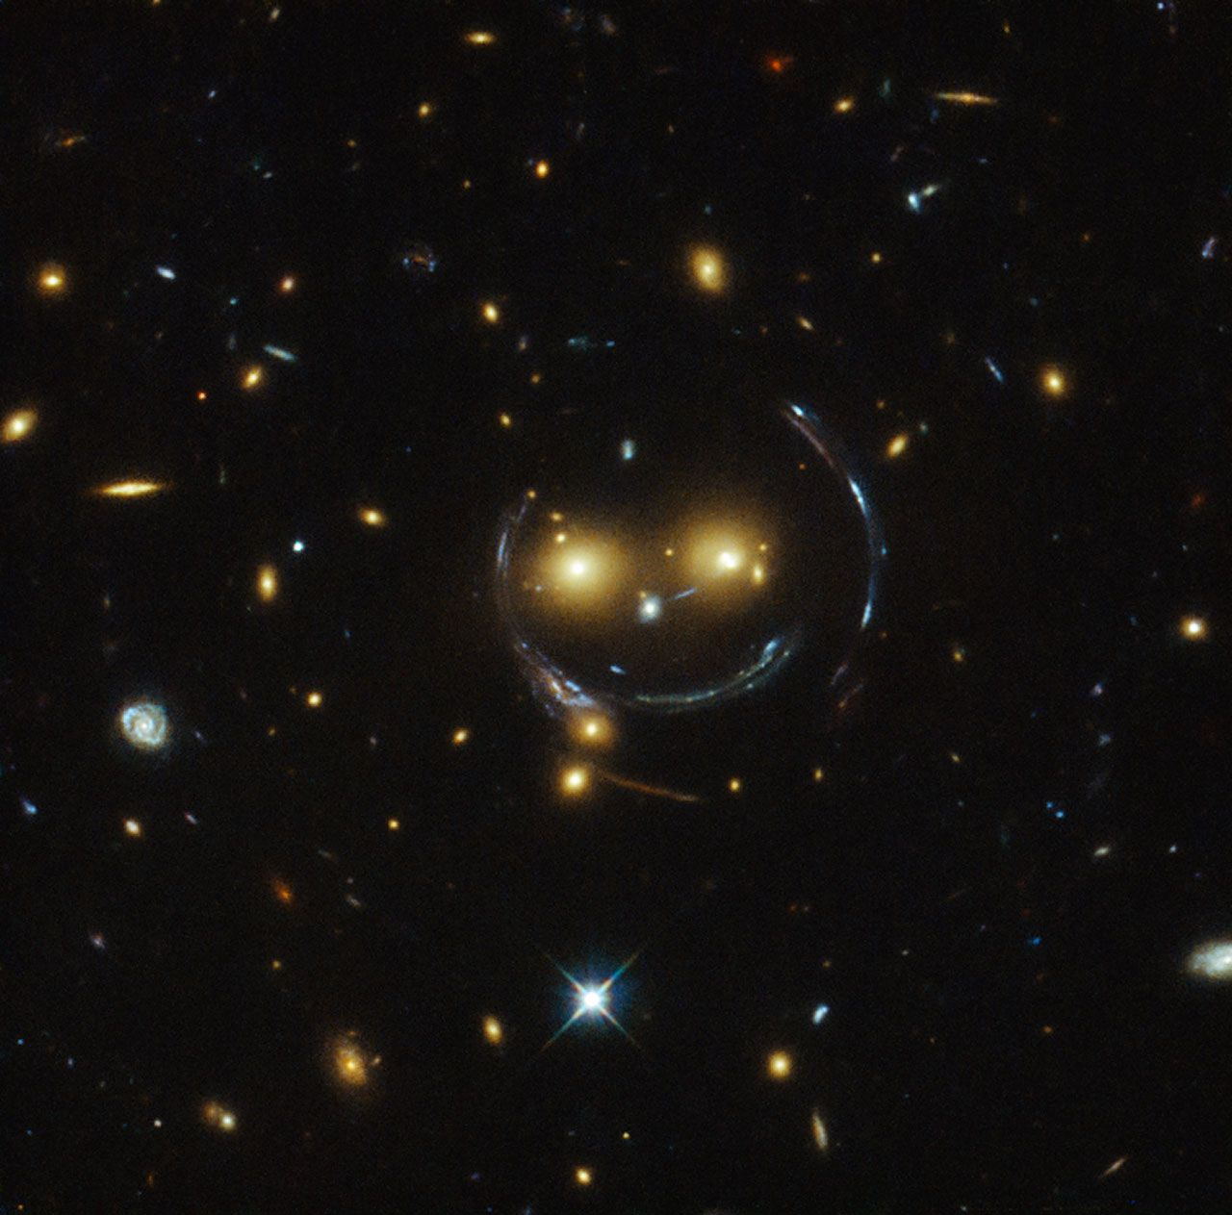
Figure 23. A gravitational lens. The mass of a distant galaxy group bends the light of a still more distant galaxy into the arc that forms this “smile”, as Hubble photographed it. Image: NASA, ESA and the Hubble Space Telescope team.
Galaxy clusters act as lenses for background galaxies. The shapes and positions of the lensed images reconstruct the projected mass distribution of the cluster. The reconstruction includes both luminous and dark matter. The method has mapped dark-matter halos on scales from galaxies to clusters and has measured the masses of individual galaxies.
Microlensing by stars or planets produces a temporary brightening of a background source. The technique has detected exoplanets and has constrained the abundance of compact dark-matter objects. All observed lensing is consistent with general relativity. No deviation that would require a modified theory of gravity has been established.

The Record of General Relativity
Because gravity carries energy of its own, the Einstein equation is nonlinear: the field acts as its own source. Its exact solutions include the Schwarzschild and Kerr black holes, the Friedmann–Lemaître–Robertson–Walker cosmologies of Chapter 31, and gravitational waves.
The equivalence principle, gravitational redshift, light deflection, the Shapiro delay, frame-dragging and the decay of the binary pulsar all agree with the predictions, and gravitational-wave signals match the waveforms computed by numerical relativity. The theory fails at singularities and, in its present form, cannot be combined with quantum mechanics. No observational trace of quantum corrections has been found. Wherever curvature is not extreme, the classical theory is the standard description of gravity.
Questions to Keep Asking
How do we know that spacetime is curved? Starlight bent around the Sun in 1919, the precession of Mercury’s orbit, time delays of radar signals and the waves from merging black holes all fit.
The equivalence principle has been tested to a few parts in a quadrillion. What kind of deviation would point to new physics?
Try it yourself. Drop a pen and a coin side by side. In the falling frame, is there any local experiment that tells you apart from floating in empty space?

20. Relativity at Work: GPS and Beyond
Your phone knows where you stand to within a few meters because it can tell time to a few billionths of a second. The clocks that do it would drift by tens of microseconds a day if relativity were ignored. Navigation is the most widely used test of Einstein’s theories ever made.

GPS and Relativity
The Global Positioning System determines position by measuring the travel time of radio signals from satellites whose locations are known. The required timing accuracy is a few nanoseconds. At that precision both special-relativistic and general-relativistic effects are large enough to matter.
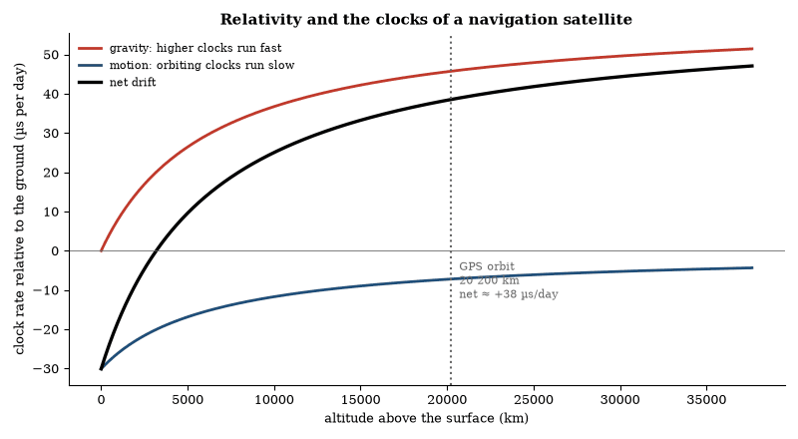
Figure 24. Computed rate difference between an orbiting clock and a clock on the ground (ignoring Earth’s rotation). At GPS altitude the gravitational gain of about 46 µs per day outweighs the 7 µs lost to speed, leaving a net gain near 38 µs per day, which would build into kilometers of positioning error if left uncorrected.
The net effect is that satellite clocks advance by roughly 38 microseconds per day relative to ground clocks. Left alone, the drift would ruin navigation within minutes. The correction is applied by offsetting the satellite clock frequency before launch and by continuous relativistic modeling in the receiver software.
The 38-microsecond daily advance of the satellite clocks is the sum of two opposing effects. The special-relativistic slowing is 1/2 v²/c². With v = 3.9 km/s the fractional shift is -8.3 × 10⁻¹¹, or −7.2 µs per day. The general-relativistic speeding is ΔΦ/c². The gravitational potential difference between the Earth’s surface and the GPS orbital radius (26 600 km) produces +5.3 × 10⁻¹⁰, or +45.6 µs per day. The algebraic sum is +38.4 µs per day.
A constant frequency offset of −4.465 parts in 10¹⁰ is applied to the satellite clocks before launch. The offset cancels the average relativistic rate difference. Residual variations caused by orbital eccentricity are calculated in the receiver from the broadcast ephemeris and removed in real time. The eccentricity term can reach several tens of nanoseconds and must be included if meter-level accuracy is required.
Without any relativistic correction the range error would accumulate at 11 km per day. After one minute the error would already exceed 7 m—larger than the nominal accuracy of the civil signal. The corrections are therefore not optional refinements. They are part of the basic operation of the system.
The same satellites provide a continuous test. The clock rates measured by the ground segment match the predicted combination of special- and general-relativistic shifts to within the stability of the clocks themselves (parts in 10¹³ or better). Independent experiments with hydrogen masers flown on aircraft and with optical clocks compared over height differences of a few tens of centimeters have confirmed the same formulae at still higher precision. GPS is simply the most widely used realization of those formulae.

Worked Examples: GPS Clock Corrections
Example 1. If the relativistic offset were left uncorrected, how large a ranging error would accumulate in one hour?
38.4 µs per day is 1.6 µs per hour. Light travels 3 × 10⁸ m s⁻¹ × 1.6 × 10⁻⁶ s ≈ 480 m in that time, so the position error would grow by nearly half a kilometer every hour.
Example 2. A satellite orbits with eccentricity 0.02. What is the maximum additional relativistic clock correction?
The eccentricity term has amplitude 2√(GMa) e/c² ≈ 2.3 × 10⁻⁶ s × e. For e = 0.02 that is about 46 ns, which corresponds to a range error of roughly 14 m if it is not applied.
Example 3. After 10 years of continuous operation, by how much would an uncorrected satellite clock have drifted relative to ground time?
38.4 µs day⁻¹ × 365.25 × 10 ≈ 0.140 s. Corresponding range error ≈ 42 000 km, larger than the GPS constellation itself.
The numerical values are those used in the actual GPS interface specifications. The system would be unusable without them.

Other Practical Consequences of Relativity
Particle accelerators must include relativistic mass increase and time dilation in their design. The Large Hadron Collider accelerates protons to 0.999999991 c. The relativistic energy is 7 TeV while the rest energy is only 0.938 GeV. Magnets, radio-frequency cavities and beam-lifetime calculations all use the relativistic relations. Without them the machine would not function.
Muon storage rings measure the anomalous magnetic moment of the muon. The muons are born polarized and decay preferentially along their spin direction. Because of time dilation they live long enough to circle the ring thousands of times. The observed precession frequency matches the prediction of quantum electrodynamics only when the relativistic kinematics are correctly included.
Commercial airline crews accumulate measurable extra proper time relative to ground personnel because of the combined velocity and gravitational shifts. The difference is a few microseconds per intercontinental flight—detectable with modern atomic clocks but irrelevant to human aging. The same calculation applied to a hypothetical high-speed interplanetary craft shows that the travelers would return younger than their stay-at-home twins by amounts that grow rapidly once v exceeds a few tenths of c.
In every case the corrections are quantitative, confirmed, and indispensable once the relevant precision or energy is reached. Relativity is not confined to exotic regimes. It is embedded in the everyday infrastructure of navigation, high-energy physics and precision time-keeping.
Questions to Keep Asking
How do we know the corrections are right? Satellite clocks are tuned before launch to allow for them, and the system’s accuracy shows that the rates match prediction.
What would the positioning error look like if only the special-relativistic correction had been applied?
Try it yourself. Light travels 300 meters in a microsecond. If an uncorrected clock gains 38 microseconds in a day, how far off would a position fix be after one day? (Answer: about 11 km.)

21. Gravitational Waves
On 14 September 2015 two mirrors four kilometers apart moved by less than a thousandth of the width of a proton. The movement came from two black holes that had collided 1.3 billion light-years away. It took a century of theory and fifty years of instrument-building to hear it.
A gravitational wave is a ripple in the curvature of spacetime that propagates at the speed of light. It is produced by any accelerating mass quadrupole. The strongest sources are the mergers of black holes and neutron stars.
The waves stretch and compress space transversely. A ring of free particles is deformed into an ellipse that oscillates at the wave frequency. The strain is minute. For a stellar-mass merger at cosmological distance the fractional change in length is of order 10⁻²¹.
Laser interferometers have detected dozens of such events. The waveforms match the predictions of general relativity. The arrival of gravitational waves from a neutron-star merger coincided with a gamma-ray burst and with an optical transient, confirming that the waves travel at c to high precision.
The detections open a new observational window. They measure the masses and spins of black holes, the equation of state of neutron-star matter, and the expansion rate of the universe. Future detectors will extend the reach to the entire observable volume and to lower frequencies.
The strain amplitude of a gravitational wave from a binary merger scales as the chirp mass to the five-thirds power and inversely as the luminosity distance. Matched filtering against theoretical templates extracts the signal from detector noise. The templates are computed from the post-Newtonian expansion and from numerical relativity.
The first detection, GW150914, was a binary black-hole merger roughly 400 megaparsecs away, in which about three solar masses were radiated away as gravitational waves in a fraction of a second. Later events include black-hole pairs far heavier than expected and binary neutron stars. The catalog now holds well over two hundred events, and the masses, spins and local expansion rate are measured from them. The gravitational-wave window is independent of electromagnetic radiation.

The Signal That Traveled for a Billion Years
In 2015 a gravitational-wave detector in Louisiana twitched. A second detector in Washington twitched 7 milliseconds later. The twitches matched the waveform of two black holes spiraling together and merging. The black holes were 1.3 billion light-years away, so the signal had been traveling since before animals existed, and it arrived on a September morning.
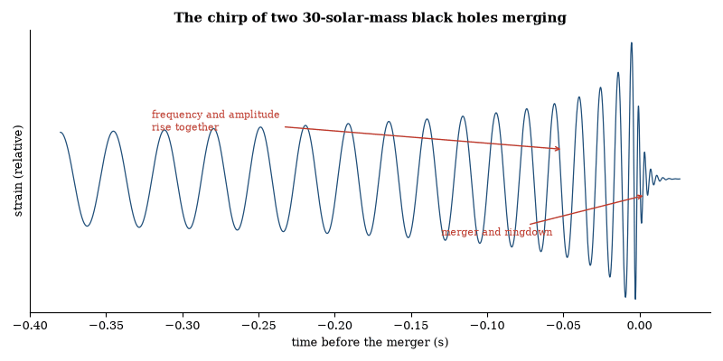
Figure 25. A simulated gravitational-wave chirp from two black holes of 30 solar masses, drawn from the leading-order inspiral formula with a damped ringing tail attached by hand. Frequency and strength rise together as the holes spiral in; the real GW150914 signal swept from 35 to 250 Hz in about 0.2 seconds.
The detectors had been built to measure a change in length of one part in 10²¹, a fraction of the width of a proton across a 4-kilometer arm. The change was detected, and its waveform matched the prediction of general relativity to high precision; no other known process produces it. The black holes merged, the waves crossed the universe, the mirrors moved, and the movement was recorded.
The event was the first direct detection of gravitational waves and the first observation of a binary black-hole merger. It was also a demonstration that a prediction made a century earlier, about a distortion of spacetime too small to imagine, could be turned into a recorded trace. The trace is now routine. It was not routine that morning.

The Stochastic Gravitational-Wave Background
A stochastic gravitational-wave background is the superposition of unresolved sources. Astrophysical backgrounds arise from binary mergers across cosmic history. Cosmological backgrounds can arise from inflation, from phase transitions or from cosmic strings. The two classes are distinguished by their spectra and by their anisotropy.
Pulsar timing arrays are sensitive to the nanohertz band, ground-based detectors to the audio band, and space-based detectors will cover the millihertz band. A detection in any band constrains the source population. A detection of a cosmological background would probe physics at energies far above those accessible to colliders. No such cosmological background has been confirmed. The astrophysical background from binaries is expected and may already have been seen.

How a Gravitational-Wave Detector Works
The LIGO detectors in Hanford, Washington, and Livingston, Louisiana, are L-shaped, with arms four kilometers long. A laser beam is split, sent down both arms and reflected back from mirrors, and the two beams are recombined. If the arms have the same length, the light waves cancel at the detector. A passing gravitational wave stretches one arm while squeezing the other, and a trace of light gets through. The change in length to be detected is about a thousandth of the width of a proton.
Reaching that sensitivity took decades. The mirrors, each weighing 40 kilograms, hang from multi-stage suspensions to isolate them from ground vibration. The laser light is bounced back and forth hundreds of times to lengthen the effective arm. The whole apparatus sits in one of the largest ultra-high vacuums ever built, and the instrument is now so quiet that quantum noise in the light itself limits it, which is partly reduced with squeezed light.
Detectors in Italy (Virgo) and Japan (KAGRA) work with LIGO, so that signals can be located on the sky by their arrival times. The 2017 Nobel Prize went to Rainer Weiss, Barry Barish and Kip Thorne for the founding of LIGO. A space-based detector, LISA, is planned for the 2030s to detect waves of much lower frequency.

The Binary Pulsar: Waves Before Detection
Direct detection came in 2015, but the case for gravitational waves was already strong. In 1974 Russell Hulse and Joseph Taylor discovered a pulsar orbiting another neutron star, and the timing of its pulses allowed the orbit to be measured with extraordinary precision. General relativity predicted that such a system should lose energy as gravitational waves and that the stars should spiral together, shortening the orbital period by a small, calculable amount.
Decades of observation showed that the orbit shrinks exactly as predicted, to better than one percent. It was an indirect proof that the waves carry off energy, and Hulse and Taylor received the Nobel Prize in 1993. The two stars will merge in about 300 million years, and the merger will resemble, at far higher frequencies, the events LIGO now detects in other systems.
The story shows how a prediction can be confirmed long before it can be observed directly. It also shows why the direct detection mattered. It opened a new window, allowing the strongest events in the universe, mergers of black holes, to be heard as well as inferred.
Questions to Keep Asking
How do we know the signal was not noise? Two detectors a continent apart saw the same waveform within ten milliseconds, and the chance of a false alarm was about once in two hundred thousand years.
A detection that appeared in only one detector, or with a delay longer than the light-travel time between them, would be viewed with suspicion. Why?
Try it yourself. The two LIGO sites are about 3,000 km apart. What is the largest delay a gravitational wave traveling at light speed can show between them? (Answer: about 10 ms.)

22. Black Holes
Squeeze the Sun to a ball six kilometers across and light could no longer escape it. We now photograph the shadows of such objects, hear them collide, and watch stars orbit one at the center of our own galaxy. What happens inside is the least tested part of general relativity.

What a Black Hole Is
A black hole is a region of spacetime from which no signal can reach distant observers. The boundary of the region is the event horizon. In the Schwarzschild solution the horizon lies at the radius r_{s} = 2GM/c², which is about 3 km for a solar-mass object. Once inside the horizon, every path forward leads to the central singularity.
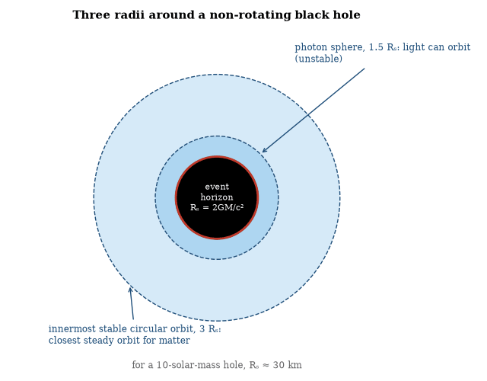
Figure 26. The geometry outside a non-rotating black hole, in units of the Schwarzschild radius Rₛ = 2GM/c². Light can circle the hole at 1.5 Rₛ; gas can orbit steadily only outside 3 Rₛ, so accretion disks end there and then plunge inward.
The sections that follow take up how such objects form and shine, what their horizons are like, how they can be described with temperature and entropy, and the unresolved question of what becomes of information that falls in.
No observation contradicts the general-relativistic description of the exterior. The interior, the singularity, and the ultimate fate of the information remain outside present experimental reach.

Horizons, Tides and the Singularity
The event horizon is not a material surface. It is the set of points beyond which all future-directed paths remain inside. Nothing of ordinary density is compressed to the Schwarzschild radius: for the Sun it is about three kilometers, for the Earth about nine millimeters. Only stellar cores above the maximum mass of a neutron star can collapse past that point.
Once an object crosses the horizon, the geometry prevents escape. Tidal forces become extreme near a small black hole. They stretch an object along the radial direction and compress it transversely. For a supermassive black hole the horizon is so large that the tidal forces at the horizon itself are mild. The singularity, where curvature becomes infinite according to classical general relativity, lies in the future of any observer who crosses the horizon.

Black-Hole Thermodynamics
A black hole has a temperature and an entropy. The temperature is the Hawking temperature
T = (ħ c³)/(8π GMk_{B}).
The entropy is the Bekenstein–Hawking entropy
S = k_{B}c³A/4Għ,
where A is the area of the horizon. Both quantities follow from the combination of general relativity, quantum field theory, and thermodynamics.
The temperature is inversely proportional to the mass. A solar-mass hole has a temperature of about 60 nanokelvin, colder than the microwave background, so it absorbs more than it emits. Only a hole lighter than roughly 4.5 × 10²² kg, about the mass of the Moon, is hotter than the background and loses mass; one lighter than a few times 10¹¹ kg would already have evaporated. The emission is thermal, following a black-body curve at the Hawking temperature.
The entropy is proportional to the horizon area, not to the volume. The proportionality suggests that the fundamental degrees of freedom of a black hole reside on its surface. The same area law appears in the holographic principle. No complete microscopic accounting of the entropy is known for a generic black hole. For certain extremal holes in string theory the counting of microstates reproduces the area law.
The four laws of black-hole mechanics are formally identical to the laws of thermodynamics. The zeroth law states that surface gravity is constant over the horizon of a stationary black hole. The first law relates changes in mass, area, angular momentum and charge. The second law states that the horizon area never decreases in classical processes. The third law states that surface gravity cannot be reduced to zero in a finite number of operations.
Hawking radiation supplies the missing identification: surface gravity is proportional to temperature and area is proportional to entropy. With those identifications the laws become the ordinary laws of thermodynamics applied to black holes. The generalized second law asserts that the sum of black-hole entropy and the entropy of matter outside the hole never decreases. The law has been verified in a variety of thought experiments and is required for consistency.
For a solar-mass hole the entropy is enormous, about 10⁷⁷ k_{B}. The thermodynamic description is robust even though the microscopic accounting is not.

Black Holes in Astrophysics
Stellar-mass black holes form in the collapse of massive stars and grow by accretion and by mergers. Supermassive black holes, millions to billions of solar masses, occupy the centers of most large galaxies.
Gravitational-wave detectors have recorded the mergers of stellar-mass black holes. The waveforms match the numerical solutions of the Einstein equation.
Matter falling toward a black hole forms an accretion disk. Viscosity transports angular momentum outward and allows the gas to spiral inward. The released gravitational energy heats the disk and can power quasars and X-ray binaries. The efficiency of conversion of rest mass to radiation can exceed 10 percent, higher than nuclear fusion.
No information about the interior can reach an external observer, and the classical theory ends at the singularity, where a quantum description will be needed. The exterior geometry is nevertheless accurately described by the Kerr or Schwarzschild solution.

Black-Hole Imaging
The Event Horizon Telescope imaged the shadow of the supermassive black hole in M87 and later the shadow in Sgr A*. The shadow diameter is approximately five times the Schwarzschild radius for a non-spinning hole. The measured diameter agrees with the prediction of general relativity given the independently measured mass and distance. The image is formed by strong gravitational lensing of emission from the accretion flow.
The observations constrain deviations from the Kerr metric. They do not yet measure the spin with high precision. Polarization maps the magnetic field near the horizon. The field is ordered. The observations confirm that the object is consistent with a black hole. They do not prove the existence of an event horizon. They are the highest-resolution test of strong-field gravity yet performed.

Primordial Black Holes
Primordial black holes could have formed from large density perturbations in the early universe. Their masses can range from the Planck mass to many solar masses. They are constrained by the absence of evaporation signals, by microlensing, by dynamical effects and by the gravitational-wave background. In most mass windows they can constitute only a fraction of the dark matter.
The window near asteroid masses remains less constrained. A detection would constitute both a dark-matter candidate and a probe of the primordial power spectrum on small scales. No confirmed detection exists, and although the possibility is tightly bounded, it is not excluded.

The Black-Hole Interior
The interior of a black hole is the region behind the event horizon. In classical general relativity it is causally disconnected from the exterior. In the quantum theory the disconnection is not absolute. The island calculations assign part of the interior to the entanglement wedge of the exterior radiation after the Page time. The assignment is state-dependent.
An infalling observer encounters a smooth geometry in the semi-classical approximation. The approximation fails near the singularity and, possibly, at the horizon of an old black hole. The failure at the horizon is the firewall question. No consensus exists. The interior is both a region of classical spacetime and a quantum system whose degrees of freedom are shared with the exterior. The sharing is the content of the island formula. Its implications for the experience of the infalling observer remain under debate.

Singularities and Chronology Protection
The Penrose–Hawking singularity theorems show that, under general conditions, gravitational collapse and cosmological expansion produce incomplete geodesics. Classical general relativity predicts its own breakdown. The theorems assume the null energy condition and the existence of a trapped surface or a cosmological focusing condition. Both are satisfied in realistic collapse and in the hot early universe. The classical theory therefore cannot be the final description.
Hawking also examined the possibility of closed timelike curves. A closed timelike curve would let a traveler come back to the very event of departure. He conjectured that the laws of physics prevent their formation. The conjecture is called chronology protection. Quantum effects near a would-be chronology horizon produce a divergent stress-energy tensor. The back-reaction is expected to destroy the horizon before closed timelike curves appear. The argument is plausible but unproven. No confirmed example of a chronology-violating spacetime is known. The protection, if it holds, keeps the causal structure of the observed universe intact.

Wormholes
A wormhole is a hypothetical tunnel connecting two distant regions of spacetime. In the simplest mathematical models the tunnel is held open by matter that violates the null energy condition. Ordinary matter does not. Quantum fields can violate the condition locally and briefly. Whether they can do so on the scale and for the duration needed to keep a macroscopic wormhole open is unknown.
No wormhole has been observed. General relativity permits the solutions but does not require them. Traversable wormholes would allow shortcuts between distant points and, in some arrangements, closed timelike curves. Closed timelike curves permit paths that return to the same event. They raise consistency problems, and proposals that prevent their formation or render them unstable exist, but none is confirmed.
The existence of wormholes is therefore an open question in classical and quantum gravity. They are not required by any confirmed observation. They are not forbidden by the present form of the field equations when exotic matter is allowed. Until a quantum theory of gravity is established, or until an observation demands them, they remain mathematical possibilities without empirical support.

Wormholes and Entanglement
Not every wormhole needs exotic matter to exist on paper. Non-traversable ones appear in the maximally extended Schwarzschild geometry, joining two asymptotic regions through a throat that pinches off faster than any signal could cross it.
Quantum versions—entanglement wormholes or ER=EPR—identify certain entangled states with non-traversable wormholes. The identification is precise in anti-de Sitter space and supplies a geometric picture of entanglement, but it does not yield a shortcut for signaling, since the wormhole remains non-traversable.
Their theoretical interest lies less in travel than in the connection they suggest between geometry and entanglement, and in the constraints they place on energy conditions. Both topics remain active, and neither has produced a confirmed macroscopic wormhole.
Questions to Keep Asking
How do we know that black holes exist? Stars at the Milky Way’s center orbit a dark, compact mass of four million Suns, and gravitational waves match the merger of horizons.
A confirmed deviation in the shape of a black hole’s shadow or in its ringdown would point to physics beyond general relativity. What precision is needed?
Try it yourself. Find the Schwarzschild radius of the Earth from 2GM/c². (Answer: about 9 mm.) What does it say about the density of a black hole’s contents?

23. Hawking Radiation and the Vacuum
Black holes are black because nothing escapes them, and yet in 1974 Stephen Hawking showed that they should glow faintly and slowly shrink. The glow has never been seen, and the argument for it ties together gravity, quantum theory and heat.

Hawking Radiation
Hawking radiation is the thermal flux emitted by a black hole. It arises when quantum fields propagate on the curved spacetime of a collapsing body. The spectrum seen by a distant observer is thermal at the temperature
T = (ħ c³)/(8π G M k_{B}).
Heavier holes are colder. A solar-mass hole radiates at about 60 nanokelvin, far below the cosmic microwave background. A hole of about 5 × 10¹¹ kg has a temperature near 2 × 10¹¹ K and a lifetime close to the present age of the universe.
The radiation carries energy, angular momentum and charge, and it reduces the mass of the hole. The final stage of evaporation is unknown and has not been observed directly. Without it, black-hole thermodynamics would contradict the ordinary second law.

How Hawking Found the Radiation
Hawking announced the result in 1974. Bekenstein had argued that a black hole should carry entropy proportional to its horizon area, and Hawking at first resisted, because an object with entropy must have a temperature and therefore must radiate. His own calculation, which joins quantum field theory to the geometry of a collapsing star, showed that the radiation is real.
The popular picture of virtual pairs split by the horizon, with one partner escaping, is a heuristic for the mismatch between vacuum modes described elsewhere, not a literal account of the calculation.
The result implies that black holes have a temperature and, by the first law, an entropy equal to one quarter of the horizon area in Planck units. The derivation links gravity, quantum mechanics and thermodynamics, which is why it is treated as a landmark although the radiation from an astrophysical hole has never been observed.

Derivation and Thermodynamics of Hawking Radiation
Hawking radiation follows from the mismatch between the vacuum defined at past null infinity and the vacuum defined at future null infinity when a horizon is present. Modes that cross the horizon during collapse become entangled. Tracing over the interior partner leaves the exterior mode in a thermal state. The temperature measured at infinity is T = ħκ/(2π k_{B} c), where κ is the surface gravity. For a Schwarzschild hole κ = c⁴/(4GM) and the familiar expression T = ħ c³/(8π GMk_{B}) is recovered.
The same temperature appears in the Euclidean path integral. The metric continued to imaginary time is regular at the horizon only when the period is 2π/κ. That period is precisely the inverse temperature of a thermal state. The agreement of the Lorentzian mode analysis and the Euclidean periodicity confirms that the radiation is thermal.
Energy conservation requires that the hole lose mass as it radiates. The luminosity scales as 1/M². The heat capacity is negative: as the hole loses mass its temperature rises and the evaporation accelerates. The process continues until the semi-classical approximation fails near the Planck mass. The flux satisfies the thermodynamic laws of black holes: area increase, constant surface gravity on the horizon, and the first law relating mass, area and angular momentum.

The Unruh Effect
The Unruh effect is the prediction that a uniformly accelerating observer in the Minkowski vacuum will detect a thermal bath of particles. The temperature is T = (ħ a)/(2π k_{B} c), where a is the proper acceleration. The effect is a consequence of the mismatch between the Minkowski vacuum and the Rindler vacuum associated with the accelerating observer’s horizon.
The Unruh effect is conceptually important because it shows that the particle content of a quantum field is observer-dependent and because it is formally related to Hawking radiation.
Reaching a temperature of 1 K would take an acceleration of order 10²⁰ m s⁻², far beyond anything macroscopic objects experience. Electrons in the focus of the most intense lasers approach the regime, which is why proposed tests look for a faint thermal signature in their response. No conclusive detection has been reported.
The analogy with Hawking radiation is exact in the semiclassical limit. Both come from comparing the vacuum defined by inertial modes with the vacuum defined by modes tied to a horizon, here the Rindler horizon of the accelerating observer. Both also rest on entanglement between modes on either side of that horizon.

Quantum Foam
Wheeler suggested that spacetime at the Planck scale is not smooth. Geometry fluctuates, and the uncertainty principle applied to the metric makes the fluctuations of order one at lengths near 10⁻³⁵ m. The fluctuations are large enough that the classical manifold description fails. He called the fluctuating geometry quantum foam. Virtual black holes, wormholes, and changes of topology appear and disappear on timescales of the Planck time. The average geometry over larger scales remains the smooth spacetime of general relativity.
No direct observation of the foam exists. Particle accelerators reach energies many orders of magnitude below the Planck energy. Indirect limits come from the absence of certain effects that large fluctuations would produce: dispersion of light from distant sources, or violations of Lorentz invariance. The limits constrain the size of the fluctuations but do not rule out a foamy structure at the Planck length.
The idea is a qualitative expectation from combining general relativity and quantum mechanics. A full quantum theory of gravity would replace the expectation with a definite spectrum of fluctuations or with a different microstructure. Until that theory exists, quantum foam remains a plausible picture of the short-distance regime and an untested one.
Questions to Keep Asking
How do we know the radiation exists if no one has seen it? We do not. Laboratory analogues, such as sound-wave horizons in cold gases, show the mechanism, and the thermodynamics of black holes requires it.
Seeing the evaporation of a tiny primordial black hole would confirm Hawking. What would its final burst look like?
Try it yourself. A solar-mass black hole has a temperature of about 60 nanokelvin. The cosmic background is 2.7 kelvin. In which direction does heat flow between them today?

24. The Black-Hole Information Question
Burn a book and its information survives, in principle, in the smoke and ash. Throw it into a black hole that later evaporates and, Hawking argued, it might be gone for good. A fifty-year argument over that claim has produced holography.

The Information Question
Hawking radiation is thermal, and a thermal spectrum is determined by temperature alone. It contains no information about the matter that formed the black hole. If the hole evaporates completely, the information appears to be lost. Quantum mechanics requires unitary evolution, so information should be preserved, and the conflict is the information question.
Hawking initially concluded that information is destroyed. Later calculations and the AdS/CFT correspondence suggested that it is preserved. The radiation is not exactly thermal. Subtle correlations among successive quanta can, in principle, encode the initial state. The correlations are exponentially small until the final stages of evaporation. Recovering them is impractical. Their existence would restore unitarity.
No consensus exists on the detailed mechanism. Proposals include remnants, information return in the late radiation, and modifications of the horizon itself. The question remains open. It is a precise conflict between the semiclassical calculation and the requirement of unitary quantum evolution. Its resolution is expected to constrain any quantum theory of gravity.

The Page Curve and the Paradox
A black hole that forms from a pure quantum state and evaporates completely into thermal radiation appears to leave behind a mixed state. The map from pure to mixed states is non-unitary, yet unitarity is a fundamental requirement of quantum mechanics, and the conflict is the information paradox.
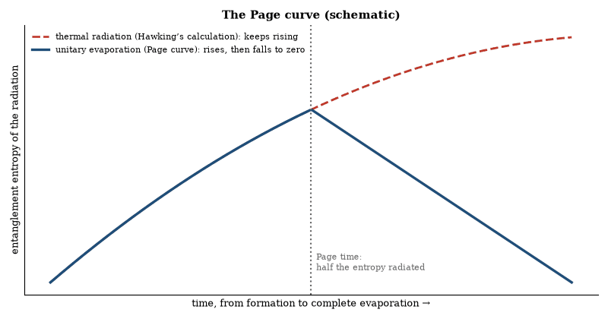
Figure 27. A schematic of the information puzzle. If Hawking radiation were exactly thermal, the radiation’s entanglement would grow for ever (dashed). If evaporation is unitary, it must peak at the Page time and fall to zero (solid). Island calculations reproduce the solid curve.
The paradox becomes acute for an old black hole. Once more than half the initial entropy has been radiated, the remaining black hole has less entropy than the radiation already emitted. If the evaporation continues to be thermal, the total state cannot purify. The Page curve—the entanglement entropy of the radiation—must therefore rise and then fall if unitarity is to be preserved. A purely thermal spectrum produces a curve that rises indefinitely.
Recent calculations that include quantum extremal surfaces reproduce a Page curve that turns over. The island formula assigns part of the black-hole interior to the entanglement wedge of the radiation after the Page time. The result suggests that information is released in subtle correlations and that the final state is pure. The calculations have been performed in simplified models and in low-dimensional gravity. Their extension to realistic, asymptotically flat black holes is incomplete.
Alternative proposals include remnants that store the information, modifications of the radiation at late times, and non-unitary evolution. None is free of difficulties. The island calculations are the first to recover the Page curve from a semi-classical gravitational path integral. They indicate that the paradox may be resolved without abandoning unitarity or introducing new degrees of freedom beyond those already present in quantum gravity. A fully controlled demonstration for an evaporating four-dimensional black hole does not yet exist.

Black-Hole Complementarity
Black-hole complementarity is the proposal that the descriptions of physics given by an observer who remains outside a black hole and by an observer who falls in are both valid, yet cannot be compared by any single observer. The external observer sees infalling matter approach the horizon asymptotically, thermalize, and eventually return as Hawking radiation. The infalling observer crosses the horizon without drama and encounters the matter in a perfectly regular spacetime region. No experiment accessible to either observer reveals a contradiction.
The principle was introduced to reconcile unitarity of the exterior evolution with the equivalence principle at the horizon. It asserts that the two accounts are complementary in the same sense that position and momentum are complementary: both are correct, but they cannot be simultaneously sharp for the same observer. Information that has crossed the horizon is, for the external observer, encoded in the radiation; for the infalling observer it remains in the interior. Because the observers cannot communicate after the horizon is crossed, no direct conflict arises.
Complementarity faces difficulties once the black hole is old. An external observer who collects the early radiation and then jumps in can, in principle, meet the same quantum information both outside and inside, violating the no-cloning theorem. The firewall argument sharpens the tension: preservation of exterior unitarity appears to require a high-energy barrier at the horizon that would destroy an infalling observer. Complementarity alone does not resolve the conflict.
Later developments—entanglement wedges, islands, and the Page curve—modify the original picture. They suggest that the interior degrees of freedom are not independent of the exterior radiation after the Page time. The complementarity of the two descriptions survives in a weakened form, but the precise location of the information and the experience of the infalling observer remain model-dependent. Complementarity is therefore a useful organizing idea whose detailed implementation is still incomplete.

Firewalls
The firewall argument states that unitarity, the equivalence principle and effective field theory outside the horizon cannot all be maintained for an old black hole. If the late radiation is entangled with the early radiation, as unitarity requires, and the horizon is a smooth vacuum, as the equivalence principle requires, then each late mode would have to be entangled both with the early radiation and with its interior partner. Monogamy of entanglement forbids that. One of the three assumptions must fail, and a firewall, a high-energy barrier at the horizon, is what preserves unitarity at the cost of the equivalence principle.
The argument has not been resolved. Island calculations suggest that after the Page time the interior is not independent of the radiation outside, which softens the conflict without removing it for all observers. A firewall remains possible but is not required by present calculations. The tension between unitarity and a smooth horizon is real, and how it is resolved depends on the model.

Replica Wormholes
Replica wormholes are saddle points of the gravitational path integral that compute the entanglement entropy. They connect the replicas of the radiation through the black-hole interior. Their contribution dominates after the Page time, and the dominance produces the turnover of the Page curve. The wormholes are not traversable; they are a calculational device.
The same saddles appear in the calculation of the purity and of higher Rényi entropies. They are required for consistency with unitarity. Their existence in the path integral is a consequence of the Euclidean gravitational action. It does not imply that an observer can travel through them. The wormholes resolve the entropy calculation. They do not by themselves resolve the experience of the infalling observer.

The Island Formula
The island formula computes the entanglement entropy of the radiation as the minimum of the generalized entropy of a region that includes an island inside the black hole. The formula is S = min ( (Area(∂ I))/4G_{N} + S_{matter}(R ∪ I) ). The minimum is taken over islands I. After the Page time the minimum includes a non-empty island. The formula reproduces the Page curve.
It has been derived from the replica trick in gravitational path integrals. It applies to evaporating black holes in anti-de Sitter space and in certain flat-space models. Its validity for realistic astrophysical black holes is assumed but not proven. The formula is the sharpest present statement of how information escapes. It remains a semi-classical expression.

Quantum Extremal Surfaces
A quantum extremal surface is a surface that extremizes the generalized entropy. It reduces to the ordinary Ryu–Takayanagi surface when the bulk entropy is negligible. When the bulk entropy is large the surface moves. In the island calculation the quantum extremal surface lies inside the horizon after the Page time. Its area plus the bulk entropy of the island and the radiation gives the Page curve.
The surface is a generalization of the classical extremal surface. It incorporates the leading quantum correction; higher-order corrections exist but are small in the semi-classical limit. The concept unifies the classical area term with the bulk entanglement. It is the geometric object that appears in the island formula and in the derivation of the Page curve.

The Information Paradox in AdS/CFT
In AdS/CFT the formation and evaporation of a black hole is dual to the unitary evolution of a thermal state in the boundary theory. Unitarity is therefore guaranteed. The paradox becomes the question of how the bulk calculation reproduces the unitary result. The island formula and the replica wormhole provide the bulk mechanism. They modify the entropy calculation after the Page time.
The resolution is explicit in low-dimensional models and in certain supersymmetric theories. Its extension to higher-dimensional, asymptotically flat black holes is not complete. The AdS/CFT example demonstrates that a unitary resolution is possible within a consistent theory of quantum gravity. It does not yet supply the resolution for the black holes that form in our universe.

The Holographic Principle
The holographic principle states that the information content of a spatial region is bounded by the area of its boundary, not by its volume. The bound is saturated by a black hole: the Bekenstein–Hawking entropy is proportional to the horizon area measured in Planck units. The principle therefore asserts that a black hole is the maximum-entropy object of a given size.
Its strongest realization is the AdS/CFT correspondence, described next.
In asymptotically flat space or in de Sitter space no equally precise duality is known. The principle is nevertheless used as a guide. It suggests that the degrees of freedom of quantum gravity are nonlocal and that locality itself is an approximate, emergent notion. It also supplies an upper limit on the entropy that can be stored in any region, a limit already respected by all known physical systems.
No direct experimental test exists. The principle remains a theoretical constraint inferred from black-hole thermodynamics and from the structure of gauge/gravity duality. Its ultimate scope—whether it governs every consistent quantum theory of gravity—is still open.

The AdS/CFT Correspondence
The AdS/CFT correspondence is an exact duality between a theory of quantum gravity in (d+1)-dimensional anti-de Sitter space and a conformal field theory in d dimensions that lives on the boundary of that space. The best-studied example equates type-IIB string theory on AdS₅ × S⁵ with N=4 super-Yang–Mills theory in four dimensions.
Bulk fields are dual to boundary operators. The mass of a bulk field fixes the conformal dimension of the dual operator. Correlation functions computed by Witten diagrams in the bulk equal correlation functions computed by Feynman diagrams in the boundary theory. The dictionary extends to finite temperature: a black hole in AdS is dual to a thermal state in the CFT. The Bekenstein–Hawking entropy equals the thermal entropy of the boundary theory.
Real-time dynamics, transport coefficients and far-from-equilibrium evolution can likewise be mapped between the two sides.
The duality is a conjecture supported by a large number of matching calculations. It has not been proved in full generality. It applies strictly to anti-de Sitter asymptotics. Its conceptual importance lies in the demonstration that a higher-dimensional gravitational theory can be exactly equivalent to a lower-dimensional quantum field theory without gravity, and that spacetime geometry can emerge from quantum entanglement.

Holography and Entanglement
The Ryu–Takayanagi formula equates the entanglement entropy of a boundary region with the area of a bulk minimal surface. The formula has been verified in many examples. It suggests that spacetime geometry is encoded in the entanglement structure of the boundary theory. In anti-de Sitter space the statement is exact. Its extension to other asymptotics is incomplete.
Entanglement wedge reconstruction shows that bulk operators inside the wedge can be represented as boundary operators. The reconstruction is state-dependent for operators behind horizons. The dependence is consistent with the island calculations of black-hole evaporation. Holography therefore supplies both a definition of quantum gravity in certain spacetimes and a concrete realization of the idea that geometry emerges from entanglement.
Questions to Keep Asking
How do we know that quantum evolution must preserve information? The equations of quantum mechanics are reversible, and every other known process obeys them.
What would convince you that information really is lost when a black hole evaporates, and what else in physics would have to give?
Try it yourself. Write down two reasons a physicist might be willing to give up the conservation of quantum information, and two reasons she might not.
Further reading for Part IV. Epstein’s Relativity Visualized teaches special and general relativity with pictures and almost no mathematics. Hawking’s A Brief History of Time is the popular classic on black holes, and Hawking and Penrose’s The Nature of Space and Time puts their two views side by side. Wheeler and Ford’s Geons, Black Holes, and Quantum Foam is a memoir of the field by one of its builders.

Part V: Planets, Stars and Galaxies
From our own Solar System out to other stars and the galaxies that hold them

25. The Solar System
The Solar System is a record of a single afternoon, cosmically speaking. A cloud of gas and dust collapsed about 4.57 billion years ago, and the craters of the Moon and the rings of Saturn are leftovers of what happened next.
The Sun is an ordinary star, a ball of hot gas about 1.4 million kilometers across, held together by its own gravity and powered by the fusion of hydrogen into helium in its core. It contains more than 99 percent of the mass of the Solar System. Everything else—planets, moons, asteroids, comets—is debris left from the cloud that formed it about 4.6 billion years ago.
The planets fall into two groups. The inner four are small and rocky: Mercury, Venus, Earth, and Mars. The outer four are large and gaseous or icy: Jupiter, Saturn, Uranus, and Neptune. Pluto, once counted as a planet, is now classified as a dwarf planet, one of many icy bodies beyond Neptune.
Mercury is the smallest and closest to the Sun. It has almost no atmosphere, a heavily cratered surface, and extreme temperature swings. Venus is similar to Earth in size but utterly different in condition. A thick atmosphere of carbon dioxide produces a runaway greenhouse effect. Surface temperatures exceed 460 degrees Celsius, and the pressure is about ninety times that at Earth’s surface. Probes that landed there survived only briefly.
Earth is the one planet known to have liquid water on its surface and life. Its Moon is unusually large relative to the planet. The leading account of the Moon’s origin is a giant impact early in the Solar System’s history, which threw debris into orbit that then gathered into the Moon. The Moon’s distance is about 384,000 kilometers, a figure first estimated reasonably by Greek astronomers and refined ever since.
Mars is smaller than Earth, cold, and thin-aired. Orbiters and rovers have mapped ancient river valleys, lakebeds, and minerals that form in water. Liquid water is not stable on the surface today, though ice exists at the poles and underground. Whether Mars ever had life remains open, and no confirmed evidence has been found.
Jupiter is the largest planet, more massive than all the others combined. It is mostly hydrogen and helium, with a small rocky core. Its Great Red Spot is a storm larger than Earth that has been watched continuously since the nineteenth century. Jupiter has nearly a hundred known moons. The four largest—Io, Europa, Ganymede, and Callisto—were seen by Galileo in 1610. Io is volcanically active. Europa has a subsurface ocean under ice.
Saturn is known for its rings, which are made of ice and rock particles, mostly close to the planet. It too is a gas giant with many moons. Titan, the largest, has a thick nitrogen atmosphere and lakes of liquid methane. Enceladus vents water from a subsurface ocean.
Uranus and Neptune are ice giants, smaller than Jupiter and Saturn, rich in water, ammonia, and methane ices as well as hydrogen and helium. Uranus rotates on its side, Neptune has the strongest winds in the Solar System, and both have ring systems and moons. Triton, Neptune’s largest moon, orbits backward and is geologically active.
Asteroids are rocky bodies, mostly between Mars and Jupiter. Comets are icy bodies from farther out. When a comet approaches the Sun, ice vaporizes and forms a tail. Meteorites that reach Earth are samples of these smaller bodies. Some are primitive material from the early Solar System. Their ages, measured by radioactive dating, confirm that the system formed about 4.56 billion years ago.
The planets were visited by robotic probes beginning in the 1960s. Every planet has now been studied at close range. Samples have been returned from the Moon, from asteroids, and from a comet. The picture that emerged is more varied than the one available in the 1980s, and still incomplete in its details. The formation process—a disk of gas and dust around a young star, grains sticking together, cores growing, gas giants capturing envelopes before the gas dispersed—is the working account. It fits the evidence from our system and from the disks now seen around other young stars.

The Collision That Made the Moon
Four and a half billion years ago a body the size of Mars struck the Earth, melting both and throwing debris into orbit. Most of the iron had already sunk into the Earth’s core, so the debris was rocky, and it gathered into the Moon. The violent phase lasted hours, but the consequences are still here.
The Moon steadies the Earth’s tilt; without it the axis would probably swing far more widely, and the seasons with it. The impact also set the initial length of the day and the distance to the Moon, and both have changed since: the day has lengthened, and the Moon is receding by 3.8 centimeters a year, measured by laser pulses bounced off mirrors that astronauts left on the surface. The mirrors are still there, and the light still returns.
The collision is the reason there is a large moon, a stable climate, and a mirror on the lunar surface. It is also the reason the Earth–Moon system carries a particular angular momentum. The angular momentum is a fossil of the impact. It has not been erased.

The Origin of the Moon
The Moon formed in a giant impact. A Mars-sized body struck the proto-Earth late in the accretion of the terrestrial planets. The collision ejected a disk of silicate vapor and melt into Earth orbit. The disk cooled and condensed. The Moon accreted from that disk within years to centuries, or, in some recent simulations, within hours.
The hypothesis accounts for the Moon’s low density, its depletion in iron relative to Earth, and, with later mixing, the nearly identical isotope ratios of lunar and terrestrial rocks. It also accounts for the angular momentum of the Earth–Moon system. Alternative models—capture, co-accretion, or fission of a rapidly spinning Earth—fail to satisfy the same constraints simultaneously.
High-resolution simulations show that the impactor’s core merged with Earth’s core while the mantle material formed the disk. Subsequent equilibration between the disk and the Earth’s atmosphere and magma ocean produced the observed isotopic match. The same event left Earth with a molten surface and an atmosphere of rock vapor. Both cooled within a few thousand years.
The impact occurred after the Earth had already differentiated. Radiometric ages of lunar samples place the event between 4.5 and 4.4 billion years ago. Giant impact, in one variant or another, remains the only kind of scenario consistent with the dynamical, chemical and chronological evidence.

Late Heavy Bombardment
The Late Heavy Bombardment is a hypothesized spike in the impact rate approximately 4.1 to 3.8 billion years ago. It was inferred from the ages of lunar basins. Dynamical models of planetary migration can produce such a spike if the giant planets crossed resonances. A spike would have repeatedly heated and resurfaced the Earth, though probably without sterilizing it entirely, and may have delivered volatiles.
Recent re-analysis of lunar samples suggests that the basin ages are spread over a longer interval. The evidence for a sharp spike is weaker than once thought. A declining but still elevated impact rate is sufficient to explain the data. The bombardment, whether spiked or declining, was the final stage of planetary accretion. It overlapped with, or slightly preceded, the earliest evidence of life. The temporal relation is consistent with either a causal or a coincidental connection.

The Nice Model
The Nice model is a dynamical scenario in which the giant planets formed in a compact configuration and later migrated. The migration was driven by interaction with a massive planetesimal disk. A resonance crossing between Jupiter and Saturn triggered an instability. The instability scattered the ice giants and depleted the disk. Early versions tied it to the Late Heavy Bombardment; recent work favors an instability within the first hundred million years.
The model reproduces the present orbits of the giant planets, the structure of the Kuiper belt, and the capture of the Trojan asteroids. Variants differ in the timing and in the initial conditions. The broad picture—an early compact configuration followed by an instability—is widely accepted. The precise timing and the mass of the disk remain adjustable. The model links the architecture of the outer Solar System to a single dynamical event.

The Grand Tack
The Grand Tack is a model in which Jupiter migrated inward to approximately 1.5 AU and then outward. The reversal was caused by the capture of Saturn into resonance. The inward migration truncated the inner planetesimal disk. The truncation limited the mass available to form Mars and scattered water-rich planetesimals into the terrestrial region.
The model accounts for the small mass of Mars and for the delivery of water to Earth. It requires a specific sequence of migration and resonance capture. Alternative explanations for the mass of Mars exist; the Grand Tack is one consistent scenario but is not uniquely required by the data. It illustrates how the early migration of the giant planets can shape the terrestrial planets.

Planetary Atmospheres
A planetary atmosphere is a gaseous envelope retained by gravity. Retention depends on the planet’s mass, radius and temperature and on the mass of the gas molecules. Light gases escape more readily. Earth retains nitrogen and oxygen but has lost most of its primordial hydrogen and helium. The giant planets retain hydrogen and helium because of their deeper gravitational wells and lower temperatures.
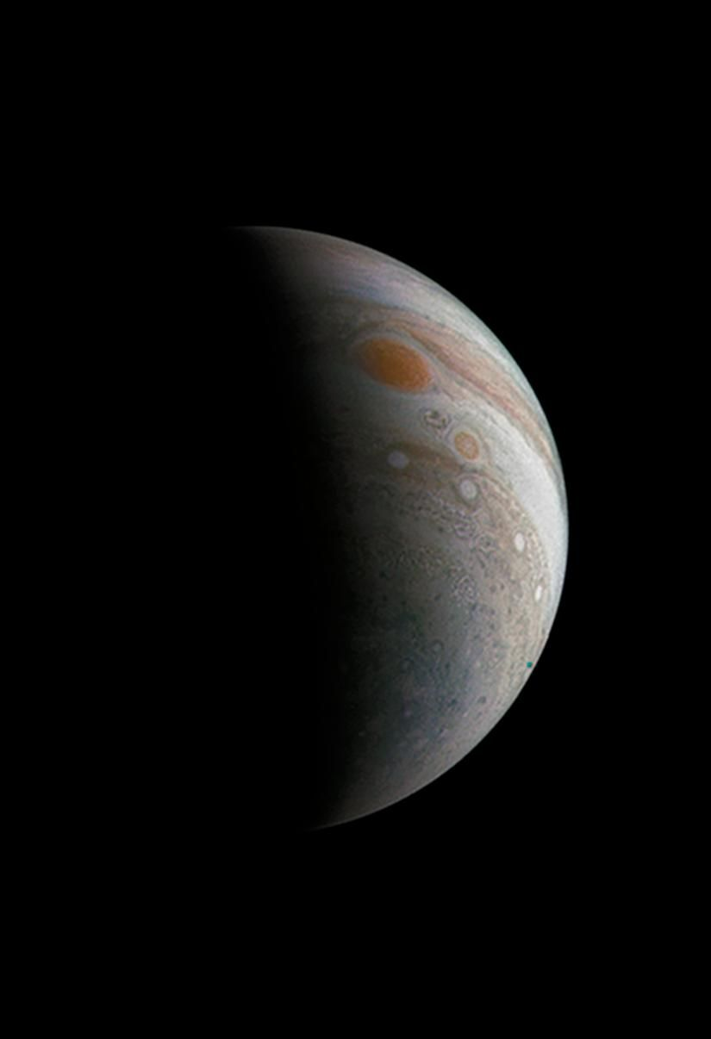
Figure 28. Jupiter and its Great Red Spot, photographed by the Juno spacecraft. The bands are winds blowing in opposite directions at hundreds of kilometers per hour. Image: NASA/JPL-Caltech/SwRI/MSSS.
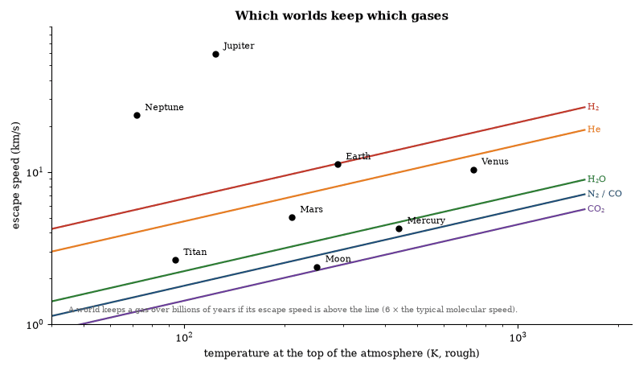
Figure 29. A planet holds a gas for billions of years if its escape speed exceeds about six times the gas molecules’ typical speed. Lines show that threshold for common gases; dots are approximate values for worlds. Earth keeps nitrogen and oxygen but has lost hydrogen; Jupiter keeps everything; the Moon keeps nothing.
Composition is set by formation and by subsequent processing. Primary atmospheres are captured from the nebula, secondary atmospheres are released by outgassing and by impacts, and photochemistry, condensation and escape then modify the mixture. Earth’s oxygen is almost entirely biological. Venus and Mars have carbon-dioxide atmospheres produced by outgassing and by the failure to sequester carbon in surface reservoirs.
Circulation is driven by differential heating. Hadley cells, jets and vortices redistribute heat. The Coriolis force organizes the flow into bands on rapidly rotating planets. Greenhouse gases raise the surface temperature above the effective radiating temperature. The same radiative and dynamical principles operate on every planet that possesses an atmosphere. The outcomes differ because mass, rotation rate, distance from the star and composition differ.

Planetary Interiors
Planetary interiors are layered by density. Differentiation occurs early, while the body is molten or partially molten. Metals sink to form a core, silicates form a mantle, and lighter materials form a crust. The process releases gravitational energy and establishes the radial structure observed today.
Heat sources are accretion, differentiation, radioactivity and, in some cases, tidal dissipation. Heat is transported by conduction, convection and, near the surface, by volcanism and hydrothermal circulation. Convection in a liquid iron core, organized by rotation, generates a magnetic dynamo. Earth, Mercury, Ganymede and the giant planets possess dynamos. Mars and Venus do not at present.
The equation of state of the constituent materials under high pressure determines the radius for a given mass. Laboratory and theoretical equations of state, combined with gravity and magnetic data, constrain the size of cores and the presence of light elements. The same methods applied to exoplanets yield bulk compositions once mass and radius are measured. Interior structure is the outcome of formation, differentiation and thermal evolution.

Moons and Ring Systems
Most planets possess moons. Regular moons orbit in the equatorial plane and in the same sense as the planet’s rotation. They condensed from circumplanetary disks or were captured and subsequently circularized. Irregular moons have inclined, eccentric or retrograde orbits and are captured objects.
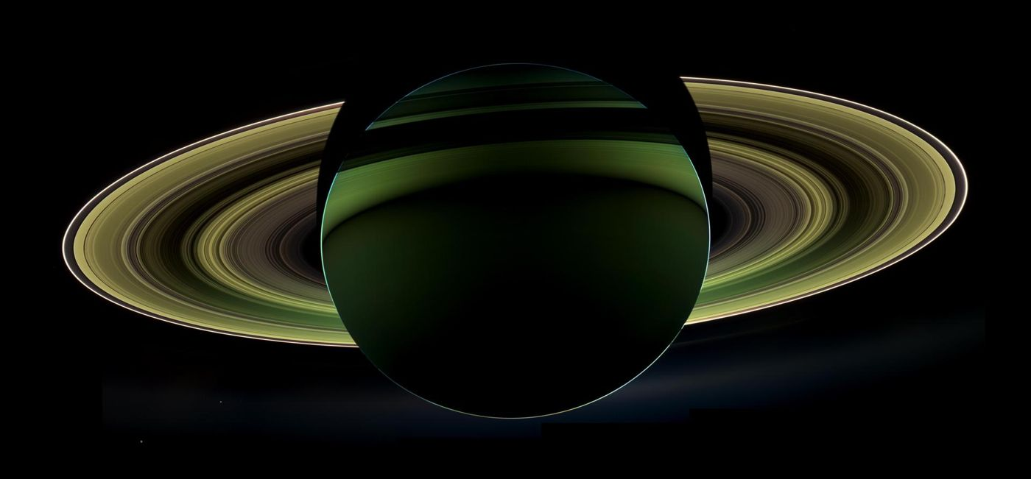
Figure 30. Saturn from behind, backlit by the Sun, photographed by the Cassini spacecraft. The rings are bright against the planet’s shadow. Image: NASA/JPL-Caltech/Space Science Institute.
Tidal interaction transfers angular momentum. It drives moons outward or inward according to whether they orbit beyond or inside the synchronous radius. Io is heated by tidal flexing and is the most volcanically active body in the Solar System. Europa, Ganymede and Enceladus maintain subsurface oceans by the same mechanism. The Earth’s Moon is receding and lengthening the day.
Ring systems are composed of ice and rock particles orbiting inside the Roche limit. Planetary rings are continually resupplied by the fragmentation of small moons and are sculpted by resonances and by shepherd satellites. Saturn’s rings are the most massive and may be young on geological timescales, though this is debated. The same dynamical processes—tides, resonances and collisions—govern both moons and rings throughout the Solar System and are expected around exoplanets.

Europa
Europa is a moon of Jupiter. Its surface is water ice. Beneath the ice lies a global ocean of liquid water, maintained by tidal heating. The ocean is in contact with a rocky seafloor. Hydrothermal activity at that interface is expected. The ice shell is estimated to be kilometers to tens of kilometers thick. Chaos terrains and possible plumes suggest that material from the ocean reaches the surface.
The combination of liquid water, rock and chemical energy makes Europa one of the most plausible sites for extant life beyond Earth. Any life would be independent of sunlight and would rely on chemical gradients. No direct sample of the ocean has been obtained. Surface radiation from Jupiter’s magnetosphere processes the ice and may destroy organic molecules near the surface. Future missions that fly through plumes or land and drill will test the habitability of the ocean more directly. Until then Europa remains a high-priority target whose subsurface environment satisfies the principal requirements for life as known on Earth.

Enceladus
Enceladus is a small moon of Saturn. It is geologically active. Plumes of water vapor and ice grains erupt from fractures at the south pole. The plumes are fed by a subsurface ocean. Cassini flew through the plumes and detected water, salts, silica nanoparticles, molecular hydrogen and organic molecules. The hydrogen and silica indicate ongoing hydrothermal reactions between the ocean and a rocky core. The ocean is alkaline, and in laboratory tests some Earth methanogens grow under similar conditions.
The energy source is tidal heating. The ocean is global or nearly global and is in contact with rock. The same chemical disequilibria that support ecosystems at Earth’s hydrothermal vents are therefore present. The plumes provide a natural sample-return mechanism. No unambiguous biosignature has been identified. The detected organics are consistent with both abiotic and biological origins. Enceladus is accessible. Its ocean can be sampled without landing or drilling. It remains one of the most favorable places in the Solar System to search for extant life.

Titan
Titan is the largest moon of Saturn. It possesses a thick nitrogen atmosphere and surface lakes and seas of liquid methane and ethane. The surface temperature is 94 K. Water ice forms the bedrock. A subsurface water ocean may exist beneath the ice crust, decoupled from the hydrocarbon surface.
The atmosphere is rich in organic compounds made by sunlight-driven chemistry, and its methane is continuously destroyed and must be replenished. The surface liquids are solvents in which a non-water biochemistry could in principle operate, though none is known, reaction rates at 94 K are extremely slow, and any life in the hydrocarbon lakes would need a chemistry very different from ours. The subsurface ocean, if it exchanges material with the rocky interior, would be a more conventional watery habitat. Titan thus offers two distinct environments; neither has yielded evidence of life, and both remain targets for exploration.

Ganymede and Other Icy Moons
Ganymede, larger than the planet Mercury, is the largest moon in the Solar System. It possesses an intrinsic magnetic field and a subsurface ocean sandwiched between ice layers. The ocean is probably not in direct contact with the rocky mantle. Tidal heating is weaker than on Europa. Callisto may also harbor a subsurface ocean, but both moons are less energetically active than Europa. Io, the innermost of Jupiter’s large moons, is the opposite case: its tidal heat drives the most intense volcanism known.
Triton, a captured moon of Neptune, shows geysers of nitrogen and a young surface. It may retain internal heat. Smaller icy moons throughout the outer Solar System display varying degrees of geological activity. In each case the availability of liquid water, chemical energy and contact with rock determines the habitability potential. Moons that combine all three are rare, with Europa and Enceladus the clearest examples; the others remain possible but less favorable. Comparative study of these worlds constrains the range of conditions under which subsurface oceans can persist and under which life, if it arises, could be sustained.
Questions to Keep Asking
How do we know the Solar System’s age? Uranium and lead in the oldest meteorites give 4.567 billion years, and the Moon rocks and Earth’s oldest minerals agree within the expected delays.
A meteorite found to be much older than the rest would contradict a single, shared formation. What would that suggest?
Try it yourself. Find Jupiter with the naked eye, then with binoculars look for up to four small points of light beside it. Watch them over two nights and sketch how they move.

26. Small Bodies and Visitors
Tens of thousands of metric tons of cosmic dust fall on Earth every year, and now and then something much larger arrives. Small bodies hold the oldest surviving material in the Solar System, and one day one of them will have to be moved.

Asteroids
Asteroids are rocky and metallic bodies that orbit the Sun, predominantly in the main belt between Mars and Jupiter. Sizes range from meters to hundreds of kilometers, and the largest, Ceres, is a dwarf planet. Most are irregular fragments that collisions continually grind down, producing dust.
Composition varies: C-type asteroids are carbon-rich and primitive, S-types stony and M-types metallic. The differences record the temperature gradient across the original disk and later mixing of the orbits. Some asteroids are rubble piles held together by gravity, others solid bodies. Spacecraft have visited several and returned samples from Itokawa, Ryugu and Bennu, confirming that many meteorites are asteroid fragments.
Asteroids are the parent bodies of most meteorites. They also supply a fraction of Earth’s water and organic material. Near-Earth asteroids are those whose orbits approach Earth’s; their impact hazard is quantified by size-frequency distributions, and deflection concepts exist. The same population records the collisional and dynamical history of the inner Solar System.

Comets
Comets are icy bodies that originate in the Kuiper belt and the Oort cloud. When perturbed onto orbits that bring them close to the Sun they develop comae and tails. The coma is a temporary atmosphere of sublimated ices and entrained dust. The tails are pushed by radiation pressure and by the solar wind.
Short-period comets come from the Kuiper belt and are confined near the ecliptic. Long-period comets come from the Oort cloud and arrive from all directions. Both reservoirs are surviving planetesimals from the outer disk. Spacecraft encounters have shown that comet nuclei are porous, low-density aggregates of ice and dust. Jets of gas and dust are localized. The surfaces are darker than expected.
Comets delivered volatiles and organic compounds to the inner planets. Their deuterium-to-hydrogen ratios vary, with some matching Earth’s oceans and others not, so the contribution of cometary water remains quantitatively uncertain. Comets are also time capsules of the outer Solar System’s composition at the epoch of planet formation.

Meteoroids, Meteors and Meteorites
A meteoroid is a solid object smaller than an asteroid moving in interplanetary space. When it enters an atmosphere it produces a meteor—the luminous trail of ablated material. If a fragment reaches the ground it is a meteorite.
Meteorites are classified by composition and texture. Chondrites are primitive and contain chondrules, while achondrites, irons and stony-irons are differentiated, and the classes correspond to different parent-body histories. Isotopic measurements date the formation of the parent bodies to within a few million years of the Solar System’s origin. Some meteorites contain pre-solar grains older than the Sun. Others contain amino acids and other organic molecules formed in space.
The flux of meteoroids is continuous. Micrometeorites dominate the mass influx to Earth. Larger impacts are rarer and are recorded in the cratering history of the Moon and planets. The same objects link laboratory samples to the asteroids and comets observed remotely. They are the principal source of hands-on material from beyond Earth.

Interstellar Objects
Interstellar objects are bodies that are not gravitationally bound to the Sun. Three have been identified: 1I/‘Oumuamua in 2017, 2I/Borisov in 2019 and 3I/ATLAS in 2025. ‘Oumuamua showed no coma and an unusual light curve; Borisov and 3I/ATLAS are active comets. All three entered the Solar System on hyperbolic trajectories and are now leaving.
Their existence demonstrates that planetesimals are ejected from other planetary systems. The ejection mechanisms are the same scattering processes that operate in the Solar System. The number density of such objects in interstellar space is estimated from the detection rate and from the survey volume. The estimate is consistent with the expected yield of planet formation and dynamical clearing.
Composition and physical properties can be measured during the brief interval when an object is near the Sun. Spectroscopy of Borisov revealed familiar cometary molecules, whereas ‘Oumuamua’s nature remains less clear, and future surveys will detect more. Each detection supplies a sample of another system’s planetesimal population. Interstellar objects are therefore messengers from elsewhere in the Galaxy.

Planetary Defense
An asteroid impact is the one natural disaster that people can in principle prevent. A rock about 20 meters across exploded over Chelyabinsk in Russia in 2013, releasing the energy of several hundred kilotons of explosives and injuring about 1,500 people, mostly by glass from broken windows. In 1908 a larger body devastated about 2,000 square kilometers of Siberian forest at Tunguska. Impacts large enough to threaten a civilization are far rarer, and the great majority of the biggest near-Earth asteroids have already been found.
Surveys by ground telescopes and space missions track near-Earth objects, so that an impact can be predicted decades ahead. The asteroid Apophis, once thought to have a small chance of hitting Earth, will pass within about 32,000 kilometers on 13 April 2029, closer than some satellites, and is now known not to be an impact threat.
In September 2022 the DART spacecraft crashed into Dimorphos, a small moon of the asteroid Didymos, and shortened its orbit by about 32 minutes. It showed that a spacecraft can alter an asteroid’s path. The method works only with enough warning, which is why finding the objects early matters. Sample-return missions, such as Japan’s Hayabusa2 from Ryugu and NASA’s OSIRIS-REx from Bennu, also let us study the composition of the bodies we might have to move.

The Kuiper Belt and the Oort Cloud
Beyond Neptune lies the Kuiper Belt, a ring of icy bodies left from the formation of the planets. Pluto, discovered in 1930, is its best-known member. The New Horizons spacecraft flew past Pluto in 2015 and found mountains of water ice, nitrogen glaciers and a thin atmosphere, a far more active world than expected. In 2019 it passed Arrokoth, a small object made of two lobes joined gently, which looks like a relic of the slow gathering of the earliest planetesimals.
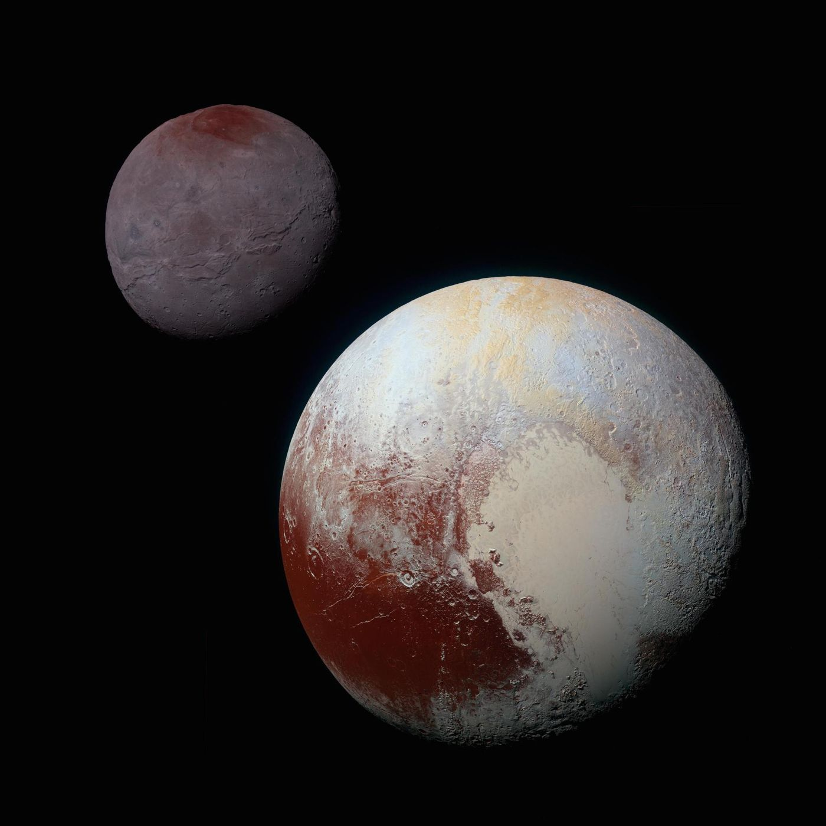
Figure 31. Pluto and its largest moon Charon, in colors enhanced to show surface differences, as seen by New Horizons in 2015. Image: NASA/Johns Hopkins University Applied Physics Laboratory/Southwest Research Institute.
Much farther out, between a few thousand and perhaps a hundred thousand times the Earth–Sun distance, is the Oort cloud, a roughly spherical halo of comets. It has never been observed directly. Its existence is inferred from the orbits of long-period comets, which arrive from every direction. Passing stars or the tidal pull of the Galaxy occasionally nudge one inward.
These distant regions hold material that has hardly changed since the Solar System formed. They are the most distant part of the Sun’s domain, and the most poorly mapped.
Questions to Keep Asking
How do we know that meteorites come from asteroids? Fireball tracks have been traced to the asteroid belt, spectra match, and returned samples from Ryugu and Bennu are like the meteorites.
If an asteroid’s orbit were found to give it a 1-in-100 chance of impact, what would you want to know before acting?
Try it yourself. Watch the sky on a dark night for an hour and count meteors. Repeat during a meteor shower. What changes, and why?

27. Planets Around Other Stars
Thirty years ago nobody knew whether other stars had planets. Now more than six thousand are known, and the most common kind, between Earth and Neptune in size, does not exist in our own Solar System.

Exoplanets
Exoplanets are planets that orbit stars other than the Sun. More than six thousand have been confirmed. Detection methods include the radial-velocity reflex of the star, the photometric transit of the planet across the stellar disk, gravitational microlensing, and direct imaging. Each method is biased toward different masses and orbital distances.
Atmospheric characterization is possible for transiting planets. The diversity of architectures found shows that planet formation is robust and that the Solar System is not an inevitable template.

Exoplanet Detection, Demographics and Atmospheres
The radial-velocity method measures the star’s reflex motion. Precision of 1 m s⁻¹ detects Jupiter-mass planets at a few astronomical units and super-Earths on close orbits. The transit method measures the periodic dimming when a planet crosses the stellar disk. The depth gives the planet-to-star radius ratio. Combined with a mass from radial velocity or from transit-timing variations, the bulk density follows.
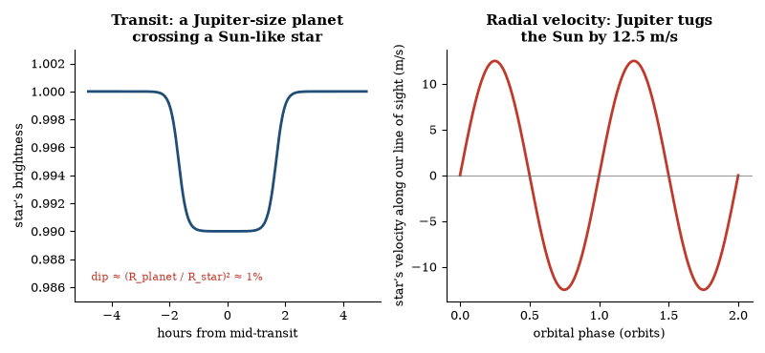
Figure 32. The two classic detection methods. Left: a transit dims the star by the square of the radius ratio. Right: the star’s reflex velocity measures the planet’s pull (12.5 m/s is Jupiter’s effect on the Sun). Both curves are illustrative.
Occurrence studies show that planets are abundant. The average number of planets per star is of order unity. Super-Earths and mini-Neptunes are the most common size class. A radius gap near 1.5–2 Earth radii separates predominantly rocky planets from those that retained substantial envelopes. Hot Jupiters exist but are rare. Rocky planets inside the habitable zones of their stars occur at rates of tens of percent around Sun-like and smaller stars.
Transmission spectroscopy during transit reveals atmospheric composition. Starlight filtered through the planetary limb carries absorption features of atoms and molecules. Water, sodium, potassium, carbon monoxide and methane are among the species seen. Clouds and hazes mute features on many worlds. Emission spectroscopy and phase curves measure dayside temperatures and heat redistribution. Strongly irradiated hot Jupiters can develop temperature inversions. The data demonstrate that exoplanet atmospheres span a wide range of metallicities, carbon-to-oxygen ratios, temperature structures and aerosol properties, and that they are not scaled versions of Solar-System atmospheres. Biosignature searches are limited by stellar activity, cloud cover and the present precision of the observations.

Exomoons
Exomoons are moons orbiting planets that themselves orbit stars other than the Sun. None has been confirmed. Detection is more difficult than planet detection because the moon’s signal is weaker and is superimposed on the planetary signal.
Transit-timing variations and transit-duration variations can reveal a moon. The planet’s transit times and durations oscillate as the planet and moon orbit their common center of mass. The amplitude scales with the moon-to-planet mass ratio and with the moon’s orbital distance. Photometric dips caused by the moon itself are possible but require high precision and favorable geometry. Direct imaging of a moon is beyond present capability except for the most massive, widely separated cases.
Habitability considerations differ from those for planets. A moon can be tidally heated even when it lies far outside the stellar habitable zone. The same mechanism that maintains oceans on Europa and Enceladus could operate around giant exoplanets. An atmosphere and a magnetic field, if present, would further improve prospects. Formation pathways include accretion in a circumplanetary disk, capture, and giant impacts. All are expected to occur. The absence of confirmed detections is a consequence of observational limits, not of physical rarity. Future transit missions and extremely large telescopes will enlarge the searchable parameter space.

How the First Exoplanets Were Found
The first planet orbiting an ordinary star was announced in 1995 by Michel Mayor and Didier Queloz, who earned a share of the 2019 Nobel Prize. The star was 51 Pegasi, and the planet was a surprise, a world with about half the mass of Jupiter orbiting in just over four days, closer to its star than Mercury is to the Sun. Such hot Jupiters had no place in theories based on our Solar System, and showed that planets can migrate after they form.
The Kepler space telescope, launched in 2009, stared at one patch of sky for years and measured the tiny dimming as planets crossed their stars. It found thousands of candidates and showed that planets are the rule. The most common sizes, between Earth and Neptune, have no counterpart in the Solar System. TESS, launched in 2018, surveys the whole sky for nearby stars.
Among the discoveries are Proxima b, a planet of roughly Earth’s mass in the habitable zone of the nearest star, and TRAPPIST-1, a small, cool star about 40 light-years away with seven planets of roughly Earth’s size. The James Webb Space Telescope now measures their atmospheres, so far with results that show the difficulty of keeping an atmosphere around planets of such stars.

Strange New Worlds
The census of exoplanets has turned up types that nobody predicted. Hot Jupiters orbit so close that their upper atmospheres are heated to thousands of degrees. Lava worlds, rocky planets with a day side hot enough to melt rock, orbit even closer. Planets with extremely low density, called super-puffs, are larger than Neptune but far lighter. Some planets orbit two stars, like the fictional Tatooine, and the very first exoplanets, found in 1992, orbit a pulsar.
Free-floating planets also exist, ejected from their systems and wandering the Galaxy without a star. They are found when their gravity briefly brightens the light of a background star, a technique that suggests they may be common. Some may have been thrown out when planets scattered each other in young systems.
These discoveries show how limited our Solar System is as a template. Planet formation produces an enormous variety, and the arrangement of the Solar System, with small rocky planets in the inside and giants outside, is only one outcome among many. Whether it is a typical one is a question that the surveys have only begun to answer.

Planetary Habitability
Planetary habitability is the capacity of a world to support liquid water on or beneath its surface for geological periods. The first filter is the habitable zone, the range of distances from a star at which a rocky planet can keep liquid water on its surface, examined in Chapter 46.
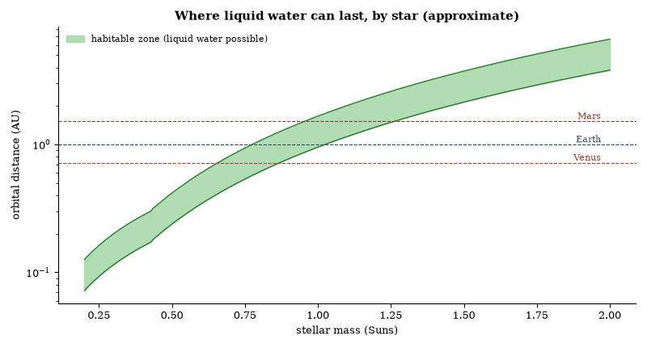
Figure 33. The habitable zone moves outward and widens for heavier, brighter stars and shrinks toward the star for small, dim ones. Computed from main-sequence luminosities with Kasting-style flux limits of 1.1 and 0.36 times the flux Earth receives. Venus and Mars lie near the Sun’s zone edges.
Additional factors matter. Plate tectonics recycles carbon and stabilizes climate on billion-year timescales. A magnetic field may limit atmospheric escape and a large moon stabilizes obliquity, though none of these is strictly necessary.
The only known inhabited planet is Earth. The conditions that permitted the origin and persistence of life here are partly understood. Which of those conditions are essential, and which are contingent, is not. Whether any rocky planet in a habitable zone is inhabited remains an open observational question. Habitability is a physical prerequisite, not a guarantee.
Questions to Keep Asking
How do we know that a dip in starlight is a planet? The dip repeats on a fixed period, the star’s velocity often confirms it, and statistics rule out most look-alikes.
What observation of an Earth-size planet’s atmosphere would suggest life, and what would show that a gas had a lifeless source?
Try it yourself. A Jupiter-size planet blocks about 1 percent of a Sun-like star’s light. By what fraction does an Earth-size planet dim it? (Answer: about 0.008 percent, or 84 parts per million.)

28. Stars and Stellar Remnants
A star is a ball of gas in a standoff: gravity squeezes inward, heat from fusion pushes outward, and the stalemate lasts for millions to trillions of years until the fuel runs out. Almost everything heavier than helium in your body was made in such a standoff.

Stars and Nuclear Burning
A star is a self-gravitating ball of plasma in which nuclear fusion supplies the energy that balances radiative loss. On the main sequence the fusion reaction is the conversion of hydrogen to helium. The proton–proton chain dominates in stars of solar mass and below. The CNO cycle dominates in more massive stars. Both release about 0.7 percent of the rest mass as energy.
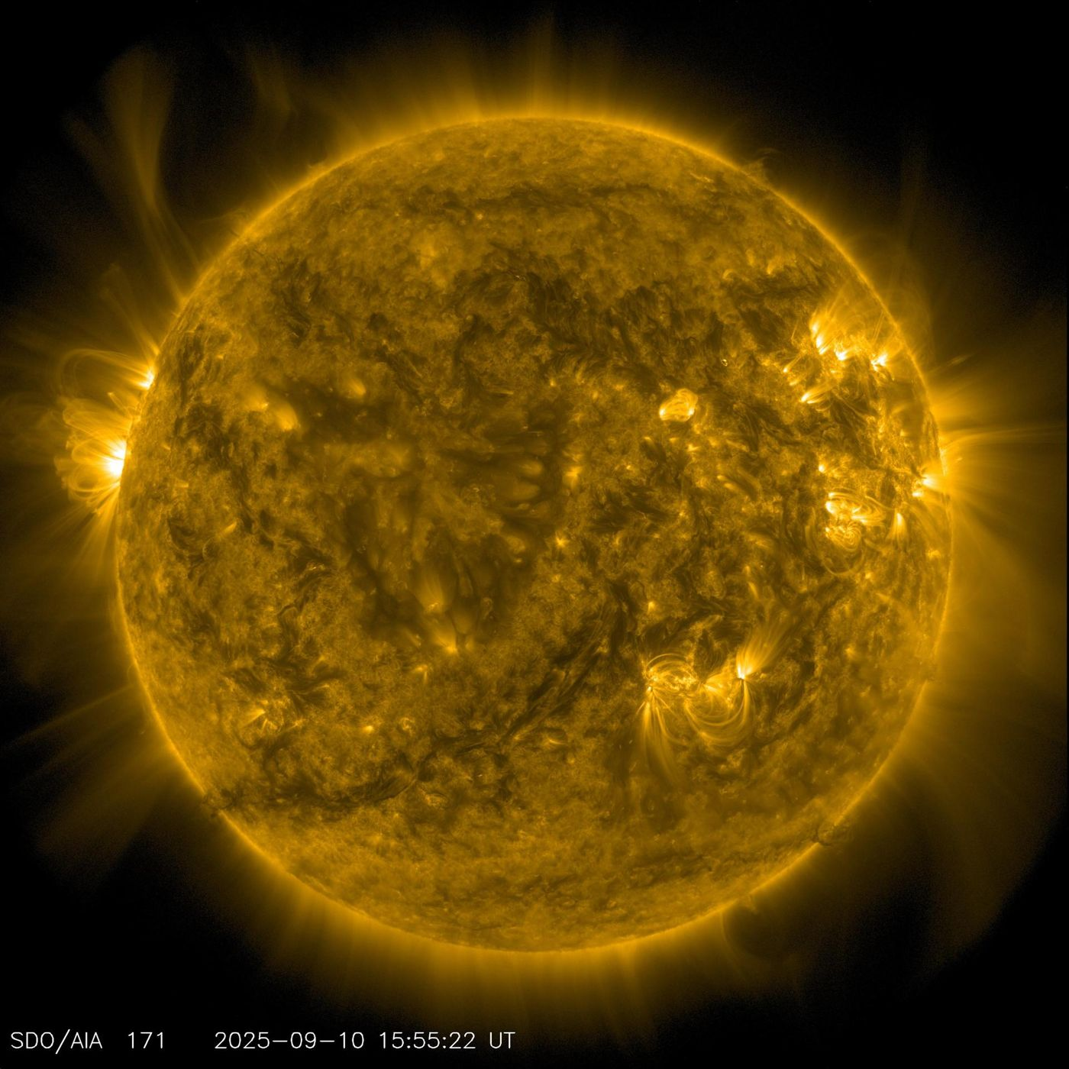
Figure 34. Our nearest star, imaged in extreme ultraviolet light by the Solar Dynamics Observatory. The bright loops and dark patches trace magnetic fields in the hot gas above the surface. Image: NASA/GSFC/Solar Dynamics Observatory.
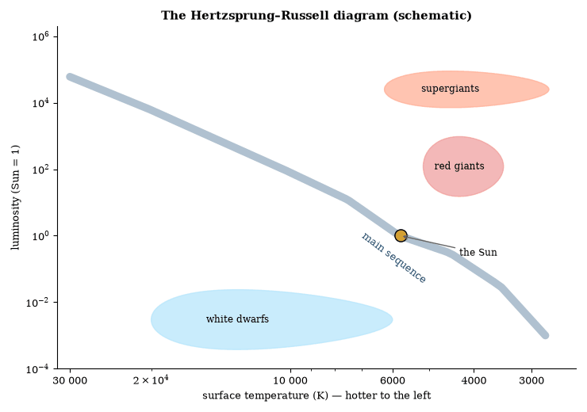
Figure 35. The Hertzsprung–Russell diagram plots a star’s brightness against its surface temperature. Most stars lie on the main sequence, where mass sets both; stars that have exhausted core hydrogen move up to the giants, or end as white dwarfs below the sequence. Regions are schematic.
The structure of a star is fixed by four equations: hydrostatic equilibrium, mass continuity, energy transport, and energy generation. The solutions form a one-parameter family labeled by mass: low-mass stars are cool and long-lived, and high-mass stars are hot, luminous, and short-lived. The Sun will remain on the main sequence for about ten billion years.
When hydrogen is exhausted in the core the star contracts, heats, and ignites helium, swelling into a red giant. Stars below about eight solar masses stop at carbon and oxygen, shed their envelopes, and leave white dwarfs. In more massive stars later stages build neon, oxygen, silicon and finally iron. Beyond iron fusion absorbs energy, the core collapses, and the result is a supernova that leaves a neutron star or a black hole. The ejected material enriches the interstellar medium with the heavy elements from which later planets and life are made.
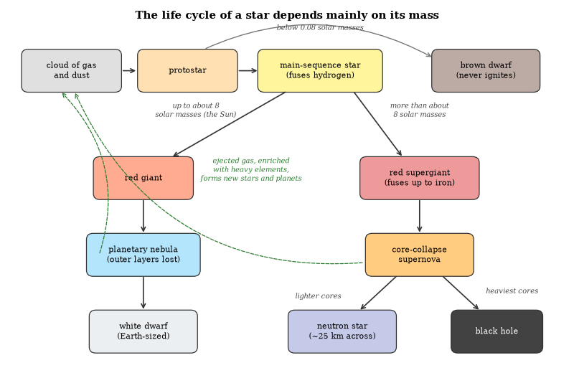
Figure 36. The life cycle of a star is set mainly by its mass.
The observed Hertzsprung–Russell diagram matches the predicted tracks and lifetimes. Mass is the primary determinant of a star’s fate; composition and rotation add secondary effects. Stellar evolution is therefore one of the best-tested applications of nuclear physics and of hydrostatics.

The Initial Mass Function
The initial mass function is the distribution of stellar masses at birth. It rises from the brown-dwarf regime, peaks near 0.2–0.3 solar masses, and declines as a power law above one solar mass. The slope of the power law is approximately -2.3. The function is observed to be similar in different environments. Claimed variations, for example in massive elliptical galaxies, remain debated.
The origin is the turbulent fragmentation of molecular clouds combined with the physics of accretion and feedback. Simulations reproduce the broad shape. They do not yet predict the peak and the slope from first principles. The function determines the luminosity, the chemical yield and the remnant population of a stellar generation. It is an empirical input to models of galaxies and of chemical evolution.

Brown Dwarfs
Brown dwarfs are objects below the hydrogen-burning limit of approximately 0.08 solar masses. They are supported by electron degeneracy. They cool continuously. Their spectra show methane, water and, in the coolest objects, ammonia. Masses range from the deuterium-burning limit of 13 Jupiter masses up to the hydrogen-burning limit.
They are abundant. Near the Sun there is roughly one brown dwarf for every four or five stars. They form by the same turbulent fragmentation that produces stars. Some may form by disk fragmentation or by ejection from multiple systems. Their atmospheres are laboratories for cloud physics and for non-equilibrium chemistry. They bridge the gap between stars and planets. The distinction is one of formation and of mass, not of a sharp physical boundary.

Worked Examples: Stellar Structure and Lifetimes
Example 1. The Sun’s luminosity is 3.8 × 10²⁶ W. How much mass is converted to energy each second?
Δ m = L/c² = 4.2 × 10⁹ kg s⁻¹.
Example 2. A star has twice the Sun’s mass. Roughly how does its main-sequence lifetime compare?
Luminosity scales approximately as M^{3.5}. Lifetime scales as M/L ≈ M^{−2.5}. The star lives about 0.18 times as long as the Sun.
Example 3. Why does the core of a massive star eventually collapse?
When the core is iron, fusion no longer releases energy. Electron degeneracy pressure supports the core only up to the Chandrasekhar mass. Beyond that limit the core collapses on a dynamical time-scale of seconds.
The estimates reproduce the observed mass–luminosity relation and the fate of massive stars.
Example. Estimate how long the Sun can shine on core hydrogen, given that fusion releases 0.7 percent of the rest mass and that only the innermost tenth of the Sun’s mass ever reaches fusion temperature.
Energy available: 0.007 × 0.1 × 2 × 10³⁰ kg × (3 × 10⁸ m s⁻¹)² ≈ 1.3 × 10⁴⁴ J. At 3.8 × 10²⁶ W this lasts 3.4 × 10¹⁷ s, about eleven billion years, in good agreement with the accepted main-sequence lifetime.
Example. A star of 10 solar masses has a luminosity roughly 10^{3.5} times solar. Estimate its main-sequence lifetime relative to the Sun.
Lifetime scales as M/L ≈ 10/10^{3.5} ≈ 0.003 solar lifetimes, or a few tens of millions of years.
The estimates recover the observed mass–luminosity–lifetime relation.

Stellar Nucleosynthesis
Hydrogen burns by the proton–proton chains in stars like the Sun and by the CNO cycle in hotter, heavier stars. The later stages, from helium burning to the iron peak and the neutron-capture processes beyond it, are traced element by element in Chapter 13. The yields depend on a star’s mass, metallicity and rotation. Stellar-evolution codes calculate them, and the results match the observed abundances of the major species, with discrepancies left for some rare isotopes. Stars made the elements from carbon to uranium; the Big Bang supplied the hydrogen, the helium and a trace of lithium.
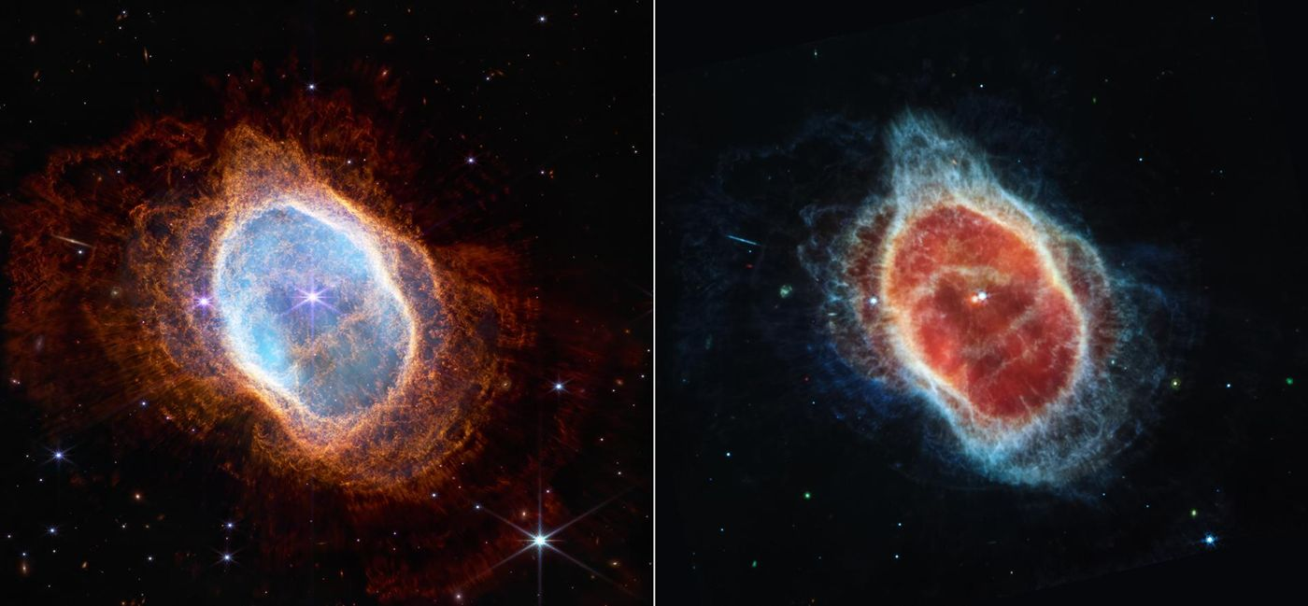
Figure 37. The Southern Ring Nebula, the shed outer layers of a dying Sun-like star, seen by the James Webb Space Telescope in near-infrared light (left) and mid-infrared light (right). Image: NASA, ESA, CSA and STScI.

Supernovae
Core-collapse supernovae end the lives of stars more massive than about eight solar masses. The iron core collapses to nuclear density, a shock is launched, and neutrino heating revives the shock. The explosion ejects the envelope and leaves a neutron star or a black hole. Type Ia supernovae are thermonuclear explosions of white dwarfs that reach the Chandrasekhar mass. They are standardisable candles.
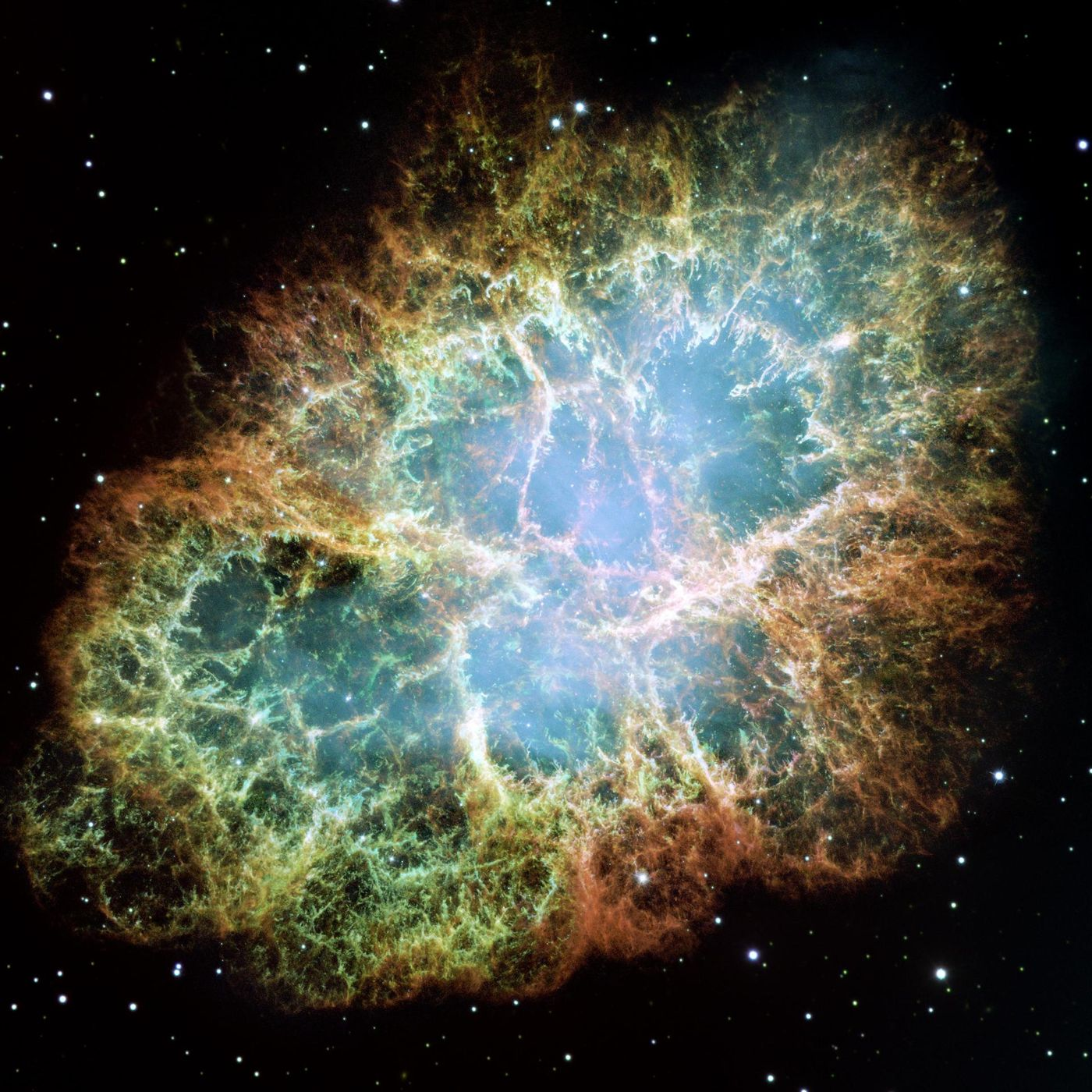
Figure 38. The Crab Nebula, the remains of a star that exploded in the year 1054. Its heart holds a pulsar that spins thirty times a second. Image: NASA, ESA, J. Hester and A. Loll (Arizona State University).
Both classes enrich the interstellar medium: core-collapse events produce oxygen, neon and magnesium, and Type Ia events produce iron. The light curves and spectra are modeled in three-dimensional simulations. The simulations reproduce the gross features. The details of the explosion mechanism and of the progenitor channels remain under study. The events are both the endpoints of stellar evolution and the principal sources of heavy elements.

The Pair-Instability Supernova
Stars with helium cores between approximately 64 and 133 solar masses encounter the pair-instability. Electron–positron pair production softens the equation of state. The core contracts, ignites oxygen explosively, and is completely disrupted. No remnant remains. The explosion produces a characteristic yield rich in silicon and deficient in elements heavier than zinc.
The predicted mass gap in the black-hole mass function has been searched for in gravitational-wave catalogs. Events inside the gap have been reported. Their interpretation is debated. They may indicate that the instability is less absolute than calculated, or that the progenitors retained less mass than expected. The gap, if real, is a direct signature of the pair instability. Its absence or partial filling constrains mass loss and binary evolution.

The Star That Should Have Been Invisible
In 1967 a graduate student noticed a repeating radio signal. The signal was precise, repeating every 1.3 seconds, and the first explanation considered was an artificial beacon. The explanation was discarded when a second source was found. The sources were pulsars—rotating neutron stars.
A neutron star is what remains when a massive star’s core gives way. Its density is that of an atomic nucleus. Its magnetic field is a trillion times stronger than Earth’s. The rotation sweeps a beam of radiation across the sky. When the beam crosses the Earth, a pulse is recorded. The pulse is the lighthouse effect of an object the size of a city spinning at hundreds of revolutions per second.
The discovery was accidental; the explanation was not. Neutron stars had been predicted decades earlier and regarded as exotic, and the pulses made them ordinary, though the ordinary object is still one of the most extreme in the universe, with a surface gravity a hundred billion times Earth’s. Its existence is routine now. It was not in 1967.

Neutron Stars and Pulsars
A neutron star is the collapsed core of a massive star. Its mass is typically 1.4 solar masses compressed into a radius of about 12 km. The mean density exceeds nuclear density. The object is supported against gravity by neutron degeneracy pressure and by nuclear repulsive forces.
Many neutron stars are observed as pulsars. A pulsar is a rapidly rotating, highly magnetized neutron star whose radio or X-ray beams sweep across the observer. Periods range from milliseconds to seconds. The fastest pulsars are spun up by accretion in binary systems. Timing precision can reach nanoseconds and is used to test general relativity and to search for gravitational waves.
How matter behaves at several times nuclear density is still not known. Mass and radius measurements of pulsars constrain it. The heaviest precisely measured neutron stars exceed two solar masses, ruling out the softest equations of state. Mergers of neutron-star binaries produce short gamma-ray bursts, kilonovae and gravitational waves, and are a principal site of rapid neutron-capture nucleosynthesis. Neutron stars are therefore both laboratories for dense matter and agents of chemical enrichment.

Neutron-Star Mergers
Neutron-star mergers produce gravitational waves, short gamma-ray bursts and kilonovae. The gravitational-wave signal encodes the masses and the tidal deformability. The electromagnetic counterparts confirm the production of heavy elements by the rapid neutron-capture process. The 2017 event GW170817 supplied the first multi-messenger observation. The inferred ejecta mass and composition match the requirements for the r-process.
The merger rate is consistent with the rate needed to account for the observed abundances of the heaviest elements. The equation of state of dense matter is constrained by the tidal deformability and by the maximum mass. Both constraints favor a relatively stiff equation of state. Future events will tighten the constraints. The mergers are a laboratory for dense matter, for nucleosynthesis and for strong-field gravity.

Magnetars
Magnetars are neutron stars with surface magnetic fields of 10¹⁴ to 10¹⁵ G. The fields are inferred from the spin-down rate and from the energetics of X-ray bursts. The energy reservoir is the magnetic field. Decay and reconnection power the persistent emission and the bursts. Giant flares release up to 10⁴⁶ erg.
A Galactic magnetar produced a fast radio burst in 2020. The association demonstrates that at least some fast radio bursts originate from magnetars. Whether all do is unknown. The birth rate of magnetars is sufficient to account for the volumetric rate of bursts if each magnetar produces many bursts. The objects are the strongest magnets in the universe. Their activity links neutron-star physics to the transient radio sky.

Pulsar Timing Arrays
Pulsar timing arrays monitor the arrival times of pulses from millisecond pulsars. A gravitational-wave background produces a correlated timing residual. The correlation has a characteristic angular dependence. A signal consistent with that dependence was reported by several arrays in 2023, at about three to four standard deviations. The amplitude is higher than the simplest predictions from supermassive black-hole binaries. The discrepancy may indicate additional sources or a different binary evolution.
The arrays work at nanohertz frequencies, far below the bands of ground- and space-based interferometers; Chapter 21 places them in the full gravitational-wave spectrum. If the signal is confirmed as a background, it measures the population of supermassive black-hole binaries and limits any cosmological sources in the same band.

Gamma-Ray Bursts
Gamma-ray bursts are the most luminous electromagnetic events in the universe. Long bursts are associated with the core collapse of massive stars. Short bursts are associated with neutron-star mergers, and both kinds launch relativistic jets. The prompt emission lasts from milliseconds to minutes and the afterglow for days to months.
The isotropic-equivalent energy can exceed 10⁵⁴ erg. Beaming reduces the true energy by two orders of magnitude. The bursts are observed to redshift 9 and beyond. They probe the early universe and the properties of relativistic shocks. The association of short bursts with gravitational waves has been confirmed. The association of long bursts with supernovae is established. Both classes are now multi-messenger sources.

Tidal Disruption Events
A tidal disruption event occurs when a star passes within the tidal radius of a supermassive black hole. The star is torn apart; roughly half the debris is ejected and half remains bound and accretes. The accretion produces a luminous flare that declines as a power law. The peak luminosity can exceed that of a supernova.
Dozens of events have been observed in optical, ultraviolet and X-ray surveys. Some launch relativistic jets. The events probe the stellar population in galactic nuclei and the spin of the black hole. The fallback rate and the circularization efficiency remain uncertain. The observations confirm that stars are disrupted. They do not yet yield precision measurements of black-hole spin.
Questions to Keep Asking
How do we know what is inside a star? The Sun’s vibrations map its interior, neutrinos come straight from its core, and the spectra of other stars show the products of burning.
A star of known mass found to be far older than its mass allows would be a puzzle. What would you check first?
Try it yourself. Estimate the Sun’s main-sequence lifetime: it can burn about a tenth of its mass at 0.7 percent efficiency, at a power of 3.8 × 10²⁶ watts. (Answer: about ten billion years.)

29. Fast Radio Bursts and High-Energy Messengers
In 2007 astronomers combing archived data found a flash of radio waves lasting a thousandth of a second that had crossed billions of light-years. Since then bursts have been traced to magnetized neutron stars, and a cosmic ray carrying about as much energy as a pitched baseball has been caught.

Fast Radio Bursts
Fast radio bursts are radio pulses lasting milliseconds. Thousands have been detected since the first was found in 2007. Each burst arrives spread out in frequency, the low frequencies later than the high, and the size of that delay, the dispersion measure, counts the free electrons along the line of sight. For every confirmed burst it exceeds what our own Galaxy can supply, which places the sources at cosmological distances. That makes the bursts probes as well as puzzles: their dispersion and scattering weigh the ionized gas between the galaxies.
The energy problem is severe. The brightest bursts release 10³¹ to 10³³ joules in milliseconds, comparable to or more than the Sun emits in a day, from a region at most a few hundred kilometers across, since a larger source would smear the pulse in time. Only coherent emission, in which charges radiate in step, can do that.
A minority of sources repeat, and repeaters can be traced to their host galaxies. In 2020 a magnetar in our own Galaxy, SGR 1935+2154, produced a burst, which secures magnetars as at least one source. Non-repeating bursts may share that origin or come from cataclysmic events such as neutron-star mergers or the collapse of supramassive neutron stars. Most bursts have no detectable counterpart at other wavelengths.
The rotation measure of a fast radio burst constrains the magnetic field along the line of sight. Several bursts show large rotation measures, indicating that they originate in dense, magnetized plasma. The plasma may be local to the source or may lie in the host galaxy. Scattering and scintillation further probe the turbulent medium.
Repeating sources exhibit burst storms—clusters of hundreds of bursts within hours—followed by long quiescent intervals. The duty cycle is low. The energy distribution of bursts from a single repeater follows a power law similar to that of earthquake aftershocks or solar flares. The similarity suggests a self-organized critical process, possibly magnetic reconnection in a neutron-star magnetosphere. The hypothesis fits the data without being demanded by them.

Fast Radio Burst Host Galaxies
Localized fast radio bursts reside in galaxies of various types. Some hosts are star-forming dwarfs. Others are massive ellipticals. The diversity indicates that the progenitors are not confined to a single galactic environment. Offsets from the centers of the hosts are consistent with the offsets of neutron-star populations. The association with magnetars is supported by the Galactic example and by the host properties of several repeating sources.
The dispersion measures, once the Galactic and host contributions are subtracted, measure the intergalactic electron column. Their values agree with the baryon density inferred from the microwave background. They confirm that the missing baryons reside in the warm-hot intergalactic medium. The bursts therefore serve both as probes of their hosts and as tracers of the ionized cosmic web.

Cosmic Rays
Cosmic rays are high-energy charged particles that arrive at Earth from space. Their composition is roughly 90 percent protons, 9 percent helium nuclei and 1 percent heavier nuclei and electrons. Energies range from 10⁸ eV to more than 10²⁰ eV. The flux falls steeply with energy.
Below about 10¹⁵ eV the rays are predominantly Galactic. Supernova remnants are the leading candidate accelerators. Above that energy an extragalactic component dominates, though no one has yet pinned down where the most energetic particles originate. Magnetic fields deflect charged particles, erasing directional information except at the very highest energies. Neutral messengers—photons and neutrinos—preserve direction and are used to locate sources.
The rays interact in the atmosphere, producing extensive air showers. Ground arrays and fluorescence detectors reconstruct the primary energy and composition. The same particles contribute to the radiation dose at aircraft altitudes and have been proposed as a mutagenic factor over geological time. Their origin and acceleration mechanisms remain active research questions.

Cosmic Rays Above the Knee
The cosmic-ray spectrum steepens at the knee, approximately 3 × 10¹⁵ eV. A flattening, the ankle, occurs near 5 × 10¹⁸ eV. The knee is attributed to the maximum energy of Galactic accelerators or to a change in propagation. The ankle is attributed to the transition to extragalactic sources. The spectrum continues to 10²⁰ eV.
Above about 4 × 10¹⁹ eV the flux is suppressed. The suppression is consistent with the Greisen–Zatsepin–Kuzmin cutoff from interactions with the microwave background. It is also consistent with a maximum energy of the sources. The composition becomes heavier above the knee. Anisotropy limits and the absence of point sources already restrict what those accelerators can be. The particles are the highest-energy messengers that reach Earth.

Ultra-High-Energy Neutrinos
Ultra-high-energy neutrinos are produced by the interaction of ultra-high-energy cosmic rays with the microwave background or by sources themselves. They propagate undeflected, so their detection would point back to the sources, and IceCube has detected neutrinos up to about 10 PeV. In 2025 the KM3NeT telescope in the Mediterranean reported a single event of roughly 220 PeV, the most energetic neutrino yet seen; its source is unknown.
Proposed detectors use radio emission from showers in ice or the atmosphere, or the fluorescence of horizontal air showers. The expected flux is low. The detection of even a few events would constrain the sources of the highest-energy cosmic rays and the composition of the cosmic-ray beam. The neutrinos are the only messengers that can travel cosmological distances at these energies without absorption or deflection.

The Greisen–Zatsepin–Kuzmin Cutoff
The Greisen–Zatsepin–Kuzmin cutoff is the suppression of the cosmic-ray flux above approximately 5 × 10¹⁹ eV. Protons above that energy lose energy by photopion production on the microwave background. The mean free path is tens of megaparsecs, and nuclei are limited by photodisintegration at similar energies, so the cutoff is a horizon.
The observed suppression is consistent with the cutoff. It is also consistent with a source maximum energy. The two interpretations are distinguished by composition and by anisotropy. Present data favor a mixed composition and show a large-scale dipole in arrival directions above about 8 × 10¹⁸ eV, but no clear point sources. The cutoff, if it is the GZK effect, implies that the sources of the highest-energy particles lie within a few hundred megaparsecs. Their identity remains unknown.

The Solar Wind
The solar wind is a continuous outflow of plasma from the Sun’s corona. It consists mainly of protons and electrons with a few percent helium nuclei and trace heavier ions. At Earth’s orbit the typical speed is 400 km s⁻¹ and the density is a few particles per cubic centimeter. Fast streams originate in coronal holes. Slow streams originate near the equatorial streamer belt.
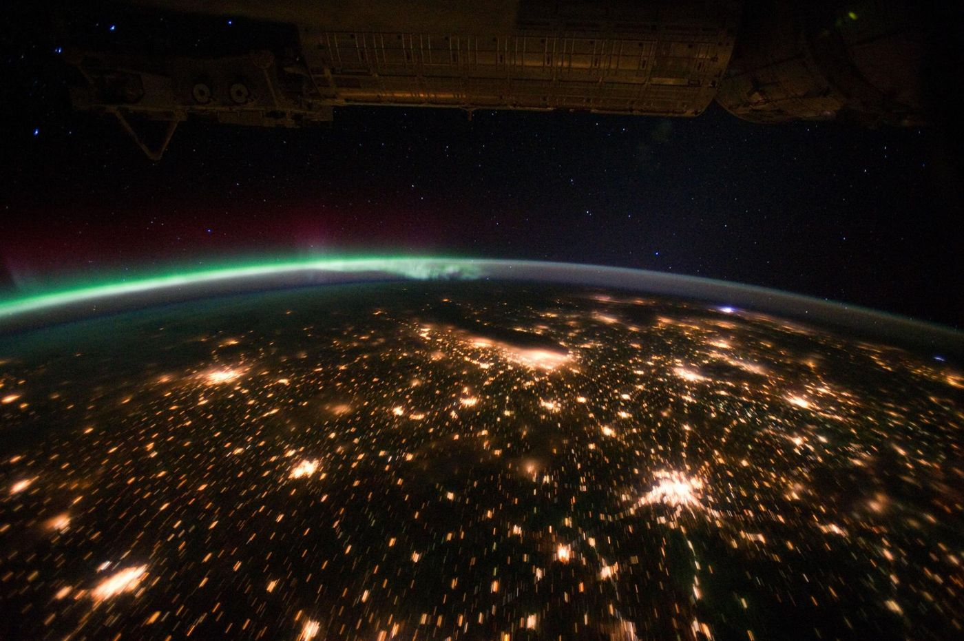
Figure 39. The solar wind made visible. A green aurora glows above Earth’s horizon, with city lights below, in a photograph taken from the International Space Station. Image: NASA, Expedition 29 crew.
The wind is accelerated by thermal pressure gradients and by wave-particle interactions in the corona. It becomes supersonic within a few solar radii. The interplanetary magnetic field is frozen into the plasma and is drawn into a Parker spiral by the Sun’s rotation. Sector boundaries separate regions of opposite polarity.
The wind inflates the heliosphere, a bubble that extends far beyond the planets. It interacts with planetary magnetospheres and atmospheres. Earth’s magnetosphere deflects most of the wind. Unmagnetized bodies such as Venus and Mars lose atmosphere to stripping. Comet tails are shaped by the wind. Variations in wind speed and density, together with coronal mass ejections, produce geomagnetic storms. The same plasma outflow is expected from every star that possesses a hot corona. The solar wind is the local realization of a general stellar phenomenon.
Questions to Keep Asking
How do we know that fast radio bursts come from outside our galaxy? The longer a burst has traveled through gas, the more its low frequencies are delayed, and the delays are too large for local sources. Several have been traced to distant host galaxies.
A repeating burst found to come from an ordinary star in our own galaxy would change the picture. Which would you give up, the magnetar idea or the cosmological distances?
Try it yourself. Why do cosmic rays arrive from all directions, while neutrinos and light from the same source point back to it?

30. Galaxies and the Large-Scale Universe
Our galaxy holds a few hundred billion stars and is one of perhaps a trillion in the observable universe. Their arrangement into filaments and voids is the oldest message in the cosmos, written in tiny fluctuations before any star existed.

Large-Scale Structure
Large-scale structure is the pattern of galaxies, clusters, filaments and voids observed on scales from a few to several hundred megaparsecs. The pattern grew by gravitational instability from the primordial density fluctuations. Over-dense regions expanded more slowly, collapsed, and formed bound objects. Under-dense regions expanded faster and became voids.
Cold dark matter supplies the dominant gravitational potential. Baryons fall into the dark-matter wells after recombination. The resulting power spectrum of density fluctuations matches the spectrum measured in galaxy surveys and in the microwave background. Baryon acoustic oscillations (Chapter 32) appear in the galaxy distribution as a standard ruler.
N-body simulations that include cold dark matter, baryons and a cosmological constant reproduce the observed filamentary web, the abundance of clusters, and the internal structure of dark-matter halos. The same simulations show that structure formation is hierarchical: small objects form first and merge into larger ones. The process continues today. The large-scale distribution of matter is therefore the evolved imprint of inflationary initial conditions filtered by gravity and by the cosmic expansion.

Galaxy Formation
Galaxies form by the gravitational collapse of dark-matter halos and the subsequent cooling of baryons. Small halos collapse first. They merge hierarchically into larger ones. Gas cools, forms stars, and is regulated by feedback from supernovae and from active galactic nuclei. The feedback prevents over-cooling and matches the observed stellar masses.
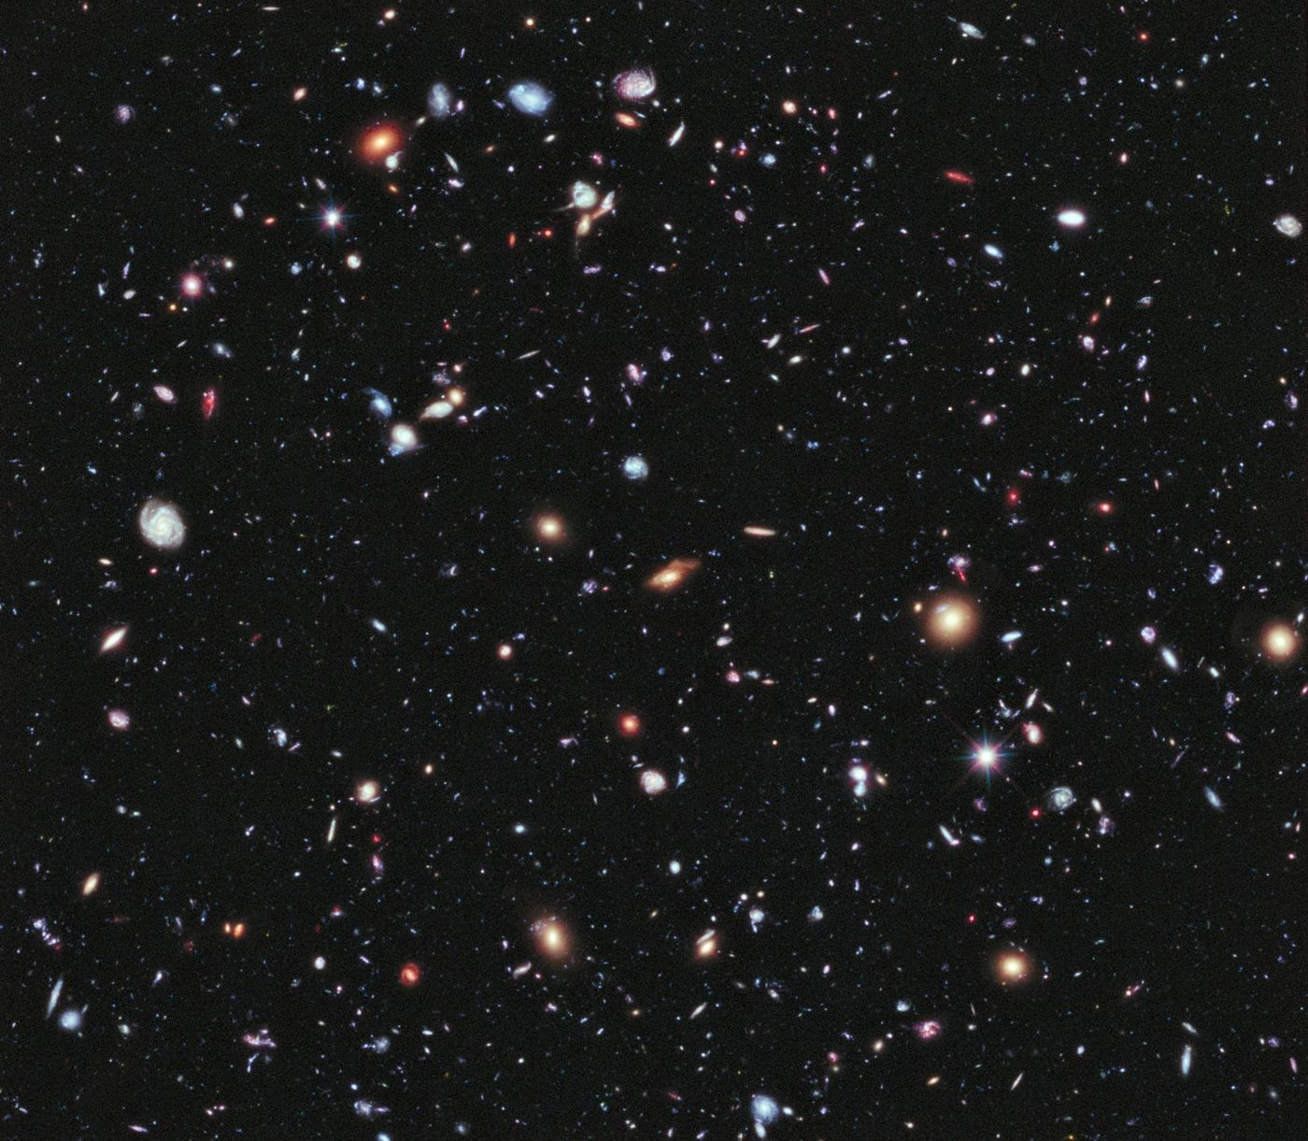
Figure 40. Hubble’s eXtreme Deep Field. Every smudge and spiral is a whole galaxy, some seen as they were within a billion years of the Big Bang. Image: NASA, ESA, G. Illingworth, D. Magee, P. Oesch, R. Bouwens and the HUDF09 and XDF teams.
The morphology—disk, bulge, elliptical—depends on the merger history and on the angular momentum of the gas. Major mergers destroy disks and build ellipticals. Quiet accretion preserves disks. The observed mix of morphologies is reproduced in simulations that include both processes. The simulations require sub-grid recipes for star formation and feedback. The recipes are calibrated and not derived from first principles, but the overall hierarchical picture is robust.

Galaxies
Galaxies are gravitationally bound systems of stars, gas, dust and dark matter. The Milky Way is a barred spiral containing a few hundred billion stars. Elliptical galaxies are smooth and gas-poor. Irregular galaxies lack ordered structure. Most large galaxies host a supermassive black hole at the center.
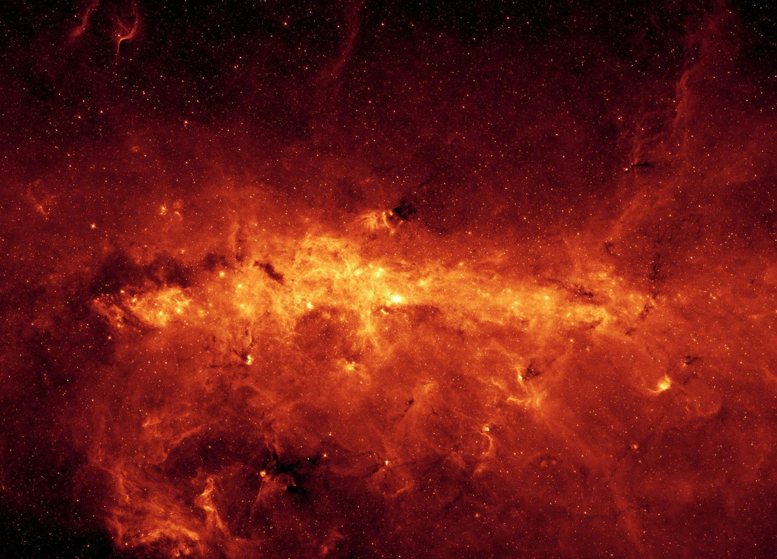
Figure 41. The center of our own galaxy in infrared light, as seen by the Spitzer Space Telescope. Dust glows where visible light cannot get through. Image: NASA/JPL-Caltech.
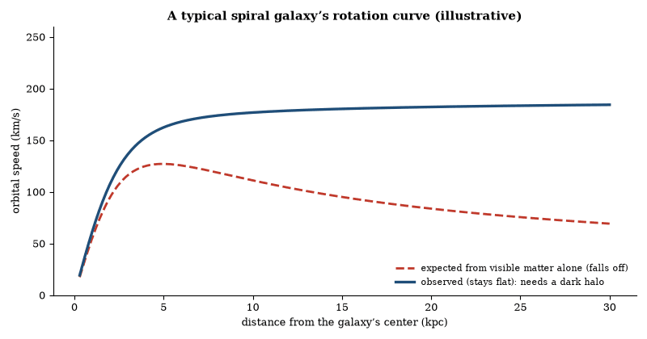
Figure 42. Stars far from a spiral galaxy’s center orbit as fast as those nearer in, instead of slowing as the visible mass would predict. The flat curve was a key early piece of evidence for dark matter. The curves are illustrative, shaped like real ones, not data from one galaxy.
Galaxies grow by accretion of gas and by mergers. Hierarchical merging is visible in both simulations and in the disturbed morphologies of many observed systems. Star formation occurs in the cold, dense phases of the interstellar medium. Supernova explosions and black-hole outflows heat and expel gas, which throttles the pace of star formation. The result is the observed range of stellar masses and morphologies.
Galaxies are not uniformly distributed. They form filaments, sheets and clusters surrounding voids—the cosmic web. The web is the evolved imprint of primordial density fluctuations. Galaxy surveys map the web to redshifts of order unity and beyond. The same large-scale structure that appears in the galaxy distribution is predicted by the cold-dark-matter model once the initial conditions are taken from the microwave background.

Andromeda and Alpha Centauri
The Andromeda galaxy is the nearest large spiral to the Milky Way. It lies about 2.5 million light-years away. It contains roughly a trillion stars and is approaching the Milky Way at about 110 kilometers per second. A collision in about four to five billion years was long the standard forecast, but a 2025 analysis of Gaia and Hubble data put the chance of a merger within the next ten billion years at only about one in two. Andromeda has its own satellite galaxies and a supermassive black hole at its center. No individual planets have been resolved there. The distance precludes detailed spectroscopy of Earth-sized worlds with present instruments.
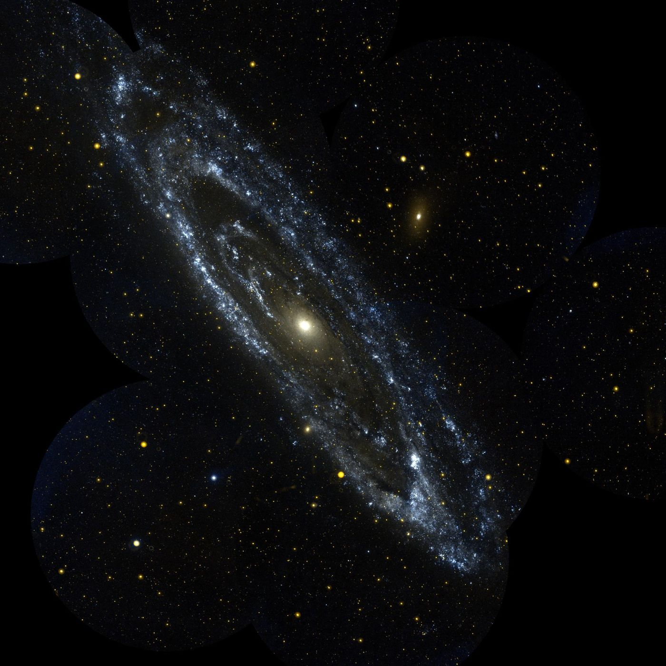
Figure 43. The Andromeda Galaxy in ultraviolet light, photographed by the GALEX satellite. The blue rings are young, hot stars. Image: NASA/JPL-Caltech.
Alpha Centauri is the nearest star system to the Sun, 4.37 light-years away. It is a triple system. Alpha Centauri A and B are Sun-like stars that orbit each other. Proxima Centauri is a red dwarf that orbits the pair at a greater distance. Proxima has at least one confirmed planet, Proxima b, with a minimum mass near that of Earth and an orbital period of about 11 days. The planet lies in the star’s habitable zone, where liquid water could exist on the surface if the atmosphere is suitable. The star is active, and flares and high-energy radiation may erode atmospheres; no atmosphere has been detected. The system is the closest place where an Earth-sized planet in a temperate orbit is known to exist. Whether that planet retains water or supports life is unknown.

Cosmic Voids
Cosmic voids are under-dense regions tens of megaparsecs across. They occupy most of the volume of the universe. Galaxies inside voids are bluer and more star-forming than average. The voids are the complementary structure to the filaments and clusters. Their size and emptiness are predicted by the cold-dark-matter model once the initial conditions are fixed by the microwave background.
Void statistics, from their abundance to their density profiles and shapes, test gravity and dark energy, because modified-gravity models change how structure grows inside them. So far the observations agree with general relativity but cannot yet tell dark-energy models apart. Voids are the largest structures in the universe and also the simplest, governed almost entirely by expansion and by the absence of matter.

The Lyman-Alpha Forest
The Lyman-alpha forest is the set of absorption lines in the spectra of distant quasars. Each line is produced by a cloud of neutral hydrogen along the line of sight. The forest traces the distribution of gas in the intergalactic medium at redshifts between 2 and 5. The absorption is sensitive to the density, temperature and ionization state.
The forest measures the matter power spectrum on small scales. It constrains the mass of warm dark matter and the amplitude of primordial fluctuations. It also measures the evolution of the ultraviolet background. The observations are consistent with cold dark matter and with a photoionized intergalactic medium. They supply an independent check on the parameters derived from the microwave background and from galaxy surveys.

The Sunyaev–Zel’dovich Effect
The Sunyaev–Zel’dovich effect is the distortion of the microwave background by inverse-Compton scattering on hot electrons in galaxy clusters. The thermal effect shifts photons to higher frequencies. The kinetic effect is a Doppler shift caused by the cluster’s bulk motion. Both are independent of redshift. They therefore detect clusters at any distance.
Cluster counts as a function of redshift constrain the growth of structure and the dark-energy equation of state. The effect has been measured by ground-based and satellite experiments. The measurements agree with X-ray and weak-lensing masses once selection effects are included. The effect is a clean probe. It does not require the cluster to be bright in any other band.

Weak Gravitational Lensing
Weak lensing is the small distortion of galaxy shapes by the intervening mass distribution. The distortion is statistical. It is measured by averaging the ellipticities of many galaxies. The signal constrains the projected mass. Tomography—division into redshift bins—constrains the growth of structure as a function of time.
Surveys measure the amplitude of matter fluctuations and the dark-energy equation of state, independently of the microwave background and in broad agreement with it. The main systematic errors, intrinsic alignments of galaxies and uncertain photometric redshifts, are controlled by calibration. Weak lensing is one of the principal probes of the late-time universe.

Strong Gravitational Lensing
Strong lensing produces multiple images, arcs and Einstein rings when the alignment of source, lens and observer is close. The image positions and magnifications determine the mass distribution of the lens. Time delays between images of a variable source measure the Hubble constant. The measurement is independent of the distance ladder.
Lensing by galaxies and by clusters has been observed in large numbers. The mass profiles are consistent with cold dark matter. Substructure is detected through flux-ratio anomalies and through gravitational imaging. The substructure abundance tests the small-scale predictions of cold dark matter. The observations agree within present uncertainties. They do not yet reveal a discrepancy that requires warm dark matter or modified gravity.

Magnetic Fields in the Universe
Magnetic fields are observed in planets, stars, galaxies and clusters. Galactic fields have strengths of a few microgauss and are ordered on kiloparsec scales. Cluster fields are of similar strength and are tangled. Intergalactic fields are constrained by the absence of certain cascade emission and by Faraday rotation. Lower limits of 10⁻¹⁷ G have been claimed. Upper limits are 10⁻⁹ G.
The origin is unknown. Primordial fields from the early universe, or fields generated by battery mechanisms and amplified by dynamos, are both possible. Dynamo action in galaxies is efficient. It can amplify seed fields to the observed strengths in a few rotation periods. The seed itself may be primordial or generated by early stars. The observations do not yet distinguish the scenarios.

The Interstellar Medium
The interstellar medium is the gas and dust between the stars. It comprises cold molecular clouds, warm neutral and ionized gas, and hot coronal gas. The phases are in approximate pressure equilibrium. Molecular clouds are the sites of star formation; they are turbulent and magnetized, and the supersonic turbulence creates the density fluctuations that collapse under gravity.
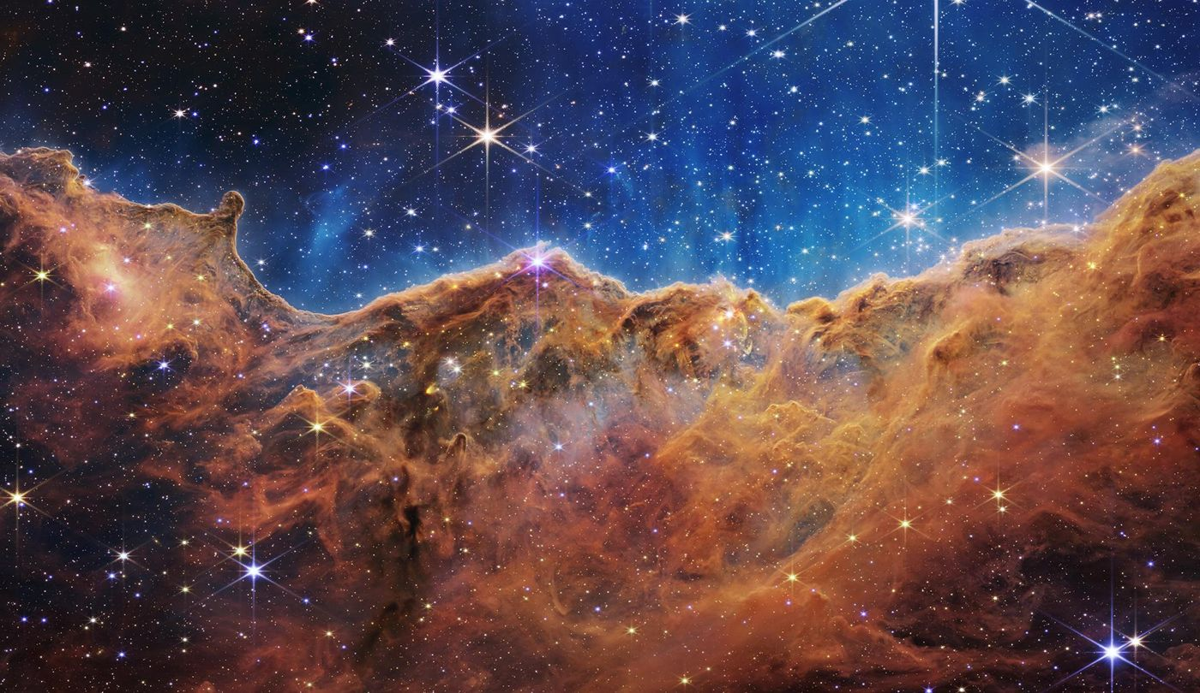
Figure 44. The edge of a star-forming cloud in the Carina Nebula, the “Cosmic Cliffs”, in the Webb Space Telescope’s first-release image. Credit: NASA, ESA, CSA and STScI.
Dust constitutes about one percent of the mass. It absorbs ultraviolet light and re-radiates in the infrared, and it catalyzes the formation of molecular hydrogen. The medium is enriched by stellar winds and supernovae and depleted by star formation. The cycle regulates the metallicity and the star-formation rate of the galaxy. The same phases and processes operate in other star-forming galaxies.

Molecular Clouds
Molecular clouds are the densest and coldest phase of the interstellar medium. Temperatures are 10–20 K. Densities exceed 10² cm⁻³. They are supported against gravity by turbulence and by magnetic fields. The support is temporary. Local regions collapse to form stars. The efficiency is low—a few percent—because feedback from the newly formed stars disperses the cloud.
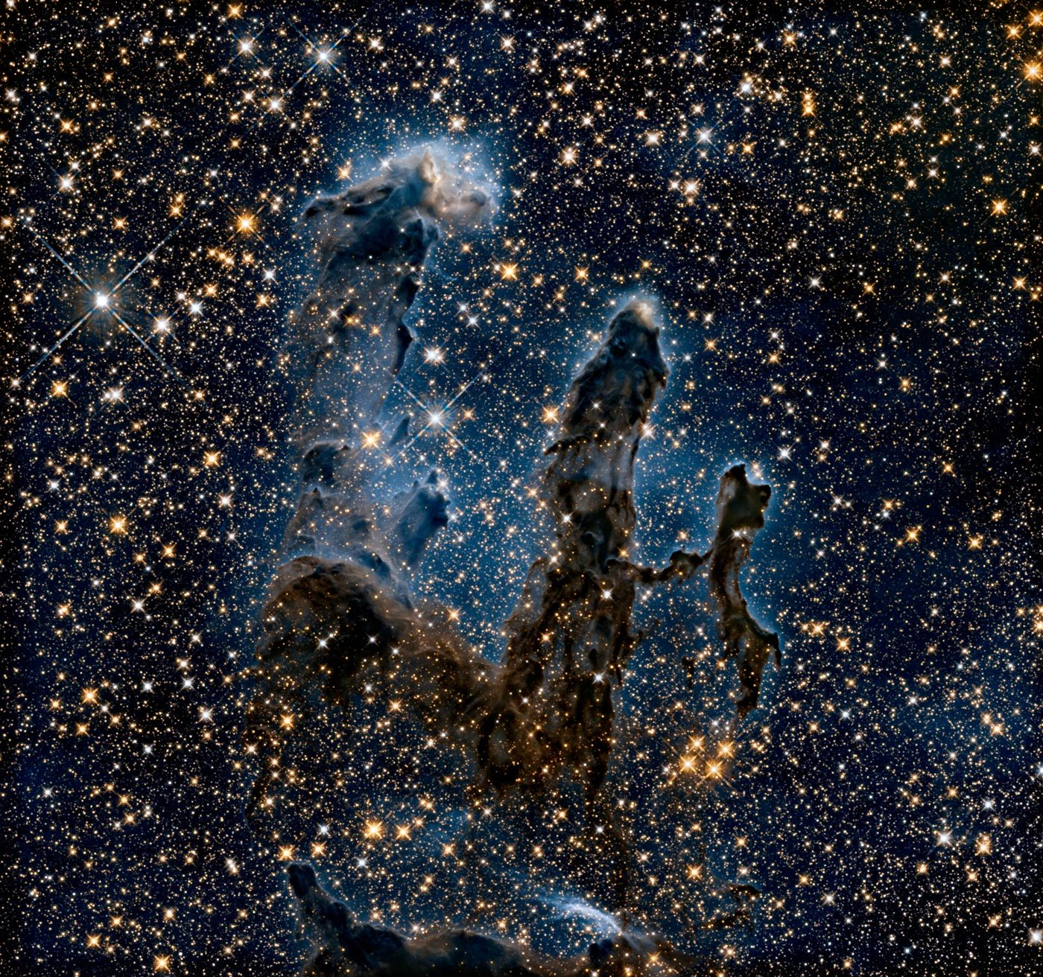
Figure 45. The Pillars of Creation in the Eagle Nebula, columns of gas and dust where new stars are forming, photographed in infrared light by Hubble. Image: NASA, ESA and the Hubble Heritage Team (STScI/AURA).
The clouds are observed in molecular lines, principally CO, and in dust continuum. Their mass spectrum is a power law. The most massive clouds form the most massive stars. The relation between cloud properties and the resulting stellar population is the initial mass function problem. The leading explanation for the stellar population that results is the turbulent fragmentation of the clouds, and that explanation is not complete.

Active Galactic Nuclei
Active galactic nuclei are powered by accretion onto supermassive black holes. The accretion disk radiates from the optical to the X-ray. A corona produces hard X-rays. Relativistic jets are launched in a subset of sources. The orientation of the observer relative to the disk and jet determines the observed class—quasar, Seyfert, radio galaxy, blazar.
The luminosity can reach 10⁴⁷ erg s⁻¹. The radiative efficiency is approximately 10 percent for a non-spinning hole and higher for a spinning hole. Feedback from the radiation and the jets regulates star formation in the host galaxy. The same feedback is required in models of galaxy formation to match the observed stellar masses. Active nuclei are both luminous beacons and agents of galactic evolution.

Quasars
Quasars are the most luminous active galactic nuclei. They are visible across the observable universe. Their spectra show broad emission lines from gas moving at thousands of kilometers per second. The lines are photoionized by the continuum. Absorption lines from intervening gas trace the intergalactic medium.
The quasar luminosity function peaks at redshift 2–3. The peak coincides with the peak of cosmic star formation. Both are regulated by the supply of cold gas. Quasars are used as backlights for absorption studies and as tracers of large-scale structure. Their clustering measures the bias of massive halos. The same objects that once seemed exotic are now standard tools of cosmology.

Blazars
Blazars are active galactic nuclei whose jets point nearly toward the observer. Relativistic beaming amplifies the emission and shortens the variability timescale. The spectral energy distribution shows two peaks—one from synchrotron radiation, one from inverse-Compton scattering. The peaks can lie in the radio, optical, X-ray or gamma-ray bands.
Variability on timescales of minutes implies emitting regions smaller than the Schwarzschild radius of the central black hole. The implication requires Doppler boosting. Blazars are the dominant sources of the extragalactic gamma-ray background. They are also candidate sources of high-energy neutrinos. In 2017 a high-energy neutrino was traced to the blazar TXS 0506+056, and archival data revealed an earlier neutrino flare from the same source; the evidence is suggestive rather than conclusive. In 2022 IceCube reported stronger evidence for neutrinos from the nearby active galaxy NGC 1068. The objects remain the brightest persistent sources in the gamma-ray sky.
Questions to Keep Asking
How do we know that Andromeda and other galaxies lie outside our own? In 1923 Edwin Hubble found Cepheid variable stars in Andromeda, whose faintness placed it far beyond the Milky Way.
Simulations that include dark matter reproduce the cosmic web. What pattern of galaxies would they fail to reproduce?
Try it yourself. On a clear autumn night, find the faint smudge of the Andromeda galaxy with the naked eye. The light you see left it about 2.5 million years ago.
Further reading for Part V. Sagan’s Cosmos remains the best invitation to the sky. Tyson and Goldsmith’s Origins tells the story from the Big Bang to the first planets, and Asimov’s New Guide to Science is a patient tour of the facts.

Part VI: The Universe as a Whole
The expanding cosmos, its hot beginning, its dark contents, and the nature of time

31. The Expanding Universe
In 1929 Edwin Hubble found that distant galaxies recede faster the farther away they are. The universe has no center from which they flee. Space itself is stretching, and the farther two points lie apart, the faster the stretching carries them away.
The universe is expanding. This chapter covers how the expansion is measured, the equations that describe it, and the disputes that remain. Chapter 32 follows the expansion back to its hot beginning, and Chapter 33 turns to the dark components that now drive it.

The Expansion of the Universe
Distant galaxies recede with a speed proportional to their distance. That is Hubble’s law, and its slope is the Hubble constant, about 70 kilometers per second per megaparsec (km s⁻¹ Mpc⁻¹). The recession is seen in every direction. It is not an explosion from a center in space but a growth in the scale of space itself, described by a scale factor a(t). Light crossing expanding space is stretched with it, so the redshift z of a distant galaxy obeys 1 + z = 1/a, where a is the size of the universe at emission relative to today.
The same stretching has cooled the radiation left over from the hot early universe into the cosmic microwave background: a thermal spectrum at 2.725 kelvin whose small temperature ripples map the density fluctuations that later grew into galaxies.
The expansion rate has not been constant. Matter slowed it for most of cosmic history. About six billion years ago, when the universe was a little more than half its present age, it began to accelerate. Type Ia supernovae, baryon acoustic oscillations and the microwave background all show this. The cause is called dark energy, a component with negative pressure whose density stays nearly constant while the density of matter falls. The name labels the effect; what dark energy is remains unknown.
Running the expansion backward with the measured contents gives an age of about 13.8 billion years, consistent with the ages of the oldest stars. The model behind that number combines general relativity, the Standard Model, cold dark matter and a cosmological constant (ΛCDM). Six parameters fit the microwave background, and the same six then predict the baryon acoustic scale, the light-element abundances and the growth of structure. It is the standard model of cosmology: wide in reach, not proven complete. Its two known strains, the Hubble tension and a milder mismatch in how strongly matter clumps, are described below.

Why the Night Sky Is Dark
The darkness of the night sky is the first cosmological observation anyone can make, and it is not obvious. Suppose the universe were infinite, eternal and uniformly filled with stars. Then every line of sight would end on the surface of some star, and the whole sky would glow as brightly as the surface of the Sun. The puzzle is usually named for the astronomer Heinrich Olbers, who discussed it in 1823, though Kepler, Halley and others had met it earlier.
The way out is not that the distant stars are too faint or are hidden by dust, since dust would heat up and glow. The way out is that the universe has a finite age. Light from stars beyond about 13.8 billion light-years has not had time to arrive, so most lines of sight end in the dark. The expansion helps as well, by stretching the light that does arrive to longer wavelengths and lower energy. Edgar Allan Poe guessed something close to this in his prose poem Eureka in 1848, long before the evidence existed.

Hubble and Webb
The Hubble Space Telescope was launched in 1990 into low Earth orbit. Its primary mirror is 2.4 meters in diameter, it observes from the near-ultraviolet to the near-infrared, and servicing missions corrected its optics and replaced instruments. It has measured the expansion rate, imaged distant galaxies, and resolved disks around young stars.
The James Webb Space Telescope was launched in 2021 and operates at the Sun–Earth L2 point, 1.5 million kilometers from Earth. Its primary mirror is 6.5 meters across, composed of 18 gold-coated beryllium segments. A five-layer sunshield keeps the telescope near 40 kelvin. Webb observes from the red visible to the mid-infrared. The longer wavelengths penetrate dust and reach the redshifted light of the first galaxies.
Webb’s collecting area is more than five times Hubble’s. Its infrared sensitivity reveals galaxies that formed within a few hundred million years after the Big Bang, the atmospheres of exoplanets by transmission spectroscopy, and the interiors of star-forming clouds. Hubble continues to provide ultraviolet and optical coverage. The two telescopes are complementary. Together they span the electromagnetic spectrum from the ultraviolet to the mid-infrared and the cosmic timeline from the present to the first luminous objects.

The Friedmann Equations
The Friedmann equations govern the expansion of a homogeneous and isotropic universe. The first equation reads
H² = (8π G)/3ρ − kc²/a² + (Λ c²)/3,
where H = ȧ/a is the Hubble parameter and k is the spatial curvature, zero for a flat universe. The second equation gives the acceleration:
(ä)/a = -(4π G)/3(ρ + 3p/c²) + (Λ c²)/3.
Matter and radiation decelerate the expansion. A cosmological constant or any component with w < -1/3 accelerates it. Present data require a positive acceleration and a density close to the critical density.
The equations are the Einstein equation applied to the Robertson–Walker metric. They assume homogeneity and isotropy on large scales. Both assumptions are supported by the isotropy of the microwave background and by the large-scale distribution of galaxies. Small-scale inhomogeneities are treated as perturbations on the Friedmann background.

Radiation, Matter and Vacuum Eras
Solving the Friedmann equations for a single dominant component gives three simple histories. When radiation dominates, the scale factor grows as the square root of time. When matter dominates it grows as time to the power two-thirds. When a cosmological constant dominates, it grows exponentially, with a doubling time set by the Hubble parameter.
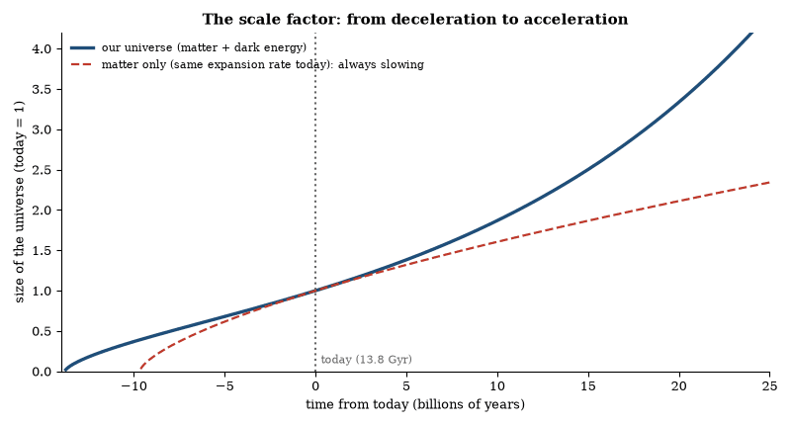
Figure 46. The scale factor a(t), computed from the Friedmann equation with 31.5 percent matter and 68.5 percent dark energy (dashed: a matter-only universe). Early on the expansion slows under gravity; since roughly 5 billion years ago dark energy has made it speed up.
The real universe has passed through these regimes in that order. Radiation gave way to matter when the universe was some 50 000 years old, at a redshift near 3 400. Dark energy overtook matter in density roughly ten billion years after the Big Bang, at a redshift near 0.3; the acceleration itself had begun a few billion years earlier, once the repulsion of dark energy outweighed the pull of matter. We live early in the third era, and if the dark energy is a true constant, the exponential phase will last forever.

Light-Travel Distance and the Size of the Observable Universe
The universe is 13.8 billion years old. Light emitted at the Big Bang has therefore been traveling for 13.8 billion years. That light-travel time corresponds to a distance of 13.8 billion light-years. The statement is correct and incomplete.
While the light traveled, space expanded. The regions that emitted the photons we now receive as the cosmic microwave background are no longer 13.8 billion light-years away. Their present-day (comoving) distance is approximately 46 billion light-years. The factor of roughly three is the stretching of space that went on while the light was in transit.
The particle horizon—the boundary of the observable universe—is therefore a sphere of comoving radius 46 billion light-years centered on the observer. Every observer, wherever located, is at the center of their own such sphere. The spheres overlap but are not identical. Nothing outside an observer’s particle horizon can yet have influenced them.
The numerical distinction is a direct consequence of expansion. It does not imply that anything travels faster than light. It implies only that the ruler used to measure distance today is longer than the ruler that would have been used when the light was emitted. Both the 13.8-billion-year age and the 46-billion-light-year radius are required for a consistent description.

Worked Examples: Cosmology
Example 1. The Hubble constant is 70 km s⁻¹ Mpc⁻¹. What is the approximate age of a matter-dominated flat universe?
t = 2/(3H). H = 70 km s⁻¹ Mpc⁻¹ = 2.27 × 10⁻¹⁸ s⁻¹. t ≈ 9.3 Gyr. (The actual age is larger because of dark energy.)
Example 2. A galaxy has redshift z = 0.1. What is its approximate recession speed and distance?
For small z, v = cz ≈ 30 000 km s⁻¹. Distance d = v/H ≈ 430 Mpc.
Example 3. The cosmic microwave background temperature today is 2.725 K. What was the temperature at redshift z = 1 100 (recombination)?
T = T₀(1+z) = 3 000 K. The same scaling applies to the wavelength of every photon.
Example 4. Critical density today for H₀ = 70 km s⁻¹ Mpc⁻¹.
ρ_{c} = 3H²/(8π G) ≈ 9.2 × 10⁻²⁷ kg m⁻³, or about 5.5 hydrogen atoms per cubic meter.
These relations convert the observed Hubble constant, redshifts and background temperature into distances, ages and densities.

The Hubble Tension
The Hubble constant measured from the local distance ladder is approximately 73 km s⁻¹ Mpc⁻¹. The value inferred from the microwave background under the standard cosmological model is approximately 67 km s⁻¹ Mpc⁻¹. The discrepancy is about five standard deviations and is not an artifact of a single method: multiple local probes give high values and multiple early-universe probes give low values.
Proposed resolutions include new physics in the early universe that changes the sound horizon, or systematic errors in the distance ladder. Neither has been established, and the tension, the most significant current discrepancy in cosmology, remains. Its resolution will either reveal new physics or identify an unrecognized systematic. Both outcomes are informative.

Gravitational-Wave Cosmology
Gravitational waves from binary mergers provide a standard siren. The waveform amplitude determines the luminosity distance. If an electromagnetic counterpart identifies the host galaxy, the redshift is obtained. The combination measures the expansion rate without a distance ladder. GW170817 yielded a measurement of the Hubble constant consistent with other methods. The uncertainty is large. Future events will reduce it.
The same events constrain the speed of gravity. The arrival of the gamma-ray burst within seconds of the waves bounds the difference from the speed of light at the level of parts in 10¹⁵. The bound eliminates large classes of modified-gravity models. The waves also probe the equation of state of dense matter through the tidal deformability. The cosmological and the strong-field uses are complementary.
Questions to Keep Asking
How do we know the expansion is real? The light curves of distant supernovae are stretched in time, the background radiation was hotter in the past, and the pattern fits one expansion history.
A disagreement between the Hubble constant measured nearby and from the early universe has persisted for years. What would settle it as new physics or as an error?
Try it yourself. Draw dots on a balloon and measure the distances between three of them before and after inflating it. Which dot seems to be the center of the expansion?

32. A Universe With a Birthday
The oldest light in the universe reaches us from every direction as a faint microwave glow at 2.7 kelvin. A small part of the static on an old analog television was this light, set free 380,000 years after the Big Bang when the universe cooled enough for atoms to form.

The Night the Universe Acquired a Temperature
In 1964 two radio astronomers at Bell Labs, Arno Penzias and Robert Wilson, were tracking down noise in a horn antenna. They found a faint hiss that came from every direction and was neither the equipment nor the atmosphere: it was the universe itself, at a temperature of about three kelvin (now measured as 2.725 K). Ralph Alpher and Robert Herman had predicted such a remnant glow of the Big Bang in 1948, at about five kelvin, but the prediction had been largely forgotten. The measurement revived it.
The photons that produce the hiss left the universe when it was 380 000 years old. They have been traveling ever since, and their wavelength has stretched with the expansion, which is the reason they are now microwaves. The spectrum follows the black-body curve with extraordinary fidelity. No other known process produces a perfect black-body spectrum across the entire sky.
The measurement ended the steady-state theory. It did not end debate. It relocated the debate to the details of the early universe. The details are now measured to parts in a hundred thousand. The hiss is still there. It is the oldest light that reaches us. It is also the most precisely measured thermal spectrum in nature.

The Big Bang
The Big Bang is the hot, dense, expanding phase from which the observable universe emerged. It is not an explosion in pre-existing space. It is the expansion of space itself, and every comoving observer sees the same recession of distant galaxies and the same cooling of the radiation field.
Cosmologists divide the story into epochs, each tied to a temperature. Near 10¹⁵ K, within a trillionth of a second, the electromagnetic and weak forces were still one electroweak force. Within about ten microseconds the universe had cooled enough for quarks to bind into protons and neutrons. Within the first few minutes the light nuclei formed. Some 380 000 years later the first atoms appeared and the universe became transparent. Each transition is calculated within the Standard Model and leaves no relic that contradicts it.
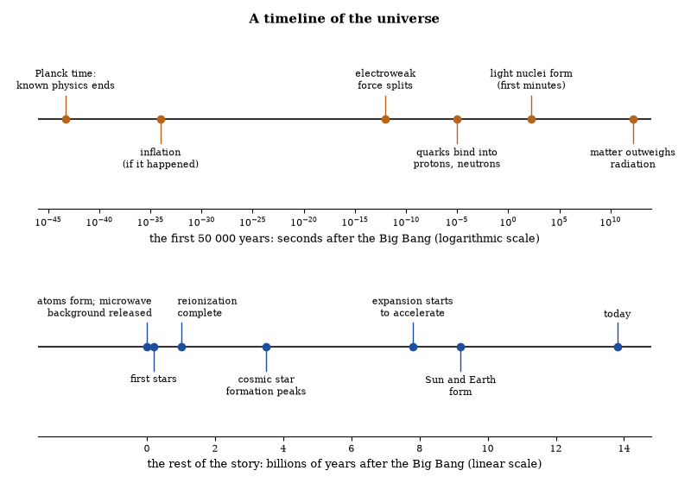
Figure 47. A timeline of the universe. Top: the first 50 000 years on a logarithmic scale of seconds. Bottom: the rest of cosmic history in billions of years.
The very beginning is the frontier, taken up in the next section. What is secure is everything from nucleosynthesis onward, confirmed by several independent observations.

The Origin of the Universe
To ask for the origin of the universe is to ask two different questions. One is how the hot, expanding phase began and what set its initial conditions. The other is whether anything came before it, or whether the question even has meaning. Observation reaches only the first, and only partly: the earliest direct evidence is the microwave background, and nothing earlier has been seen in light.
Before nucleosynthesis the energies exceeded those accessible to accelerators. The electroweak transition, the confinement of quarks into hadrons, and any preceding inflationary phase lie in that regime. Inflation, if it occurred, would have stretched a microscopic region to macroscopic size, diluted curvature, and generated the nearly scale-invariant fluctuations later seen in the microwave background. No direct relic of inflation has been detected. The hypothesis remains the simplest account of the initial conditions required by the later evolution.
The expansion itself has no center and no edge within the observable volume. Run the Friedmann equation backward under the assumptions of classical general relativity and ordinary matter, and it reaches a singularity in finite time. That result marks the limit of the theory more than a moment of creation, and no controlled calculation yet replaces it with an earlier state.
The origin of the low entropy that permits the thermodynamic arrow, the origin of the baryon asymmetry, and the nature of the dark-matter particles are likewise open. They are the questions a complete account of the beginning would have to answer.

The First Three Minutes
The early universe was hot and dense. At temperatures above 10¹⁰ K neutrons and protons were in equilibrium through weak interactions. As the universe expanded and cooled, the weak interactions froze out. The neutron-to-proton ratio was then fixed at about one to six. Below roughly 10⁹ K deuterium became stable. Almost all the remaining neutrons were incorporated into helium-4. The process left roughly 75 percent hydrogen and 25 percent helium by mass, plus trace amounts of deuterium, helium-3, and lithium-7.
The abundances match the observations of the oldest stars and of interstellar gas once the baryon density is set to the value measured by the microwave background. The agreement is one of the principal successes of the hot Big Bang. It fixes the conditions between about one second and three minutes after the initial singularity.
The clock mattered. Free neutrons decay with a mean life of about fifteen minutes, so the neutron fraction was already sinking as the universe cooled toward the temperature at which deuterium could survive. Had the nuclear fires lit much later, less helium would have formed; had the weak interactions frozen out earlier, more. The observed quarter by mass is therefore a direct readout of the expansion rate in the first seconds.
The first three minutes therefore determined the composition of ordinary matter. The subsequent three hundred thousand years determined the radiation we still detect. Both calculations rest on measured particle-physics cross-sections and on general relativity. Both match observation.

Big Bang Nucleosynthesis
Between about one second and three minutes after the Big Bang the temperature fell from 10¹⁰ K to 10⁹ K. Neutrons and protons froze out of equilibrium. Nearly every neutron that survived ended up inside a helium-4 nucleus. Trace amounts of deuterium, helium-3, and lithium-7 were also produced.
The predicted mass fraction of helium-4 is approximately 0.25. The predicted abundances of the lighter isotopes depend sensitively on the baryon-to-photon ratio. That ratio is now measured independently from the microwave background. The abundances observed in the oldest stars and in interstellar gas match the predictions. The agreement fixes the conditions of the early universe and confirms that the expansion rate was close to the general-relativistic value.
No heavier elements were produced. The Coulomb barriers are too high and the densities fall too rapidly. All nuclei beyond lithium were synthesized later in stars. Big Bang nucleosynthesis therefore accounts for the light-element abundances and for nothing else.

The Cosmic Microwave Background
The cosmic microwave background is thermal radiation that fills the universe. Its spectrum is that of a black body at 2.725 K. The radiation was released when the universe cooled to about 3000 K and electrons combined with nuclei to form neutral atoms. The photons have traveled freely ever since. The expansion has redshifted their temperature by a factor of approximately 1100.
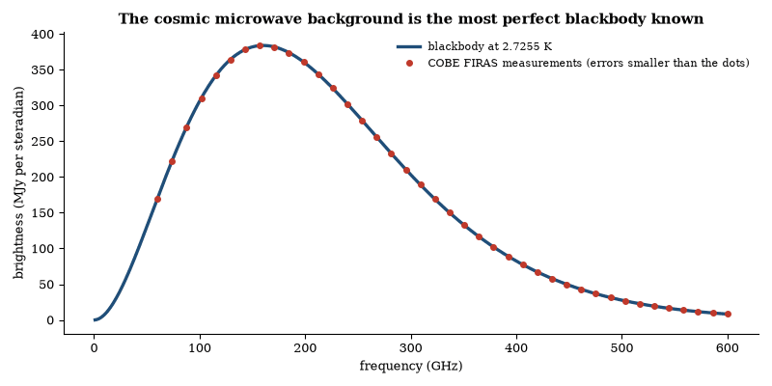
Figure 48. The spectrum of the cosmic microwave background follows the Planck curve for 2.7255 K to better than one part in ten thousand. The dots stand for the measurements made by COBE’s FIRAS instrument in 1990; they lie on the curve within the line width.
The background is isotropic to one part in 10⁵. The small anisotropies are the imprint of density fluctuations that existed at recombination. Those fluctuations grew by gravitational instability into the galaxies and clusters observed today. The angular power spectrum of the anisotropies measures the baryon density, the dark-matter density, the curvature of space, and the spectral index of the primordial fluctuations.
Polarization of the background records the motion of the plasma at last scattering and, potentially, the presence of primordial gravitational waves. Current limits on the latter constrain the energy scale of inflation. The background therefore supplies the most precise cosmological data set available.

Cosmic Inflation
Cosmic inflation is a brief epoch of accelerated expansion in the earliest universe. It is driven by the potential energy of a scalar field—the inflaton—that rolls slowly toward the minimum of its potential. While the field is slow-rolling the scale factor grows exponentially. A tiny, causally connected region is stretched to a size far larger than the present observable universe.
Both puzzles described in the previous section dissolve, because the whole observable universe descends from one small patch that was once in causal contact and was then stretched flat. Quantum fluctuations of the inflaton are stretched to cosmological wavelengths and become the nearly scale-invariant, adiabatic, Gaussian density perturbations observed in the microwave background.
The simplest models predict a tensor-to-scalar ratio r that measures the amplitude of primordial gravitational waves. Current upper limits are r < 0.03. Detection of a non-zero r would fix the energy scale of inflation. Non-detection continues to constrain the shape of the potential. Inflation ends when the inflaton reaches the bottom of its potential and oscillates, reheating the universe and initiating the hot Big Bang. The mechanism is theoretically attractive and consistent with all present data. It is not yet uniquely confirmed.

The Horizon and Flatness Problems
The hot Big Bang accounts for the expansion, the microwave background, and the abundances of the light elements. It leaves two puzzles. The first is the horizon problem. The cosmic microwave background is uniform to one part in a hundred thousand in every direction. Regions that are now on opposite sides of the sky were never in causal contact in the standard expanding model. They had no time to exchange heat or information, yet they have the same temperature. The second is the flatness problem. The density of the universe is close to the critical density that separates expansion forever from eventual recollapse. The critical density is unstable, so a small departure early on grows rapidly. To be as close as it is today, the density at one second after the Big Bang had to match the critical value to one part in 10^15 or better. No mechanism in the standard model explains either fact.
Inflation supplies a mechanism. A brief period of accelerated expansion, driven by a scalar field in a false vacuum, stretches a small, causally connected region to a size larger than the present observable universe. The region is smoothed. Temperature differences are erased. The same expansion drives the density toward the critical value, so that the universe appears flat. The quantum fluctuations of the field are stretched to cosmic scales and become the seeds of later structure. The spectrum of those fluctuations is nearly scale-invariant. It matches the pattern measured in the microwave background and in the large-scale distribution of galaxies.
The idea was proposed in the early 1980s. It is not yet derived from a confirmed particle-physics model. The field that drove it has not been identified. The duration and the energy scale remain free parameters within broad limits. What the observations require is some process that produced a large, nearly uniform, nearly flat region with small density perturbations of the observed amplitude. Inflation is the leading candidate, and although other proposals exist none has yet replaced it. The problems it solves were already visible in the 1970s. The microwave data that confirmed the uniformity and the flatness arrived later. The sequence is the reverse of the usual one: the solution was offered before the precision measurements that made the problems sharp.

Inflationary Predictions
Inflation predicts a nearly scale-invariant spectrum of scalar perturbations, with a spectral index slightly less than one; the observed value is n_{s} ≈ 0.965. The amplitude is fixed by the height of the potential. Tensor modes are predicted with an amplitude set by the energy scale of inflation. The tensor-to-scalar ratio r is bounded above by 0.03. Non-detection continues to constrain the potential.
The perturbations are adiabatic and Gaussian to high precision, with isocurvature modes and non-Gaussianity small, and these predictions match the microwave-background data. They do not single out the inflaton potential. The simplest monomial potentials are disfavored, while plateau potentials and many others remain compatible. The data confirm the broad predictions but do not yet identify the underlying model, and rival scenarios that mimic the same spectrum can be told apart only by better measurements of non-Gaussianity or of primordial gravitational waves.

Baryogenesis
Baryogenesis is the generation of the observed excess of matter over antimatter. The universe contains roughly 10⁹ photons for every baryon, and essentially no antibaryons. Sakharov identified three necessary conditions: baryon-number violation, C and CP violation, and departure from thermal equilibrium.
The Standard Model contains all three ingredients: electroweak sphalerons violate baryon number, and the CKM matrix supplies CP violation. The electroweak phase transition can be out of equilibrium if it is strongly first-order. Quantitative calculation shows that the Standard Model CP violation and the strength of the transition are both insufficient to produce the observed asymmetry. Additional physics is required.
Two leading proposals, leptogenesis and electroweak baryogenesis, are described in Chapter 11. A third, Affleck–Dine baryogenesis, uses scalar fields of supersymmetric theories. Each remains a hypothesis awaiting experimental support, and all of them tie the matter excess to physics beyond the Standard Model.

Baryon Acoustic Oscillations
Baryon acoustic oscillations are the frozen sound waves of the pre-recombination plasma. The sound horizon at recombination is a standard ruler of approximately 150 Mpc. It appears as a peak in the galaxy correlation function and as a series of peaks in the microwave-background power spectrum. The angular scale of the peaks measures the angular-diameter distance to recombination. The same ruler measured in galaxy surveys at lower redshift measures the expansion history.
The measurements fit a flat universe dominated by a cosmological constant and constrain the dark-energy equation of state. Because they are independent of the supernova distance ladder, their agreement with it strengthens the case for acceleration. The ruler is calibrated by the microwave background, so its use at late times is a direct geometric probe.

Reionization
Reionization is the process by which the intergalactic medium was ionized by the first stars and galaxies. It occurred between redshifts of approximately 15 and 6. The optical depth to reionization is measured by the large-scale polarization of the microwave background. The measurement constrains the integrated ionizing output. Direct observations of high-redshift galaxies and of the Lyman-alpha forest constrain the timing.
The sources were mainly galaxies, with quasars joining later. How many ionizing photons escaped from those galaxies is uncertain, and that escape fraction is the main free parameter of the models. Reionization ended the cosmic dark ages and was the last major phase change in the history of ordinary matter; current telescopes are still mapping its details.

The Cosmic Infrared Background
The cosmic infrared background is the integrated emission from dust-obscured star formation across cosmic history. It peaks at wavelengths of 100–200 µm. The intensity is comparable to the optical background. Most of the energy was emitted at redshifts between 1 and 3. The sources are resolved by far-infrared and submillimeter telescopes. They are dusty star-forming galaxies.
The background constrains the total star-formation rate density. It is consistent with the rate inferred from ultraviolet and optical surveys once dust extinction is included. Fluctuations in the background probe the clustering of the unresolved sources. The fluctuations are detected. They match the expectations from known galaxy populations. The background is the bolometric record of cosmic star formation.
Questions to Keep Asking
How do we know there was a Big Bang? The expansion, the background radiation, the abundances of hydrogen and helium and the way galaxies have evolved all fit one hot, dense beginning.
A star older than the universe, or a helium fraction far from 25 percent in the oldest gas, would contradict the picture. How are those two quantities measured?
Try it yourself. The universe has expanded by a factor of about 1,100 since the light of the background was released, and its temperature today is 2.7 K. What was its temperature then? (Answer: about 3,000 K.)

33. Dark Matter and Dark Energy
Stars and gas make up barely a tenth of the matter in a galaxy. The rest, and an even stranger something that speeds up the expansion, has never been seen in any laboratory. Seventy percent of the cosmos is described by a number, not a substance.

The Dark Sector at a Glance
Dark matter and dark energy are the two dominant components of the present universe. Neither emits, absorbs or scatters light, and both are detected solely through their gravitational effects.
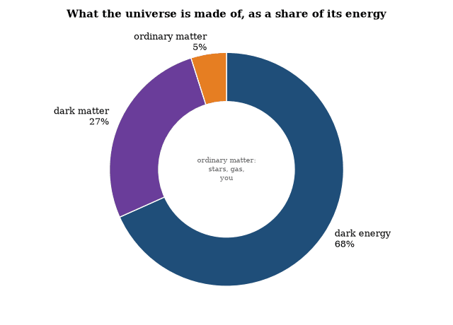
Figure 49. The cosmic energy budget today, from the Planck satellite’s ΛCDM fit: about 68 percent dark energy, 27 percent dark matter and 5 percent ordinary matter. Of the ordinary 5 percent, stars and planets make up only about a tenth.
Dark matter makes up roughly a quarter of the cosmic energy budget and dark energy roughly two-thirds to seven-tenths. Ordinary atoms, everything that shines or can be built into a star, a planet or a person, supply the remaining five percent. The expansion history and the growth of structure are described accurately once all three are included.
The two differ in character. Dark matter clumps: it gathers into halos, pulls galaxies together and shapes the cosmic web. Dark energy does not clump, and its density hardly changes as space expands. One slowed the expansion while structures formed; the other is speeding it up now. Neither has a known microphysical identity.

Dark Matter
Galaxies rotate faster in their outer regions than the visible mass can explain. Clusters of galaxies bend light and bind hot gas more strongly than their luminous matter allows. The cosmic microwave background shows acoustic peaks whose positions require additional non-baryonic matter. These observations converge on a component that gravitates but does not emit, absorb, or scatter light at detectable levels. It is called dark matter.
The density of dark matter is about five times the density of ordinary matter. It is cold, meaning that its particles moved slowly when structures formed. Cold dark matter collapses into halos, and ordinary matter falls into the halos and forms galaxies. The halos are larger than the visible galaxies. Their presence is inferred from rotation curves, gravitational lensing, and the growth of structure.
No dark-matter particle has been detected in the laboratory. Candidates include weakly interacting massive particles, axions and sterile neutrinos, and three kinds of search hunt for them: direct-detection experiments, which set limits on the scattering cross-section, indirect searches for annihilation products, and collider searches for missing energy. None has produced a confirmed signal. The gravitational evidence remains; the identity of the matter does not.
Modified-gravity theories attempt to explain the observations without new particles. They reproduce some galactic rotation curves. They have greater difficulty with clusters, with the microwave background, and with the separation of mass and light in merging clusters. The dark-matter hypothesis accounts for all of these with one additional component. It is the working description. It is not yet a completed identification.

Dark Energy
The expansion of the universe is accelerating. Type Ia supernovae at high redshift are fainter than they would be in a decelerating universe. The microwave-background acoustic peaks and the large-scale distribution of galaxies independently require a component that drives acceleration. The component has negative pressure. Its energy density is roughly constant as the universe expands. It is called dark energy.
The simplest model is a cosmological constant. Einstein introduced the term to permit a static universe and it was later set to zero, but the observations revive it with a small positive value. The constant corresponds to an energy density of about 10⁻²⁹ grams per cubic centimeter. A naive quantum-field-theory estimate of the vacuum energy comes out many orders of magnitude too large, a mismatch examined below.
Other models allow the density to vary slowly. They are parameterized by an equation-of-state index w. Current data are consistent with w = -1, the value for a cosmological constant, to within a few percent. Future surveys of supernovae, baryon acoustic oscillations, and weak lensing will tighten the constraint. A clear departure from -1 would rule out the simplest model.
Dark energy dominates the present energy budget, though it did not dominate in the past, and its presence sets the ultimate fate of the expansion. If it remains constant, the expansion continues forever and galaxies beyond the local group eventually leave the observable universe. The inference rests on the measured acceleration and on the assumption that the component persists. Both are supported by present data. Both remain open to revision.

Beyond the Cosmological Constant
A true cosmological constant is only one way to make the universe accelerate. Quintessence replaces it with a slowly rolling scalar field whose energy density can change with time. Modified-gravity models alter the Einstein equation on large scales instead of adding a new substance. Each can be tuned to mimic a constant, which is why the choice is hard to make from the expansion history alone.
The tests are the expansion history and the growth rate of cosmic structure. A pure constant fixes both with no free parameters, so any measured drift in the equation-of-state parameter w, or any mismatch between how fast space expands and how fast structure grows, would point beyond it. Recent baryon-acoustic-oscillation maps, combined with supernova and microwave-background data, show a mild preference for dark energy that weakens with time. The significance depends on which supernova sample is used, and it has not been confirmed.
A constant also fixes when acceleration began. Because its density does not dilute, it overtook the falling matter density only recently, and the switch from deceleration to acceleration happened at a redshift near 0.7.

The Cosmological-Constant Problem
The cosmological-constant problem is the discrepancy between the observed vacuum energy density and the value predicted by quantum field theory. Every quantum field possesses a zero-point energy. Summing the ground-state energies 1/2ħω of all modes up to the Planck scale yields a density of order 10¹¹³ J m⁻³. Even a cutoff at the electroweak scale still produces ~ 10⁴⁵ J m⁻³.
The density inferred from the acceleration of the universe is approximately 6 × 10⁻¹⁰ J m⁻³. The mismatch is between 50 and 120 orders of magnitude. No symmetry of the Standard Model cancels the vacuum energy. Unbroken supersymmetry would cancel the leading term, yet supersymmetry, if present, is broken at a scale that still leaves a residual many orders of magnitude too large.
Anthropic selection among many vacua can account for the fact that observers inhabit a region whose vacuum energy permits structure and life. It does not eliminate the fine-tuning inside any given vacuum. No dynamical mechanism is known that relaxes the vacuum energy to the observed value after the Standard Model parameters are fixed. The problem remains unsolved.

A Number That Should Not Be Small
The cosmological constant is small, and it is not zero. Both halves of that sentence are measured. The explanation of either half is absent: no symmetry forces the value to vanish, and no mechanism is known that would relax it to the tiny number observed.
The smallness is not a detail. A much larger value would have driven matter apart before galaxies could form, and there would be no stars, no chemistry and no observers. That observation has led to anthropic arguments. They may be correct, yet they explain only in a thin sense: they derive what observers will find from the fact that observers exist, not from a dynamical principle.
The constant is therefore both the dominant component of the present universe and the least understood. Its smallness is the sharpest quantitative failure of present theory, and the failure is not hidden. It is written in the expansion rate of the universe and in the existence of the reader.

Dark Matter Detection
Direct detection experiments search for the elastic scattering of dark-matter particles on nuclei or electrons. The expected rate is low, so detectors are placed underground to reduce cosmic-ray backgrounds and use liquid xenon, liquid argon, or cryogenic crystals. No confirmed signal has been observed. The experiments exclude large regions of the parameter space for weakly interacting massive particles.
Indirect detection searches for annihilation or decay products—gamma rays, neutrinos, antimatter. Excesses have been reported and later attributed to astrophysical sources. Collider searches look for missing energy carried by particles that escape the detector. No significant excess has been confirmed. The absence of signals has pushed the favored mass range upward and the favored coupling strength downward. The particles, if they exist, have not yet been produced or detected in the laboratory.
Annual modulation is a predicted signature. The Earth’s orbital motion causes the dark-matter flux to vary by a few percent over the year. One experiment has reported a modulation that others have not confirmed, and the discrepancy remains unresolved. Directional detectors aim to measure the arrival direction of the recoiling nucleus. The direction would point opposite the solar motion through the galactic halo. No directional detector has yet reached the required sensitivity.
Axion searches use resonant cavities in strong magnetic fields, where an axion would convert into a photon at a frequency set by its mass. The search is therefore a slow scan through frequencies, and nothing has turned up in the ranges covered so far. Much of the allowed mass range is still unexplored. Primordial black holes are constrained by microlensing, by dynamical effects on stars, and by the absence of evaporation signals. Across most mass ranges they can account for only a small share of it.
Questions to Keep Asking
How do we know dark matter is not just modified gravity? The Bullet Cluster, the pattern of the microwave background and the growth of structure all fit invisible mass better than a change to the law.
A particle found in an underground detector or a collider would settle the question one way. What result would favor modified gravity instead?
Try it yourself. A galaxy’s stars orbit at nearly constant speed far from its center. Sketch the mass you would need as a function of radius to make that happen.

34. Quantum Gravity, Strings and the Multiverse
General relativity and quantum theory each pass every test we can give them, and they contradict each other at the smallest scales. A theory that joins them needs energies a million billion times beyond our accelerators, so ideas must be judged by consistency until nature offers more.

Quantum Gravity
Quantum gravity is the attempt to reconcile general relativity with quantum mechanics. General relativity describes spacetime as a dynamical geometry whose curvature is fixed by the distribution of energy and momentum. Quantum mechanics describes matter and fields by operators on a Hilbert space and by amplitudes that interfere. At ordinary energies the two frameworks are used in succession: quantum fields propagate on a fixed classical background. The approximation fails when curvature radii approach the Planck length, approximately 10⁻³⁵ m, or when energies approach the Planck energy, approximately 10¹⁹ GeV.
No complete theory is known. The two best-developed research programs are string theory, which replaces point particles by extended objects, and loop quantum gravity, which quantizes geometry itself; both are described in the sections below. Other approaches—asymptotic safety, causal dynamical triangulations, and emergent-gravity scenarios—explore different quantization schemes or different ontological starting points. None has been experimentally confirmed.
The only present evidence that a quantum theory of gravity is required is the existence of singularities in the classical theory and the expectation that quantum effects cannot be neglected at the Planck scale.
The problem is therefore well-posed and unsolved. Its solution will determine whether spacetime is fundamental or emergent, whether information is preserved in black-hole evaporation, and whether the initial conditions of the universe can be derived rather than postulated.

Loop Quantum Gravity
Loop quantum gravity is a non-perturbative, background-independent quantization of general relativity. The fundamental variables are holonomies of the Ashtekar connection along paths and fluxes of the densitised triad through surfaces. These variables are promoted to operators on a Hilbert space of spin-network states. A spin network is a graph whose edges carry SU(2) representations and whose nodes carry invariant tensors.
The area of a surface and the volume of a region become discrete operators. Their spectra are bounded below by multiples of the Planck area and the Planck volume. The classical continuum geometry is recovered only as an approximation when the spin network is finely grained and the expectation values of the geometric operators are large compared with the Planck scale.
The dynamics are encoded in a Hamiltonian constraint. Solutions of the constraint define the physical Hilbert space. In cosmological models the same techniques yield a difference equation for the scale factor. The equation replaces the big-bang singularity by a bounce at a critical density of order the Planck density. The bounce connects a contracting phase to an expanding phase. Whether the bounce is generic in the full theory is not yet established.
Matter can be coupled. Fermions and gauge fields are incorporated by extending the spin-network labels. The recovery of the Standard Model spectrum and of a realistic value of the cosmological constant has not been achieved. The theory also lacks a complete demonstration that its low-energy limit is classical general relativity plus quantum field theory on curved spacetime, although several calculations of graviton propagators and of black-hole entropy are consistent with that limit.
Loop quantum gravity therefore supplies a concrete realization of discrete quantum geometry and a possible resolution of cosmological singularities. It remains incomplete as a unified theory of all interactions and as a fully controlled continuum limit.

String Theory and M-Theory
String theory replaces point particles by one-dimensional extended objects. The different vibrational modes of a string appear, at energies low compared with the string scale, as different particle species. One mode is a massless spin-2 state that couples precisely as a graviton. The theory therefore contains general relativity as a low-energy limit.
Consistent quantization requires additional spatial dimensions and, in the superstring versions, supersymmetry. The extra dimensions are compactified on a small manifold. The geometry and fluxes of the compact space determine the spectrum and couplings of the four-dimensional effective theory. A large number of distinct compactifications exist, forming what is called the landscape.
The theory is perturbatively finite order by order. Non-perturbative definitions are available in certain backgrounds via dualities, including the AdS/CFT correspondence. These dualities relate apparently different string theories and relate string theory to ordinary quantum field theories. They have not yet produced a unique, realistic vacuum.
Direct experimental tests are absent. The string scale is expected to lie near the Planck energy, far beyond accelerator reach. Indirect signatures—supersymmetric partners, extra dimensions, or modified gravitational laws at short distances—have not been observed. String theory remains the most developed framework that unifies gravity with the other interactions in a quantum-mechanically consistent manner. As a theory of nature it is still unfinished.
Five consistent superstring theories exist in ten dimensions. In the mid-1990s it was shown that they are related by dualities, and that a single eleven-dimensional framework, called M-theory, contains all five as different limits. Membranes and higher-dimensional objects appear in the eleven-dimensional description, and its low-energy limit is eleven-dimensional supergravity.
The framework also contains gauge fields and fermions and can accommodate chiral matter.

Branes
A brane is an extended object on which open strings can end. A p-brane has p spatial dimensions, so a 1-brane is a string and a 2-brane is a membrane, and higher-dimensional branes appear in string theory and in M-theory. The endpoints of open strings are confined to the brane. Closed strings propagate in the full spacetime, the bulk.
In some constructions the Standard Model fields are localized on a brane while gravity propagates in the extra dimensions. The weakness of gravity relative to the other forces can then be a consequence of the volume of the extra dimensions rather than of a high fundamental scale. The idea is called a brane-world. No experimental signature of large extra dimensions or of brane-localized matter has been confirmed.
Branes carry charges under antisymmetric tensor fields and are stable when that charge is conserved. Parallel branes of the same charge repel, while branes and anti-branes attract and can annihilate, which in some models ends an inflationary phase. The process is calculable within the theory but has not been observed.
Branes are therefore part of the extended-object spectrum of string theory and M-theory. They supply a geometric setting for gauge fields and a possible explanation for the hierarchy between gravity and the other forces. Both uses remain theoretical. No direct evidence for branes exists.

Folded Dimensions
Extra spatial dimensions can be compactified. Their size is finite and small enough that they have not been detected. A circle of radius R is the simplest example. Momentum around the circle is quantized in units of 1/R. From the viewpoint of the large dimensions the quantized momentum appears as a tower of massive particles. The masses begin at 1/R and rise in steps of the same size. The tower is called a Kaluza–Klein tower.
If R is near the Planck length the tower begins at the Planck mass and is unobservable. If R is larger, the lightest modes could appear at accelerator energies. Searches for missing energy or for deviations from Newtonian gravity at short distances have set limits. No signal has been found. The radius of any flat extra dimension accessible to those searches must be smaller than roughly a tenth of a millimeter.
Compactification need not be a simple circle. The internal space can be a Calabi–Yau manifold or another curved geometry. The shape determines the spectrum of particles and the couplings that appear in the large dimensions. Different shapes produce different low-energy theories.
Folded dimensions therefore remain a consistent theoretical possibility. They supply a geometric origin for gauge symmetries in the original Kaluza–Klein construction and for the particle spectrum in string compactifications. They have not been observed. Their size, if they exist, lies below present experimental bounds.

Everything, Everywhere, All at Once
The many-worlds interpretation of quantum mechanics asserts that the universal wave function evolves unitarily at all times. There is no collapse. Every outcome that has a non-zero amplitude is realized in some branch of the wave function. The branches do not interact once they have decohered. An observer who records one outcome is correlated with that branch and has no access to the others.
The interpretation was introduced by Everett in 1957. It reproduces the statistical predictions of ordinary quantum mechanics because the measure of branches in which a given relative frequency occurs matches the Born rule in the limit of many trials. The derivation of the Born rule from the unitary evolution alone is still debated. Decision-theoretic and envariance arguments have been offered. None is universally accepted.
The interpretation removes the measurement problem by denying that measurement is a special process. It multiplies the ontology, since every possible outcome occurs somewhere in the wave function, and the multiplication is not observed. Decoherence explains why the branches do not interfere, but why one branch is the experienced world remains a question. The selection remains an open question within the interpretation.
No experiment distinguishes many-worlds from other interpretations that yield the same probabilities. The choice is metaphysical. The formalism is the same. The claim that all outcomes occur is an additional assertion about what the formalism describes. It is consistent, it is not required, and it is not ruled out.

Warped Extra Dimensions
Warped extra dimensions can generate hierarchies exponentially. The Randall–Sundrum model places the Higgs on a brane where the warp factor suppresses its mass, and it predicts Kaluza–Klein gravitons that have not been seen.
Such models remain a possible ultraviolet completion. They are constrained by precision tests and by the non-observation of new particles, but the constraints do not exclude all realizations.

String Compactifications
String theory requires additional dimensions. Compactification on a Calabi–Yau manifold preserves supersymmetry in the low-energy theory. Fluxes and branes stabilize the moduli. The number of distinct compactifications is astronomically large, each yielding a different four-dimensional effective theory, and the vast majority do not resemble the Standard Model.
No principle selects the compactification that reproduces the observed particle content and couplings. Anthropic selection among those that permit observers is one proposal. It is not predictive beyond the requirement of habitability. The compactifications demonstrate that string theory can produce four-dimensional physics. They do not yet demonstrate that it produces our physics. The gap is the absence of a selection mechanism.

The Swampland
The swampland is the set of effective field theories that cannot be consistently coupled to quantum gravity. Swampland conjectures propose criteria that separate the landscape from the swampland. One conjecture states that the scalar potential must satisfy a lower bound on its gradient. Another states that towers of light states appear when a scalar field traverses a large distance in field space.
The conjectures are motivated by examples in string theory and are not proven; if true, they constrain inflation and the cosmological constant. Some versions are in tension with the observed dark energy. The conjectures illustrate an attempt to extract general lessons from string theory without a complete non-perturbative definition. Their status is provisional.

The Planck-Scale Cutoff
The Planck scale is the energy and length at which quantum field theory and general relativity are expected to cease being separately valid. The Planck length is LPl = √((ħ G)/c³) ≈ 1.6 × 10⁻³⁵ m. The Planck energy is EPl = √((ħ c⁵)/G) ≈ 1.2 × 10¹⁹ GeV. At this scale the Schwarzschild radius of a quantum becomes comparable to its Compton wavelength. Gravity and quantum mechanics can no longer be treated independently.
In calculations of vacuum energy the Planck energy is therefore adopted as a natural ultraviolet cutoff. Modes of higher frequency are excluded because the present theory does not describe them. That choice gives the most extreme form of the cosmological-constant problem, discussed with the dark sector.
The cutoff is not an observed boundary. It is the point at which existing theories become unreliable. A complete theory of quantum gravity is expected to modify or cancel the vacuum contribution before the Planck scale is reached. No such mechanism is known. Lower cutoffs (electroweak, QCD) still leave a discrepancy of many orders of magnitude. The Planck scale merely marks the highest energy at which the problem can be posed within present frameworks.

Unified Theories
Maxwell’s equations unified electricity, magnetism, and light. The electroweak theory unified the electromagnetic and weak forces. At energies above roughly 100 GeV the two forces are aspects of a single interaction. Below that scale the Higgs mechanism gives mass to the W and Z bosons and leaves the photon massless. The strong force is described by quantum chromodynamics. It has not been unified with the electroweak force in a confirmed theory.
Grand unified theories would embed the strong, weak and electromagnetic forces in a single gauge group; Chapter 11 describes them. None is confirmed, and the proton decay they predict has not been seen.
Gravity is described by general relativity, a classical theory of curved spacetime. Gravity has no established quantum theory. String theory and loop quantum gravity are research programs. Neither has made a confirmed prediction that distinguishes it from the others or from general relativity plus the Standard Model. The Standard Model plus general relativity accounts for all confirmed particle-physics and gravitational phenomena. The unification of gravity with the other forces remains open.
The pattern of past unifications is clear. Phenomena once thought distinct were shown to be aspects of a single framework. The framework then made new predictions. The same pattern is sought for the remaining forces, and it has not yet been completed.

The Multiverse
The multiverse is the hypothesis that the observable universe is one of many domains that may differ in their physical parameters, initial conditions or even effective laws. Several distinct proposals exist.
Eternal inflation generates a multitude of bubble universes. Quantum fluctuations of the inflaton prevent inflation from ending everywhere at once. Each bubble thermalizes with potentially different vacuum energy and low-energy constants. The string-theory landscape supplies a large number of metastable vacua, making such variation conceivable. No observation has identified another bubble.
The many-worlds interpretation of quantum mechanics, described in Chapter 6, supplies a different kind of multiplicity: branches of one wave function rather than regions of one space. It adds no new dynamical law, and empirical distinction from other interpretations is lacking.
Other constructions include cyclic models, varying-speed-of-light scenarios, and mathematical ensembles in which every consistent structure is realized. None yields a unique, testable prediction that has been confirmed. Selection effects (anthropic reasoning) can explain why observers find themselves in a region compatible with life, but they do not predict the values of parameters that are already measured.
The multiverse therefore remains a set of theoretical possibilities. Some versions address the cosmological-constant problem or the initial conditions of inflation. All versions currently lack direct empirical support. The observable universe continues to be described, to high precision, by a single Friedmann–Lemaître–Robertson–Walker geometry with a single set of low-energy constants.

The Anthropic Principle
The values of the fundamental constants permit the existence of carbon-based life. Small changes in several of them would prevent it. The strong force, if slightly stronger, would bind the diproton and alter the path of stellar nucleosynthesis. If slightly weaker, deuterium would be unbound and the same path would close. The electromagnetic force and the electron-to-proton mass ratio set the sizes of atoms and the stability of molecules. The cosmological constant, if much larger, would have prevented the formation of galaxies. These relations are observed. They are not explained by a deeper theory that derives the constants.
The weak anthropic principle states that the observed values are restricted by the requirement that observers exist to measure them. Observers can exist only in regions or in universes where the constants allow the formation of stable nuclei, long-lived stars, planets, and chemistry complex enough for life. The principle is a selection effect. It does not explain why the constants have the values they have. It explains why we should not be surprised to find ourselves in a universe where those values permit our existence.
The strong anthropic principle asserts that the universe must have properties that allow life to develop at some stage. The final anthropic principle adds that information processing, once begun, will continue forever. Neither claim follows from the weak principle, and both go beyond the evidence. The weak principle is a reminder about sampling; the others are conjectures.
Hoyle predicted a resonance in carbon-12 that allows the triple-alpha process to proceed in stars. The resonance was found. The prediction is sometimes cited as an anthropic success. It was a nuclear-physics calculation guided by the requirement that carbon be produced. The requirement is empirical, since carbon exists, and the calculation showed where the resonance had to lie. The episode illustrates how the existence of a known outcome can constrain an unknown parameter. It does not demonstrate that the parameter was chosen for that outcome.
The constants may be fixed by a more fundamental theory. They may vary across a multiverse, with observers appearing only in the compatible regions. Both possibilities are open: the anthropic observation records the compatibility, and it does not decide the mechanism. The observation remains: the universe we inhabit is one in which the constants allow chemistry, stars, and observers. That fact is not in dispute. Its explanation is.

Orders of Magnitude from the Constants
Many characteristic sizes and energies in physics follow from the fundamental constants by dimensional analysis. The Bohr radius is a₀ = ħ² / (m_{e} e²). Atomic densities are then of order m_{N} / a₀³, a few grams per cubic centimeter for light elements. The result matches the densities of ordinary solids and liquids.
Nuclear sizes follow from the range of the strong force. The pion Compton wavelength sets that range at about 1.4 femtometers. The binding energy per nucleon is a few MeV. The same constants that fix atomic sizes fix nuclear sizes once the strong coupling is given. The ratio of the two scales is large because the strong force is strong and short-range while electromagnetism is weaker and long-range.
Stellar masses and lifetimes are constrained by the same constants. A self-gravitating body of atomic density reaches a central temperature set by the balance of gravitational compression and electron degeneracy pressure. For the temperature to ignite hydrogen fusion the mass must lie in a range that produces main-sequence stars. The main-sequence lifetime is then fixed by the nuclear energy release and the luminosity. The Sun’s lifetime is long enough for planetary evolution and short enough that the universe is still young when the first such stars appear. Both facts follow from the constants once the requirement of stable nuclear burning is imposed.
Planetary atmospheres are retained only when the escape velocity exceeds the thermal speed of the gas at temperatures where liquid water or complex chemistry can exist. Bodies much smaller than Earth lose their atmospheres. Bodies much larger become gas giants. The window is set by gravity, temperature, and molecular mass. The existence of rocky planets with atmospheres is therefore a consequence of the same constants that permit stars and chemistry.
These relations do not require the anthropic principle. They are ordinary dimensional consequences of the measured constants. The anthropic observation is that the constants permit the relations to produce long-lived stars, rocky planets, and carbon chemistry at the same epoch. The dimensional results stand independently. They show how little freedom the constants leave once they are fixed.
Questions to Keep Asking
How do we know that string theory is physics and not mathematics? Today we do not: it has made no confirmed prediction. Its test is whether it can.
What result in cosmology, particle physics or black-hole physics would count against the whole string program?
Try it yourself. List three requirements any theory of quantum gravity must meet, and judge which of them each program in this chapter meets.

35. The Arrow of Time
Film a cup falling and shattering, run it backward, and everyone knows which film is real. Yet the equations of motion cannot tell the two apart. The difference lies not in the laws but in the state of the early universe.
The laws of mechanics are nearly symmetric under the reversal of time. If a set of particle trajectories is allowed, the reversed trajectories are also allowed. A film of two billiard balls colliding looks almost the same run backward. The exception is friction and other dissipative processes, which convert organized motion into heat.
Thermodynamics supplies the direction. The second law forbids the entropy of an isolated system from falling. Entropy is a measure of the number of microscopic arrangements consistent with the macroscopic state. A gas that fills a room has far more arrangements than the same gas confined to one corner. The probability of the gas spontaneously returning to the corner is negligible. The direction of time in everyday experience is the direction of increasing entropy.
The universe began in a state of low entropy. The hot, dense early universe was smooth. Gravity later clumped matter into stars and galaxies, increasing the entropy. The low-entropy initial condition is what allows the second law to define a direction. Without it, there would be no preferred direction for the growth of entropy. Why the initial condition was low-entropy is an open question. It is not explained by the second law itself.
Memory and records point in the same direction. A memory is a correlation between a present state and a past state. The formation of that correlation increases the entropy of the surroundings. We remember the past and not the future because the past is the direction of lower entropy. The same asymmetry appears in the fact that causes precede effects in ordinary experience. The microscopic laws do not enforce the asymmetry. The boundary condition does.
The arrow is not absolute in every sense: in small systems fluctuations can temporarily decrease entropy, though the decreases are rare and short-lived. On the scales of everyday objects and of the universe as a whole, the second law holds. The direction of time that we experience is the direction in which entropy increases. That is the content of the thermodynamic arrow. Other arrows—the psychological arrow, the causal arrow—align with it under the low-entropy initial condition. The alignment is observed. The ultimate reason for the initial condition is not yet known.

Three Arrows of Time
The fundamental dynamical laws are time-reversal invariant, but the observed world is not: entropy increases and memory points one way only. That asymmetry is the arrow of time.
The thermodynamic arrow is the increase of entropy. It originates in the low-entropy initial condition of the universe. The early universe was smooth. Smoothness is a low-entropy state for the gravitational field. Subsequent clumping into stars, galaxies and black holes raises the entropy. The psychological arrow—the fact that memory and records point toward the past—aligns with the thermodynamic arrow because records form only when entropy increases.
The cosmological arrow is the expansion itself. Expansion does not by itself define a direction of increasing entropy; the origin of the low initial entropy is taken up in the section on the arrow in cosmology.

Time Reversal
The fundamental equations of classical mechanics, electromagnetism, and quantum mechanics are invariant under reversal of the time coordinate. If a sequence of events is allowed, the time-reversed sequence is also a solution. The equations do not prefer one direction.
The observed universe does: entropy increases, heat flows from hot to cold, and memory records the past, not the future. The asymmetry is statistical. Left alone, a system that starts in a low-entropy state will almost certainly move toward higher entropy, and the early universe was in such a state, as the microwave background and the smoothness of the large-scale geometry record. Why its entropy was so low is not explained by the time-symmetric equations.
Weak interactions violate time-reversal symmetry by a small amount. The violation has been measured in the decays of neutral kaons and B mesons. It is required by the observed excess of matter over antimatter. The effect is tiny. It does not account for the thermodynamic arrow. The thermodynamic arrow is explained by the initial condition, not by a fundamental asymmetry in the microscopic laws.
Time reversal is therefore a symmetry of the equations and a broken symmetry of the solutions we inhabit. The equations permit both directions. The universe we observe has a past boundary of low entropy and a future of higher entropy. The origin of that boundary remains an open question in cosmology.

Entropy
Entropy is a measure of the number of microscopic arrangements that correspond to a given macroscopic state. A system with many accessible microstates has high entropy. A system with few has low entropy. The second law of thermodynamics states that the entropy of an isolated system does not decrease. It stays the same in reversible processes and increases in irreversible ones.
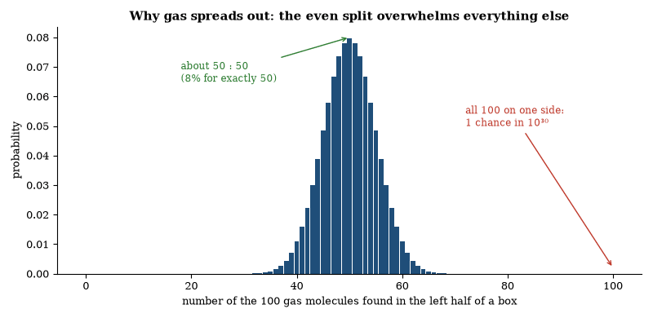
Figure 50. Entropy as counting. For 100 molecules the number of ways of having k on the left is the binomial coefficient C(100, k). Nearly all arrangements are close to an even split, so the gas ends up there; with 10²³ molecules the peak is a spike.
The law is statistical. Every microstate is equally likely. There are vastly more microstates that look disordered than microstates that look ordered. A system that begins in a low-entropy state is therefore overwhelmingly likely to evolve toward higher entropy. The reverse evolution is not forbidden. It is improbable to a degree that makes it unobservable in ordinary systems.
Heat flows from hot to cold because the combined system has more microstates when the temperatures are equal. Gases expand to fill their containers because the expanded state has more arrangements. Living things, which keep their internal entropy low, are a special case taken up at the end of this chapter.
The early universe was in a state of remarkably low entropy. The microwave background is smooth to one part in a hundred thousand. That smoothness is a low-entropy condition for the gravitational field. The subsequent increase in entropy includes the formation of stars, galaxies, and black holes. Black holes have entropy proportional to the area of their event horizons. They dominate the entropy budget of the observable universe.
Entropy defines a direction in time. The microscopic equations are time-symmetric. The boundary condition of low entropy in the past is not. The second law is the macroscopic consequence of that boundary condition. Why the boundary condition was low remains unexplained.

Maxwell’s Demon
Maxwell imagined a being that could sort molecules. A partition with a small door divides a box of gas, and the demon opens the door when a fast molecule approaches from the left and keeps it shut for slow ones. The right side grows hotter and the left colder, so entropy appears to fall without any work being done, and the second law seems violated.
The resolution is that the demon must acquire information. Measuring the speed of a molecule requires a physical interaction. The interaction increases the entropy of the measuring apparatus by at least as much as the entropy decrease in the gas. When the demon’s memory is erased to make room for the next measurement, the erasure dissipates heat. The total entropy of gas plus demon plus surroundings does not fall. The second law holds.
The argument was made precise by Szilard, Landauer, and Bennett. Landauer’s principle states that erasing one bit of information in a system at temperature T dissipates at least kT ln 2 of heat. The principle has been tested in small systems, and the measured dissipation matches the bound. Information is physical, and its acquisition and erasure have thermodynamic costs.
The demon does not refute the second law. It illustrates that the law applies to the complete system, including whatever performs the measurement and the erasure. No known process sorts molecules in a way that reduces the entropy of an isolated system. The thought experiment remains useful because it forces the accounting to be complete.

Feynman’s Ratchet
Richard Feynman asked a question about Maxwell’s demon that anyone can picture. Take a tiny wheel with vanes, immersed in a gas, and attach to its axle a ratchet with a pawl that lets the wheel turn only one way. Molecular impacts jostle the vanes at random. Surely the ratchet will turn the random jostling into steady rotation, and the wheel could lift a weight?
It cannot, if the whole device is at one temperature. The pawl is also a tiny object, and it too is knocked about by thermal motion. Every so often it bounces up and lets the wheel slip backward, and over time the forward and backward slips balance exactly. Only if the vanes are hotter than the pawl does the wheel turn, and then it is an ordinary heat engine moving heat from hot to cold, as the second law allows.
The lesson reaches into biology. Molecular motors in cells do move in one direction in a thermal bath, but they are never at a single temperature in this sense. They are driven by a continual supply of chemical free energy, usually from the splitting of ATP. Order in a cell is paid for, as the second law requires.

The Arrow of Time in Cosmology
Cosmology adds the question of why the low-entropy boundary condition holds. Inflationary models push the condition to still earlier times without explaining why it was satisfied. If an explanation exists, it probably lies in quantum gravity or in a selection principle among possible initial states, and no such principle is established.
The expansion itself does not define the arrow. A contracting universe with the same low-entropy boundary condition would also have a thermodynamic arrow pointing away from that boundary. What the observations show is a particular solution, with a smooth beginning and an expansion that happens to run the same way as entropy. The alignment is a fact about the solution rather than a law.

Friction and the Irreversibility of Everyday Motion
Friction converts ordered mechanical energy into disordered thermal energy, and the conversion is irreversible: a sliding block comes to rest. The reverse process—a block spontaneously beginning to slide by absorbing heat from its surroundings—has never been observed. The second law of thermodynamics quantifies the irreversibility.
At the microscopic level every collision is reversible. The irreversibility appears only when the number of degrees of freedom is large. The ordered motion of the block is shared among an enormous number of molecular degrees of freedom. The probability of those degrees of freedom reorganizing so as to return the energy to the block is vanishingly small. Friction is therefore the macroscopic signature of the second law.
The same irreversibility appears in viscosity, in electrical resistance, and in the damping of sound. In each case a macroscopic current or oscillation decays while the entropy of the thermal bath increases. No exception is known. The arrow of everyday time is the arrow of increasing entropy.

Static and Kinetic Friction
Friction is the force that opposes relative motion between surfaces in contact. Dry friction has a static coefficient that must be overcome before motion begins and a lower kinetic coefficient once motion is under way. Both coefficients are empirical. They depend on surface roughness, material and contamination. The microscopic origin is the formation and rupture of adhesive junctions and the interlocking of asperities.
The heat it generates is the everyday price of motion, and it is why no machine runs forever without a supply of energy. Lubrication reduces the coefficients by separating the surfaces with a fluid film. The same principles govern the design of bearings, brakes and joints. Biological joints are lubricated by synovial fluid. The engineering and the biology solve the same problem with different materials.

Life and the Second Law
A living organism maintains a low internal entropy by exporting entropy to its surroundings. It takes in free energy—sunlight or chemical fuel—and returns heat and waste. The total entropy of organism plus surroundings increases. The second law is not violated.
The free energy is used to synthesize ordered macromolecules, to maintain concentration gradients, and to perform mechanical work. The efficiency of the conversion is limited by the Carnot factor and by the irreversibility of the chemical reactions. Typical biological efficiencies lie well below the theoretical maximum.
Evolution by natural selection increases the adaptedness of populations. It does not decrease the entropy of the biosphere. The information stored in genomes is paid for by the entropy exported during the metabolic processes that replicate and repair the DNA. The arrow of biological complexity points in the same direction as the thermodynamic arrow.
No known organism operates outside these constraints. Life is a far-from-equilibrium process that is fully consistent with the second law.
Questions to Keep Asking
How do we know that entropy increases? Every large system observed obeys it, and laboratory experiments on tiny systems show the rare, brief violations that statistics allows.
A process that regularly turned heat into work with no waste would break the second law. What would you check before believing a report of one?
Try it yourself. How likely is a freshly shuffled deck of cards to be in the original order? (Answer: 1 in about 8 × 10⁶⁷.)

36. What Is Time?
Clocks tick at different rates for people who move or sit at different heights, no “now” is shared by everyone, and the equations for the whole universe may not contain time at all. The thing we feel most surely is the thing physics understands least.

The Measurement of Time
Time is measured by counting periodic processes. The rotation of the Earth, the orbit of the Moon, and the vibration of a quartz crystal have all served as clocks. The present definition of the second is 9 192 631 770 periods of the radiation corresponding to the transition between two hyperfine levels of the caesium-133 atom.
Atomic clocks achieve stabilities better than one part in 10¹⁶. Optical clocks that use transitions in the visible or ultraviolet are expected to reach one part in 10¹⁸. At that level the gravitational redshift produced by a height difference of one centimeter becomes measurable. Clocks therefore function as gravimeters.
The same atomic transitions define the meter through the fixed value of the speed of light. Length and time are no longer independent. The practical realization of both units rests on the same quantum standard. The historical separation of the two quantities has been replaced by a single metrological foundation.

The Block Universe
The block-universe view treats spacetime as a four-dimensional whole. Every event—past, present, and future—exists in the manifold. The passage of time is not an additional physical process. It is the relation between events ordered by the metric. An observer’s experience of “now” is the set of events on one spacelike surface. Different observers have different surfaces. None is privileged by the geometry.
The view is compatible with special and general relativity. The relativity of simultaneity already denies a universal present. The block description simply extends that denial to the entire history. Deterministic equations reinforce the picture: the solution on the whole manifold is fixed by data on any Cauchy surface. Stochastic equations replace a single block with a measure over blocks. In either case the fundamental object is the spacetime, not a moving present.
The view does not deny change. Change is the difference between events at different times. It denies that change requires a meta-time in which the present advances. The denial is metaphysical: physics supplies the metric and the field equations, and it does not supply an additional flowing now. Whether the block description is the correct ontology is not settled by experiment. It is a consistent reading of the existing formalism.

Time as a Parameter
In ordinary quantum mechanics and in classical field theory, time is a parameter, not an operator. The state evolves with respect to an external time. Position and momentum are operators, but time is the variable that labels the evolution. There is no time operator conjugate to the Hamiltonian that satisfies the canonical commutation relation on the full Hilbert space. Pauli showed that a self-adjoint time operator bounded below by the spectrum of the Hamiltonian cannot exist.
The parameter status is unproblematic in non-gravitational physics. Clocks exist. They are physical systems whose readings correlate with the parameter. The correlations are reliable. The underlying equations remain parameterized by an external t.
In canonical quantum gravity the situation changes. The Hamiltonian constraint generates evolution, there is no external time, and the Wheeler–DeWitt equation is timeless. Solutions are static wave functionals on the space of geometries. Time must be recovered, if at all, as a relation among the degrees of freedom. Different choices of internal clock yield different approximate Schrödinger equations. The recovery is approximate and contingent on the existence of suitable semiclassical degrees of freedom.
Time is therefore fundamental in the sense that the non-gravitational theories are written in terms of it, and emergent in the sense that a quantum theory of the gravitational field may not contain it as a basic variable. Both descriptions are in use. Neither has been shown to be the final one.

Complex Time
The Schrödinger equation is first-order in time and contains the imaginary unit. The formal substitution t → -iτ converts it into a diffusion equation. The substitution is useful in calculations. Euclidean path integrals rotate the time contour to make the action positive and the integral convergent. Instanton methods and lattice gauge theory rely on the rotation. The rotation is a mathematical device. It does not imply that physical time is complex.
Some proposals in quantum gravity and in the study of the wave function of the universe treat the early universe as Euclidean and the later universe as Lorentzian. The signature of the metric changes, but the change is a feature of particular minisuperspace models and is not required by a general theory, and no observation demands complex time coordinates.
Complex spacetime appears in twistor theory and in some string-theory constructions. The constructions are equivalent, in their physical predictions, to ordinary real spacetime plus additional structure. They do not alter the measured reality of real time intervals. Clocks still advance along real world-lines. The use of complex variables simplifies certain calculations. It does not replace the real parameter that orders events in the laboratory.

Barbour and the End of Time
Julian Barbour argues that time is not a fundamental entity. What exists are configurations of the universe—complete specifications of the relative positions and velocities of all particles, or of the geometry of space. Each configuration is a point in a vast configuration space. There is no external time in which these configurations occur. Change is the difference between configurations. The experienced flow of time is the reading of records that correlate one configuration with another.
The proposal is motivated by the structure of general relativity and of quantum gravity. The Einstein equations can be cast in a form that contains no explicit time. The Wheeler–DeWitt equation is likewise timeless. Barbour interprets the absence of a time variable as evidence that time is absent from the fundamental description. Dynamics is replaced by a relation among configurations. A path through configuration space is a history. The path is selected by a principle of least action or by a quantum amplitude. No meta-time is required for the path to exist.
Records supply the arrow. A configuration that contains structures correlated with other configurations is a record of those configurations. The correlation is asymmetric because of the low-entropy boundary condition of the early universe. The asymmetry is not a property of time. It is a property of the distribution of configurations. Observers inside a configuration that contains records experience a direction. The direction is real as a relation. It is not an additional flowing substance.
The account does not deny the utility of time in laboratory physics. Clocks work. The Schrödinger equation with an external parameter is an excellent approximation when a suitable internal clock exists. The claim is that the parameter is emergent. It is constructed from correlations among the timeless configurations. Whether the construction can be carried through in a realistic quantum cosmology is an open technical question. The conceptual proposal is that the question has an affirmative answer and that time is therefore not fundamental.

Time Prevents Everything from Happening at Once
The geometry of spacetime limits what can influence what. An event can affect another event only if a signal traveling at or below the speed of light can pass from the first to the second. The set of events that can be reached is the future light cone. The set that can reach the given event is the past light cone. Events outside both cones are spacelike separated. No causal influence passes between them.
The restriction is not an extra rule imposed on the laws. It is the causal structure already contained in the metric of special and general relativity. The same structure appears in quantum field theory, where operators at spacelike separation commute and measurements in those regions do not disturb each other. The prohibition on faster-than-light signaling is therefore both geometric and quantum-mechanical.
Without the restriction every event could influence every other event. The notion of a localized experiment, of a record that is stable until it is read, and of a sequence of causes and effects would not exist. The existence of time as an ordering that prevents everything from occurring in one undifferentiated moment is the existence of this causal structure. The structure is observed: signals do not outrun light and records persist. The prevention is not metaphorical. It is the light-cone structure of the spacetime we inhabit.

It from Bit
Wheeler proposed that every physical entity derives its significance from answers to yes-or-no questions. The slogan is “it from bit.” A particle, a field, or a region of spacetime acquires its properties through the registration of binary outcomes by measuring apparatus. The proposal does not claim that information replaces the field equations. It claims that the meaning of the physical quantities is fixed by the information those quantities yield under interrogation.
The idea draws on the structure of quantum mechanics. A measurement yields a definite result from a set of possible results. The result is recorded. Subsequent predictions use the updated state. Wheeler elevated the recording step from an epistemic convenience to an ontological primitive. Whether the elevation is required by the formalism is disputed. The formalism works with or without it. The proposal remains an interpretation.
Quantum information theory has since shown that information-theoretic constraints reproduce parts of quantum mechanics. No-cloning, no-deletion, and the existence of entanglement follow from simple axioms about information. These results are consistent with the spirit of the slogan. They do not demonstrate that spacetime or the metric emerges from bits. That demonstration is still absent.

The Participatory Universe
Wheeler argued that the observer is a participator. The act of measurement is not a passive registration of a pre-existing value. It is an intervention that elicits one outcome from a set of possibilities. The universe, on this view, does not sit finished and independent of all acts of observation. Its definite properties are brought about, in part, by those acts.
The delayed-choice experiment illustrates the claim. A photon passes through a double slit. After it has passed, the experimenter chooses whether to measure which-path information or an interference pattern. The choice appears to determine whether the photon behaved as a particle or as a wave in the apparatus it has already traversed. The quantum calculation accounts for the statistics without assigning a trajectory. Wheeler read the result as evidence that the past is not fixed until the measurement is completed.
The reading is optional. The standard formalism predicts the same correlations whether or not one speaks of participation. No experiment has shown that a conscious observer is required. Apparatus alone suffices. The participatory language emphasizes that measurement outcomes are not revealed properties of a detached system. It does not alter the predictive rules. The rules remain those of quantum mechanics.

The No-Boundary Proposal
Hawking and Hartle proposed that the wave function of the universe is given by a path integral over compact Euclidean geometries. There is no initial boundary. The universe does not begin at a singular edge. It is finite in the past yet without a boundary, in the same way that the surface of a sphere is finite yet has no edge.
The proposal selects a particular solution of the Wheeler–DeWitt equation. In simple minisuperspace models it yields a wave function that is large for geometries close to de Sitter space and small for highly irregular ones. The classical spacetime that emerges is an inflating universe. The arrow of time and the low initial entropy are related to the Euclidean section.
The proposal is a candidate boundary condition. It is not derived from a more fundamental theory. Different choices of contour and different operator orderings produce different wave functions. Observational tests are indirect: they constrain the duration and the spectrum of inflation but do not uniquely confirm the no-boundary condition. The idea remains a well-defined and influential suggestion for the quantum origin of the classical universe.

Conformal Cyclic Cosmology
Penrose has proposed that the universe consists of a sequence of aeons. Each aeon begins with a Big Bang and expands forever. In the remote future, after black holes have evaporated and massive particles have decayed or redshifted beyond relevance, only massless radiation remains. For massless particles the conformal geometry is all that matters; scale becomes meaningless. The infinite future of one aeon can be matched, by a conformal rescaling, to the Big Bang of the next. The low gravitational entropy of the new Big Bang is inherited from the smooth, empty state of the previous aeon.
The proposal requires no inflation and no multiverse. It uses only classical general relativity plus the assumption that rest mass eventually becomes irrelevant. It predicts concentric circles of anomalous temperature in the cosmic microwave background, produced by gravitational waves from black-hole encounters in the previous aeon. Claims of such circles have been published and disputed. The statistical significance remains contested.
The model is a possible extension of general relativity. It is not required by existing data. It offers one account of the low entropy of the Big Bang without invoking a special initial condition inside a single universe. Whether the predicted circles exist at the required amplitude is an observational question still under examination.

The Omega Point
Frank Tipler has proposed that the universe will end in a final singularity, the Omega Point, in which infinite information processing becomes possible. In that state, he argues, every past event can be reconstructed and every possible mind can be emulated. The proposal is a cosmological conjecture joined to a claim about computation.
The conjecture requires that the universe recollapse and that the collapse be sufficiently chaotic for the available energy to be used for computation without limit. Current observations indicate that the expansion is accelerating. A recollapse is not expected. Even if the expansion later reversed, the conditions required for unbounded computation are not known to be satisfied. The second law still applies. The entropy of the universe increases. The energy available for computation is finite in any region that remains finite.
The further claim is that a sufficiently powerful computation could resurrect every person who has ever lived by simulating them. The claim assumes that a simulation of a person is the person. That assumption is contested. It also assumes that the required information about each person survives or can be reconstructed. Most information about individual lives is not preserved. The proposal does not supply a mechanism that recovers it.
The Omega Point is therefore a speculative extrapolation, not a prediction of established cosmology. Logic does not rule it out; the evidence does not support it; and the accelerating expansion, the second law and the absence of any known way to recover lost information stand in its way.
An older, non-mathematical version comes from Pierre Teilhard de Chardin, who pictured a future state of maximum complexity and consciousness toward which the universe evolves. Neither version follows from established physics. A closed universe recollapses and an accelerating one expands and cools, and neither trajectory contains an attractor that maximizes consciousness. Both ideas need assumptions from outside present theory.

The Far Future of the Universe
The future can be forecast far further than the past can be recovered, because it is governed by laws we know. In about a billion years the Sun’s rising luminosity will end liquid water on Earth. In about five billion years it will swell into a red giant, and about then the Milky Way and Andromeda will merge. The merged galaxy will go on forming stars for some trillions of years, until the gas is used up.
The longest-lived stars, small red dwarfs, burn for ten trillion years or more. After the last of them fades, what remains are cold stellar remnants and black holes. If the proton is stable, as all experiments so far indicate, the remnants cool and persist. Black holes then evaporate by Hawking radiation, a stellar-mass hole in roughly 10⁶⁷ years and the largest supermassive holes in about 10¹⁰⁰. What is left is a thin, cold gas of photons and light particles in an ever-expanding space.
That picture assumes that dark energy is a true constant. If it changes, the ending changes with it, from a stretching that tears apart structures to a reversal that brings everything back together. Present data favor the cold, empty ending. Nothing in the equations makes the far future matter to anyone, and the timescales are so long that the question is mostly one of understanding the laws rather than predicting events. Brian Greene’s Until the End of Time treats the same story at greater length, with the question of how mind and meaning fit into it.
Questions to Keep Asking
How do we know that there is no universal “now”? Experiments with fast-moving clocks and the structure of signals show that events simultaneous for one observer are not for another.
What experiment could detect a preferred frame in which time is absolute?
Try it yourself. Imagine two lightning strikes at either end of a moving train, seen as simultaneous by someone on the platform. Why does a passenger in the middle disagree?
Further reading for Part VI. Weinberg’s The First Three Minutes and Barrow’s The Origin of the Universe give the standard picture in short books. Greene’s The Fabric of the Cosmos takes on space, time and the arrow of time, Penrose’s Cycles of Time proposes a stranger answer, and Barbour’s The End of Time denies that time exists at all. Carroll’s The Big Picture ties these questions to everything else.

Part VII: Life
From the first chemistry that copied itself to chemistry we can write, and to ourselves

37. The Origin of Life
Life appeared on Earth within a few hundred million years of the planet becoming habitable, and no one has watched it start. What chemistry did in that window is the largest question between cosmology and biology.
Life is chemistry that persists, copies, and changes. How ordinary chemistry first managed that is unsolved.
The Earth formed about 4.5 billion years ago. Within a few hundred million years, perhaps sooner, the planet had water and a crust. By about 3.5 billion years ago, and possibly earlier, life was present. The evidence is chemical and structural: traces in ancient rocks that look like the work of microbes, and isotopes sorted in ways life sorts them. The dates are argued but the conclusion is not: life started early, and it started small.
No one has watched life start, but the laboratory can show pieces. In 1953 Stanley Miller and Harold Urey sparked a mixture of gases then thought to resemble the early atmosphere and produced amino acids, the building blocks of proteins. Later work showed that the early atmosphere was probably less favorable than they assumed, and that the building blocks can form elsewhere: at hydrothermal vents, in drying ponds, in impacts and in the ices of space, and meteorites carry amino acids. The building blocks are not the mystery. The organization is.
A living cell keeps a boundary, a metabolism, and a way to copy instructions. Which came first is the argument. Genes-first theories put copying at the center. RNA is the favorite molecule, because it can store information and catalyze reactions. An “RNA world” may have preceded DNA and proteins. Membrane-first theories put the compartment at the center. A bubble of lipid can grow and split, and chemistry inside can differ from chemistry outside. Metabolism-first theories put energy at the center. Vents on the seafloor offer natural proton gradients, the same kind of gradient cells still use. Each school has evidence. None has a cell.
The deeper requirement is a source of order that does not rely on a cell already being there. Energy flow can do that. A system that takes in energy and exports waste can maintain structure. Life, once started, is such a system. The origin problem is how the first structures became self-copying rather than merely persistent.
We should be honest about the gap. Origin-of-life research is a serious field with real constraints from geology, chemistry, and genetics. It does not have a standard model. When it does, the model will have to explain not only how the parts can form, but how they can assemble under conditions the early Earth actually offered, and why the genetic code has the form it has. Until then, the origin of life is the largest blank between cosmology and biology.
The geological constraints are tighter than the chemical possibilities. The early Earth was bombarded. It had oceans, at least intermittently, by about 4.4 billion years ago, judging from ancient mineral grains. It had land and water and mineral surfaces. It may have had an atmosphere rich in carbon dioxide and nitrogen, with less free oxygen than today. Oxygen came later, produced by life. Any origin scenario has to work under those conditions, or under conditions that local environments, such as vents or ponds, could have provided.
Membranes are the other early requirement that chemistry can supply. Fatty acids and related molecules form vesicles in water. The vesicles can grow by taking up more material and can divide. They can hold different chemistry inside than outside. A plausible origin does not need a modern cell membrane at the start. It needs some compartment that persists long enough for copying to matter. Mineral surfaces can also concentrate and organize molecules. They may have served as the first scaffolds.
Energy is the third requirement, because a system that copies must be fed. Hydrothermal vents offer continuous chemical gradients. Alkaline vents, in particular, create natural proton gradients across mineral walls, and living cells still use proton gradients to make their energy currency. The resemblance may be a clue or a coincidence. Wet-dry cycles in ponds offer another energy regime, concentrating molecules and driving reactions that dilute water would not favor. Impact-delivered materials and atmospheric chemistry offer further inputs. More than one setting may have contributed. The origin need not have happened in a single kind of place.
What would count as a solution? A laboratory system that starts from plausible early-Earth materials, builds a compartment, a metabolism and a copying molecule, and then evolves without further intervention. No such system exists. RNA molecules have been evolved to perform new reactions, and protocells have been made to grow and divide, but nothing yet closes the loop. A headline announcing that life has been made in the laboratory should be checked against the actual system, which will be impressive and incomplete. The origin of life is a scientific problem with constraints: neither a mystery closed to investigation nor a solved problem in costume.
The genetic code is part of the residue. Nearly all life uses the same mapping from DNA triplets to amino acids. The mapping is not random. Some features of it reduce the effect of errors. Whether the code was inevitable or a frozen accident is debated. Its near-universality is evidence that all known life shares an ancestry. It does not, by itself, say how the first copying began.
One more constraint is phylogenetic. The last universal common ancestor was already complex. It had a membrane, a genetic code, ribosomes, and a metabolism. The origin has to reach that complexity, or reach something that could evolve into it. Scenarios that stop at a self-copying molecule have done something important and have not yet done the whole job. Scenarios that start with a metabolic cycle have the same gap in reverse. The full path is the unsolved problem. Partial paths are the progress. Both should be reported, and neither should be sold as the complete crossing.
Time is available. Several hundred million years separate the formation of a habitable surface from the first widely accepted evidence of life. That is a long interval for chemistry. It is a short interval compared with the history that followed. The early appearance of life is sometimes taken to mean that life starts easily. It may mean that. It may mean that we have only one sample, and the sample happened to start early. One sample cannot calibrate a rate. The early start is a constraint on scenarios, not a measurement of how common life is on other worlds.

The Definition of Life
No single definition of life is universally accepted. The working criteria used in exobiology are metabolism, reproduction, and evolution by natural selection. A system that maintains itself far from equilibrium, produces copies of itself, and can undergo heritable change that is subject to selection satisfies the criteria.
The criteria are operational. They do not require carbon chemistry or water. They do require a source of free energy and a mechanism of heredity. On Earth both requirements are met by chemistry based on carbon compounds in aqueous solution. Whether other chemistries can meet them is unknown. No example has been observed.
The same criteria distinguish life from non-life in laboratory experiments and in the search for biosignatures. A biosignature is a feature that is difficult to produce by abiotic processes. Atmospheric disequilibrium, chiral excesses, and complex organic polymers are candidates. None is conclusive by itself. The conjunction of several is more persuasive.

The RNA World Hypothesis
The RNA world hypothesis proposes that early life used RNA both to store genetic information and to catalyze the reactions of metabolism. DNA later assumed the storage role and proteins assumed most catalytic roles. The hypothesis is motivated by the dual capacity of RNA and by the central position of RNA in modern translation and in many coenzymes.
Ribozymes demonstrate that RNA can catalyze specific reactions, including the formation of peptide bonds and the replication of short RNA strands. Laboratory evolution has produced ribozymes with improved polymerase activity. No ribozyme yet copies long RNA templates with the fidelity and speed required for an autonomous cell. The gap is quantitative, not qualitative.
Prebiotic synthesis of nucleotides under plausible early-Earth conditions has been demonstrated in several pathways. Polymerization on mineral surfaces or in wet–dry cycles yields chains of tens of nucleotides. The spontaneous appearance of a self-replicating ribozyme from such mixtures has not been shown. Once such a molecule exists, Darwinian evolution can in principle improve it.
The hypothesis does not claim that RNA was the first informational polymer. It claims that an RNA-based stage is sufficient to bridge geochemistry and the last universal common ancestor, and that the molecular fossils in modern cells are the expected remnants of that stage. Alternative scenarios that begin with proteins, with lipids, or with other nucleic acids remain possible. The RNA world is the most fully articulated and experimentally supported of the current proposals. It is not yet a demonstrated historical pathway.

Prebiotic Chemistry
Prebiotic chemistry is the study of the reactions that could have produced the molecular components of life from inorganic and simple organic precursors under early-Earth conditions. The field began with the demonstration that electrical discharges in reducing gas mixtures yield amino acids. Subsequent work has produced sugars, nucleobases, nucleotides, lipids and short polymers by a variety of pathways.
Aqueous spark-discharge and photochemical reactions generate amino acids and some nucleobases. Formose-type chemistry produces sugars from formaldehyde. More recent pathways synthesize activated nucleotides from cyanosulfidic precursors under conditions that include ultraviolet irradiation and wet–dry cycling. Mineral surfaces catalyze polymerization. Lipid molecules spontaneously form vesicles that can grow and divide.
No single set of conditions has yet generated all required monomers and assembled them into replicating, compartmentalized systems. Concentrations, pH, temperature and the presence of interfering side reactions remain constraints. The chemical inventory of carbonaceous meteorites shows that many of the same compounds form in abiotic settings beyond Earth. The reactions are therefore cosmochemically plausible.
The experimental results establish that the building blocks of nucleic acids, proteins and membranes can arise without biological catalysts. They do not establish the sequence or the environment in which those building blocks first cooperated. That sequence is the unsolved core of the origin-of-life problem.

Organic Molecules and Proteins
Life is built from organic molecules—molecules based on carbon. Carbon atoms form stable bonds with each other and with hydrogen, oxygen, nitrogen, and other elements. They can make chains, rings, and branches of almost any length. No other element does this as readily under the conditions of a planet’s surface.
The simplest organic molecules are hydrocarbons, chains of carbon and hydrogen. Adding oxygen, nitrogen, or other atoms produces alcohols, acids, amines, and the rest of the vocabulary of organic chemistry. The same rules of bonding that govern a laboratory reaction govern the chemistry inside a cell. There is no separate vital chemistry. There is ordinary chemistry in a special setting.
Proteins are the workhorse molecules of life. They are chains drawn from twenty standard amino acids, and each chain folds into a characteristic shape that determines what the protein does. Some proteins are structural; many are enzymes, catalysts that speed particular reactions by factors of millions or more, without which metabolism would be far too slow to sustain life at ordinary temperatures.
The sequence of amino acids is specified by the gene. Change the gene, and in many cases you change the protein. The folding is determined by the sequence and by the cellular environment. Predicting the fold from the sequence was a long-standing problem. It is now largely solved for many proteins by computational methods trained on known structures. The experimental methods—X-ray crystallography and cryo-electron microscopy—still supply the reference structures.
Enzymes are specific. An enzyme that breaks down one sugar usually does not break down a different sugar. That specificity is why metabolism can be regulated. Pathways can be turned on or off by controlling the enzymes. Many drugs work by inhibiting a particular enzyme. The active site, the pocket where the reaction occurs, is the target.
Metabolism is the network of enzyme-catalyzed reactions that extract energy and build the molecules a cell needs. The central pathways—breaking down sugars, capturing energy in ATP, building amino acids and nucleotides—are shared across a wide range of life. The sharing is evidence of common ancestry. The variations are evidence of adaptation. A cell is a chemical system that maintains itself by running these pathways continuously, taking in fuel and exporting waste. Stop the flow, and the structure collapses.

The Protein That Should Not Fold
A protein is a chain of amino acids. The chain folds into a specific three-dimensional structure in milliseconds to seconds. The number of possible conformations is astronomical. A random search would take longer than the age of the universe. The chain nevertheless finds the native structure reliably. The discrepancy is Levinthal’s paradox.
The resolution is that the search is not random. The energy landscape is shaped like a funnel, and local interactions guide the chain toward its native state, helped by folding intermediates and by chaperone proteins. Misfolding happens, but as the exception, and the exception can cause disease.
Folding shows that a search through a vast space can be fast when the landscape is structured. The structure is written in the sequence, the sequence in the genome, and the genome is the product of selection, which kept the chains that fold. The reader is built from them.

Alternative Biochemistries
Carbon chemistry in water is the only known basis for life. Other possibilities have been examined. Silicon can form chains, but the bonds are weaker and the oxides are solid. The temperature range in which silicon chemistry remains fluid is narrow. Ammonia and methane can serve as solvents at lower temperatures. The reaction rates are slower. No self-replicating system based on either solvent has been demonstrated.
Energy sources other than chemical redox or sunlight are conceivable. Tidal heating, radiolysis, and geothermal gradients already power ecosystems on Earth that do not rely on photosynthesis. The same sources could operate elsewhere. The requirement is a sustained free-energy flux and a mechanism of heredity. The particular molecules that satisfy the requirement may vary.
Laboratory work has expanded the genetic alphabet with synthetic base pairs, which shows that other informational polymers are chemically possible. No living system built on them has been made, so alternative biochemistries remain possible but unsupported by observation.
Questions to Keep Asking
How do we know when life began? Carbon isotopes in ancient rocks and layered mats of microbes called stromatolites show living processes by about 3.5 billion years ago, with hints earlier.
A fully lifeless explanation of every early trace would not prove life absent. What would settle it?
Try it yourself. List three things a protocell must do, and name a place on the early Earth that could supply each.

38. The Cell
Every cell in your body descends, by an unbroken line of divisions, from the first cells almost four billion years ago. The cell is the smallest thing we call alive, and it is a city.
The cell is the basic unit of life. Every organism is either a single cell or a collection of cells. The idea was established in the nineteenth century. It remains the foundation of biology.
Cells are of two broad kinds. Prokaryotic cells—bacteria and archaea—have no nucleus, and their DNA is in the cytoplasm. Eukaryotic cells—the cells of animals, plants, fungi, and protists—have a nucleus that holds the DNA, and they have other internal compartments. Mitochondria, which produce most of the cell’s usable energy, and chloroplasts, which carry out photosynthesis in plants and algae, were once free-living bacteria. They were taken in and became permanent. The evidence is their own DNA and the structure of their membranes.
A cell is bounded by a membrane made of lipids, with proteins embedded in it. The membrane controls what enters and leaves. Inside, the cytoplasm is crowded with molecules; it is not a bag of dilute solution but a dense, organized environment. In eukaryotic cells, an internal skeleton of protein filaments gives shape and moves cargo. Energy is obtained by oxidizing organic molecules or by photosynthesis, with ATP as the common currency, and information flows from DNA to RNA to protein.
Cells reproduce by dividing. In prokaryotes the process is relatively simple. In eukaryotes, mitosis parcels the chromosomes so that each daughter cell receives a full set. Meiosis, used in sexual reproduction, halves the chromosome number so that fertilization restores it. Errors in these processes cause many genetic diseases and contribute to cancer.
The cell cycle is regulated. Checkpoints ensure that DNA is copied accurately and that the cell is ready to divide. Failures of regulation are a hallmark of cancer. Many cancer drugs target the machinery of division or the signals that drive it.
Cells communicate. They release signals, and they carry receptors that detect signals from other cells or from the environment. Development—the building of a body from a fertilized egg—is a conversation among cells, guided by genes that are turned on and off in sequence. The same genes appear in different animals, used in different combinations. A gene involved in building an eye in a fly has a relative involved in building an eye in a mouse. The parts were reused. The arrangements diverged.
Every cell alive today is the product of an unbroken sequence of divisions stretching back to the origin of life. The sequence is the deepest continuity in biology. Understanding the cell is understanding the unit in which that continuity is maintained.

Cell Theory and Germ Theory
The cell theory states that all living organisms are composed of cells and that cells arise only from pre-existing cells. The statement was assembled in the nineteenth century from observations by Schleiden, Schwann, and Virchow. It replaced earlier views that living matter could arise spontaneously or that tissues were continuous substances. Every organism examined since has confirmed the rule. Viruses are not cells, but they replicate only inside cells.
The germ theory, described in the next section, states that many diseases are caused by microorganisms. It does not claim that every illness is infectious, only that infectious illnesses have microbial causes that can be demonstrated.
Both theories are now foundational: cell theory for development, physiology and evolution, germ theory for public health and medicine. Neither required a new force. Both followed from the consistent use of microscopy, staining and controlled experiment, and the observations stand independently of the wording in which they were first announced.

Spontaneous Generation and the Germ Theory
For most of history it seemed obvious that life could arise from non-life. Maggots appeared in meat and mice appeared in grain, and the process was called spontaneous generation. It was accepted by Aristotle and by most writers after him.
Experiments gradually closed the claim. In the seventeenth century Francesco Redi showed that maggots did not appear in meat if flies were kept away, and in the eighteenth Lazzaro Spallanzani showed that broth, boiled and sealed, did not spoil. Critics said the sealing shut out a vital principle in the air, so in the nineteenth century Louis Pasteur used flasks with curved necks that let air in but trapped dust and microbes. The broth stayed clear until the neck was broken, and then it spoiled. Life comes from life.
The same work opened the germ theory of disease. Specific diseases are caused by specific microorganisms. Robert Koch set the criteria: the organism must be found in the diseased host, grown in pure culture, produce the disease when introduced into a healthy host, and be recovered again. Those postulates identified the agents of anthrax, tuberculosis, cholera, and many others.
Vaccination uses the immune system’s memory: Edward Jenner showed that cowpox protected against smallpox, and Pasteur developed weakened strains that protected against other diseases. Antibiotics, beginning with penicillin, kill or stop bacteria without killing the host. Viruses are not affected by antibiotics. They are stopped by the immune system, by vaccines, or by antiviral drugs.
The disproof of spontaneous generation did not close the question of how life began. It closed the claim that life arises readily and continuously under ordinary conditions. The origin of life is a separate problem, pushed back to the early Earth, where conditions were different and time was long.

Microbiology
Microbiology is the study of organisms too small to see without magnification. The group includes bacteria, archaea, many fungi, protists, and viruses. Bacteria and archaea are prokaryotes. They lack a membrane-bound nucleus. Their DNA is usually a circular chromosome in the cytoplasm, often accompanied by smaller plasmids. Eukaryotic microbes have nuclei and organelles.
Bacteria reproduce by binary fission, and under favorable conditions some species double in twenty minutes. They exchange genes by transformation, transduction, and conjugation. These processes move DNA between cells that are not parent and offspring. The result is rapid spread of traits, including antibiotic resistance.
Archaea resemble bacteria in size and simplicity but differ in membrane lipids, cell-wall chemistry, and the machinery of transcription and translation. Many live in extremes of temperature, salinity, or acidity. Some produce methane. Their ribosomal RNA sequences place them on a separate branch of the tree of life.
Fungi and protists are eukaryotes. Yeasts are unicellular fungi used in fermentation, and molds form filaments. Protists include algae that photosynthesize and protozoa that ingest food. Amoebae, described in their own section, are protists that move and feed by extending pseudopods.
Microbes drive the major chemical cycles of the planet. They fix nitrogen, produce oxygen, decompose organic matter, and generate methane. They also cause disease. The same tools—culture, microscopy, staining, and sequencing—identify both the beneficial and the pathogenic species. The distinction is ecological, not taxonomic.

The Uncultured Majority
Culture-independent methods—16S rRNA sequencing and metagenomics—have revealed that the majority of microbial species have never been grown in the laboratory. The uncultured majority includes entire phyla. Their ecological roles are inferred from genomes and from environmental correlations. The inference is incomplete. It is already sufficient to show that microbial diversity and activity dominate the biosphere.
Prokaryotic metabolism is more diverse than that of all eukaryotes combined, and microbes cycle carbon, nitrogen, sulfur and metals from hydrothermal vents to the human gut. Viruses, the most abundant biological entities, regulate microbial populations and mediate horizontal gene transfer. The microbial world is therefore both the metabolic foundation of the biosphere and a continuous source of genetic innovation.

Viruses
Viruses are particles that replicate only inside living cells. They consist of nucleic acid enclosed in a protein coat. Some have a lipid envelope derived from the host membrane. The nucleic acid is DNA or RNA, single- or double-stranded, linear or circular. The coat protects the genome and, in many cases, attaches to a receptor on the host cell.
Outside a cell a virus is inert. It has no metabolism and no independent replication. Inside a susceptible cell it redirects the host machinery to copy its genome and synthesize its proteins. New particles assemble and leave, often destroying the cell. The host range is limited by the receptors the virus can bind. A virus that infects one species may be unable to infect another.
Bacteriophages infect bacteria. They were used to show that DNA, not protein, carries genetic information. Animal and plant viruses cause many diseases. Some insert their genome into the host chromosome and remain latent. Others kill the cell quickly. Retroviruses reverse-transcribe RNA into DNA that integrates into the host genome. The integrated form can be transmitted to daughter cells.
Viruses evolve. Mutation rates are high, especially in RNA viruses. Recombination and reassortment occur when multiple viruses infect the same cell. The result is rapid change in surface proteins and in host range. Vaccines and antiviral drugs select for resistant variants. The same processes that generate diversity in cellular organisms operate, at higher speed, in viruses.
Viruses are not classified as living by most definitions because they lack independent metabolism. They are biological entities that evolve and that affect every domain of life. They move genes between hosts, regulate microbial populations, and shape the evolution of immune systems. Their study is part of microbiology whether or not they are counted as organisms.

Amoebae
Amoebae are unicellular eukaryotes that move by pseudopods. The pseudopod is a temporary extension of the cytoplasm. Actin filaments polymerize at the leading edge and push the membrane forward. Myosin and other motors contract at the rear and the cell advances. The same machinery is used for phagocytosis. The amoeba surrounds a particle of food, encloses it in a vesicle, and digests it with enzymes delivered from lysosomes.
Most amoebae are free-living, in soil, fresh water and marine sediments, feeding on bacteria, algae and detritus. A few are parasites or opportunists: Entamoeba histolytica infects the human intestine and can invade the liver, and Naegleria fowleri, which lives in warm fresh water, can infect the brain if it enters through the nose. Such cases are rare, and most amoebae never meet a human host.
Amoebae were among the first microbes observed. Leeuwenhoek described them in the seventeenth century. Later workers used them to study cell movement, phagocytosis, and cytoplasmic streaming. The mechanisms proved to be general. The same actin–myosin system operates in the white blood cells of animals and in the crawling of many other cells. The amoeba is a convenient model because the entire organism is one cell and the behavior is visible under a light microscope.
The group is not a single evolutionary lineage. “Amoeba” describes a body plan that has evolved more than once. Some amoeboid organisms are closely related to animals and fungi. Others belong to distant branches of the eukaryotic tree, so the shared appearance is convergent while the underlying cell biology is ancient.

Endosymbiosis and Multicellularity
Eukaryotic cells contain mitochondria. Plant cells also contain chloroplasts. Both organelles have their own DNA, their own ribosomes, and double membranes. The DNA is circular, like bacterial DNA. The sequences show that mitochondria are related to alphaproteobacteria and chloroplasts to cyanobacteria. The organelles were once free-living bacteria that became permanent residents of host cells. The process is endosymbiosis.
The host gained the ability to produce ATP by oxidative phosphorylation or to fix carbon by photosynthesis. The endosymbiont gained a stable environment and a supply of nutrients. Over time most of the endosymbiont’s genes were transferred to the host nucleus. The organelles retained a reduced genome that encodes some of their own proteins. The arrangement is stable. It occurred once for mitochondria, early in eukaryotic history, and once for the primary chloroplast, in the ancestor of the Archaeplastida; a second, much later primary event gave the amoeba Paulinella its own photosynthetic organelle. Secondary endosymbioses, in which a eukaryotic cell engulfed another eukaryote that already had a chloroplast, occurred several times and produced the chloroplasts of other algal groups.
Multicellularity evolved independently many times. Animals, plants, fungi, and several groups of algae and bacteria all contain multicellular species. The transition requires cells to adhere, to communicate, and to differentiate. In animals the extracellular matrix and cell-adhesion molecules hold cells together. Signaling pathways control division and specialization. Programmed cell death removes cells that are no longer needed. The genetic toolkit for these functions existed in unicellular ancestors and was co-opted. The Cambrian radiation, about 540 million years ago, produced most of the major animal body plans in a geologically short interval. The causes are debated. They include rising oxygen, ecological interactions, and the evolution of developmental gene networks. The fossil record shows the outcome. The precise triggers remain under study.

Photosynthesis
Photosynthesis converts light energy into chemical energy. In oxygenic photosynthesis water is the electron donor and oxygen is released. The overall reaction is 6 CO₂ + 6 H₂O → C₆H₁₂O₆ + 6 O₂. Light is absorbed by chlorophyll and accessory pigments in the thylakoid membranes. Two photosystems operate in series: photosystem II splits water, and photosystem I reduces NADP⁺. The electron transport chain between them generates a proton gradient that drives ATP synthesis.
The ATP and NADPH are consumed in the Calvin cycle. Ribulose bisphosphate carboxylase/oxygenase fixes carbon dioxide into organic molecules. The cycle regenerates the acceptor and produces triose phosphates that are converted to sugars, starch or other compounds. The enzyme also reacts with oxygen, initiating photorespiration. The competition is an unavoidable consequence of the active-site chemistry.
Photosynthesis supplies the free energy and the reduced carbon that support almost all ecosystems. Its oxygen byproduct transformed the atmosphere. The same core reactions operate in cyanobacteria, algae and plants. Variations in carbon-concentrating mechanisms and in pigment composition adapt the process to different light and carbon regimes. The quantum efficiency of the light reactions is high. The overall energy efficiency of biomass production is far lower.

Cellular Respiration
Cellular respiration extracts energy from organic molecules. Glycolysis converts glucose to pyruvate in the cytosol, yielding a net of two ATP and two NADH. In aerobic organisms pyruvate enters the mitochondria. The citric-acid cycle oxidizes the acetyl group to two molecules of carbon dioxide and produces additional reduced coenzymes. The electron-transport chain transfers electrons from NADH and FADH₂ to oxygen. The free energy is used to pump protons. The return of protons through ATP synthase produces the majority of the ATP.
The overall yield from one glucose is approximately thirty ATP under cellular conditions. The theoretical maximum is higher. Proton leaks and the cost of transporting metabolites reduce the net gain. Anaerobic pathways regenerate NAD⁺ by reducing pyruvate to lactate or to ethanol and carbon dioxide. They yield only the two ATP from glycolysis.
The same respiratory chain operates in bacteria and in mitochondria. Mitochondria are the descendants of endosymbiotic bacteria. The chemiosmotic mechanism—proton gradient coupled to ATP synthesis—is universal among aerobic organisms. Respiration and photosynthesis are complementary: one stores energy in organic molecules and oxygen, and the other releases it.

Gene Expression and Regulation
Gene expression is the conversion of genetic information into functional products. Transcription produces an RNA copy of a DNA segment. In eukaryotes the primary transcript is processed: introns are removed, a cap and a poly-A tail are added. Translation on the ribosome converts the messenger-RNA sequence into a polypeptide. The genetic code is read in non-overlapping triplets.
Regulation occurs at every step. Transcription factors bind specific DNA sequences and recruit or block RNA polymerase. Chromatin structure modulates access. Alternative splicing generates multiple protein isoforms from one gene. Messenger-RNA stability and translational efficiency are controlled by proteins and small RNAs. Post-translational modifications activate, inhibit or target the finished protein.
The regulatory network of a cell is dense. A single transcription factor may control dozens of genes. Feedback loops, both positive and negative, produce switches, oscillators and homeostatic responses. The same basic machinery operates in bacteria, archaea and eukaryotes. The additional layers of chromatin, splicing and compartmentalization in eukaryotes allow more elaborate control. The outcome is that genetically identical cells can adopt different phenotypes according to their history and their environment.

Development and Differentiation
Development is the progressive specialization of cells from a single zygote. Early cleavage produces a blastula, gastrulation rearranges the cells into three germ layers, and subsequent inductive interactions between layers generate the organs. The process is controlled by gradients of signaling molecules and by sequential activation of transcription-factor networks.
Cell differentiation is usually irreversible under normal conditions. The differentiated state is maintained by feedback loops in the gene-regulatory network and by chromatin modifications that are copied at mitosis. Stem cells retain the capacity to produce multiple cell types. Embryonic stem cells are pluripotent. Adult stem cells are multipotent and replenish specific tissues.
Regeneration varies widely. Some animals replace entire limbs or organs, while mammals regenerate liver and blood but not limbs. The difference lies in whether patterning information persists and whether differentiated cells can re-enter the cell cycle or be replaced by stem cells. The molecular toolkit of signaling pathways, transcription factors and adhesion molecules is ancient, but its deployment differs, so development is both conserved and plastic.
Questions to Keep Asking
How do we know that mitochondria were once bacteria? They have their own circular DNA and ribosomes and a double membrane, and their genes are closest to those of free-living bacteria.
What would you conclude if a modern eukaryote were found with no trace of either endosymbiosis?
Try it yourself. Look at a drop of pond water or yogurt under a magnifier or a phone with a macro lens. What moves, and what stays still?

39. Evolution and Genetics
Darwin knew nothing of genes. He needed variation, inheritance and differences in survival, and he had the evidence for all three. The molecular century then supplied the machinery, and the pattern written in DNA matches the tree he drew from bones and beaks.
Once copying exists, evolution is difficult to avoid.
Copies are not perfect, and some of the changes make the copy more likely to be copied again in that environment, so those changes become common. The process needs no foresight, only inheritance, variation and unequal success. Charles Darwin and Alfred Russel Wallace stated the logic in 1858, and the evidence since has become overwhelming.
Evolution is not only selection. Drift, the luck of small populations, also changes gene frequencies; genes move between lineages, especially in microbes; and development biases which variations appear. None of this repeals selection. It fills in the picture.
The theory’s power is that it connects. Antibiotic resistance, the fit of a moth to a tree, the useless hind limbs of a whale, and the shared code of all known life are one subject. A biology that rejected evolution would have to explain each of them again, separately, and worse.
Given enough time, and given the way development builds bodies, the changes that selection accumulates can be large. The logic does not require progress, purpose, or a direction toward complexity. Complexity has increased in some lineages and not in others, and bacteria have remained bacteria, with enormous biochemical sophistication, for billions of years. They are not failed animals. They are the most successful living things on Earth by number, by mass, and by tenure, and the history of life is mostly microbial.
The evidence is independent in kind and convergent in result. Fossils show a sequence. They do not show modern animals in the oldest rocks. They show earlier forms, then later forms, with transitional fossils in many lineages: fish with limb-like fins, dinosaurs with feathers, whales with hind limbs, hominins with intermediate brain sizes and bipedal skeletons. Biogeography shows that islands and continents carry the descendants of whoever could get there. Anatomy shows common structure under different uses. Embryology shows related species passing through related stages. Molecular biology shows the same code, shared genes, shared errors, and shared viral insertions. A single lineage explains all of these. Separate creation of each species would have to explain them again, one by one, as coincidences.
Genetics filled the gap Darwin noted. He did not know how traits were inherited or how variation was supplied. Mendel’s work, rediscovered at the start of the twentieth century, showed particulate inheritance. Later work identified the particles as stretches of DNA. Mutation, recombination, and gene flow supply variation, and selection, drift, and the biases of development filter it, so the modern synthesis joined Mendel to Darwin. Later work has added regulatory genetics, developmental genetics, and the movement of genes between lineages, especially in microbes. The additions refine the mechanism and do not replace the filter.
Speciation is the production of separate lineages that no longer freely intermix. It can happen when populations are divided by geography, and it can happen, less simply, without that division. Once separated, populations accumulate differences. Eventually they may be unable to produce fertile offspring together, or they may simply not meet. Species are real lineages. The boundaries can be messy, especially in plants and in microbes, where hybridization and gene transfer are common. Messy boundaries are what a branching process produces. They are not an objection to the process.
Human evolution, the subject of Chapter 47, is the same process applied to one lineage, plus the cultural inheritance that lineage eventually produced. The genetic difference between humans and chimpanzees is small in percentage and large in consequence, much of it in gene regulation rather than in protein-coding sequence.
Evolution is as well supported as any theory in science. It is also, in its details, an active research field. The relative importance of selection and drift, the role of development in biasing variation, the frequency of gene transfer, and the genetic basis of particular adaptations are debated. Debate about details is not doubt about the framework. A reader can treat the framework as settled and the details as the place where new work happens. That is the accurate division.
Resistance is the evolution a person can watch. Bacteria exposed to an antibiotic evolve resistance, by mutation or by acquiring a gene from elsewhere. Viruses evolve as they spread and tumors evolve under treatment. The process is not confined to the fossil record but is a present mechanism. Medicine that ignores it produces resistant infections and resistant cancers. Agriculture that ignores it produces resistant pests. The practical importance of evolution is not only that it explains the history of life. It is that it is still running, on timescales that policy and medicine have to respect.
Sexual reproduction is a puzzle the theory has to solve, because it has a cost. An organism that reproduces sexually passes on only half its genes, relative to one that clones. The advantage that pays for the cost is probably the mixing of genes, which produces variety that helps in the presence of parasites and of changing conditions, and which clears harmful mutations. The debate about the exact advantage is ongoing. The existence of the cost is clear. The near-universality of sex among complex organisms suggests the advantage is large. The theory is strong enough to have puzzles of this kind. A weaker theory would not define them so sharply.
Convergence is the evidence that selection can reach similar solutions more than once. Eyes have evolved several times. Wings have evolved several times. Antifreeze proteins in cold-water fish have evolved separately in different lineages. Convergence shows that the space of possible forms is constrained by physics and by development, and that selection finds the workable regions of that space repeatedly. It is not evidence against common ancestry. It is evidence about the power of the filter once ancestry has supplied a lineage. The two together, shared descent and repeated solution, explain both the unity and the rhyming of life.

Natural Selection
Natural selection is the differential reproductive success of individuals that differ in heritable traits. When the differences affect survival or fertility, the frequencies of the underlying alleles change. The change is evolution by natural selection.
The process requires three conditions: variation, heritability, and differential success. All three are observed. The response to selection is the product of the heritability and the selection differential. Artificial selection in domesticated plants and animals demonstrates the magnitude of the response when the conditions are met.
Selection can be directional, shifting the average of a trait; stabilizing, reducing its variance; or disruptive, favoring the extremes. Sexual selection is the special case in which success differs through competition for mates. All these forms are documented in natural populations.
Selection acts on phenotypes. It therefore acts on genotypes only to the extent that they influence phenotypes. The mapping from genotype to phenotype is often complex. Epistasis, pleiotropy, and environmental effects modulate the response. The net result over geological time is the diversity of adapted organisms.
The appearance of design in living things is real: the eye focuses and the wing generates lift. The enzyme catalyzes a reaction at a rate that would otherwise take longer than the age of the universe. For centuries the inference was that such arrangements required a designer. The inference is unnecessary.
Natural selection produces cumulative adaptation without foresight. Variation exists, some variants leave more offspring than others, and the difference is inherited, so over generations the population changes. The change is not random: it is directed by how well the variants do in the environment they actually inhabit. That direction is local and retrospective, aims at no distant goal, and requires no organism to understand it.
The cumulative character is essential. A single mutation rarely produces a complex organ. A sequence of mutations, each preserved because it conferred a small advantage in its own generation, can. The intermediates need not be useful for the final function. They need only be useful for something at the time they appear. The history is recoverable in the fossil record, in comparative anatomy, and in the sequences of genes. The same gene families appear in organisms that use them for different purposes. The pattern is the pattern of descent with modification, not the pattern of separate creation.
The process has no designer and no plan, and it guarantees no progress in any global sense: lineages go extinct, and complexity can decrease. What it does guarantee is that, given variation, heritability and differential reproduction, adaptation will accumulate where conditions allow, as they have for more than three billion years. The result is the diversity of life. The mechanism is ordinary; the outcome is not.

Genetics Before DNA
Darwin’s theory of natural selection required that offspring resemble their parents and that variation exist. It did not explain how the resemblance or the variation was transmitted. The mechanism was missing, and it arrived in stages: first Mendel’s factors and the chromosomes that carry them, described in the next sections, then mutation, and finally DNA itself.
Mutations are changes in genes. They arise spontaneously at low rates, which radiation and certain chemicals raise, and most are neutral or harmful; a rare few help in a particular environment. Natural selection acts on the variation that mutation supplies, and the combination of mutation, selection and Mendelian inheritance, the modern synthesis, is the working account of evolution.
The physical nature of the gene was unknown until the middle of the twentieth century. Experiments showed that DNA, not protein, carries the genetic information. The structure of DNA, a double helix with complementary bases, explained how it can be copied. A triplet code of bases specifies amino acids, and its near-universality is evidence of common ancestry.
The history from Mendel’s ratios to the structure of DNA took less than a century. The facts accumulated and the explanations followed, and the same pattern continues.

Mendel and the Chromosomes
Gregor Mendel crossed pea plants that differed in clear traits and counted the offspring. Tall crossed with dwarf gave all tall in the first generation. Self-pollination of those hybrids gave three tall to one dwarf in the next. The dwarf trait had not disappeared. It had been hidden. Mendel proposed that each plant carries two factors for each trait, that the factors separate when gametes form, and that one factor can mask the other. The ratios followed. The same pattern held for other traits he tested.
The factors are now called genes, and they are segments of DNA. The separation Mendel inferred is the separation of paired chromosomes in meiosis: each gamete receives one member of each pair, and fertilization restores the pair. The masking is dominance, and the hidden factor is recessive, so the trait appears only when both copies are recessive. The arithmetic is the same whether the factors are abstract or molecular.
The work was published in 1866 and ignored. It was rediscovered in 1900 by investigators who had reached the same ratios. Within a few years the factors were located on chromosomes. Sutton and Boveri noted that chromosomes behave as Mendel’s factors must behave. Morgan’s group in fruit flies mapped genes to specific positions by measuring how often traits are inherited together. Linkage and recombination became measurable. The chromosome theory of inheritance was established.
The theory accounts for the transmission of traits. It does not by itself account for the origin of new traits. That required the later recognition of mutation. Together, Mendelian transmission and mutational variation supplied the genetic mechanism that Darwin’s theory had lacked. The mechanism is now molecular. The ratios Mendel counted remain.
Segregation occurs in meiosis. The two copies of a gene separate so that each gamete receives one. Independent assortment occurs when genes lie on different chromosomes or are far apart on the same chromosome. Linked genes tend to be inherited together. The frequency of recombination measures the distance between them.
Dominance and recessiveness describe the relation between alleles. A dominant allele produces its phenotype when present in one copy. A recessive allele produces its phenotype only when present in two copies. Many traits are not simply dominant or recessive. They show incomplete dominance, codominance, or continuous variation produced by multiple loci and by the environment.
The Mendelian rules hold for the great majority of nuclear genes in sexual organisms. Exceptions—cytoplasmic inheritance, imprinting, and meiotic drive—are known and are themselves genetically controlled.

The Double Helix
DNA is a double helix: two strands of sugar and phosphate wind around each other, running in opposite directions, with the bases pointing inward and paired, adenine with thymine and guanine with cytosine, held by hydrogen bonds. James Watson and Francis Crick proposed the structure in 1953, using X-ray diffraction data from Rosalind Franklin and Maurice Wilkins.
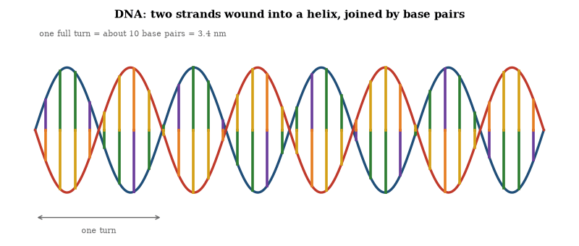
Figure 51. A schematic of the double helix. Two sugar–phosphate backbones wind around each other, joined by pairs of bases: A with T and G with C. About ten base pairs make one turn of 3.4 nanometres. The sequence along one strand fixes the sequence of the other, which is the copying rule.
The proposal rested on several lines of evidence. Erwin Chargaff had shown that in any sample of DNA the amount of adenine equals that of thymine, and guanine equals cytosine, which suggested pairing. X-ray diffraction images of DNA fibers, made by Rosalind Franklin and Raymond Gosling at King’s College London and by Maurice Wilkins, showed that the molecule is helical and gave its dimensions; the best known, Photograph 51, is the X-shaped pattern characteristic of a helix. The helix is about 2 nanometers wide and repeats every 3.4 nanometers, with about ten base pairs per turn.
Franklin’s data reached Watson and Crick indirectly: Wilkins showed Watson Photograph 51, and a report summarizing Franklin’s measurements was also seen. Watson and Crick used the constraints to build a physical model. Earlier attempts had failed because the chemistry was wrong. The successful model placed the sugar-phosphate backbones on the outside and the base pairs on the inside. The pairing of A with T and G with C made every rung the same width, and the strands are antiparallel. The structure immediately suggested a copying mechanism, since each strand can serve as a template for a new complementary strand, and Watson and Crick noted the implication in their paper.
Three papers appeared together in Nature in April 1953: one by Watson and Crick presented the model, one by Wilkins and colleagues presented diffraction data, and one by Franklin and Gosling presented their X-ray results. Watson, Crick, and Wilkins received the Nobel Prize in 1962. Franklin had died in 1958 and was not eligible.
The structure explains how genetic information is stored and copied. The sequence of bases is the information, the complementary pairing is the copying rule, and mutations are changes in the sequence. The same double helix is found in bacteria, plants, animals, and humans. The differences are in the sequence, not in the architecture. The architecture is what makes inheritance possible.

The Structure and Replication of DNA
The 1953 paper by Watson and Crick proposed a specific structure for the salt of deoxyribose nucleic acid. Two helical chains coil around the same axis. The chains are related by a dyad perpendicular to the fiber axis, so the sequences of atoms run in opposite directions. The bases are on the inside. The phosphates are on the outside. There is a residue every 3.4 angstroms along the axis. The angle between adjacent residues is 36 degrees, so the structure repeats after 10 residues, or 34 angstroms. The distance of a phosphorus atom from the axis is about 10 angstroms.
The chains are held together by hydrogen-bonded pairs of bases. One member of each pair is a purine and the other is a pyrimidine. The pairing rules are adenine with thymine and guanine with cytosine, and they account for Chargaff’s ratios. It also makes every rung the same width, so the backbone is regular. The structure is open and contains a good deal of water. At lower water content the bases tilt and the structure becomes more compact. That matches the observation of two forms, A and B, depending on humidity.
A second paper by Watson and Crick, published weeks later, spelled out the genetical implications. The two chains are complementary. The sequence on one determines the sequence on the other. Before duplication the hydrogen bonds break and the chains unwind and separate. Each chain then serves as a template for a new complementary chain. The result is two pairs where there was one. The sequence is duplicated exactly. The genetic information is carried in the sequence of the bases. The paper did not explain how that sequence specifies proteins. That explanation came later.
The X-ray papers published with the model supplied the supporting measurements. Franklin and Gosling described the B form as a helix with the phosphate groups on the outside. Wilkins and colleagues reported similar dimensions from other samples and noted that the pattern is consistent with a helical structure. The model fit the data. Later crystallographic work confirmed the coordinates in detail.
The technical result is a molecule that can store a sequence and copy it. The sequence is the information. Complementarity is what makes the copying possible. Everything that followed in molecular biology rests on that architecture.

DNA and the Genetic Code
Each strand of the double helix is a polymer of nucleotides, and the sequence of its four bases encodes information. The pairing allows each strand to serve as the template for the other.
The genetic code maps triplets of bases to amino acids. The code is nearly universal and is degenerate: most amino acids are specified by more than one codon. Translation occurs on the ribosome, where messenger RNA carries the transcript and transfer RNA molecules bring the amino acids. The sequence of codons determines the sequence of the polypeptide.
Replication is semi-conservative. Each daughter molecule contains one parental strand and one new strand. The fidelity is high. Error rates are of order one in 10⁹ to 10¹⁰ bases after proofreading and mismatch repair. The residual errors, together with recombination and other rearrangements, supply the variation on which natural selection acts.

Mutation and Variation
A mutation is a heritable change in the nucleotide sequence. Point mutations substitute one base for another, insertions and deletions add or remove bases, and larger rearrangements include duplications, inversions, and translocations. The rate of point mutation in humans is approximately 10⁻⁸ per base per generation.
Most mutations are neutral or deleterious. A minority are beneficial in a given environment. The supply of mutation is random with respect to need. Selection retains those changes that increase reproductive success and removes those that decrease it. The combination of mutation, selection, drift, and recombination generates the genetic variation observed within and between populations.
In large populations selection efficiently removes deleterious alleles, while in small populations drift lets them accumulate, and standing variation supplies the raw material for adaptation when the environment changes. Variation is measured by the heterozygosity of individuals and by the nucleotide diversity of populations. Two human genomes typically differ at about one base in a thousand. The differences are the raw material of evolution and the basis of genetic individuality.

The Gene That Was Not Supposed to Move
In the late 1940s Barbara McClintock found that certain genes in maize changed position. The finding was largely ignored. Genes were supposed to be fixed. Two decades later the same phenomenon was found in bacteria. The genes were transposons. They move. They are now known to constitute a large fraction of many genomes, including the human genome.
The movement is not random. Some transposons are tightly controlled and others are silenced by the host, but the silencing is imperfect, and when it fails a transposon can disrupt a gene or change its regulation. That disruption is a mutation, and mutation is the raw material of evolution, including sequences once dismissed as junk.
The discovery did not overturn genetics; it enlarged it. The genome is not a static text but one that contains instructions for editing itself. Most edits are harmless and a few are consequential, and the consequential ones are part of the history that produced the reader, whose genome still carries the editors.

Epigenetic Inheritance
Epigenetic inheritance is the transmission of information from one cell or organism to the next without a change in the DNA sequence. The principal molecular carriers are DNA methylation, histone modifications, and certain non-coding RNAs.
DNA methylation in vertebrates occurs mainly at cytosine residues in CpG dinucleotides. Methylation patterns are copied by maintenance methyltransferases at replication. They typically repress transcription when present in promoters. Histone modifications—acetylation, methylation, phosphorylation and others—alter chromatin compaction and recruit regulatory proteins. Some modifications are re-established after replication by reader-writer complexes. Small RNAs can direct both DNA methylation and histone modification in a sequence-specific manner.
These marks are mitotically heritable and therefore maintain cell identity through development. Meiotic heritability is rarer. In mammals extensive reprogramming erases most methylation marks in the primordial germ cells and again in the early embryo. A few loci, including imprinted genes, escape erasure and produce parent-of-origin effects. Transgenerational epigenetic inheritance beyond one or two generations has been documented in plants, nematodes and, under special conditions, in mammals. Its frequency and stability in humans remain limited.
Epigenetic mechanisms allow genetically identical cells to adopt stable, different phenotypes. They also provide a route by which environmental conditions can influence gene expression in the next generation without altering the nucleotide sequence. The nucleotide sequence itself remains the primary hereditary material. Epigenetic marks modulate its use.

Genomic Imprinting
Genomic imprinting is the parent-of-origin-dependent expression of certain genes. An imprinted gene is expressed from only the maternal or only the paternal allele. The silent allele is marked by DNA methylation and histone modifications established in the respective germ line. The marks survive the genome-wide demethylation that occurs in the early embryo and are maintained through somatic cell divisions.
Approximately one hundred mammalian genes are imprinted. Many lie in clusters controlled by imprint control regions, and the clusters frequently contain genes that regulate growth: paternally expressed genes tend to promote growth and maternally expressed genes tend to restrain it. The pattern matches the parental-conflict hypothesis: in species where offspring of one mother may have different fathers, paternal alleles favor greater maternal investment while maternal alleles favor conservation of resources for future offspring.
Imprinting is reset each generation. In the primordial germ cells the existing marks are erased. New marks are placed according to the sex of the developing individual. Failure to erase or reset an imprint produces disorders such as Prader–Willi and Angelman syndromes, which result from opposite parental deletions or uniparental disomy of the same chromosomal region. Imprinting is known in mammals and in flowering plants. It is absent in birds and in most other vertebrates. It constitutes a regulated exception to the usual rule of biallelic expression.

Parental-Conflict Theory of Imprinting
Parental-conflict theory accounts for the evolution of genomic imprinting. In species in which a female may produce offspring by different males, the genetic interests of maternal and paternal alleles diverge. A mother is equally related to all her present and future offspring, whereas a father may be related to none of the half-siblings that later share the same mother. A paternal allele therefore gains by increasing the resources extracted from the mother. A maternal allele gains by conserving those resources for later offspring.
Imprinting is the molecular consequence. Growth-promoting genes are expressed from the paternal chromosome and silenced on the maternal chromosome. Growth-restraining genes show the opposite pattern. The two sets of imprints reach an evolutionary equilibrium. Disruption of either imprint produces the over-growth or under-growth phenotypes observed in human imprinting disorders and in experimental deletions.
The theory predicts that imprinting will appear only where mothers provision offspring after fertilization and where multiple paternity is possible. It predicts the absence of imprinting where offspring are nutritionally independent at birth or where lifelong monogamy eliminates the conflict. The phylogenetic distribution of imprinting matches these predictions. The theory therefore supplies both a selective explanation for the existence of imprints and a set of comparative tests that the explanation has passed.

Horizontal Gene Transfer
Horizontal gene transfer is the movement of genetic material between organisms other than by vertical descent. In bacteria it occurs by transformation, transduction and conjugation. Plasmids, transposons and bacteriophages are the principal vectors. The process allows rapid acquisition of new functions, including antibiotic resistance and metabolic pathways.
In eukaryotes horizontal transfer is rarer but documented. Endosymbiotic gene transfer moved thousands of genes from the mitochondrial and chloroplast ancestors into the nuclear genome. Other transfers from bacteria, fungi and plants into animals have been identified. The transfers complicate phylogenetic reconstruction. They do not erase the dominant vertical signal.
Horizontal transfer accelerates adaptation in prokaryotes and has contributed to eukaryotic genomes. It is a major reason that bacterial evolution cannot be represented by a simple tree. The same process spreads both useful genes and selfish elements. Its quantitative importance varies by domain. It is ubiquitous among bacteria and archaea and intermittent among eukaryotes.

Population Genetics
Population genetics describes the change in allele frequencies under mutation, selection, migration, and drift. In an infinite population without those forces the frequencies remain constant. That is the Hardy–Weinberg equilibrium. Real populations deviate from it.
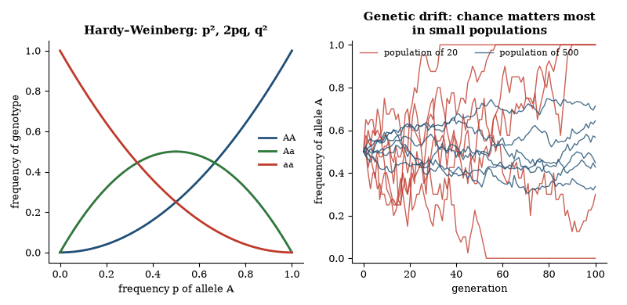
Figure 52. Left: with random mating and no selection, genotype frequencies settle into p², 2pq and q² in one generation. Right: simulated drift with no selection. Six runs each start with allele A at 50 percent; in a population of 20 the allele soon drifts to loss or fixation, while in 500 it barely moves.
Genetic drift is the random change in frequency caused by finite population size. Its strength is inversely proportional to the effective population size. Drift fixes neutral alleles and can override weak selection; selection dominates only when the selection coefficient exceeds the reciprocal of the effective population size. The molecular clock—the roughly constant rate of accumulation of neutral substitutions—is a consequence of drift.
Selection changes frequencies deterministically. The change per generation is proportional to the selection coefficient and to the variance in fitness. Migration homogenizes populations. Mutation introduces new alleles. The joint action of the four forces produces the patterns of variation observed in nature. The theory is quantitative and has been tested in laboratory populations and in the wild.
The framework accounts for the maintenance of polymorphism, the rate of molecular evolution and the genetic structure of subdivided populations, and it is the quantitative core of evolutionary genetics.

Worked Examples: Population Genetics
Example 1. A recessive lethal allele has frequency 0.01. What fraction of the population dies from it each generation under random mating?
Frequency of homozygotes = q² = 10⁻⁴. One in ten thousand individuals is affected.
Example 2. A haploid allele with selective advantage s = 0.01 starts at frequency 0.001 in a large population. Approximately how many generations are required for it to reach frequency 0.5?
The odds p/(1-p) grow by a factor 1+s each generation. The odds must rise from about 0.001 to 1, so the time is ln (1000)/ln (1.01) ≈ 6.9/0.00995 ≈ 690 generations.
Example 3. In a population of effective size 10 000, what is the probability that a new neutral mutation eventually becomes fixed?
The fixation probability of a neutral allele is 1/(2N) = 5 × 10⁻⁵.
These elementary results are the starting point for every calculation of evolutionary rates and of the expected frequency of genetic disease.

Speciation
Speciation is the process by which one population becomes two populations that no longer exchange genes. The most common route is allopatric: a geographic barrier divides the population, the separated groups diverge by selection and drift, and when contact is restored, reproductive isolation may be complete.
Isolation can be prezygotic or postzygotic. Prezygotic barriers include differences in mating time, place, or behavior, and mechanical or gametic incompatibility. Postzygotic barriers include hybrid inviability and hybrid sterility. Both classes are observed. The genetic basis ranges from single loci to many loci of small effect.
Sympatric speciation, without geographic separation, is rarer but documented in plants through polyploidy and in some animals through habitat or host shifts. The essential requirement in every case is the cessation of gene flow. Once gene flow stops, independent evolution proceeds, and chromosomal rearrangements or cytoplasmic incompatibilities can speed the process. The result is the branching pattern of the tree of life.

Classification and the Tree of Life
Aristotle listed hundreds of animals and grouped them. He noticed that the dolphin, though it looks like a fish and lives in the sea, breathes air and bears live young. He placed it with the mammals. The observation was correct. The principle was that structure and function matter more than habitat.
Carl Linnaeus, in the eighteenth century, gave the system its modern form. Every species receives a two-part name, genus and species. Species are grouped into genera, genera into families, families into orders, orders into classes, classes into phyla, phyla into kingdoms. The ranks are a filing system, useful for communication but not the deepest fact.
The deepest fact is descent. Darwin argued that the groups exist because of common ancestry. The tree of life is the diagram of that ancestry. Modern classification aims to make the groups reflect the branches of the tree. A group that includes an ancestor and all its descendants is monophyletic. Groups that do not are revised or abandoned.
The evidence is now molecular as well as anatomical. DNA sequences can be compared. The more similar the sequences, the more recent the common ancestor, in general. The comparisons have rearranged some branches: birds are nested inside the dinosaurs, and fungi are closer to animals than to plants. The three domains—Bacteria, Archaea, and Eukarya—replace the older two-kingdom or five-kingdom schemes.
The number of described species is on the order of two million. The total alive today is estimated at roughly eight to ten million eukaryotic species, and far more if microbes are counted. Most are insects, microbes, and other small organisms. Extinction removes branches and speciation adds them, so the tree is not static. Classification is an attempt to describe it at a moment in time.
All cellular life shares a common ancestry. The evidence is the universal genetic code, the shared core of metabolic pathways, and the nested hierarchy of morphological and molecular similarities. Molecular sequences allow the hierarchy to be reconstructed as a phylogenetic tree.
The tree has three principal domains: Bacteria, Archaea, and Eukarya. Eukaryotes arose from a symbiotic association between an archaeal host and a bacterial endosymbiont that became the mitochondrion; recent genomic work places the host close to the Asgard archaea, which would make the eukaryotes a branch inside the Archaea and the deep tree two-domained. Plants acquired a second endosymbiont, a cyanobacterium that became the chloroplast. Subsequent diversification produced the kingdoms and phyla recognized by traditional taxonomy.
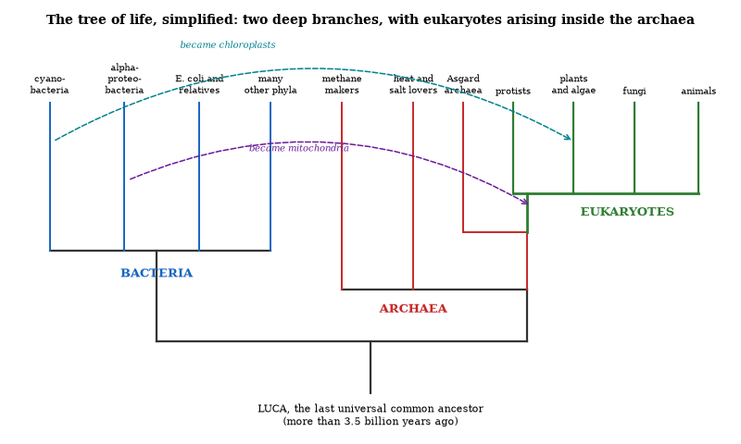
Figure 53. The tree of life, simplified: two deep branches, with the eukaryotes arising inside the archaea.
Horizontal gene transfer is common among prokaryotes and has occurred between domains. It complicates but does not erase the vertical signal. The overall topology remains robust. The last universal common ancestor was already a cell with a DNA genome, a translation system, and a membrane. Everything that has followed is modification of that ancestral organization.

Sexual Reproduction and Parthenogenesis
Sexual reproduction combines genomes from two parents and shuffles alleles by recombination. The process generates new genetic combinations every generation. Beneficial mutations that arise in different individuals can be united in a single descendant. Genetically diverse offspring are also more resistant to rapidly evolving parasites and pathogens. The advantage is known as the Red Queen effect.
The cost is a twofold reduction in reproductive rate: only females produce offspring, and mates must be located. Despite the cost, sex is the dominant mode among complex eukaryotes. The diversity benefit outweighs the cost under most natural conditions.
Parthenogenesis is development from an unfertilized egg. It eliminates the cost of sex. It is favored when mates are absent, when the environment is stable and the current genotype is already well adapted, or when rapid population growth is required. Many insects, some lizards, and numerous plants reproduce parthenogenetically for extended periods.
Most parthenogenetic lineages are short-lived on geological time-scales. Without recombination they accumulate deleterious mutations and cannot assemble new adaptive combinations when conditions change. Parthenogenesis therefore arises repeatedly but rarely persists. Sexual reproduction remains the prevailing solution to the problem of generating heritable variation in variable environments.

Ethology and the Evolution of Behavior
Ethology is the study of animal behavior under natural conditions. Behavior, like morphology, has a genetic basis and evolves. Fixed action patterns are stereotyped sequences triggered by specific sign stimuli. They are innate. Learning modifies behavior within limits set by the genotype.
The evolution of behavior is studied by the comparative method and by measuring heritability and response to selection. Altruistic behavior that reduces the actor’s direct reproduction can spread if it increases the reproduction of genetic relatives. The condition is Hamilton’s rule: the cost to the actor is less than the benefit to the recipient weighted by relatedness. The rule accounts for the evolution of sterile castes in social insects and for many forms of parental care and cooperation.
Sexual selection produces traits that increase mating success even when they reduce survival. The peacock’s tail and the elaborate songs of birds are classic examples. Female choice and male–male competition are both documented. The same principles apply to human behavior to the extent that the relevant genetic variation and selective pressures exist. The extent is an empirical question, not a philosophical one.

Ants, Termites and Bees
Ants, termites and the social bees and wasps are eusocial. Reproduction is restricted to one or a few individuals. The remaining members of the colony are sterile workers that raise siblings. The system has evolved independently many times. It is the most extreme form of social organization known in animals.
In the Hymenoptera (ants, bees and wasps) sex is set by haplodiploidy: females develop from fertilized eggs and are diploid, males from unfertilized eggs and are haploid, so full sisters share three-quarters of their genes. That asymmetry favors sterile female workers that raise sisters rather than their own offspring, but it is not sufficient by itself. Ecological factors, such as a nest to defend, young fed progressively and a queen able to dominate reproduction, are also required, and many haplodiploid species are not eusocial.
Termites are diploid and both sexes work, so relatedness among siblings is the ordinary one-half. Eusociality in termites is associated with the need to care for a slowly developing brood inside a defended nest and with the advantage of a soldier caste. The genetic system differs from that of the Hymenoptera. The ecological outcome is similar.
Colony-level traits include division of labor, communication by pheromones, construction of complex nests, and, in some species, agriculture or slave-making. The sterile castes are altruistic at the individual level and cooperative at the colony level. The colonies function as superorganisms for many purposes. The underlying selective process remains kin selection acting on the genes that produce the sterile phenotypes.

The Map That Contains Itself
A cell contains a genome, and the genome contains the instructions for building the cell, including the machinery that reads the genome. The map, in other words, contains the instructions for building its own reader. The arrangement is ordinary, and it is the reason life can persist: without the map the machinery cannot be rebuilt, and without the machinery the map cannot be read, so both are required and both are copied.
The copying is imperfect. Most mutations are harmful or neutral; the few beneficial ones spread, and that spread is evolution. It has produced organisms whose maps of themselves are accurate enough to build the next generation but never perfect, and the imperfection is the source of all later change. The reader still carries a slightly imperfect copy.
Questions to Keep Asking
How do we know that species share common ancestors? Genes and broken genes are shared in a nested pattern, as are inserted viral fragments, in exactly the places an ancestry tree predicts.
A rabbit fossil in rock a billion years old would overturn evolutionary history. Why has nothing like it ever been found?
Try it yourself. Draw the arm bones of a human, the wing of a bat and the flipper of a whale side by side, and match them bone by bone.

40. Quantum Biology
A robin may navigate by seeing the Earth’s magnetic field, and plants may move energy through their leaves by quantum coherence. Both claims are live research and neither is settled, which makes the subject a model of how to tell a promising idea from a proven one.
Most biological processes are well described by classical chemistry. A few involve quantum effects that cannot be ignored.
Enzyme catalysis sometimes uses tunneling. In hydrogen-transfer reactions the proton or hydrogen atom can pass through the energy barrier rather than over it. The rate is higher than a classical calculation predicts. Kinetic isotope effects—the change in rate when hydrogen is replaced by deuterium—are larger than expected from mass alone and are consistent with tunneling. The effect is temperature-dependent in ways that match quantum models.
Photosynthetic light-harvesting complexes transfer energy from antenna pigments to the reaction center with high efficiency. Spectroscopic measurements show coherent oscillations in the energy transfer. The coherence persists for hundreds of femtoseconds at physiological temperatures. Later work suggests that much of the long-lived signal comes from molecular vibrations rather than electronic coherence and that it probably contributes little under natural sunlight. The oscillations are real; their functional importance is doubtful.
Avian magnetoreception is another candidate. Some migratory birds orient using the Earth’s magnetic field. One proposed mechanism is a radical-pair reaction in cryptochrome proteins in the eye. The yield of the reaction depends on the orientation of the radical pair relative to the magnetic field because of the interplay of electron spins. The mechanism is plausible and consistent with behavioral experiments. Direct proof that it is the sensor used by the bird is still incomplete.
Quantum effects in biology are real where they have been measured. They do not require that the organism maintain macroscopic coherence. They occur in specific reactions where the energy barriers, the timescales, and the isolation from the environment allow them. The majority of cellular chemistry remains classical. The exceptions show that evolution can use quantum mechanics when it is available.

What Quantum Biology Does Not Show
The claims for quantum computation in the brain or for quantum-enhanced olfaction lack experimental support. The thermal environment of a cell destroys coherence on timescales far shorter than those required for such processes. Ordinary quantum chemistry—tunneling, zero-point energy, discrete spectra—is sufficient to explain the established cases. Exotic macroscopic quantum effects are not required.
The field therefore consists of a small set of confirmed tunneling and coherence phenomena embedded in an otherwise classical biochemical framework. The confirmed cases are interesting. They do not rewrite the foundations of biology.

Quantum Effects in Genetics
Most genetic processes are classical. Base pairing, replication, transcription, and translation are described by ordinary chemistry. A few steps show quantum signatures that affect the outcome.
Proton tunneling contributes to some mutation rates. In DNA the hydrogen bonds that hold base pairs together can shift by tunneling. The tautomeric forms that result can mispair during replication, at a rate that is low but not zero. The contribution is measurable in some systems by comparing rates in ordinary water and in heavy water. The difference is consistent with a tunneling component. The bulk of mutations still arise from other causes: copying errors, chemical damage, and radiation. Tunneling is one channel among several.
Electron transfer in some repair enzymes and in photosynthetic reaction centers proceeds by tunneling. The distance dependence and the temperature dependence match quantum calculations. The proteins position the donors and acceptors so that the tunneling rate is useful. The positioning is the product of selection. The tunneling itself is a physical fact that selection has used.
The quantum contributions that have been demonstrated are local, specific, and already incorporated into the ordinary chemical account. They do not require a separate quantum genetics; they show that the chemistry of life includes the quantum mechanics of its atoms. The larger claim, that genetic information is held in macroscopic superposition, is taken up in the section on evolution.

Adaptive Mutation and Quantum Coherence
In 1999 Johnjoe McFadden and Jim Al-Khalili proposed a quantum model for adaptive mutation. Adaptive mutation is the reported phenomenon in which certain mutations appear more frequently when they confer an advantage than when they are neutral. The classical expectation is that mutation rates are independent of utility. The observations, first described in bacteria under starvation, have been disputed. Some are explained by ordinary growth and selection on pre-existing variants. Others remain unresolved.
The quantum proposal begins with proton tunneling in DNA base pairs. A proton can occupy either of two positions. The two positions correspond to different base-pairing possibilities. The model treats the proton as remaining in a coherent superposition of the two positions for a biologically relevant time. Interaction with an environment that contains a usable substrate is argued to accelerate decoherence and thereby increase the rate at which the mutant state is realized. The model requires the coherence to last far longer than standard estimates for a warm, wet cell allow.
The proposal has not been confirmed. Direct measurements of coherence in DNA under cellular conditions have not shown the required superposition. Decoherence calculations that include more of the molecular environment yield shorter times. The adaptive-mutation experiments themselves have alternative classical explanations in many cases. The idea remains a possible mechanism for a disputed phenomenon. It is not an established modification of evolutionary theory.
McFadden and Al-Khalili later surveyed a wider set of quantum effects in biology: tunneling in enzymes, coherent energy transfer in photosynthesis, the radical-pair mechanism for magnetoreception, and a proposed vibration-assisted tunneling in olfaction. Some of these effects are measured. Their functional importance varies. The adaptive-mutation model is the most specific claim that quantum coherence could bias the generation of heritable variation. That claim is still open. The broader observation that quantum mechanics is part of the chemistry of life is not.

Quantum Biology and Evolution
Evolution is a classical process at the scale of populations. Mutation, selection, drift, and recombination are described by ordinary population genetics. The underlying chemistry of mutation and catalysis includes quantum steps. Those steps do not change the structure of the evolutionary account. They change the rates and the channels through which variation appears.
Proton and electron tunneling contribute to mutation and to the work of repair enzymes, as the previous sections describe. The positioning is classical, the transfer step is quantum, and selection acts on the outcome, not on the mechanism.
Photosynthetic energy transfer and enzyme catalysis show coherent or tunneling contributions under physiological conditions. These processes affect the efficiency with which organisms capture energy and carry out metabolism. Efficiency is a selectable trait. Organisms that harness the quantum step more effectively leave more offspring, other things equal. The quantum step itself is not selected. The molecular architecture that makes the step available is selected. The distinction matters, because evolution does not need to “know” about quantum mechanics and needs only to retain variants that work.
No established mechanism allows a cell to maintain a macroscopic superposition of genetic states and to collapse that superposition preferentially toward adaptive outcomes. The adaptive-mutation model remains a proposal. Decoherence in the cellular environment is rapid. The successful description of the origin and spread of adaptations continues to be the classical one: variation arises, most of it is neutral or deleterious, a fraction is advantageous, and selection increases the frequency of the advantageous fraction. Quantum mechanics is part of the physics that generates the variation and powers the metabolism. It is not a separate evolutionary force.
The practical consequence is modest and real. Calculations of mutation rates, of catalytic rates, and of energy-transfer efficiency are more accurate when the quantum channels are included. The evolutionary conclusions drawn from those rates do not change. The tree of life, the genetic code, and the history of adaptations remain the same. Quantum biology refines the chemistry. It does not rewrite the theory of evolution.

How Birds Navigate
Migratory birds reach distant destinations without maps or instruments. They integrate several independent cues.
A magnetic compass is widespread. The leading candidate sensor is a light-dependent chemical reaction in the retina involving the protein cryptochrome. The reaction yields a directional signal relative to the Earth’s field. The compass is inclination-based in many species: it distinguishes poleward from equatorward rather than north from south.
Celestial cues supply a second reference. Diurnal migrants use the Sun’s azimuth, compensated by an internal circadian clock. Nocturnal migrants learn the rotation of the star field around the celestial pole before their first migration. Both systems function under natural skies and fail under experimental disruption of the clock or of the stellar pattern.
Experienced birds also follow landmarks—coasts, rivers, mountain chains—and, in some species, olfactory gradients. Homing pigeons and certain seabirds deprived of smell are disoriented. The odor map is learned.
First-autumn juveniles often fly a genetically encoded direction for a genetically encoded duration. Only after the journey do they acquire a more detailed map. Adults can correct displacements and return to the normal route, showing that learned information supplements the innate program.
The systems are redundant. Birds switch among them when one is unavailable. No evidence indicates an internal calculation of absolute geographic position comparable to satellite navigation. Accuracy arises from the continuous cross-checking of simpler directional and landmark cues, together with social information from experienced companions in many species.
Questions to Keep Asking
How do we know that quantum effects matter in living things? The rates of some enzyme reactions show isotope effects that only tunneling explains.
What result would show that a bird’s compass depends on a quantum process and not on iron-bearing cells?
Try it yourself. Thermal energy at body temperature, kT, is about 0.027 electron-volts. Why does that make long-lived quantum coherence in a warm, wet cell so hard?

41. The Human Genome
The human genome is about three billion letters. Printed in the type of this book it would fill about four thousand copies. The surprise of reading it was how few genes it holds, about twenty thousand, and how much else it contains.
In 2001 two drafts of the human genome were published. In 2003 the project was declared complete, with reservations. In 2022 the last gaps, mostly difficult repetitive regions, were filled. We now have a continuous sequence of a human genome, a string of about three billion base pairs.
The string is not a blueprint in the way a blueprint specifies every board. It is closer to a recipe that assumes a cell already running. Genes, in the classical sense of protein-coding sequences, are a small minority of the total, on the order of one to two percent.
What the sequence gave biology was a reference. Variation could be compared to something. Common differences among people, single-letter changes and larger rearrangements, could be cataloged. Disease studies could ask which differences are more common in people with a condition than in people without it.
Reading the genome was the achievement of one generation. Writing it, in living people, is the argument of the next chapter.
Sequencing the genome was a technical achievement and a conceptual correction. The technical achievement was the reading of three billion base pairs with enough accuracy to be useful, first as drafts, then as a finished reference, then as a complete end-to-end sequence including the hard repetitive regions. The conceptual correction was the discovery that gene number did not measure complexity in any simple way. Humans have on the order of twenty thousand protein-coding genes. So do other animals. Some plants have more. Complexity, where it exists, is in the regulation, the splicing, the timing, and the networks, not in a longer list of parts.
Noncoding DNA is the majority of the sequence. Some of it is regulatory: switches that determine when and where a gene is used. Some of it is structural. Some of it is the remains of ancient viruses that inserted themselves and were inherited. Some of it may have no selected function. The fraction with function is disputed, and the dispute depends on what “function” is taken to mean. A sequence can affect a molecular measurement without affecting the organism’s success. The careful claim is that noncoding DNA is a mixture, not a wastebasket and not a hidden second genome of equal importance to the genes. Its importance is real and uneven.
Variation among people is the genome’s other lesson. Any two people differ at millions of sites. Most differences are common, small in effect, and shared across populations in different proportions. Some are rare and consequential in a single gene. The common differences are the raw material of polygenic scores and of adaptation. The rare ones are the raw material of many genetic diseases. Both kinds are inherited. Neither kind supports the older idea that human groups are discrete biological types. Human genetic variation is real, geographically patterned, and small compared with the variation inside any one population. The patterning is what migration and history produce. It is not a set of separate species.
The clinical use of the sequence has been most decisive for rare disease. A child with a severe, unexplained condition can have their genome, or their exome, sequenced and compared with their parents’. A new mutation in a known gene, or a pair of mutations in a recessive gene, can end a diagnostic search that once took years. Treatment does not always follow diagnosis, though sometimes it does, and the diagnosis itself is a change in medicine.
For common disease the contribution is statistical. Genome-wide association studies find variants that are more common in people with a disease than in people without it. Each variant usually has a small effect. Together they can predict a fraction of the risk. The fraction is useful for research and, in some cases, for sorting people into higher and lower risk groups. It is not a personal prophecy. Environment, chance, and the limits of the studies intervene. Scores trained in one population often work less well in another, because the pattern of genetic correlation differs. Equity in the data is a scientific requirement, not only a social one.
The genome is a reference and a parts list. It is not a blueprint that specifies the finished body in detail. Development uses the list in a context: a fertilized egg, a womb, a sequence of signals, an environment. Read the list and you do not yet have the person. That limit is not a failure of the project. It is the next subject, and it is why genomics did not replace the rest of biology.
Privacy and ownership are the social edge of sequencing. A genome identifies a person and their relatives. It can reveal disease risk, ancestry, and, in some cases, information the person did not want. Databases that enable research also enable reidentification if they are careless. The scientific value of shared data is large. The harm of careless sharing is real. The balance is a governance problem sitting on top of a measurement revolution. The measurement will not slow down. The governance has to be built at the same speed.
Ancestry and identity should not be confused with the sequence. Genetic ancestry tests report similarities to reference populations. They are useful for genealogy and for the history of migrations. They do not assign a person to a race in any biological sense that withstands scrutiny, because human variation is continuous and overlapping. The tests measure real patterns. The social categories they are sometimes taken to support are coarser than the patterns. Keeping the measurement and the category apart is a service both to the science and to the people who use it.
Editing and sequencing together change what a variant means. A variant of unknown significance, found in a patient, can sometimes be tested in a cell or in an organoid to see whether it disrupts the gene’s function. The test turns a correlation into a mechanism. Mechanism is what makes a diagnosis solid and a therapy conceivable. The genome supplies the variant and the functional test supplies the interpretation, and neither alone is enough for the hardest cases. The combination is the direction of clinical genetics, slower than sequencing alone and more decisive.

The Genome in Numbers
The human genome is the complete DNA sequence of a human cell. The haploid genome contains approximately 3.2 billion base pairs. About 1.5 percent codes for proteins. The remainder consists of introns, regulatory sequences, transposable elements, and other non-coding DNA. Roughly 20 000 protein-coding genes are present. Many genes produce multiple transcripts by alternative splicing.
The sequence was first completed in draft form in 2001 and in finished form in 2003. Subsequent projects have cataloged common variation. Any two unrelated individuals differ at about one site in a thousand. Most variants are single-nucleotide polymorphisms, though structural variants—insertions, deletions, inversions and copy-number changes—also contribute. The majority of variants are neutral or nearly neutral, and a minority affect disease risk or drug response.
Genes are not uniformly distributed: some chromosomal regions are gene-rich and others are gene-poor. The mitochondrial genome is a separate circular molecule of 16 569 base pairs that is maternally inherited and encodes 13 proteins of the respiratory chain. Nuclear and mitochondrial genomes together constitute the hereditary material.
The genome is not a blueprint that specifies the organism in every detail. It is a parts list and a regulatory network whose output depends on cellular context, developmental history and environment. Sequencing has made that list available. Interpreting the regulatory logic remains incomplete.

Human Genetics
Within the genome, variants matter in very different ways. Most are neutral, and a minority affect traits or disease risk.
Monogenic disorders are caused by variants in a single gene. Sickle-cell disease, cystic fibrosis, and Huntington’s disease are examples. The inheritance follows Mendelian ratios when the variant is fully penetrant. Many common diseases are polygenic. Height, blood pressure, and susceptibility to type 2 diabetes or schizophrenia are influenced by thousands of variants of small effect, plus environment. Polygenic scores sum the effects. They are predictive in populations similar to the ones in which they were derived and less predictive in others.
Genome-wide association studies scan hundreds of thousands of people for statistical links between variants and traits. The links identify regions and do not by themselves prove causation, so functional studies are required. The same methods have mapped genes that affect drug response, a field called pharmacogenetics. A variant that is harmless in one context can determine whether a drug is effective or toxic.
Editing the human germline changes DNA that can be inherited. The 2018 birth of edited twins, discussed in the chapter on gene editing, had legal consequences: He Jiankui was convicted in China of illegal medical practice and imprisoned. Chinese regulations now prohibit clinical research that alters germ cells or embryos for reproduction. Somatic editing, which affects only the treated individual, is in clinical trials for several diseases. The distinction between somatic and germline alteration is the current regulatory boundary.

Modern DNA Methods
Restriction enzymes cut DNA at specific sequences and DNA ligase joins the ends, a combination that allowed recombinant DNA in the 1970s. A gene from one organism could be inserted into a plasmid and propagated in bacteria. The technique produced insulin, growth hormone, and many other proteins.
The polymerase chain reaction amplifies a chosen segment of DNA exponentially. A pair of primers, a heat-stable polymerase, and thermal cycling generate millions of copies from a few molecules. Sequencing reads the order of bases: Sanger sequencing used chain-terminating nucleotides, and next-generation methods read millions of fragments in parallel. A human genome that once required years and hundreds of millions of dollars can now be sequenced in about a day for a few hundred dollars.
CRISPR-Cas systems are adaptive immune mechanisms in bacteria. A guide RNA directs the Cas nuclease to a matching DNA sequence. The nuclease cuts. The cell repairs the break. Repair can disable the gene or, if a template is supplied, insert a new sequence. Base editors and prime editors change single bases or short stretches without double-strand breaks. The tools work in bacteria, plants, animals, and human cells. They are used in research, in agriculture, and in clinical trials for genetic disease.
Gene drives bias inheritance so that a chosen allele spreads through a population faster than Mendelian ratios allow. They have been demonstrated in insects in the laboratory. Their use outside containment is contested because the spread is designed to be difficult to reverse.
The methods are precise relative to earlier mutagenesis but not perfectly precise, and off-target cuts occur. Delivery to the right cells in a living organism remains difficult. The capability to read, write, and edit DNA at scale now exists. The limits are technical, regulatory, and ethical.

Cloning
Cloning produces a genetic copy of an organism. In plants it is routine, since cuttings and tissue culture generate identical individuals; in animals the method is somatic-cell nuclear transfer. The nucleus of a somatic cell is placed in an enucleated egg, the reconstructed egg is stimulated to develop, and the resulting animal has the nuclear genome of the donor.
Dolly the sheep was the first mammal cloned from an adult somatic cell. She was born in 1996, but the success rate was low and many reconstructed embryos failed. Those that developed often showed abnormalities in imprinting and in telomere length, which indicates that reprogramming of the somatic nucleus is incomplete. The genome of a differentiated cell evidently retains the information required to build an organism, but the process is neither routine nor free of epigenetic defects. Subsequent work produced cloned cattle, pigs, goats, cats, dogs, and other species. Efficiency has improved but remains far below natural reproduction.
In 2018 Chinese researchers produced the first cloned primates, two macaques, from fetal fibroblasts. A rhesus monkey cloned in 2024 survived only after the cloned placental tissue was replaced with tissue from a normal embryo. Attempts using adult primate cells have so far had very poor survival, because reprogramming of an adult nucleus remains incomplete under current methods.
Reproductive cloning of humans has not been achieved. No verified human clone has been born. Therapeutic cloning, the production of embryonic stem cells genetically matched to a patient, has been performed in the laboratory. The embryos are not implanted. Most countries prohibit reproductive human cloning. A smaller number permit research on cloned human embryos under license. The technical barrier in primates remains high. The regulatory barrier is explicit.
Questions to Keep Asking
How do we know that a variant causes a disease and does not merely travel with it? We need statistics across many people, a mechanism, and, ideally, a test of the variant in cells.
What would you conclude about a gene if people lacking it entirely were healthy?
Try it yourself. Two people differ at roughly four or five million places in their genomes, yet are 99.9 percent identical. Check the arithmetic against three billion letters.

42. CRISPR and Gene Editing
In 2012 a bacterial immune system became a tool that can be aimed at any chosen stretch of DNA. Eleven years later the first CRISPR medicine, for sickle-cell disease, was approved.
Bacteria have been at war with viruses for billions of years. One of their defenses is a memory. They store snippets of viral DNA and use them to recognize the virus if it returns. A protein then cuts the viral genome. The system is called CRISPR.
In 2012 Jennifer Doudna, Emmanuelle Charpentier, and colleagues showed that the system could be aimed. A guide sequence could be designed, and the cutting protein, Cas9, would cut a chosen place in a chosen genome. Other laboratories reached the same capability at nearly the same time. Biology acquired an editor.
The editor is not magic: it cuts, and the cell repairs the cut. The repair can disable a gene, or, if a template is supplied, sometimes insert a chosen sequence. Newer variants nick a single strand, or change one letter without a full break. The tools have multiplied. The principle remains: a sequence can be addressed.
In research, the effect has been a change of speed. Genes in mice, fish, crops, and cell lines can be altered in weeks rather than years. In medicine, the first wave of therapies edits cells outside the body and returns them, and the sickle-cell treatments described below are the leading example.
Editing embryos is a different act. In 2018 a researcher announced the birth of children whose genomes had been edited, ostensibly to reduce HIV risk. The experiment was widely condemned as premature, poorly justified, and a breach of norms that the field had stated. The condemnation was not a rejection of the tool. It was a rejection of using a tool, on people who cannot consent, before accuracy, necessity, and oversight were in place.
The line is worth keeping clear. Somatic editing changes a patient’s cells and ends with that patient. Germline editing changes descendants. Agriculture sits in a third category, and societies are already arguing it crop by crop. CRISPR did not create these distinctions. It made them urgent.
Gene editing is the point at which biology became, in a practical sense, a writing discipline as well as a reading one. The power is real. The gaps in delivery, specificity, and ethics are also real. A serious account refuses both the miracle story and the ban.
Delivery is the difference between a result in a dish and a result in a patient. In a dish, the editor can be put into cells directly. In a body, it must reach the right cells, in the right tissue, in sufficient number, without damaging the rest. Viral vectors, lipid nanoparticles, and direct injection are the current methods. Each has limits on cargo, on which tissues it reaches, and on immune response. Many of the first successes have been in blood, in the eye, and in the liver, where delivery is more tractable; in 2025 a baby with a rare inherited liver disorder received a base editor designed for his own mutation, carried to the liver in lipid nanoparticles. Whole-body editing of arbitrary genes is not the present state. The map of what can be edited in a living person is, for now, a map of delivery as much as of genetics, and improving delivery would expand therapy more than improving the editor alone.
The sickle-cell treatment approved in Britain and the United States in late 2023, Casgevy, shows both the power and the cost. Cells are taken from the patient, edited so that they produce fetal hemoglobin or so that a repressor of fetal hemoglobin is disabled, and returned after the remaining bone marrow is cleared. Patients have been freed from the crises of the disease. The procedure is intensive, expensive, and not without risk. It is also a proof that a genetic disease can be treated by editing the relevant cells. Other blood and immune disorders are following the same path.
Off-target cuts are the technical objection that has to be measured rather than assumed. An editor aimed at one sequence may cut similar sequences elsewhere. The rate depends on the guide, the editor, and the cell. It can be measured and has been reduced by better design, but it is not zero in every setting. For a therapy, the question is whether the residual rate is small compared with the benefit. For an embryo, the question is stricter, because every cell of the future person, and of their descendants if the change is inherited, carries the result.
Germline editing is the line most countries and most scientific bodies have treated as not yet permissible, outside tightly limited research that does not lead to a birth. The reasons are practical and ethical. Accuracy and long-term effects are not well enough known. The medical need is often addressable by other means, including selection of embryos in cases where that is accepted. The people affected cannot consent.
Agriculture is the third domain. Edited crops can resist disease, tolerate stress, or improve nutrition. Some jurisdictions treat certain edits, those that could have arisen by mutation, more like conventional breeding than like older transgenic methods. Others do not. The biological question and the regulatory question are different. The biological question is what change was made and what it does. The regulatory question is how a society chooses to label and approve it. A guide can state both and should not pretend they are the same question.
CRISPR did not invent the desire to change inheritance; it made the desire cheap and specific, and the specificity is the advance. The cheapness is why the ethical and safety questions, which were once hypothetical, now have deadlines.
Somatic editing and enhancement should be distinguished. Treating a disease in a consenting patient’s cells is medicine. Editing an embryo for a trait that is not a disease, or editing a person for advantage rather than for treatment, is a different act. The line is argued. The existence of a difference between treatment and enhancement is clear even where the boundary is not. A therapy for sickle cell is not the same kind of decision as a speculative edit for muscle or for height. Keeping the difference visible is part of using the tool without confusing it with a general permission to redesign people.
Equity will decide whether the tool is a general advance or a narrow one. The first therapies are expensive, need specialized facilities, and will reach patients in rich health systems first unless deliberate provision is made. Science does not make that provision; institutions do. An account that celebrates a cure in a trial and omits who receives it describes a result, not a change in the burden of disease, and the burden shifts only when the result is delivered.
Questions to Keep Asking
How do we know that an edit hit only the intended place? Genome-wide sequencing of edited cells looks for unintended cuts, and each method has a detection limit.
What kind of unexpected result in a clinical trial would make you stop a therapy at once?
Try it yourself. Name one change you would accept in a patient’s own blood cells and one you would not accept in an embryo. What exactly separates them?

43. Synthetic Biology
In 2010 a team built a bacterial genome from chemicals in a machine and used it to run a living cell. The DNA carried watermarks, including a quotation about creation and understanding. Writing life, and not only reading it, had begun.
If editing changes an existing text, synthetic biology asks whether the text can be written from scratch, or joined in combinations nature did not try.
The field has several layers, from DNA synthesis at the bottom, through engineered pathways and minimal cells, to expanded genetic alphabets at the top.
The enabling change is the fall in the cost of reading and writing DNA. Sequencing now costs a tiny fraction of what it cost at the end of the Human Genome Project. Synthesis of genes, and of whole small genomes, is a commercial service. A design can be a file. The file can be ordered. The distance from idea to test has collapsed for any project that lives in a microbe or a cell line. That is the practical meaning of synthetic biology.
Pathway engineering is the workhorse. A cell has a metabolism. A pathway is a sequence of enzymatic steps from a starting material to a product. If the enzymes exist somewhere in nature, their genes can be moved into a production host, usually a yeast or a bacterium, and tuned. If they do not exist, they can sometimes be designed or evolved. The antimalarial precursor artemisinin, flavors, fragrances, and industrial chemicals have been made this way. The successes are real. So are the failures, which are less famous. A pathway that works in a flask can poison its host, or cost too much feedstock, or lose to an existing chemical process. The field is an industry as well as a science. Industries count costs.
Minimal cells test how much of a genome is required for life under comfortable laboratory conditions. A bacterial genome can be reduced, synthesized, and used to boot a cell. The reduced genome still contains genes of unknown function. Life, even pared down, is not yet a fully annotated machine. The result is a limit on our understanding and a tool for studying what the remaining genes do. It is not a cell built from first principles out of nonliving parts. That harder goal remains ahead.
Expanded alphabets and nonstandard amino acids show that the particular code we inherited is contingent. Cells have been made to use six-letter DNA and to incorporate amino acids that nature does not use. The purpose is usually a better protein for a particular job, or a cleaner biological system that cannot easily exchange genes with the wild. Containment by dependence on a synthetic nutrient is one proposed safety measure. It is a measure, not a guarantee. Evolution is patient.
Safety and misuse are part of the subject because the tools are widely available. Ordering a pathogen’s genome is restricted and screened by responsible suppliers. Not every supplier is responsible, and not every sequence reveals its purpose. The practical barriers to harm remain significant: expertise, equipment, delivery, and the fact that engineered organisms are often fragile. The barriers are lower than they were. Governance has been a mix of self-regulation, screening, and law. It will have to keep pace with cheaper synthesis and with automated design. The scientific opportunity and the governance problem grew from the same cause.
Synthetic biology’s place in a guide is as the writing side of the reading revolution. We can sequence life. We can, in increasing measure, specify changes and build new pathways. We cannot yet design a cell from scratch with the reliability of an engineer designing a bridge. The gap is the size of the remaining mystery of living systems. It is also a gap that narrows with each working pathway and each booted genome.
Automation is the next practical change. Design software, robotic liquid handling, and automated testing let a small team run a cycle of design, build, and measure that once required a large one. The cycle is the method. Faster cycles mean more of the design space can be searched. They also mean that the limits of understanding become clearer: a design that fails does so for a reason in the cell, and the reason is often a regulation, a toxicity, or a burden that the design did not include. Synthetic biology teaches the complexity of cells by trying to write them. The failures are data.
Biosafety levels and screening are the present controls. Laboratories are classified by the hazard of the organisms they handle. DNA synthesis companies screen orders against lists of dangerous sequences. The controls are imperfect and useful: they raise the cost and the visibility of misuse and do not make misuse impossible. As synthesis moves into more hands and more automated settings, the controls have to move too. The alternative is a capability that grows faster than the practice of watching it. Watching is less exciting than designing, but it is part of the same subject if the subject is to remain a public good.
Standards and parts registries are the attempt to make biology more like engineering. Catalogued parts, with measured behavior, can be combined with less surprise. The attempt has helped. Biology’s context dependence has limited it. A part that works in one strain, in one condition, may fail in another. The limit is not a reason to abandon standards. It is a reason to measure context as part of the standard. Synthetic biology matures as it records its failures of transfer and designs around them. Maturity looks like better annotation, not like the end of surprises.
The scientific point is quieter. Life is a material system whose parts can be listed, synthesized and recombined. The list is incomplete, yet the recombination has already left the page for factories and clinics. The field is no longer young.

Synthetic Biology: Definitions and Tools
Synthetic biology is the design and construction of new biological parts, devices and systems, and the redesign of existing natural systems for useful purposes. It applies engineering principles—standardization, modularity and abstraction—to molecular biology.
Standardized genetic parts (promoters, ribosome-binding sites, coding sequences, terminators) are assembled into circuits that perform logical operations, oscillate or produce defined outputs. Entire genomes have been synthesized and transplanted into recipient cells, producing viable organisms controlled by the synthetic genome. Minimal genomes that contain only the genes required for life under laboratory conditions have been constructed.
Applications include the production of pharmaceuticals, fuels and materials, the engineering of biosensors, and the exploration of the minimal requirements for cellular life. Risks include unintended ecological effects and the possibility of misuse. Containment strategies—auxotrophy, kill switches and physical isolation—are under development. The field demonstrates that the genetic code and cellular machinery can be treated as a programmable technology. It also reveals how much of cellular function remains incompletely understood.
Questions to Keep Asking
How do we know that a synthetic genome works? The cell boots, grows and divides, and its proteins match the designed sequence.
What result would show that we do not yet understand a minimal cell’s genes?
Try it yourself. Think of an organism you would not want engineered. What safeguards would you require before anyone tried?

44. Life Through Deep Time
If Earth’s history were a single day, bacteria would appear before dawn, animals with shells at about nine in the evening, and the dinosaurs would vanish at about 11:40 at night. Humans would arrive in the last six seconds.

The Fossil Record of Life
The fossil record is the sequence of preserved remains and traces of organisms in sedimentary rocks. It begins with chemical and morphological traces of microbial life 3.5–3.8 billion years ago. Multicellular organisms appear in abundance only in the Ediacaran, about 575 million years ago. The Cambrian explosion, beginning 540 million years ago, marks the rapid appearance of most major animal phyla that possess hard parts.
Subsequent radiations and extinctions are documented in increasing detail. The colonization of land by plants, arthropods and vertebrates occurs in the Paleozoic. The end-Permian extinction eliminates roughly 80 to 90 percent of marine species. The Mesozoic is dominated by dinosaurs and gymnosperms. The end-Cretaceous extinction removes the non-avian dinosaurs and many other groups. The Cenozoic radiation of mammals, birds and flowering plants follows.
Molecular clocks and phylogenetic trees calibrated by fossils recover the same broad sequence. Gaps exist—soft-bodied organisms are under-represented, and some intervals are poorly sampled—but the overall order of first appearances is robust. The record demonstrates that life has been continuously present for at least 3.5 billion years, that its complexity and diversity have increased, and that this increase has been repeatedly punctuated by mass extinctions and subsequent recoveries. It supplies the historical evidence for evolution.

The Great Oxidation Event
The Great Oxidation Event was the first sustained rise of free oxygen in Earth’s atmosphere, occurring between approximately 2.4 and 2.1 billion years ago. Before the event the atmosphere and oceans were anoxic. Oxygen produced by cyanobacteria was consumed by reduced volcanic gases and by ferrous iron dissolved in seawater. When those sinks became saturated, oxygen accumulated.
The transition is recorded in the rock record. Detrital pyrite and uraninite, stable only under low oxygen, disappear. Red beds containing oxidized iron appear. Major banded-iron formation ceases. A pronounced positive carbon-isotope excursion indicates increased burial of organic carbon. Atmospheric oxygen rose from negligible levels to a few percent of the present concentration. The rise was permanent, although later fluctuations occurred.
The oxygenation transformed surface chemistry. It enabled aerobic respiration and thereby the higher energy yields required by large, active organisms. It also oxidized atmospheric methane, a potent greenhouse gas, and is implicated in the Huronian glaciation that followed. The event marks the point at which biological oxygen production permanently altered the planetary environment. All subsequent aerobic life depends on it.

The Bacterium That Changed the Air
By two and a half billion years ago, cyanobacteria were releasing oxygen as a waste product. Iron and reduced gases absorbed it until those sinks were full; then it accumulated, and the atmosphere changed. The new gas was toxic to many anaerobic organisms, which retreated to oxygen-free refuges, but it also made aerobic respiration possible, and the far higher energy yield of respiration made larger bodies possible.
The rocks keep the record, as described above. The cyanobacteria planned nothing: they excreted a gas, and the gas altered the planet in a way that eventually permitted the reader. Every breath since depends on their descendants, or on the chloroplasts that were once their kin, a total dependence that is rarely noticed.

The Snowball Earth Hypothesis
The Snowball Earth hypothesis proposes that the planet was repeatedly covered by ice from pole to equator during the Neoproterozoic, roughly 720–635 million years ago. Two main glacial intervals—the Sturtian and the Marinoan—are recognized. Geological evidence includes glacial deposits at low paleolatitudes, banded-iron formations that reappear after a billion-year absence, and cap carbonates that overlie the glacial strata, indicating rapid warming and high atmospheric carbon dioxide.
The proposed trigger is a runaway ice-albedo feedback. Once ice sheets reach a critical latitude, their reflectivity cools the planet further, driving the ice to the equator. Escape from the snowball state requires the accumulation of volcanic carbon dioxide to levels hundreds of times the present concentration. The resulting greenhouse warming melts the ice in a geologically short interval. The cap carbonates are the predicted chemical consequence of that deglaciation.
The hypothesis accounts for the unusual association of glacial deposits with indicators of low latitude and for the extreme carbon-isotope excursions of the Neoproterozoic. Alternative models invoke less complete ice cover—“slushball” states—with open equatorial oceans. Both versions remain under discussion. The episodes coincide with major changes in the carbon cycle and precede the appearance of the first large, complex organisms. Whether the glaciations directly facilitated that appearance is unresolved. The geological evidence for widespread, low-latitude ice is robust. The recovery shows in turn that the carbon-silicate cycle can restore habitable conditions even after global glaciation.

The Cambrian Explosion
The Cambrian explosion is the relatively rapid appearance of most major animal phyla in the fossil record between about 540 and 520 million years ago. Preceding Ediacaran organisms are largely soft-bodied and of uncertain affinity. Cambrian strata contain arthropods, mollusks, brachiopods, echinoderms and early chordates, many with mineralized skeletons.
The suddenness is partly taphonomic. Hard parts preserve more readily than soft tissues. Molecular clocks nevertheless place the divergences of the major clades in the late Neoproterozoic, indicating that the explosion records both an increase in disparity and an improvement in preservability. Ecological drivers include the evolution of predation, the oxygenation of shelf seas, and developmental genetic innovations that permitted more complex body plans.
The explosion established the phylum-level architecture of animal life, and subsequent evolution has largely elaborated within those body plans; no comparable radiation of new phyla has occurred. The Cambrian event therefore marks the principal diversification of animal form.

The Evolution of Plants
Plants originated from freshwater green algae. The closest living relatives are the charophytes. The transition to land required cuticles, stomata, and protected reproductive structures. The earliest fossil evidence of land plants is spores from the Ordovician, about 470 million years ago. Vascular tissue appears in the Silurian. By the Devonian, forests of lycophytes, ferns and progymnosperms existed.
Seeds evolved in the late Devonian. They freed reproduction from the requirement for free water and allowed colonization of drier habitats. Gymnosperms dominated the Mesozoic. Flowering plants (angiosperms) appear in the Early Cretaceous and radiate rapidly. Flowers and fruits coevolved with animal pollinators and dispersers. By the end of the Cretaceous, angiosperms were the most diverse plant group. They remain so today.
Photosynthetic efficiency, vascular architecture and reproductive strategy have been the principal axes of innovation. Polyploidy is common and has contributed to speciation. The same core genetic toolkit that patterns shoots and roots in mosses operates in flowering plants. The fossil record, comparative morphology and molecular phylogenies converge on a single origin of land plants and on the subsequent sequence of major innovations. Plants transformed the terrestrial surface, altered the atmosphere and created the habitats in which animals evolved.

The Evolution of Animals
Animals are multicellular heterotrophs that develop from a blastula. Their closest unicellular relatives are the choanoflagellates. The earliest animal fossils are Ediacaran impressions, about 575 million years old. The Cambrian explosion, treated in its own section, brings most extant phyla into the record. Molecular clocks place the origin of the major clades somewhat earlier, in the late Neoproterozoic.
Bilaterians—animals with a single plane of symmetry and three germ layers—dominate the subsequent record. Two great branches exist: the protostomes (arthropods, mollusks, annelids and others) and the deuterostomes (echinoderms and chordates). Segmentation, jointed appendages, and a through-gut evolved independently in several lineages. The colonization of land by arthropods occurred in the Silurian–Devonian. Vertebrates followed in the Devonian. Tetrapods, amniotes and, later, endotherms each opened new ecological possibilities.
Mass extinctions repeatedly reset diversity, the end-Permian and end-Cretaceous events being the most severe, and recoveries produced the characteristic faunas of the following eras. Developmental genetics shows that the same Hox and other regulatory genes pattern the body axes of flies and mice. The morphological disparity of animals therefore rests on a conserved genetic toolkit deployed in different combinations. The fossil record, comparative anatomy and molecular phylogenies converge on a single origin of animals and on the subsequent branching order of the major phyla.

Mass Extinctions
Mass extinctions are geologically brief intervals in which a large fraction of species disappear. Five major events are recognized in the Phanerozoic. The end-Ordovician, late Devonian, end-Permian, end-Triassic and end-Cretaceous extinctions each eliminated more than 70 percent of species in some estimates. The end-Permian is the most severe. Roughly 80 to 90 percent of marine species disappeared.
Causes differ. The end-Cretaceous coincides with the Chicxulub impact and with Deccan volcanism. The end-Permian coincides with the Siberian Traps eruptions and with evidence of ocean anoxia and warming. Other events are linked to glaciation, sea-level change or anoxia. In each case the extinction is rapid relative to background rates and is followed by a recovery interval of several million years.
Recoveries are not simple restorations. Surviving lineages radiate into vacated niches. The characteristic faunas of successive eras are the products of these resets. Mass extinctions demonstrate that external perturbations can override ordinary competitive and adaptive processes on a global scale. They are recurring features of the history of life.

The End-Cretaceous Extinction
The end-Cretaceous extinction, 66 million years ago, eliminated the non-avian dinosaurs, marine reptiles, ammonites and a large fraction of other species. The event coincides with the impact of an asteroid approximately 10 km in diameter at Chicxulub, Mexico, and with the later stages of the Deccan Traps volcanism in India.
The impact excavated a crater 180 km wide, injected dust, soot and sulfate aerosols into the stratosphere, and generated a global heat pulse from re-entering ejecta. Sunlight was blocked for months to years, photosynthesis collapsed, and acid rain and cooling followed. The volcanic eruptions released large volumes of carbon dioxide and sulfur dioxide over a longer interval. Both perturbations are recorded in the sedimentary boundary layer that contains an iridium anomaly, shocked quartz and microspherules.
Survivors included birds, mammals, crocodilians and many marine invertebrates. Recovery of ecosystems required hundreds of thousands to millions of years. The extinction demonstrates that a single, geologically instantaneous event can remove dominant clades and reset the trajectory of terrestrial and marine life. The relative contributions of impact and volcanism remain debated. The coincidence of the impact with the extinction horizon is precise.

Dinosaur Physiology and the Survivors
Non-avian dinosaurs were the dominant terrestrial vertebrates for more than 150 million years. Growth rates inferred from bone histology were rapid. Many species possessed feathers or filamentous integument. Metabolic rates were elevated relative to modern reptiles, although the precise degree of endothermy varied. The largest sauropods achieved masses exceeding 50 metric tons through a combination of efficient respiration, lightweight skeletons and high primary productivity.
Birds are the surviving dinosaur clade. They inherited feathers, a unidirectional respiratory system and, in most lineages, endothermy. The end-Cretaceous extinction removed all non-avian dinosaurs. Avian lineages that survived were small-bodied and capable of flight or of rapid terrestrial locomotion. Mammals, previously small and nocturnal, radiated into the vacated niches. The extinction therefore both terminated the dinosaur-dominated ecosystems and opened the ecological space in which modern birds and mammals diversified. The physiological traits that characterized dinosaurs did not disappear. They persist in birds.

Other Dinosaur-Related Extinctions and Radiations
Dinosaurs originated in the Triassic after the end-Permian extinction had removed earlier dominant tetrapods. Their rise was gradual. They became ecologically dominant only in the Jurassic. Within the Mesozoic they experienced smaller extinction pulses, notably at the end of the Triassic and in the mid-Cretaceous, that pruned diversity but did not eliminate the group.
The end-Triassic extinction removed many competing archosaurs and is linked to the Central Atlantic Magmatic Province. Dinosaurs expanded into the vacated niches. Mid-Cretaceous turnover affected marine reptiles and some dinosaur clades but left the major terrestrial groups intact. These earlier events illustrate that dinosaur dominance was not continuous or uniform. It was repeatedly shaped by extinction and recovery. The final, total removal of non-avian dinosaurs at the end of the Cretaceous was unique in its completeness. Prior perturbations had been survivable.
Questions to Keep Asking
How do we know the dates? Radioactive decay in volcanic ash layers gives ages, and independent methods check each other.
A mass extinction found to have happened at very different times in different places would challenge a single cause. What would that suggest?
Try it yourself. Find a road cut or cliff showing layered rock. Which layers are oldest, and what evidence in the rock tells you?

45. Life at the Extremes
Microbes live in boiling springs, in rock two kilometers underground, in acid as strong as battery fluid, and in ice. Each find stretches the definition of where life can exist, and so changes how we look for it on other worlds.

Extremophiles
Extremophiles are organisms that grow under conditions lethal to most life. Thermophiles and hyperthermophiles live at temperatures above 60 °C and, in some cases, above 100 °C. Psychrophiles grow at temperatures below 15 °C and can remain metabolically active below 0 °C. Acidophiles and alkaliphiles tolerate pH values below 3 or above 9. Halophiles require high salt concentrations. Barophiles grow at pressures of hundreds of atmospheres.
The record holders are cultured or observed in hydrothermal vents, in polar ice, in acid mine drainage, in salt lakes, and in the deep subsurface. Their membranes, proteins, and nucleic acids are stabilized by adaptations that include increased ionic bonding, chaperone proteins, and compatible solutes. The adaptations are genetic. They demonstrate that the biochemical machinery of life can be adjusted to a wide range of physical conditions.
No organism is known to grow above approximately 122 °C or below approximately −20 °C in the presence of liquid water. No organism is known to grow at pressures above a few hundred megapascals or in the complete absence of liquid solvent. The limits are empirical: they mark the boundary of the known biosphere and not a fundamental chemical limit.

Temperature Limits
The upper temperature limit for growth is set by the stability of membranes and proteins. Lipid bilayers become too fluid. Proteins denature. Hyperthermophiles raise the melting temperature of their proteins by increasing the number of ionic bonds and by compacting the hydrophobic core. They also use reverse gyrase to introduce positive supercoils into DNA, raising its melting point.
The lower limit is set by the availability of liquid water and by the kinetics of enzyme reactions. Psychrophiles produce enzymes with greater flexibility and membranes with a higher proportion of unsaturated lipids. Metabolic rates decline with temperature. Growth becomes immeasurably slow below about −20 °C even when liquid brine is present.
Laboratory experiments have extended the survival range. Spores and some vegetative cells remain viable after exposure to temperatures near absolute zero or above 150 °C for short periods. Survival is not growth. The window for sustained metabolism and reproduction is narrower. Outside the window, liquid water may exist but known biochemistry does not operate.

Pressure Limits
Pressure affects volume. Reactions that decrease volume are favored at high pressure. Barophilic organisms adjust membrane fluidity and protein stability so that their enzymes continue to function at hundreds of atmospheres. The deepest cultured organisms come from the Mariana Trench, where the pressure is about 110 MPa.
At still higher pressures water freezes into high-pressure ice phases even at elevated temperatures. The availability of liquid solvent therefore declines. Laboratory studies have subjected microbes to pressures above 1 GPa. Survival occurs. Growth has not been demonstrated. The practical limit for active life appears to lie well below the pressures at which liquid water disappears.
Low pressure is equally restrictive. Below the triple point of water, liquid water is unstable. Organisms can survive desiccation as spores or in a dormant state. They cannot grow. The requirement for a liquid solvent therefore sets both an upper and a lower pressure bound once temperature is fixed. The bounds are observed on Earth and are expected to apply wherever the solvent is water.

Other Physical Extremes
Radiation resistance is highest in organisms such as Deinococcus radiodurans. Multiple genome copies and efficient DNA-repair systems allow survival after doses of thousands of grays. The resistance is a byproduct of desiccation tolerance. It is not an adaptation to natural radiation levels on Earth. The same mechanisms would confer resistance to the radiation environments of Mars or of icy moons.
Desiccation tolerance allows survival for years or decades without liquid water. Trehalose and other compatible solutes stabilize membranes and proteins. Revival occurs when water returns. The strategy is common in arid soils and in the upper atmosphere. It does not permit growth in the absence of water.
High salinity, high metal concentrations, and low nutrient availability are tolerated by specialized organisms. In each case the adaptation is biochemical and genetic. The existence of these organisms expands the range of environments that must be considered potentially habitable. It does not remove the requirement for a liquid solvent, a free-energy source, and a mechanism of heredity. Those three requirements remain the practical boundary of the search for life.

Worked Examples: Habitable Zones and Extremophiles
Example 1. A star has luminosity 0.25 L⊙. Where are the approximate inner and outer edges of its habitable zone?
The boundaries scale as √L. Inner edge ≈ 0.95 × 0.5 = 0.48 AU. Outer edge ≈ 1.7 × 0.5 = 0.85 AU.
Example 2. A hyperthermophile grows at 113 °C. By what factor is the thermal energy kT higher than at 20 °C?
T₁ = 386 K, T₂ = 293 K. Ratio = 1.32. The organism’s proteins remain folded despite the 32 percent increase in thermal energy.
Example 3. Pressure at the bottom of the Mariana Trench is 110 MPa. By what percentage is the volume of liquid water reduced relative to the surface (bulk modulus of water ≈ 2.2 GPa)?
Δ V/V = -P/B ≈ -0.05. Water is compressed by about 5 percent. Barophilic enzymes function under that compression.
The numbers fix the physical boundaries within which known life operates and the locations where similar boundaries might be crossed elsewhere.
Questions to Keep Asking
How do we know that these organisms are growing and not merely surviving? Cultures increase in number, and isotopes show that they are metabolizing.
A living cell found at 150 °C would change the temperature limit. What evidence would you need to be sure?
Try it yourself. List three conditions life needs everywhere it has been found. Name a place on another world that offers them.

46. The Search for Life Elsewhere
Planets in the habitable zones of their stars are common, and so far every one of them is silent. Whether the silence means that life is rare or that it is hard to see is the question the next generation of telescopes is built to answer.

Habitable Zones
A habitable zone is the range of distances from a star at which a rocky planet can maintain liquid water on its surface. For a Sun-like star the zone lies roughly between 0.95 and 1.7 astronomical units. The inner edge is set by the runaway greenhouse and the outer edge by the maximum greenhouse. The boundaries depend on the stellar luminosity, the planetary albedo, and the greenhouse effect.
Liquid water is required only under the assumption that life is aqueous. Other solvents—ammonia, methane, or supercritical carbon dioxide—have been proposed. Each defines a different zone. The conventional zone remains the most conservative target because water is abundant and because terrestrial life demonstrates that aqueous chemistry works.
Tidal heating can extend habitability beyond the conventional zone. Moons of giant planets can maintain subsurface oceans even when the stellar flux is low. Europa, Enceladus, and Titan are examples in the Solar System. There the heat comes from tides, not from starlight. The chemistry may still be aqueous.
The concept of a habitable zone is a guide for observation. It is not a guarantee of life. Many planets inside the zone may be sterile. Planets outside the zone may harbor life in protected niches. The zone merely identifies the most accessible places to look. Occurrence-rate studies show that rocky planets inside it are common; whether any is inhabited is unknown.

Biosignatures
A biosignature is an observable feature that is more readily produced by life than by abiotic processes. Atmospheric oxygen together with methane is a strong candidate, because the two gases react and must be continuously replenished, and on Earth the replenishment is biological. An abiotic source that maintains both at high abundance has not been demonstrated.
Surface pigments that absorb in characteristic bands, seasonal variations in gas concentrations, and the presence of complex organic molecules with a preferred chirality are additional candidates. None is unambiguous. False positives are possible. Oxygen can be produced by photodissociation of water on planets that have lost their hydrogen. Methane can be produced by serpentinization.
The search therefore requires multiple lines of evidence and a quantitative understanding of the abiotic background. Spectra of exoplanet atmospheres, surface imaging, and, eventually, in-situ sampling are the available methods. The absence of a biosignature does not prove the absence of life. It only raises the upper limit on the abundance or the productivity of any life that may be present.

Life in the Solar System
Mars possessed liquid water on its surface for extended periods in the past. The evidence is valley networks, lake beds, and hydrated minerals. Present surface conditions are hostile. Subsurface aquifers or transient brines remain possible habitats. No definitive biosignature has been detected by the landers and rovers.
Europa and Enceladus hide oceans beneath their ice, in contact with rock and kept liquid by tidal heating; the next section weighs them as habitats.
Titan has a thick nitrogen atmosphere and surface lakes of liquid methane and ethane. Its chemistry is rich in organic compounds, but at about −180 °C any life there would need a different solvent and far slower reactions than life on Earth; whether such a biochemistry is possible is unknown.
Venus has a temperate cloud layer at about 50 km altitude. The droplets are acidic, and the proposal that microbes could inhabit them is speculative, with no supporting evidence. The surface itself is too hot for any known biochemistry.
The moons and planets of the outer Solar System remain the most accessible places where the question of extraterrestrial life can be tested by direct measurement.

Icy Moons as Habitats
Of the icy moons described in Chapter 25, Europa and Enceladus are the strongest candidates for present-day habitable environments beyond Earth. Both have liquid water in contact with rock, a supply of chemical energy from tides and hydrothermal reactions, and organic molecules. Ganymede’s ocean is probably sealed between layers of ice, and Callisto’s is less certain still. None has yielded a confirmed biosignature. Missions that sample the plumes or reach the ocean will test whether the chemistry has stayed abiotic or crossed into biology. NASA’s Europa Clipper, launched in 2024, reaches Jupiter in 2030, and ESA’s JUICE, launched in 2023, arrives the following year.
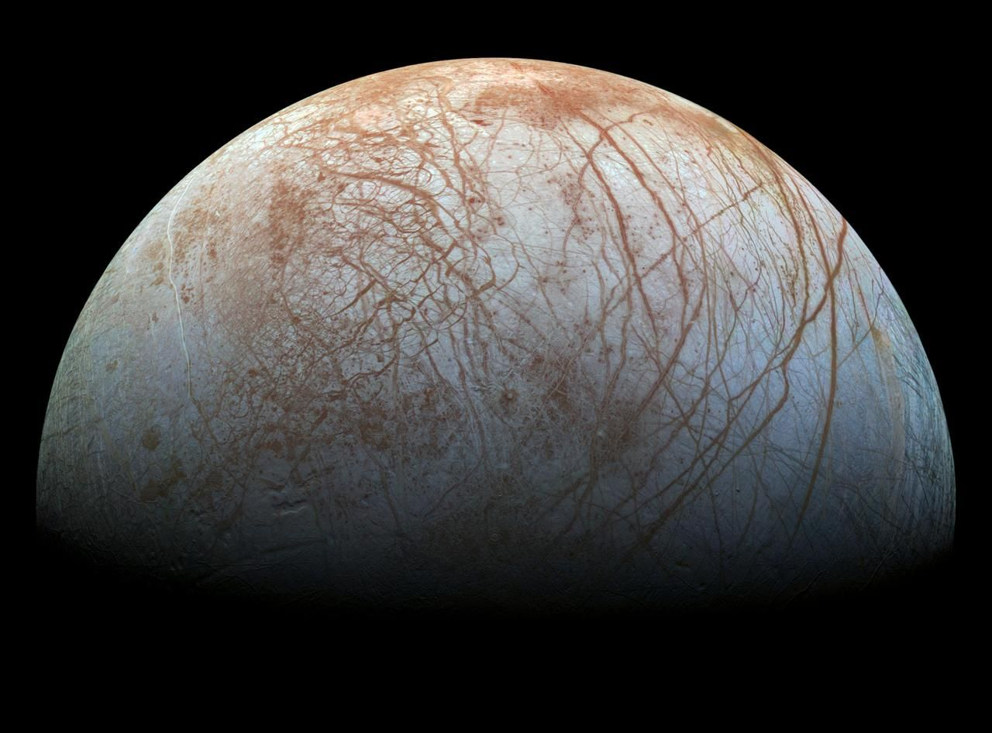
Figure 54. Europa, an ice-covered moon of Jupiter with a salt-water ocean below the crust, assembled from Galileo spacecraft images. The reddish lines are cracks in the ice. Image: NASA/JPL-Caltech/SETI Institute.

Exoplanets and the Frequency of Life
As Chapter 27 shows, rocky planets in the habitable zones of their stars are common, found around tens of percent of Sun-like stars. The raw material for life is therefore abundant.
The transition from habitability to inhabited status is unmeasured. The only known example is Earth. The time required for the origin of life on Earth is poorly constrained. It may have been short. It may have been rare. The subsequent evolution of complex, multicellular, and technological life took billions of years and may depend on contingent events.
Statistical arguments based on the single known case are weak. The absence of detected technosignatures within a few tens of light-years sets a weak upper limit on the abundance of technological civilizations. It does not constrain microbial life. The frequency of life remains an open empirical question. The answer will come from atmospheric spectroscopy of nearby exoplanets and from continued exploration of the Solar System.

Exobiospheres
An exobiosphere is a biosphere on a planet or moon orbiting a star other than the Sun. None has been detected. The search proceeds by identifying habitable environments and then seeking biosignatures—observable features more readily produced by life than by abiotic processes.
Surface liquid water remains the most conservative target because it is the solvent of terrestrial life and because its presence can be inferred from orbital distance, albedo and atmospheric composition. Subsurface oceans maintained by tidal heating enlarge the target list to include moons of giant planets. The atmospheric and surface biosignatures under consideration are described in the preceding sections; each admits abiotic false positives, which is why multiple lines of evidence are required.
The statistical context is the occurrence-rate picture given earlier. A single detection would demonstrate that life is not unique to Earth. Non-detection in a large sample would place an upper limit on the abundance of biospheres that produce strong, global signatures. Present instruments can characterize the atmospheres of a few favorable targets. Future telescopes will enlarge the sample. The existence of exobiospheres remains an open empirical question whose answer will be obtained by observation, not by theory alone.

Exobiology
Exobiology is the study of the origin, evolution and distribution of life beyond Earth. It encompasses the conditions required for life, the possible biochemistries that could satisfy those conditions, and the observational signatures that would reveal its presence.
The only known life is terrestrial. It is carbon-based, uses water as solvent, and employs nucleic acids and proteins. Laboratory experiments have shown that many of its building blocks form under abiotic conditions and that alternative solvents and backbones are chemically conceivable. No alternative system has been shown to replicate and evolve. The working definition of life used in exobiology therefore remains operational: a chemical system that maintains itself far from equilibrium, reproduces, and undergoes Darwinian evolution.
Within the Solar System the most accessible targets are Mars, Europa, Enceladus and Titan. Mars preserves evidence of past surface water. Europa and Enceladus possess subsurface oceans in contact with rock. Titan offers a methane-rich environment whose biochemistry, if any, would differ from Earth’s. Beyond the Solar System the targets are exoplanets and exomoons whose atmospheres or surfaces can be characterized. The search is limited by distance and by the ambiguity of biosignatures.
Exobiology does not assume that life is common. It asks what physical and chemical conditions permit life and how those conditions can be recognized at a distance. The answers are constrained by terrestrial biochemistry and by the universal laws of chemistry and thermodynamics. They will be settled by observation.

The Drake Equation
The Drake equation estimates the number of communicative civilizations in the Galaxy. It is the product of the star-formation rate, the fraction of stars with planets, the number of habitable planets per star, the fraction that develop life, the fraction that develop intelligence, the fraction that develop technology, and the lifetime of the communicative phase. Most factors are unknown, so the equation organizes the ignorance and does not compute a number.
The only factors constrained by observation are the star-formation rate and the occurrence of planets. The remaining factors are speculative. The equation is therefore a framework for discussion, not a prediction. Its value lies in identifying which quantities must be measured. Those measurements are the program of astrobiology and of the search for technosignatures.

Technosignatures
Technosignatures are observable evidence of technology. Radio transmissions, optical lasers, waste heat, atmospheric pollutants and artificial structures have been proposed. Searches for narrow-band radio signals have been conducted for decades. No confirmed signal has been found, though the sensitivity and the sky coverage have increased and the parameter space remains large.
Waste-heat searches look for infrared excesses from Dyson spheres or from industrial activity. Atmospheric searches look for gases that are not produced by known abiotic or biological processes. Both are limited by the precision of present data. The absence of detections constrains the abundance of powerful, continuously radiating technologies within a few hundred light-years. It does not constrain intermittent or low-power technologies. The search continues.

The Fermi Paradox
The Fermi paradox is the apparent contradiction between the expectation that technological civilizations should be common and the absence of evidence for them. The Galaxy contains hundreds of billions of stars. Many host planets. If even a small fraction develop technology and if that technology spreads, the Galaxy should have been visited or colonized many times. No unambiguous evidence of such activity exists.
Proposed resolutions include the rarity of life, the rarity of intelligence, the short lifetime of technological civilizations, the difficulty of interstellar travel, and the possibility that evidence exists but has not been recognized. None is established. The paradox is not a formal contradiction. It is a statement that the silence is surprising under certain assumptions. Those assumptions may be false. The observational upper limits on technosignatures within a few tens of light-years are still weak. The paradox will be resolved by better observations or by a clearer understanding of the evolutionary bottlenecks.

Panspermia
Panspermia is the hypothesis that life or its precursors can be transferred between planets or between stellar systems. Lithopanspermia proposes transfer inside rocks ejected by impacts. The rocks must survive ejection, transit and entry. Laboratory experiments show that bacteria can survive the shock and the radiation for limited periods. The transfer of viable organisms between Mars and Earth is possible on dynamical grounds. It has not been demonstrated.
Interstellar panspermia faces greater obstacles: transit times of millions of years and a lethal radiation dose unless the organisms are deeply shielded. The hypothesis does not solve the origin of life; it relocates it. No evidence requires it, none excludes it for the nearest planets, and on present knowledge it remains an open possibility of low probability.
Questions to Keep Asking
How do we know that a gas is a biosignature and not geochemistry? We look at it in context, with several gases together, and ask whether any lifeless process could supply them.
What would a confirmed, repeatable sign of life on another world do to our estimate of how common life is?
Try it yourself. Choose a value for each factor of the Drake equation and compute the result. Then change each factor within a plausible range, and see how the answer ranges from nobody to millions.

47. Human Evolution
At least twenty species of human relatives have lived and died in the past seven million years, and for much of that time several lived at once. We are the last survivors of a crowded family, and our genomes still carry traces of two of the others.
Human evolution is the phylogenetic history of the hominin lineage after its divergence from the chimpanzee lineage, approximately 6–7 million years ago. Early hominins were bipedal and small-brained. The genus Homo appears around 2.8 million years ago, and brain size increases thereafter. Stone tools appear by 3.3 million years ago, and the Acheulean industry is associated with Homo erectus. Control of fire is documented by 1 million years ago.
Homo sapiens emerges in Africa around 300 000 years ago. Anatomically modern humans disperse out of Africa after 60 000 years ago. They interbreed with Neanderthals and Denisovans. Those archaic populations disappear. Genetic data show that non-African populations carry 1–2 percent Neanderthal ancestry. Some Oceanian populations carry additional Denisovan ancestry.
Cultural evolution accelerates. Symbolic behavior, complex tools and, later, agriculture and writing appear. Biological evolution continues but is now accompanied by rapid cultural and technological change. The fossil, archaeological and genetic records converge on an African origin of Homo sapiens and on subsequent global dispersal with limited archaic admixture.
The hominin fossil record now includes more than twenty named species. The sequence is not a single line: multiple species coexisted for long intervals, and Australopithecus and early Homo overlapped. Homo erectus persisted in Asia while other lineages evolved in Africa. Neanderthals, Denisovans and Homo sapiens overlapped in time and interbred.
Genetic data calibrate the divergences. The sapiens–Neanderthal split is dated to approximately 600 000 years ago. The admixture events are detected by the excess sharing of derived alleles and by the length distribution of introgressed haplotypes.
Cultural evidence appears early: cut-marked bones, ochre use by 300 000 years ago, and symbolic artifacts after 100 000 years ago. The acceleration of cultural change after 50 000 years ago coincides with the global dispersal of Homo sapiens. Biological and cultural evolution have proceeded together since the origin of the genus. The genetic and fossil records are mutually consistent on the broad outline.

Australopithecus and Early Hominins
The hominin lineage diverged from the chimpanzee lineage between 7 and 6 million years ago. The earliest well-sampled genus is Australopithecus, appearing around 4.2 million years ago. Australopithecus afarensis, known from East Africa, was bipedal yet retained arboreal adaptations. Brain size was only slightly larger than that of chimpanzees. Sexual dimorphism was pronounced.
Other species—Australopithecus africanus in South Africa, Australopithecus sediba, and the robust australopiths (Paranthropus)—show dietary and locomotor variation. Stone-tool use is documented by 3.3 million years ago, before the appearance of Homo. The australopiths demonstrate that bipedalism preceded significant brain enlargement. They occupy the morphological and temporal interval between earlier, poorly known hominins and the genus Homo. Their extinction coincides with the rise of early Homo and with environmental shifts toward more open habitats.

Lucy and the Laetoli Footprints
Australopithecus afarensis is known from dozens of individuals, including the partial skeleton Lucy. The pelvis and knee are adapted for bipedalism, while the arms and curved fingers retain arboreal capability. Sexual dimorphism is high and brain size is 380–430 cm³. Footprints at Laetoli, dated to 3.6 million years ago, confirm bipedal gait with a human-like stride.

Homo habilis
Homo habilis is the earliest widely recognized species of the genus Homo. Fossils from East Africa date between approximately 2.4 and 1.4 million years ago. Brain volume averages about 600 cm³, larger than australopiths yet smaller than later Homo. The face is less projecting. The hands show adaptations for precision gripping.
The species is associated with the Oldowan stone-tool industry—simple flakes and cores. Whether habilis itself made the tools is inferred from chronological and spatial coincidence. Body size remained small and locomotion was fully bipedal, while the taxonomic boundaries are debated. Some specimens may belong to Australopithecus or to a separate early Homo species. Regardless of the precise allocation, the fossils document the appearance of larger brains and systematic tool use in the hominin lineage by 2.4 million years ago.

Tools and Bodies of Homo habilis
Homo habilis is associated with the Oldowan industry at multiple East African sites. The tools consist of flakes struck from cores. Use-wear studies show that the flakes were used to cut meat and plant material. Whether habilis itself made them is inferred rather than proved.
Body size estimates range from 30 to 50 kg. Limb proportions are more human-like than those of australopiths, yet the arms remain relatively long. Brain size varies from 500 to 700 cm³. The variation has led some workers to split the sample into more than one species. Whether the split is justified or whether the sample represents a single variable species remains debated.

Homo erectus and the First Dispersals
Homo erectus appears in Africa around 1.9 million years ago. Brain size is substantially larger than in australopiths. Body proportions approach those of modern humans. The Acheulean stone-tool industry, characterized by hand-axes, is associated with the species. Control of fire is securely documented by 1 million years ago and may be older.
Homo erectus was the first hominin to leave Africa. Fossils and tools in Georgia, China and Indonesia date to between 1.8 and 1.6 million years ago. The dispersals demonstrate that a hominin with a larger brain, more efficient locomotion and improved technology could occupy a wide range of environments. Regional populations persisted for more than a million years. The species is the probable ancestor of both later African Homo and of the archaic Eurasian lineages that include Neanderthals and Denisovans.

Homo heidelbergensis
Homo heidelbergensis is a Middle Pleistocene species known from Africa and Europe, dated between roughly 700 000 and 200 000 years ago. Brain size overlaps the modern human range, averaging 1 200 cm³. The species is associated with the later Acheulean industry and with the earliest evidence of constructed shelters and of hafted spears.
African populations of heidelbergensis are regarded by many researchers as the ancestors of Homo sapiens. European populations are regarded as the ancestors of Neanderthals. The species therefore occupies the last common ancestral position before the sapiens–Neanderthal divergence. Regional variation is considerable. Some authors prefer to split the sample into additional taxa. The fossils nevertheless document a hominin with a large brain, advanced tools and a wide geographic range in the Middle Pleistocene.

The Schöningen Spears
The Schöningen spears, found in Germany and dated to about 300 000 years ago, are among the oldest wooden hunting weapons known. Their balance resembles that of modern javelins, which indicates planned hunting of large game and a long tradition of woodworking behind it.
They are usually attributed to Homo heidelbergensis, a species defined by a combination of archaic and derived traits: a prominent brow ridge, a brain within the modern range, and a link to the later Acheulean tool industry. The geographic split between African and European populations is supported by both morphology and the genetic divergence date of approximately 600 000 years ago, though some researchers prefer to assign the two samples to separate species.

Neanderthals and Denisovans
Neanderthals occupied Europe and western Asia from approximately 400 000 to 40 000 years ago. They possessed large brains, robust skeletons and a Mousterian tool culture. They interbred with modern humans.
Denisovans are known primarily from DNA recovered from fragmentary remains in Siberia and from sediments. They contributed ancestry to modern Oceanian and some Asian populations. Both Neanderthals and Denisovans are sister groups to Homo sapiens within the genus Homo. Their extinction coincides with the arrival of modern humans in their respective ranges. The genetic legacy demonstrates that the replacement was not complete. Archaic admixture is a documented feature of recent human evolution.
Neanderthal genomes recovered from bones and from cave sediments show that the population was small and structured. Genetic diversity was lower than in modern humans. The low diversity is consistent with repeated bottlenecks. Adaptive alleles introgressed into modern humans include variants that affect skin and hair pigmentation and immune response. Some of the introgressed haplotypes are associated with increased risk of certain diseases. The net effect of the admixture was not uniformly beneficial.
Denisovan ancestry is highest in populations of New Guinea and Australia, reaching 4–6 percent. The introgressed segments include alleles that improve adaptation to high altitude in Tibetans. The source population of the Denisovan contribution appears to have been diverse. At least two distinct Denisovan lineages contributed. The genetic evidence therefore reveals a more complex history of archaic admixture than the fossil record alone had indicated.

What Neanderthals Were Like
The Neanderthals of popular imagination were brutes. The Neanderthals of the evidence were something else. They lived through harsh glacial climates for hundreds of thousands of years, with stocky bodies suited to the cold. They hunted large animals and also ate shellfish, plants and, in some places, cooked plant foods. Starch grains and plant compounds preserved in the dental calculus of some individuals show a varied diet.
They made tools of great skill, including stone blades and composite tools in which a stone point was fixed to a handle with birch-bark tar, a glue that has to be made by controlled heating. In Bruniquel Cave in France, rings of broken stalagmites about 176 000 years old show that they went deep into dark caves and built there. Some groups wore ornaments made of eagle talons and marine shells. Whether they buried their dead on purpose remains debated, and so does the question of how far they used symbols.
The archaeologist Rebecca Wragg Sykes, in her book Kindred, shows how much of this picture is recent, and how the older view was shaped by the first, poorly interpreted skeletons. The modern picture is of another human species with its own culture, not a failed draft of our own.

Homo floresiensis
Homo floresiensis is a small-bodied hominin known from the island of Flores, Indonesia. Its skeletal remains date to between about 100 000 and 60 000 years ago, and its stone tools to as late as 50 000 years ago. Adult stature was about 1.1 m, brain volume was approximately 400 cm³, and stone tools are associated with the remains.
The diminutive size has been interpreted as island dwarfism acting on an earlier Homo erectus population, or as the persistence of an even earlier, small-bodied lineage. Pathological explanations for the type specimen have been excluded by the discovery of additional individuals. The species demonstrates that hominins reached Wallacea and that isolated populations could evolve extreme body-size reduction. Its survival until at least 50 000 years ago means it overlapped in time with modern humans in the broader region. The phylogenetic placement remains uncertain.
Stone tools associated with the species are found in deposits that span hundreds of thousands of years. The tools are simple yet consistent. They indicate a stable technological tradition maintained by a small-bodied population.
The island setting supplies the selective context for dwarfism. Limited resources and the absence of large predators favor reduced body size in large mammals. The same process is documented in other island lineages. Whether floresiensis descended from Homo erectus or from an earlier, smaller-bodied migrant remains unresolved. The brain size of approximately 400 cm³ is among the smallest known in the genus, about that of a chimpanzee. The combination of small brain, small body and persistent tool use shows that technological behavior is not strictly proportional to absolute brain volume.

Homo naledi
Homo naledi is a hominin species known from the Rising Star cave system in South Africa. The remains of at least fifteen individuals have been recovered from the Dinaledi Chamber. The skeleton combines primitive and derived features. The shoulders, trunk and pelvis are australopith-like. The hands, feet and dentition are closer to later Homo. Brain volume is small, approximately 500 cm³.
Dating of the fossils yields an age between 335 000 and 236 000 years ago. The species therefore coexisted with early Homo sapiens in Africa. The location of the remains deep inside a cave system that lacks evidence of occupation has prompted the hypothesis that the bodies were deliberately placed there. Alternative explanations—natural trapping or water transport—have not been excluded. No associated stone tools or other cultural remains have been found in the chamber.
Homo naledi demonstrates that morphological diversity within Homo persisted into the later Middle Pleistocene. A small-brained species with a mosaic of primitive and derived traits lived alongside larger-brained hominins. Its phylogenetic position remains unresolved. It may represent a surviving lineage of early Homo or a convergent form. The fossils enlarge the known range of hominin variation in the period immediately preceding the appearance of anatomically modern humans.

Brain-Size Discrepancy in Later Hominins
Brain size within the genus Homo was not uniform. By the later Middle Pleistocene, species with very different cranial capacities coexisted. Homo naledi, described above, had a brain volume of approximately 500 cm³. Contemporary early Homo sapiens and other archaic humans already had brains of 1 200–1 400 cm³. Earlier Homo erectus populations had averaged 800–1 100 cm³ for more than a million years. Neanderthals and early modern humans later overlapped in the range 1 200–1 700 cm³.
The discrepancy demonstrates that encephalization was not a single, progressive trend shared by all lineages. Large brains are metabolically costly. A small-brained species could persist if its niche did not demand the same cognitive expenditure. The fossil record therefore contains both highly encephalized and persistently small-brained members of Homo until late in the Pleistocene. Brain size alone does not define the genus, nor does it increase monotonically through time. The variation is real and temporally overlapping.

What Made Our Species Different
Homo sapiens appeared in Africa about 300 000 years ago, and the features that define us did not arrive together. A rounded braincase, a small face and a chin came gradually. Ochre was in use early, and shell beads and engraved patterns appear by about 100 000 to 75 000 years ago. Symbolic behavior, in other words, built up over a long time inside Africa before it spread.
The anthropologist Ian Tattersall has emphasized in Masters of the Planet how late and how sudden the full expression of symbolic thought seems to have been, compared with the anatomy that carried it. Yuval Noah Harari, in Sapiens, argued that the decisive novelty was the ability to speak of things that do not exist, such as gods, nations and money, which allowed cooperation among thousands of strangers. The idea is vivid and widely discussed. It is a hypothesis about cognition that the bones cannot settle.
What is secure is that by 50 000 years ago people with fully modern minds lived on several continents, and that Australia had been reached by then or earlier. Over the following tens of thousands of years their descendants crossed the Arctic into the Americas and, much later, settled the islands of the Pacific. They did it with the same bodies we have, and there is no evidence that they differed biologically from us.

The Origin of Language
Language is a species-specific human capacity. It combines a finite set of discrete units into an unbounded set of meaningful expressions. The capacity has a genetic basis. Mutations in the gene FOXP2 impair speech and language while sparing general intelligence. Comparative studies show that the human version of FOXP2 differs from the chimpanzee version by two amino acids. The functional consequences of those differences remain under investigation.
Anatomical prerequisites include a vocal tract suited to speech, fine control of breathing, and expanded cortical areas for sequencing and semantics. None is sufficient by itself. The archaeological record supplies indirect evidence. Symbolic artifacts, complex tools and long-distance exchange appear sporadically after 100 000 years ago and become widespread after 50 000 years ago. These behaviors are widely regarded as requiring language. Direct fossil evidence of speech is absent.
The selective pressures that produced language are debated. Proposals include social coordination, teaching, and the negotiation of relationships in large groups. The capacity is universal among human populations and is acquired by children with minimal explicit instruction. It remains the clearest cognitive distinction between humans and other living primates.

Cave Art and the Ice Age Mind
Some of the most striking evidence of the human mind is painted on cave walls. The Chauvet cave in France, with its lions, rhinoceroses and horses, was decorated more than 30 000 years ago. Lascaux, with its great bulls, is about 17 000 years old. Paintings on the Indonesian island of Sulawesi show that figurative art, including a scene with human-like figures and an animal, is at least 51 000 years old. Hand stencils appear on several continents. The Lion-Man ivory figure from Germany, carved about 40 000 years ago, joins a human body to a lion’s head.
What the images meant is not known. David Lewis-Williams argued in The Mind in the Cave that many of them came from altered states of consciousness, in which the nervous system produces patterns and visions that a community then interprets, and that the caves were places of ritual. The thesis explains some features, such as the recurrence of geometric signs, and is contested in others, and ethnographic analogy can only carry it so far.
Whatever their meaning, the paintings show skilled hands, a feeling for movement and a willingness to go far underground with torches. They also show that the capacity for imagined worlds, which sits at the center of the question of language, was present at least tens of thousands of years ago.

After the Ice: Foragers and Early Farmers
The last ice age ended about 11 700 years ago, and in the warming that followed, human societies began to change. In the Levant, the Natufian people lived in permanent settlements before farming, buried their dead in cemeteries and gathered wild cereals with sickles. Residues in a cave near Haifa suggest that they brewed a beer-like drink some 13 000 years ago. At Göbekli Tepe in Turkey, around 11 500 years ago, hunter-gatherers raised monumental carved stone pillars before there were farms.
Steven Mithen, in After the Ice, follows the world from the end of the glaciation to the first cities in a series of vivid scenes. David Graeber and David Wengrow argue in The Dawn of Everything that early societies were more varied and more experimental than the old story of a ladder from bands to tribes to states allows. They point to seasonal shifts in social organization and to deliberate choices about hierarchy. Archaeologists debate how much weight the evidence will bear.
The older picture of farming as a single invention, spreading from a Fertile Crescent, has not survived. Plants and animals were domesticated in several regions, at different speeds, by people who often kept foraging at the same time. The change was gradual, and not always an improvement in health, as the next section shows.

Agriculture and the Neolithic Transition
Agriculture is the cultivation of domesticated plants and animals. It appeared independently in several regions after 12 000 years ago: the Fertile Crescent, China, Mesoamerica, the Andes, New Guinea and West Africa. The transition from foraging to farming was gradual. It involved the selective propagation of plants with non-shattering seed heads and of animals with reduced aggression.
Farming supported higher population densities, making permanent settlements, food surpluses and specialized crafts possible. It also introduced new selective pressures, and diets narrowed. Infectious disease increased with crowding and with proximity to livestock. Skeletal evidence shows a decline in average stature and an increase in dental caries in early farming populations. Lactase persistence and amylase copy-number variation are genetic adaptations to agricultural diets.
The Neolithic transition is the demographic and ecological foundation of later urban societies. It is not a uniform improvement in health or leisure. It is a shift in subsistence that permitted larger populations and more complex social organization at the cost of new physiological stresses. The domesticated species and the human populations that depend on them have coevolved since.

Horses, Wheels and the Spread of Languages
Most languages of Europe, Iran and northern India belong to one family, Indo-European, whose members are far more alike in basic words than chance would allow. Linguists reconstructed a common ancestor, with words for wheel, wagon and horse, before there was any genetic evidence of where its speakers lived. David Anthony’s The Horse, the Wheel, and Language argues that they were herders of the Pontic-Caspian steppe, north of the Black Sea and Caspian, about 5 000 years ago.
Ancient DNA has since given the idea a powerful support. Genomes from the Yamnaya culture of the steppe, from about 3300 to 2600 BCE, appear to have contributed a large share of the ancestry of people in northern and central Europe soon after. Wheeled wagons and herding on horseback, or at least with horses, made a mobile way of life possible.
Questions remain. Some scholars prefer an earlier, Anatolian origin linked to the spread of farming, and the dating of horse riding is argued. Language spreads for many reasons, not only by migration, and the match between genes and languages is never exact. Still, the case shows how archaeology, linguistics and genetics can be tested against one another.
Questions to Keep Asking
How do we know that our ancestors interbred with Neanderthals? Ancient DNA, which earned Svante Pääbo the 2022 Nobel Prize, shows their genes in living people outside Africa.
A skeleton of a modern human found in clearly older rock than the oldest Homo sapiens fossils would change the story. What dating would you want?
Try it yourself. Lay out a strip of paper seven meters long, one millimeter for each thousand years. Where do the Neanderthals, the pyramids and you fall?
Further reading for Part VII. Dawkins’s The Blind Watchmaker explains natural selection as clearly as anyone has, and Watson’s The Double Helix is a candid memoir of the discovery of DNA’s shape. Lane’s The Vital Question asks why complex cells evolved only once, and McFadden and Al-Khalili’s Life on the Edge covers quantum effects in living things. For human origins, read Tattersall’s Masters of the Planet, Wragg Sykes’s Kindred, Mithen’s After the Ice, and the articles in Scarre’s The Human Past. Harari’s Sapiens and Graeber and Wengrow’s The Dawn of Everything disagree usefully about what came next, Anthony’s The Horse, the Wheel, and Language follows the steppe herders, and Lewis-Williams’s The Mind in the Cave asks about the first art.

Part VIII: The Human Body and Mind
How a body is run and defended, how a brain works, and what we do not yet know about experience

48. The Human Body
Your heart beats about three billion times in a lifetime and your body replaces most of its cells every few years, yet the temperature of your blood stays within a degree or so. That stability is not rest. It is constant correction.
The body is a system of organs that maintain conditions compatible with the life of its cells. Temperature, acidity, salt balance, and the supply of oxygen and fuel are held within narrow ranges. The holding is called homeostasis; it is active, it costs energy, and when it fails, illness follows.
Food supplies the energy and the building materials. Carbohydrates, fats, and proteins are broken down by digestion into sugars, fatty acids, and amino acids, which are absorbed and distributed. Vitamins and minerals are required in smaller amounts, as the next section explains.
Oxygen is carried by hemoglobin in red blood cells. The same protein that makes blood red binds oxygen in the lungs and releases it in the tissues. Carbon dioxide is carried back, mostly as bicarbonate, while the heart pumps the blood and the lungs exchange the gases. The system is simple in outline and finely regulated in practice. Exercise, altitude, and disease all change the demands. The body adjusts the rate of breathing and the output of the heart to match.
Hormones are chemical signals carried in the blood, described in the next section. Together with the nervous system, they form the body’s two great communication networks.
The immune system tells self from non-self and attacks the latter; its workings are described below. Autoimmune diseases occur when the distinction fails and the system attacks the body’s own tissues, and allergies when it overreacts to a harmless substance.
Aging, infection, injury, and genetic error are the main ways the system fails. Medicine is the attempt to restore or replace the failed function. Surgery, drugs, hormones, and, increasingly, cells and genes are the tools. The body is not a machine in the simple sense. It is a living system that repairs itself until it cannot. Understanding the repair, and its limits, is the practical face of physiology.

Vitamins, Hormones, and the Chemical Control of the Body
In the early twentieth century, diseases such as scurvy, beriberi and rickets were traced to substances missing from the diet, which were named vitamins. They are needed in small amounts, and some act as cofactors for enzymes: vitamin C is needed to make collagen, the B vitamins take part in energy metabolism, and vitamin D regulates calcium. Deficiency produces specific diseases, and an excess of some vitamins is also harmful. The discovery turned nutrition from general advice about food into a chemistry of specific molecules.
Hormones are chemical signals produced by glands and carried in the blood. Insulin, from the pancreas, lowers blood sugar, and its absence or ineffectiveness produces diabetes; thyroid hormone regulates metabolic rate, adrenaline prepares the body for action, sex hormones regulate reproduction and growth hormone regulates growth. The endocrine and nervous systems, the body’s two main networks of control, interact, and many signaling molecules are used by both.
Blood groups are determined by molecules on the surface of red cells. The ABO system and the Rh system are the best known. Transfusion requires matching, since mismatch can destroy the transfused cells, and the groups are inherited in a Mendelian pattern. They are also useful as markers in genetics and in anthropology.
The chemical control of the body is precise. Concentrations are regulated by feedback. Too much of a hormone usually suppresses its own production. Too little stimulates it. The same logic appears in enzyme pathways and in gene regulation. The body is a set of chemical systems that maintain themselves by continuous adjustment. When the adjustment fails, disease follows. When the missing molecule can be supplied, as with insulin or a vitamin, the failure can often be corrected.

Hormones and Their Hierarchies
Hormones are signaling molecules released into the blood. They act on distant targets that possess the appropriate receptors. Peptide hormones bind surface receptors and activate second-messenger cascades. Steroid hormones cross the membrane and bind intracellular receptors that regulate transcription. The distinction determines speed and duration of effect.
The endocrine system is organized in hierarchies: the hypothalamus controls the pituitary, the pituitary controls peripheral glands, and negative feedback from the peripheral hormones stabilizes the set points. Disruption at any level produces disease. Diabetes mellitus is a failure of insulin signaling and hypothyroidism a failure of thyroid-hormone production, and both can be managed once the missing signal is supplied.
Local chemical signals—neurotransmitters, cytokines, growth factors—operate over shorter distances and use the same receptor logic, so the difference is range, not mechanism. Chemical control, whether endocrine or local, is the means by which cells coordinate activity without direct contact.

The Circulation of the Blood and the Rise of Physiology
For centuries the heart was thought to heat the blood and the blood was thought to move back and forth in the vessels. The lungs were thought to cool it. The idea came from the Greeks and was refined by Galen in the second century. It lasted more than a thousand years.
In 1628 William Harvey published a different account. He measured the volume of blood the heart pumps. The quantity was far too large for the blood to be made and consumed continuously. It had to circulate. He traced the path from the right side of the heart to the lungs, back to the left side, out to the body, and back again. The valves in the veins allow flow only toward the heart. The capillaries that complete the circuit were seen later, with the microscope.
Harvey’s method was quantitative: he counted and measured, and the conclusion followed from the numbers. Physiology, the study of function, began to replace anatomy alone. The same approach was later applied to respiration, digestion, and the nervous system.
The blood carries oxygen, bound to hemoglobin, along with nutrients, waste, and hormones. The heart is a pump and the vessels are a closed system. The pressure is maintained by the heart and regulated by the vessels. High blood pressure damages the vessels and the organs they supply. Low pressure fails to deliver oxygen. The whole arrangement is a closed loop under constant adjustment.
The same quantitative habit that established circulation established the rest of modern physiology. Measure the input, measure the output, and find the path; the method is still the one used today.

The Heart and Blood Pressure
The heart is a four-chambered pump in mammals and birds. The right side receives venous blood and sends it to the lungs. The left side receives oxygenated blood and sends it to the systemic circulation. Valves enforce one-way flow. The cardiac cycle consists of systole (contraction) and diastole (filling). Stroke volume times heart rate equals cardiac output, which is typically 5 liters per minute at rest and can rise fivefold during exercise.
Blood pressure is the force exerted on arterial walls: systolic pressure is the peak during ejection, and diastolic pressure is the minimum during filling. Mean arterial pressure is regulated by baroreceptors, the autonomic nervous system and the kidneys. Chronic elevation damages vessels and organs. The regulatory loops are negative feedback. They maintain pressure within a narrow range under ordinary conditions and adjust it when demand changes.
The same double circulation and pressure regulation operate, with variations in detail, across mammals and birds. They are the physiological basis of sustained high metabolic rates.

Blood
Blood is a specialized connective tissue that circulates through the vascular system. It transports oxygen, carbon dioxide, nutrients, hormones and waste products. It also distributes heat and contributes to immune defense and hemostasis. In an adult human the volume is approximately five liters.
Plasma constitutes about 55 percent of the volume. It is an aqueous solution of proteins (albumin, globulins, fibrinogen), electrolytes, nutrients and metabolic wastes. The remaining 45 percent is cellular. Erythrocytes (red cells) are anucleate in mammals, contain hemoglobin and carry oxygen, and their biconcave shape maximizes surface area and flexibility. Leukocytes (white cells) comprise neutrophils, lymphocytes, monocytes, eosinophils and basophils. They mediate innate and adaptive immunity. Platelets are cell fragments that initiate clotting.
Hemoglobin binds oxygen cooperatively. The binding curve is sigmoid. Affinity is reduced by lowered pH and elevated carbon dioxide (the Bohr effect) and by increased 2,3-bisphosphoglycerate, which helps unloading in active tissues. Carbon dioxide is carried partly as dissolved gas, partly bound to hemoglobin, and mostly as bicarbonate after conversion by carbonic anhydrase in the red cell.
Hemostasis begins with vasoconstriction and platelet adhesion to exposed collagen. The coagulation cascade converts fibrinogen to fibrin, stabilizing the platelet plug. Anticoagulant pathways and fibrinolysis limit the clot to the site of injury. Disorders of any step produce thrombosis or bleeding.
Blood cells are produced in the bone marrow from hematopoietic stem cells. Erythropoietin, thrombopoietin and colony-stimulating factors regulate lineage output. The average lifespan of a human red cell is 120 days. Senescent cells are removed by macrophages in the spleen and liver. Iron from hemoglobin is recycled. The same fluid and cellular system operates, with variations in detail, throughout the vertebrates.

The Immune System
The immune system distinguishes self from non-self and eliminates pathogens. Innate immunity is immediate and non-specific. Barriers, phagocytes, complement and inflammatory cytokines constitute the first response. Pattern-recognition receptors detect conserved microbial molecules and trigger the innate pathways.
Adaptive immunity is slower and specific. Lymphocytes carry receptors generated by somatic recombination, so each clone recognizes a different antigen, and clonal selection expands the clones that bind it. Helper T cells coordinate the response, cytotoxic T cells kill infected cells, and B cells secrete antibodies. Memory cells persist after the pathogen is cleared and speed the response on re-exposure.
Self-tolerance is established by deleting or inactivating clones that recognize the body’s own antigens, and when tolerance fails the result is autoimmune disease. The system is not perfect: pathogens evolve ways to evade it and hosts evolve countermeasures, in a continuous arms race. Vaccination exploits immunological memory by presenting an antigen without the disease, so the same principles underlie natural immunity and medical immunization.
Questions to Keep Asking
How do we know how the body works? William Harvey measured how much blood the heart pumps and showed that it must circulate, and every physiology textbook since has rested on that kind of measurement.
A treatment that lowered blood pressure but increased deaths would show that the measurement was not the same as the outcome. Why can that happen?
Try it yourself. Count your pulse at rest, then after climbing stairs, and time how long it takes to return to normal. What does the delay tell you?

49. Disease, Microbes and Resistance
Smallpox killed hundreds of millions of people in the twentieth century alone and was declared eradicated in 1980. It shows what understanding germs, immunity and public health can do, and the later pages show what happens when the lessons are forgotten.

Antibiotics and Resistance
Antibiotics are compounds that kill or inhibit bacteria at concentrations tolerable to the host. Most clinical antibiotics are natural products or their derivatives. They target cell-wall synthesis, protein synthesis, nucleic-acid synthesis or membrane integrity. The therapeutic window exists because these targets differ between prokaryotes and eukaryotes.
Resistance arises by mutation or by acquisition of resistance genes. Mechanisms include enzymatic inactivation, target modification, efflux pumps and reduced permeability. Resistance genes are frequently carried on plasmids and transposons and spread by horizontal transfer. The same genes occur in environmental bacteria that have never encountered clinical antibiotics. Clinical use merely enriches pre-existing resistance, and multi-drug-resistant strains combine several mechanisms to survive more than one class of drug.
The rate of discovery of new antibiotic classes has slowed. Resistance continues to spread. The evolutionary process is ordinary natural selection acting on large bacterial populations with short generation times. Stewardship, combination therapy and the development of new agents are the available countermeasures. The underlying biology is the same biology that governs any host–parasite interaction.

Vaccines and mRNA Medicine
A vaccine teaches the immune system to recognize a pathogen without causing the disease. The oldest vaccines used weakened or killed microbes. An mRNA vaccine instead supplies a set of instructions: a strand of messenger RNA, packaged in a droplet of fat, that tells a person’s own cells to make one harmless piece of the pathogen, such as the spike protein of a coronavirus. The cells make it for a few days, the immune system learns it, and the RNA is then broken down.
The enabling work was done over years by Katalin Karikó and Drew Weissman, who found in 2005 that modifying a building block of the RNA stops it from setting off alarm responses, and who received the Nobel Prize in 2023. Vaccines against COVID-19 were authorized in December 2020, within a year of the virus being sequenced. Early trials showed efficacy of about 95 percent against symptomatic disease. Because the instruction can be rewritten quickly, updates for new variants take weeks to design, and an mRNA vaccine against respiratory syncytial virus has also been approved.
Limits are real. Protection against infection fades over months, so boosters are needed. Side effects exist, nearly all mild and short-lived. The first products needed cold storage. Experimental mRNA treatments for cancer, which write a tumor’s own mutations into a personalized vaccine, are in trials, and whether they will work is not yet known.

Pandemics and Emerging Infections
Most new infectious diseases of people come from animals. HIV passed from chimpanzees in Central Africa in the early twentieth century. The coronaviruses that caused SARS in 2002 and MERS in 2012 came through bats and, in turn, civet cats and camels. The influenza pandemic of 1918, one of the deadliest events in modern history, killed an estimated fifty million people, with estimates ranging from less than twenty million to more than ninety.
The cause of such events is ordinary evolution. Viruses mutate quickly, and when one finds a way into a new host and spreads efficiently, it has an enormous population in which to try variations. Crowding, travel, farming of animals and trade in wildlife increase the chances. The origin of SARS-CoV-2, the virus behind COVID-19, remains debated, and the debate is a reminder of how limited the monitoring of animal pathogens still is.
Defenses are known. Genomic sequencing of samples lets a new virus be identified within days and followed as it changes. Wastewater monitoring shows spread in a community before clinics are full. Vaccines and antivirals can be prepared in advance for related viruses. The hard part is not knowledge but funding that continues between emergencies, and the habit of acting early.

Handwashing, Sanitation and the Victory over Infection
The greatest reduction in infectious disease in history came before the antibiotic. In 1847 the Hungarian physician Ignaz Semmelweis noticed that deaths from childbed fever were far higher in a ward served by doctors, who came from the autopsy room, than in a ward served by midwives. When he required handwashing in chlorinated water, deaths fell. His colleagues largely rejected the finding, since no theory yet explained it.
The germ theory supplied the explanation. Joseph Lister applied carbolic acid to wounds and instruments in the 1860s and brought surgical infection under control. Clean water, sewers, pasteurized milk, refrigerated food and vaccination followed, and in industrial countries mortality from infectious disease fell dramatically before most effective drugs existed.
The lesson is that prevention is often cheaper and more reliable than cure. It remains true in places without safe water, where diarrheal disease still kills many children, and it is true in hospitals, where simple hygiene reduces infections that antibiotics increasingly fail to cure.

Antibiotics: Discovery and the Empty Pipeline
Alexander Fleming noticed in 1928 that a mold had killed bacteria on a culture plate, and Howard Florey, Ernst Chain and their colleagues turned penicillin into a drug in the early 1940s. The decades that followed were a golden age, with new classes of antibiotic found in soil microbes and then improved by chemistry. Mortality from bacterial pneumonia, tuberculosis and wound infection fell sharply.
The pipeline has since thinned. Few entirely new classes have reached the clinic since the 1980s, partly because discovery is difficult and partly because a drug used briefly and held in reserve earns little for its makers. Resistance has meanwhile grown, so that infections once easily treated can now require drugs of last resort.
New approaches are under study. Bacteriophages, the viruses that infect bacteria, are used experimentally against resistant infections. Machine-learning systems have been used to search chemical libraries for compounds with antibacterial activity, and at least two new candidates found this way have shown promise in laboratory and animal tests. Whether any will become a drug is not yet known. What is clear is that stewardship, using drugs only when needed, is as important as discovery.
Questions to Keep Asking
How do we know that a microbe causes a disease? Koch’s tests ask whether it is present in cases, can be isolated, causes the disease in a new host and can be recovered again, and genomic evidence adds more.
What would it take to show that a new pathogen can spread between people and does not merely cross from animals?
Try it yourself. Wash your hands the way a hospital does, with soap for twenty seconds, and notice how often you normally do not.

50. The Microbiome
You carry about as many bacterial cells as human ones, some forty trillion of each, and they act as an organ you did not know you had. The best-proven medical use of them is, on first hearing, unpleasant: donated stool that cures a lethal infection.
You are not only your cells. You are an ecosystem.
The gut alone holds trillions of bacteria, with fungi, viruses, and archaea in attendance. Skin, mouth, and lungs have their own communities. The genes in these microbes outnumber the genes in the human genome by a large factor. For a long time medicine treated this fact as contamination. It is closer to an organ.
The community helps digest what we cannot, trains the immune system, and produces molecules that enter the blood. Mice raised without microbes have abnormal immune systems and abnormal guts. Transfer the microbes, and some of the abnormalities change.
Antibiotics are the blunt history of the subject: they save lives and strip communities, and the recovery is usually good and sometimes not. The long project is more precise: add the missing organism, feed the useful one, stop feeding the harmful one, and leave the rest alone. Microbiome science is past the stage of discovering that the organisms are there. It is at the stage of learning which ones matter, and when.
The community in the gut is the best studied because it is the largest and the most accessible. It is dominated by bacteria, with important contributions from archaea, fungi, and viruses that infect the bacteria. Its composition varies along the gut, between people, and within a person over time. Diet is the fastest lever. A change in fiber intake changes the community within days. Antibiotics change it within hours, and illness, travel, and drugs change it too. A single sample is a snapshot, not a fate.
What the community does is specific, and specificity is the cure for hype. Some bacteria ferment fiber into short-chain fatty acids, which feed the cells lining the colon and influence immune signaling. Some modify bile acids, some synthesize vitamins, and some inactivate drugs while others activate them. A cardiac drug, digoxin, is inactivated by a particular gut bacterium in some people, which changes the drug’s effect. That is a precise, actionable finding. “The microbiome affects health” is a slogan. A named organism, a named molecule, and a named host response is a result.
Fecal microbiota transplantation proved that a community can be a treatment. In recurrent C. difficile infection, the normal community has been damaged, often by antibiotics, and a pathogen occupies the niche. Transferring a healthy donor’s community restores resistance and cures most such patients. Defined consortia of cultured bacteria are being developed to do the same job more cleanly. The success is a proof of principle. It does not imply that transferring communities will cure unrelated diseases. Trials in other conditions have been mixed; the principle is real, and the indications are narrow until shown otherwise.
Associations with obesity, diabetes, autism, depression, and autoimmune disease are widely reported and hard to interpret. People with these conditions often have different average communities. Diet, medication, and the disease itself can produce the difference. Establishing cause requires intervention or a mechanism, preferably both. Some mechanisms are emerging. Others will not emerge, because the association was a passenger. The field is in the stage where the passenger count is being reduced.
The hygiene observation belongs here. Populations with less exposure to diverse microbes in early life have more allergic and autoimmune disease. The observation is epidemiological. The mechanism is probably a matter of immune education: the developing immune system expects certain microbial signals and behaves differently without them. The practical implication is not a return to unmanaged infection. It is a more precise understanding of which exposures train the immune system and which only cause harm. That understanding is incomplete. It is far enough along to be part of pediatrics and of the design of future interventions.
The microbiome is an organ in the functional sense. It contributes to digestion, immunity, and drug response. It is not an organ in the anatomical sense, and it is not a second brain, despite the existence of real gut-brain signaling. Treating it as a partner rather than as dirt was the conceptual change. Treating it with the same demand for mechanism that the rest of medicine requires is the present task.
Diet is the intervention a person can actually control. Fiber feeds the bacteria that produce short-chain fatty acids. A varied plant diet tends to support a more varied community. The tending is not a guarantee of any particular health outcome. It is a lever with evidence behind it, unlike many of the commercial tests that classify a person’s microbiome and sell a tailored cure. Most such tests are ahead of the evidence: the research is real, and the retail interpretation is often not. The difference is the ordinary one between a field in progress and a market in a hurry.
Early life is when the community is assembled. Birth mode, feeding, antibiotics and environment shape the first colonizts, and the assembly influences immune development, an effect that is clear in animal studies and supported by human epidemiology. It is not a script, and children differ. The practical implication is caution with unnecessary antibiotics in infancy and attention to early feeding, not a rigid protocol sold as optimization: assembly is a window, not a machine.
Causality runs both ways: the community affects the host, and the host’s diet, immune system and drugs affect the community. Cross-sectional studies cannot sort out the directions; longitudinal studies and interventions can, and the field has moved toward both. A result that includes a time course, a transfer, or a metabolite traced from microbe to effect on the host can support a direction. A single comparison of two groups cannot. Readers can apply that distinction themselves, and it removes a large part of the overclaimed literature at a stroke.
Questions to Keep Asking
How do we know that microbes cause a condition and do not merely follow it? Germ-free mice that receive a microbiome can acquire traits, and transplants in people can cure certain infections.
What kind of study would persuade you that a gut community causes depression, and not the reverse?
Try it yourself. Think of what you ate last week. Which habits could change your gut community fastest, and which slowest?

51. Precision Medicine
Two people with the same diagnosis can respond to the same drug in opposite ways, and sometimes one letter of DNA explains why. Medicine that reads that letter before prescribing is already routine for a few drugs and for some cancers.
Medicine spent a century learning the average patient. Precision medicine asks what differs in this one.
Outside cancer, discussed below, precision is uneven. Rare-disease sequencing can end a diagnostic odyssey. Polygenic risk scores can, in some populations, identify people at high risk of heart disease who look ordinary by older measures. Wearable sensors and repeated blood tests promise a medicine of trajectories rather than annual snapshots. Most of that promise is still infrastructure.
mRNA medicine belongs in this chapter. The vaccines against COVID-19 demonstrated that a genetic instruction, packaged in lipid droplets, can be designed in days once a viral sequence is known, and manufactured as a platform rather than as a bespoke organism. The same platform is being aimed at other infections and at cancer antigens personal to a tumor. The demonstration was public and global. It is easy to forget how implausible it would have sounded in a science guide written in 1984.
Cancer is where precision has changed outcomes most clearly. A tumor is sequenced, and a driver mutation is found. A drug aimed at the protein that mutation alters is given. In cancers with the right driver, the response can be rapid. Resistance almost always follows, because the tumor is a population of cells and selection applies. The next drug, or a combination, may answer the resistance for a time. The pattern has turned some diagnoses that were uniformly fatal into chronic or, in a minority of patients, curable diseases. It has left other cancers, without a usable driver or without a drug, where they were. Precision here means matching, not magic.
Immunotherapy is the other transformation. Checkpoint inhibitors remove a brake that tumors exploit. The immune system, once released, can clear cancers that had resisted everything else. It can also attack healthy tissue. Biomarkers, including the number of mutations in the tumor and the expression of certain proteins, predict response imperfectly. Cell therapies that engineer a patient’s own immune cells to recognize a cancer antigen have produced lasting remissions in some leukemias and lymphomas. They are complex to make and not yet general. The direction is clear. The immune system is a drug target and a drug.
Pharmacogenomics is quieter and already useful. Variants in genes that metabolize drugs change the dose a patient needs, or the risk of a severe reaction. Testing before prescribing is standard for some drugs and some ancestries where a dangerous variant is common. The principle extends further than the current testing. Implementation, not knowledge, is often the limit.
The limits are as important as the wins. Most common diseases are not single-gene diseases. A polygenic score can stratify risk and cannot yet dictate a unique treatment for each person. Data can accumulate without a decision attached. Cost can confine a therapy to the wealthy unless systems are built to do otherwise. Precision medicine earns its name when the extra information changes what is done and the change helps the patient. By that standard it has earned the name in parts of oncology, in rare disease, in drug safety, and in vaccines. It is still earning it everywhere else.
Data integration is the unfinished infrastructure. A patient’s genome, records, images, and wearable data are usually in different systems. Combining them safely and usefully is an engineering and a governance task. Where it has been done, rare-disease diagnosis has improved and research has accelerated. Where it has not, precision remains a set of separate tests. The science has outrun the plumbing. The plumbing is not glamorous. It is what turns a result in a paper into a result in a clinic.
Rare disease is where sequencing has already changed the standard of care. Many children with suspected genetic conditions now receive a sequencing test as part of diagnosis rather than as a last resort. The yield is substantial. A fraction of diagnoses lead to a change in treatment. A larger fraction lead to an end of uncertainty and to better counseling. The change is quiet compared with a new cancer drug. It is a change in what medicine considers ordinary. Ordinary sequencing for unexplained serious disease is the precision medicine that has most clearly arrived.
Prevention is the precision that scales. Identifying people at high genetic risk of heart disease, and treating the risk before the disease, changes outcomes for a population. The identification is imperfect. The treatment is often an ordinary drug. The combination is precision in the sense that the information selects who benefits most from an intervention that could not be given to everyone. This form of precision is less dramatic than a gene therapy and more consequential in total lives. A balanced account includes it, because drama is not the measure; lives and years of health are.

Reading the Genome in the Clinic
The first human genome cost about 2.7 billion dollars and took thirteen years. A genome can now be sequenced for a few hundred dollars in a day or two, and that change in price is what moved genetic information from research papers into ordinary appointments. The best-known uses are in families where a harmful variant runs through the generations. A woman who carries a harmful change in the BRCA1 gene faces a lifetime risk of breast cancer somewhere between 55 and 72 percent, against about 12 percent for the general population, so knowing her status lets her choose closer screening or preventive surgery. Lynch syndrome, a hereditary risk of bowel and other cancers, works the same way: the test does not cure anything, but it tells the family where to look.
The most striking successes are drugs built for one genetic cause. Imatinib, approved in 2001, blocks the abnormal protein made by the fusion gene that drives chronic myeloid leukemia. Before it, only about a third of patients were alive five years after diagnosis, and afterward roughly nine in ten were. In cystic fibrosis, a single faulty protein can now be helped by a combination of drugs that nudge the damaged protein into working form, and the most recent combination suits about nine in ten patients. In each case the path ran from a cause found in the genome, to a molecule that fits it, to a trial in the patients who carry it.

Why a Risk Score Is Not a Verdict
A polygenic risk score adds up the small effects of thousands of common variants into a single number. For a trait like height, such scores now predict a substantial share of the differences between people in the populations they were built from. For common diseases the predictions are weaker, and they tell you where a person sits in a distribution, not what will happen to them. Two people in the top tenth of a heart-disease score will not both fall ill; many in the bottom tenth will.
There is also a fairness problem that scientists have openly acknowledged. Most large genetic studies have drawn on people of European ancestry, so scores built from them perform markedly worse in people of African or Asian ancestry, whose genetic variation is different. A score that works well for one group and poorly for another can widen health gaps instead of closing them. The remedy is plain and slow: study many more people from many more populations, and say honestly where a tool has been tested and where it has not.
A score earns a place in a clinic only if it changes what a doctor does, and does so in a way that helps. A high cholesterol result already tells a doctor to consider a statin, so a genetic score adds little for the patient whose numbers are clearly high. The score may matter most for the person whose conventional numbers look normal but whose family history is not, and trials are now asking whether acting on it saves lives.

Therapies Written for One Gene
Gene therapy delivers a working copy of a gene into a patient’s cells, usually inside a harmless virus. The first treatments targeted rare inherited diseases. One of them, for a form of spinal muscular atrophy that once killed most affected infants, is a single infusion that can largely prevent the disease. The prices of these treatments run to millions of dollars per patient, and the figure is a fair summary of the field’s problem: the science can work, while the number of people who can be treated depends on manufacturing, safety monitoring, and who pays.
Gene editing adds a second route. In 2023 regulators approved the first therapy based on CRISPR editing, for sickle cell disease and beta-thalassemia. Cells are taken from the patient, edited to switch on fetal hemoglobin, and returned after the patient’s own marrow has been cleared. The results in trials were striking and the procedure is arduous and costly. Treatments that are simpler, cheaper, and given in a single injection are the aim of the next generation. Chapter 42 describes the tools behind them.
Questions to Keep Asking
How do we know that a treatment works for an individual and not just on average? Trials, biomarkers and carefully designed single-patient studies each help.
Why would a test that raises the risk of a very rare disease by a fifth change little, while the same rise in a common disease changes a lot?
Try it yourself. Take a disease with a 1 percent chance and a gene that raises it by 20 percent, and another with a 20 percent chance and the same rise. Work out the absolute changes.

52. Aging and Longevity
Mice live two years or so. Naked mole-rats, no larger, live thirty and rarely get cancer, and a bowhead whale can live two centuries. Lifespan is not a fixed law of chemistry but a trait that evolution tunes, which is why it can in principle be changed.
Aging is not a single disease. It is the rising risk of many diseases, and the slow loss of repair.
Some mechanisms of aging can be tested directly. Animals with altered single genes live substantially longer. Nutrient-sensing pathways, including those involving insulin and a regulator called mTOR, affect lifespan in yeast, worms, flies and mice, and rapamycin, a drug that damps mTOR, extends life in mice. Whether it does so usefully in humans, at a dose that does not cost too much immunity, is not settled.
Comparative biology supplies clues. A mouse lives two or three years, while a naked mole-rat of similar size lives for decades and rarely develops cancer, and a bowhead whale can pass two centuries. Some of the difference is size and metabolic rate; some is specific protection, such as better DNA repair, different immune strategies and membranes less prone to oxidation. These protections are genetic and in principle intelligible, though none has yet been turned into a human therapy. They show that lifespan is not a fixed law of biochemistry but a trait, and traits differ.
Interventions in laboratory animals are the other source. Senolytic drugs, which clear cells that have stopped dividing but refuse to die and secrete inflammatory signals, improve health measures in old mice. Partial reprogramming with factors that can reset cell identity has reversed some age-related changes in animal tissues, with a risk of cancer or of loss of cell type that has to be managed. These results are why the field is active. They are results in animals, under controlled conditions, often with tradeoffs. Translation is the unsolved step.
Human evidence is slower and more important. Life expectancy rose mainly because fewer people died young. The maximum human lifespan has not shown a comparable rise. Centenarians exist and are studied. Their genetics and habits are informative and not yet a recipe. Caloric restriction extends life in many species and has given mixed results in monkeys; in people it and related diets improve some risk markers and have not been shown to extend maximum lifespan. Metformin, rapamycin, and other candidates are in trials aimed at healthspan. The trials are the correct next evidence. Marketing that precedes the trials is not evidence.
The practical conclusion is modest and still large. Some processes of aging are modifiable in animals. Some diseases of aging are already modifiable in people by ordinary medicine: blood pressure, lipids, smoking, vaccines, cancer screening. Further modification of the underlying processes is a research program with animal proof-of-concept and incomplete human proof. The goal that matches the evidence is more years of health, not a promise of indefinite life. Indefinite life is a speculation. Slower aging is a hypothesis with enough support to be worth testing carefully.
Inequality belongs in any honest chapter on longevity. Life expectancy differs by country, by income, and by access to ordinary medicine by amounts that dwarf the effect of any anti-aging supplement on the market. The largest available gains, globally, are still in infection control, in maternal care, in smoking reduction, and in the management of blood pressure and diabetes. Research on the biology of aging may add further gains. It does not replace the gains that public health already knows how to deliver. A reader should hold both projects in view: they are not rivals, and they operate on different parts of the same curve.
Biomarkers of aging are an attempt to measure the process rather than the calendar. Epigenetic clocks, built from methylation patterns, predict mortality better than age alone in some studies. Other markers use proteins, inflammation, or physical function. None is yet a replacement for tracking actual disease and death in a trial. A clock that moves in response to an intervention is a hint. A trial that shows fewer heart attacks, or a longer life, is a result. The field is rich in hints and poorer in results of the second kind. The distinction should govern the headlines.
The tradeoff with cancer is structural. Mechanisms that allow cells to divide and repair also allow cells to divide when they should not. Mechanisms that suppress tumors, such as senescence and apoptosis, contribute to aging. An intervention that pushes on one side of the tradeoff must watch the other. Some of the most promising aging interventions are being studied with cancer surveillance built in. The surveillance is not a bureaucratic addition. It is a recognition of the biology. A longer life bought with a large increase in cancer would be a different kind of result. The field is looking for interventions that improve the whole, not only the marker.

The Hallmarks of Aging
Researchers who wanted to bring order to the field proposed in 2013 a list of nine hallmarks, features that appear in aging tissues, can be made worse in experiments, and can be improved in animals when treated. The list grew to twelve in 2023. It includes damage to the genome, shortening of the protective ends of chromosomes, changes in the chemical marks that regulate genes, and the loss of the cell’s ability to fold and clear proteins. It also includes disturbed nutrient sensing, failing mitochondria, cells that stop dividing yet linger and signal damage, exhaustion of stem cells, and altered communication between cells. The newer additions are failing cellular housekeeping, chronic low-grade inflammation, and a disturbed community of gut microbes.
The value of the list is that it turns a vague process into measurable parts. Its weakness is that the hallmarks interact, and nobody yet knows which are causes and which are consequences. A treatment that fixes one may leave the others unchanged, or worse, trade one for another. The wide agreement that these are the right things to study is real progress; the agreement that any one of them is the master switch does not exist.

Counting Divisions: Telomeres
In 1961 Leonard Hayflick found that normal human cells grown in a dish divide only about fifty times and then stop. The counting mechanism is largely the telomere, a repeating stretch of DNA at the end of each chromosome that works like the plastic tip on a shoelace. Each division shortens it by tens of bases, because the copying machinery cannot quite reach the very end. When the telomeres become critically short, the cell stops dividing or dies.
An enzyme called telomerase can rebuild the ends, and Elizabeth Blackburn, Carol Greider, and Jack Szostak shared the 2009 Nobel Prize for working it out. It is active in embryonic cells and in some stem cells, and silent in most adult tissue. It is switched back on in roughly nine of ten cancers, which is a clear warning about turning it on casually. The cell’s ability to divide without limit is the property cancer needs, and the limit is one of the body’s defenses.

Why Evolution Allows Aging
If aging is harmful, why has it not been selected away? Peter Medawar gave the first answer in 1952. In nature almost every animal is eventually eaten, starved, or killed by disease, so very few survive to be old. A gene that does damage only late in life is therefore almost invisible to natural selection, because few carriers live long enough for it to matter. George Williams added in 1957 that a gene can be selected despite late harm if it helps early, by improving growth or reproduction. Thomas Kirkwood’s disposable-soma idea adds a budget: energy spent on perfect repair is energy not spent on reproducing, and evolution tends to choose the cheaper compromise.
The theory makes predictions that have been confirmed. Animals that face fewer predators, like bats, tortoises, and some birds, tend to live longer for their size. Guppies moved to streams with fewer predators evolved slower aging within about a dozen years. In humans, the risk of dying doubles roughly every eight years after early adulthood, a pattern called the Gompertz law. With a yearly risk of about 1 in 1,000 at age 30, that doubling puts the risk near 6 percent at 78 and a quarter at 94. Any real anti-aging treatment would need to bend that curve, not merely shift where we are on it.
Questions to Keep Asking
How do we know that an intervention extends lifespan in people? So far we do not. Trials need decades, so researchers look for markers that predict health.
What result would show that a pill that works in mice also works in humans?
Try it yourself. Choose one product that claims to slow aging. Write down what evidence in humans would convince you.

53. The Brain and Nervous System
The brain weighs about 1.4 kilograms, uses a fifth of the body’s energy and holds some eighty-six billion neurons, each connected to thousands of others. It does all this on roughly twenty watts, less than a bright light bulb.
The nervous system coordinates the body. It receives signals from the senses and from the internal organs. It sends signals to muscles and glands. It stores information and generates behavior.
The basic unit is the neuron, with a cell body, dendrites that receive signals and an axon that carries them away. The signal is an electrical impulse, the action potential, produced by sodium and potassium ions flowing across the membrane: polarized at rest, the membrane depolarizes when stimulated past a threshold, and the impulse travels. At the synapse, the junction at the end of the axon, the signal usually passes to the next cell as a chemical neurotransmitter such as acetylcholine. Most drugs that affect the brain act at synapses.
The brain and spinal cord form the central nervous system. The peripheral nerves connect them to the rest of the body. The autonomic system controls involuntary functions—heart rate, digestion, pupil size—and has sympathetic and parasympathetic divisions that often oppose each other.
The brain has major divisions. The brainstem controls basic life functions such as breathing, heart rate and arousal, and the cerebellum coordinates movement and balance. The cerebrum, the largest part in humans, has a folded cortex whose folds increase its surface area. Its lobes specialize: the frontal in planning, decision and voluntary movement, the parietal in touch and spatial information, the temporal in hearing and aspects of memory, and the occipital in vision. The regions are interconnected, and damage to each produces characteristic deficits.
The senses convert physical stimuli into nerve signals. The eye focuses light on the retina, where photoreceptors respond to it. The signals travel through the optic nerve to the brain. Color vision depends on three types of cones with different sensitivities. The ear converts sound waves into mechanical vibration and then into nerve signals in the cochlea. Balance is sensed by the vestibular organs in the inner ear. Taste and smell are chemical senses. Touch, temperature, and pain are sensed by receptors in the skin and elsewhere.
Reflexes are rapid, automatic responses. The knee-jerk reflex involves a sensory neuron, a motor neuron, and a synapse in the spinal cord. More complex behaviors involve the brain. Learning changes the strength of connections between neurons. Memory involves changes in synapses and, for long-term memory, changes in gene expression and structure.
Hormones and nerves work together, linked by the hypothalamus, which controls the pituitary and through it other glands; stress, growth, reproduction and metabolism are all regulated by both. The brain is not separate from the body but the organ that integrates its signals into coordinated action. Its large capacities, such as language, abstract thought and planning, come from the same cellular machinery that operates in every other tissue, arranged in a particular architecture.

The Nervous System
The nervous system transmits and processes information by means of electrical and chemical signals. Neurons generate action potentials—brief, all-or-none reversals of membrane potential produced by voltage-gated sodium and potassium channels. The potential propagates along the axon without decrement. At chemical synapses the arriving action potential triggers calcium influx and vesicle release. Neurotransmitter binds receptors on the postsynaptic cell and opens or closes ion channels.
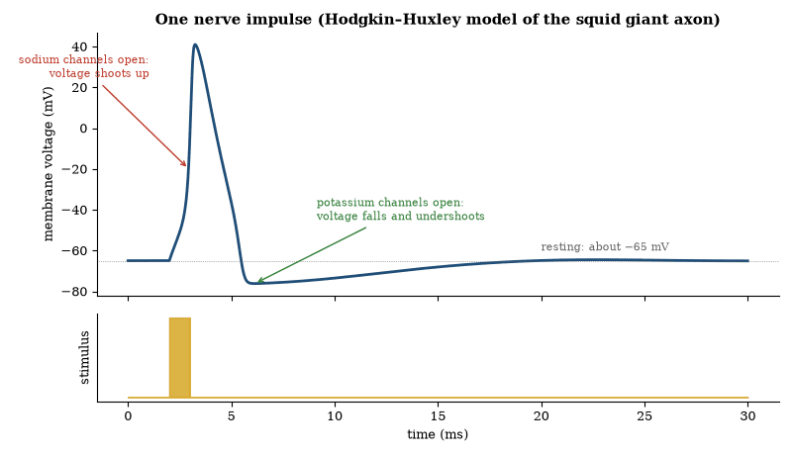
Figure 55. A computed nerve impulse. A brief stimulus pushes the membrane past threshold; sodium channels open and the voltage spikes to about +40 mV within a millisecond, then potassium channels open and the voltage falls back, briefly undershooting the resting level. The shape is all-or-none.
Synaptic strength is modifiable. Long-term potentiation and long-term depression are cellular correlates of learning. They depend on receptor trafficking, second-messenger cascades and, ultimately, changes in gene expression. Neural circuits implement sensation, motor control, homeostasis and, in larger brains, cognition. The same ionic mechanisms operate from jellyfish to humans.
Glia support, insulate and modulate neurons. Myelination increases conduction speed. The blood–brain barrier isolates the central nervous system from many blood-borne substances. Development of the nervous system requires precise axon guidance and activity-dependent refinement of connections. The adult brain retains limited plasticity. The principles of excitability, synaptic transmission and circuit computation are conserved across animals that possess nervous systems.

The Human Brain
The human brain contains approximately 86 billion neurons and a comparable number of glial cells. The cerebral cortex, a folded sheet of gray matter a few millimeters thick, is disproportionately large relative to body size. It supports the expanded capacities for language, planning and abstract reasoning that distinguish humans.
The neurons work as described earlier. What differs is the scale and the architecture of the circuits. Long-range white-matter tracts connect distant cortical areas. Subcortical structures—thalamus, basal ganglia, cerebellum, brainstem—handle sensory relay, motor coordination, autonomic control and arousal. The connectome is the complete map of these pathways. It is still only partially known.
Development begins with a neural tube. Neurons are generated, migrate, and extend axons under genetic and activity-dependent guidance. Synaptic pruning in childhood and adolescence eliminates unused connections. Adult plasticity persists, most clearly in the hippocampus and in sensory and motor cortices after injury or training. The brain consumes about 20 percent of the body’s resting energy budget despite constituting 2 percent of its mass.
No single “center” implements cognition. Functions are distributed. Lesion, stimulation and imaging studies show that language, memory, attention and decision-making each recruit partially overlapping networks. The physical substrate is cellular and molecular. The relation between that substrate and subjective experience remains an open empirical question. The anatomy and physiology, however, are ordinary biology scaled to an unusual degree.

What Neuroscience Knows
The brain is an organ of about eighty-six billion neurons, supported by a comparable population of glial cells, wired by roughly a hundred trillion connections. It is not a computer in any simple sense. It is the organ that makes computation, perception, memory, and movement out of cells.
The neuron is the signaling unit, and its signal is better understood than the system it belongs to. At rest, the inside of the cell is negative relative to the outside. Channels in the membrane, selective for particular ions, open and close. A sufficient input opens sodium channels, sodium enters, the voltage reverses briefly, and the reversal travels along the axon. At the synapse, the arrival of the pulse triggers the release of neurotransmitter. The receiving cell’s response depends on which transmitter and which receptor. Some inputs excite, some inhibit, and the cell sums them. Learning changes the strengths and the numbers of these connections. The summary is accurate and incomplete. Modulation, timing, and the identity of the cells matter as much as the bare on and off.
Maps of function came first from damage. Broca’s area and Wernicke’s area entered the vocabulary because injury there disrupted speech in different ways. The hippocampus entered the study of memory because a patient who lost much of both hippocampi in an operation for epilepsy could not form new episodic memories and could still learn some skills. The cases were cruel and informative. Imaging later showed which regions are active, on average, during which tasks in healthy people. Activity is a correlation. It does not, by itself, prove that the region is necessary. Necessity is tested by disruption. Disruption in humans is limited to what disease, surgery, and careful noninvasive methods allow. In animals it can be precise.
Optogenetics made disruption precise in animals. A gene for a light-sensitive channel is inserted into chosen neurons. Light delivered to the tissue switches those neurons on or off. A behavior can be started or stopped by the switch. The method has linked particular cell types to fear, thirst, movement, and memory retrieval in mice. It is not a human therapy in any ordinary form. It is a research instrument that turned correlation into a stronger kind of evidence.
Recording has scaled. Arrays now listen to hundreds or thousands of neurons at once. The data are large and the interpretation is the bottleneck, since a pattern of firing is not yet a content. Decoding work can predict, from the pattern, which stimulus was shown or which movement is about to occur, with imperfect accuracy. Prediction of that kind is evidence that the information is present in the recorded cells. It is not a reading of thought in the ordinary sense. The gap between a decoded variable and a subjective report remains.
Disease keeps the claims modest. Neurodegenerative diseases show that particular proteins, misfolded and spreading, can dismantle particular systems. Parkinson’s disease shows that replacing a missing chemical signal can restore movement for a time and does not restore the lost cells. Depression and schizophrenia show that the chemistry matters and that no single chemical account covers the patients. The brain is not one organ in the way the liver is one organ. It is many systems. A treatment that helps one system can leave the others untouched. That is a reason for precision and a reason against slogans.
The physical basis of thought is not in serious doubt among neuroscientists. Thought depends on the brain. Change the brain in particular ways and thought changes in particular ways. What remains open is the mapping: which patterns constitute which mental operations, how development wires the patterns, and how the patterns relate to conscious experience. The open questions are large. They sit on top of a base that is already physical, cellular, and, in increasing measure, testable.
Development is the part of neuroscience that a focus on the adult brain understates. The brain wires itself: genes set the outline, and activity, before and after birth, refines the connections. Critical periods, taken up under plasticity below, show how much the plan depends on input. The wiring is not a readout of a fixed plan. It is a plan that expects input. That fact connects neuroscience to pediatrics, to education, and to the effects of early environment, without reducing any of those to a slogan about plasticity. Plasticity is real and bounded. The bounds are part of the science.
Memory is not a single store. Working memory holds a little information briefly. Episodic memory records events and depends heavily on the hippocampus for formation. Semantic memory holds facts and becomes partly independent of the hippocampus over time. Skill memory lives in other circuits. The distinctions are supported by patients who lose one and keep another. They matter for education, for dementia, and for the design of any interface that claims to match how people learn. A single word, memory, covers several systems. The systems fail separately and are studied separately.
Brain-computer interfaces are the applied edge. Electrodes decode intended movement and allow a paralyzed person to control a cursor or a robotic arm. The decoding is imperfect and improving. The clinical benefit, for some patients, is already real. The interface is not a reading of private thought in general. It is a reading of specific, trained signals related to a task. Keeping the specificity in view prevents both the understatement of a real assistive technology and the overstatement of a general mind-reading. The technology does what it is trained to do. That is enough to matter.

Systems Neuroscience
Systems neuroscience asks how populations of neurons carry out perception, action and cognition. Sensory systems turn physical stimuli into trains of spikes: the retina compresses visual information and the cochlea breaks sound into frequencies. Thalamic nuclei relay and gate the signals, primary cortices extract features, and higher areas integrate them into representations of objects and scenes.
Motor systems reverse the process. Premotor and motor cortices, the basal ganglia and the cerebellum plan and refine movements. The spinal cord executes patterned reflexes and locomotion. Feedback from proprioceptors continuously corrects the output. The same loops operate in skilled action and in simple withdrawal.
Cognitive functions—attention, working memory, decision-making—are distributed across fronto-parietal and temporal networks. The precise contribution of each area remains under investigation. The principles of receptive fields, population coding and recurrent dynamics are shared across systems. The implementation details differ. Systems neuroscience maps those details onto behavior.
Population coding is the representation of a variable by the joint activity of many neurons. In motor cortex, direction of reach is encoded by a population vector. In visual cortex, orientation is encoded by the relative firing of cells with different preferred orientations. The code is redundant and robust to the loss of individual cells.
Recurrent connectivity produces dynamics richer than feed-forward filtering. Attractor networks can store memories as stable states. Decision-making circuits integrate noisy evidence until a threshold is reached. Oscillations in the gamma and theta bands coordinate activity across areas and are modulated by attention and by behavioral state.
Learning alters synaptic weights. Spike-timing-dependent plasticity strengthens synapses when presynaptic spikes precede postsynaptic spikes and weakens them when the order is reversed. The rule is local yet capable of implementing reinforcement learning and unsupervised feature extraction when embedded in appropriate circuits. The same principles—population codes, recurrence and synaptic plasticity—operate from sensory periphery to prefrontal cortex. Their parameters differ. The computational repertoire is shared.

Brain Plasticity
Brain plasticity is the capacity of neural circuits to change with experience. Synaptic strength is modified by long-term potentiation and long-term depression. Dendritic spines appear and disappear. Adult neurogenesis occurs in the hippocampus and olfactory bulb of many mammals. Cortical maps reorganize after injury or training. The changes are activity-dependent and are constrained by molecular brakes that increase with age.
Plasticity is highest in early life. Critical periods exist for vision, language and certain social behaviors. During these windows experience exerts a lasting effect. After the window closes the same experience has a smaller effect. The windows can be reopened to a limited degree by environmental enrichment, pharmacological intervention or intensive training. They do not remain open indefinitely.
Plasticity is not unlimited. Large lesions are not fully compensated. Skills acquired in adulthood rarely match the fluency of those acquired in childhood. The brain continues to adapt throughout life, yet the rate and extent of adaptation decline. Plasticity is the biological substrate of learning and recovery. It is also the reason that early experience has disproportionate consequences.

Sleep and Memory Consolidation
Sleep is a regularly recurring state of reduced responsiveness and altered brain activity. It appears to be universal among animals that possess nervous systems, down to jellyfish. During slow-wave sleep cortical neurons oscillate between up and down states. During rapid-eye-movement sleep the electroencephalogram resembles waking and most muscles are paralyzed.
Memory consolidation is one established function. Hippocampal replay during slow-wave sleep strengthens and reorganizes traces of recent experience. Synaptic homeostasis hypotheses propose that sleep renormalizes synaptic weights that have grown during waking, preserving the capacity for further learning. Neither account is complete. Both are supported by physiological and behavioral evidence.
Sleep deprivation impairs attention, working memory and metabolic regulation, and chronic restriction carries cumulative costs. The precise restorative processes remain incompletely identified. The universality of sleep and the severity of its disruption indicate that it is not optional. It is a biological requirement whose neural mechanisms are still being mapped.

Memory Improvement
Memory improvement rests on established principles of encoding, consolidation and retrieval. Attention at the moment of encoding is required. Divided attention markedly reduces later recall. Elaborative encoding—relating new material to existing knowledge—produces stronger traces than rote repetition. The spacing effect is robust: distributed practice yields better long-term retention than massed practice. Retrieval practice (testing oneself) strengthens memory more than additional re-reading.
Sleep after learning enhances consolidation, particularly for declarative material. Aerobic exercise increases hippocampal volume and improves memory performance in adults. No pharmacological agent licensed for healthy individuals produces large, reliable gains. Mnemonic techniques (method of loci, peg systems) are effective for ordered lists because they supply distinctive retrieval cues. They do not expand general capacity.
The limits are biological. Working-memory span remains a few items. Long-term memory is vast but subject to interference and forgetting. Improvement comes from more effective use of ordinary mechanisms—attention, elaboration, spacing, retrieval and sleep—not from unlocking unused stores. The same principles apply across ages, with slower acquisition and greater benefit from spacing in older adults.

Brain Exercises and Cognitive Training
Cognitive training comprises structured tasks intended to improve specific mental functions. Working-memory training produces reliable gains on the trained tasks and on closely related tests. Transfer to distant domains—fluid intelligence, everyday functioning, academic achievement—is small or absent in well-controlled studies. The pattern is consistent with improvement in task-specific strategies rather than in a general cognitive resource.
Commercial “brain-training” programs have not demonstrated broad benefits in independent replications. Physical exercise, particularly aerobic exercise, produces modest improvements in executive function and memory and is supported by physiological changes in the hippocampus and prefrontal cortex. Learning a new skill (a language, a musical instrument) engages wider networks and is associated with measurable structural changes. The effects are domain-specific and require sustained practice.
No regimen reverses normal age-related decline or produces large gains in general intelligence in healthy adults. The brain adapts to the demands placed upon it. Those adaptations are real, local, and bounded by the same plasticity constraints that operate throughout life. Effective “exercise” is therefore the deliberate practice of the skill one wishes to improve, not a generic workout claimed to enhance all functions.

Unused Brain Potential
The claim that humans use only 10 percent of their brains is false. Metabolic studies, lesion data and functional imaging show that virtually every region is active at some time. No large silent areas exist. Energy consumption is high and continuous. A brain that maintained 90 percent of its tissue in reserve would be biologically implausible.
What is true is that performance can be improved by training, that different tasks recruit different networks, and that injury can reveal latent capacities through reorganization. These facts do not imply a reservoir of unused tissue. They imply that existing circuits can be tuned and that alternative pathways can be strengthened. The limits are set by anatomy, by the molecular constraints on plasticity, and by the trade-offs inherent in any finite network.
Exceptional skills arise from extended deliberate practice acting on ordinary neural mechanisms, often aided by favorable genetics and early exposure. They do not arise from unlocking dormant regions. The brain is already fully engaged. Improvement comes from more efficient use of what is present, not from activating what is absent.
Questions to Keep Asking
How do we know which region does what? Injuries, imaging, electrical stimulation and, in animals, turning chosen neurons on and off with light have all been used, and they have to agree.
A brain region lit up in a scan is not necessarily needed for the task. What kind of experiment can show that it is?
Try it yourself. Close your left eye, look at a cross on a page and move a dot toward it from the right at arm’s length. Where does the dot vanish, and why?

54. Consciousness
A surgeon can stop your heart, cool your brain and restart both, and ask you afterward what you remember. Science can now tell from brain activity alone which unresponsive patients are aware. It cannot yet say why awareness feels like something.
Consciousness is the fact that there is something it is like to be you. A camera does not, so far as we know, have a point of view. You do. Explaining the point of view is the problem.
The easy problems, which are not easy, are the functional ones. How does the brain discriminate, integrate, report, and control? These can be studied. The hard problem, as the philosopher David Chalmers named it, is why any of that functioning is accompanied by experience. A complete diagram of the visual system would not, by itself, seem to explain why seeing red feels like something.
Science has not solved the hard problem. It has narrowed the easy ones.
Competing theories make different bets. Global workspace theories say a content becomes conscious when it is broadcast widely through the cortex for use by many systems. Integrated information theories say consciousness tracks a particular kind of internal causal structure, and try to quantify it. Higher-order theories say a state is conscious when the brain represents itself as being in that state. Predictive-processing accounts fold experience into the brain’s work of guessing the causes of its inputs. The theories are testable at the edges. None is established.
Two cautions follow. First, consciousness is not a license to ignore mechanism. Whatever experience is, in humans it depends on particular brain processes, and those processes can be disrupted in particular ways. Second, the unsolved problem is not evidence for a particular doctrine. It is evidence that the problem is unsolved. A guide written now should say so without embarrassment. The great guides of the twentieth century could not close this question either, and neither can this one.
A useful distinction separates access from experience. Access consciousness is the availability of information for report, for reasoning, and for the control of action. Experience is the felt quality that accompanies having the information. The two usually travel together in healthy people. They can be pulled apart in experiments and in clinical cases. A stimulus can influence behavior without being reportable. A patient can show brain responses consistent with awareness and be unable to move or speak. The distinction does not solve the hard problem. It makes the experimental subject less muddy.
Correlates of consciousness are the empirical foothold. When a subject reports seeing a stimulus, certain cortical patterns are present. When the same stimulus is presented but masked or missed, those patterns are absent or reduced, even though earlier sensory areas may still respond. The timing and the spread of activity matter. Each of the theories above makes predictions, and adversarial collaborations have begun to test them against the same experiments. That is the right method. It is too early to declare a winner.
Anesthesia and sleep are natural experiments. Under general anesthesia, report and the associated cortical patterns cease, and they return together. Different anesthetics act by different molecular routes and converge on similar network effects. Sleep stages show that behavior and experience can dissociate: in some stages people dream and in some they do not, and the brain signatures differ. Disorders of consciousness after injury show a spectrum from unresponsive wakefulness to states in which communication is possible through brain activity even when movement is not. These findings matter clinically. They also constrain theory. A theory of consciousness that cannot say why anesthesia abolishes it is incomplete.
The hard problem remains a problem about explanation, not about evidence that experience exists. Experience exists for the reader. The question is why any physical process should be accompanied by it, and whether a future theory will close the question or dissolve it. Some philosophers argue that the question is misconceived. Some neuroscientists argue that a sufficiently detailed account of access and of self-modeling will leave no further question that has an empirical grip. The argument is open. What is not open is the dependence of human experience on the brain. Damage, drugs, stimulation, and development all demonstrate the dependence. A theory that ignored them would not be a theory of this phenomenon.
Nonhuman consciousness is a related and unsettled question. Many animals have nervous systems that support learning, perception, and flexible behavior. Whether and where experience accompanies those capacities is inferred from anatomy, behavior, and, increasingly, from comparative neuroscience. The inference is not certainty. It is strong enough, for mammals and birds in particular, that welfare decisions already treat them as experiencing subjects. The guide’s claim is limited: consciousness in humans is tied to measurable brain processes, and those processes have relatives in other animals. The hard problem is unsolved in every species, including ours.
The clinical stake keeps the subject from being only philosophical. Decisions about withdrawing care, about anesthesia, and about the treatment of infants and of nonhuman animals all assume something about the presence of experience. Better correlates make those decisions better informed. They do not make them automatic. A signature of awareness in an unresponsive patient changes what the family and the physicians know. It does not by itself say what should be done. The science improves the information, but the decision remains a decision, and confusing the two helps neither.
Report is the usual measure and a limited one. Adults who can speak are the easiest subjects. Infants, nonhuman animals, and patients who cannot move require other measures: behavior, physiology, and neural signatures validated against report in those who can report. The extension is uncertain and necessary. A science of consciousness confined to verbal adults would miss most of the subjects who have nervous systems. The correlates established in adults are the bridge. Crossing the bridge carefully is the work. Refusing to cross it leaves the science narrower than the phenomenon.
The study of consciousness has attracted theories that outrun their tests. The corrective is the same as in any science. A theory must say what would count against it. Several current theories have begun to do so, and to be tested in shared experiments. The outcome of those experiments will retire some claims without, by itself, solving the hard problem, and retiring claims is progress. A field that cannot retire claims is not yet a science. The presence of adversarial tests is a sign that this field is acquiring the habit. The habit matters more, at this stage, than any single theory’s success.

What Consciousness Is
Consciousness is the subjective experience of being aware. It includes perceptual experiences, bodily sensations, emotions and the sense of self. The phenomenon is private: it is reported by language and inferred from behavior, and no objective measurement captures the experience itself.
Neural correlates exist. Specific patterns of cortical activity, particularly in fronto-parietal networks and in posterior hot-zone regions, are reliably associated with reportable awareness. Disruption of those patterns by anaesthesia, seizures or lesions abolishes or fragments consciousness. The correlates identify necessary circuitry. They do not explain why the circuitry is accompanied by experience.
Theories differ. Global-workspace models propose that consciousness arises when information is broadcast widely across the brain. Integrated-information theories assign consciousness to systems that integrate information above a threshold. Higher-order theories require a representation of one’s own mental states. Predictive-processing accounts treat experience as the brain’s best hypothesis about the causes of sensory input. None is established. All attempt to relate the third-person facts of neuroscience to the first-person fact of experience.
The hard problem—why any physical process should give rise to subjective experience—remains unsolved. The easy problems—how the brain discriminates, integrates, reports and controls—are tractable and are being mapped. Consciousness is an evolved biological capacity whose neural basis is increasingly constrained by experiment and whose ultimate explanation is still open.

The Hard Problem
The hard problem is the explanatory gap between physical processes and subjective experience. Neural correlates identify which processes are associated with awareness. They do not show why those processes are felt. Functional accounts explain what consciousness does—integrates information, enables report, guides behavior. They do not explain why the performance is accompanied by experience rather than occurring “in the dark.”
Proposed dissolutions include the claim that the gap is illusory once the functions are fully specified, and the claim that experience is a fundamental feature of certain information structures. Neither dissolution is widely accepted. Empirical progress continues on the correlates, on the effects of targeted disruption, and on the differences between conscious and unconscious processing. The metaphysical question remains open. The scientific constraint is that any solution must be consistent with the observed neural dependence and with the evolutionary continuity of nervous systems.

Thought Experiments About the Self
The Mind’s I, edited by Douglas Hofstadter and Daniel Dennett, collects stories and arguments that treat questions of mind as puzzles to be worked through. A classic is the teleporter. A machine scans you, destroys the original, and builds an exact copy elsewhere. Is the copy you, or someone who thinks so? Philosophers split. Derek Parfit argued that what matters is the continuity of memory and character, not which atoms are used.
Other puzzles press on different points. John Searle’s Chinese room imagines a person who follows rules to answer Chinese questions without understanding Chinese, and asks whether a program alone could understand anything. Thomas Nagel asked what it is like to be a bat, to show that a complete physical description of an echo-locating brain might leave out how it feels from the inside. Dennett’s own stories of a brain kept alive in a vat show how odd it becomes to say where one is.
None of the puzzles has a consensus answer. They are useful because they separate what science can settle from what it cannot. Experiments determine what brains do and what copies would preserve. They do not decide, by themselves, which of the competing meanings of the word I ought to survive.
Questions to Keep Asking
How do we know that anesthetics remove consciousness and not just memory? Brain responses and behavior with an isolated arm that is not anesthetized show who is aware during an operation.
What kind of evidence would make you accept that a machine has experience?
Try it yourself. Describe the color red to someone who has never seen it. What can you not put into words?

55. Minds That Are Not Ours
An octopus unscrews a jar to reach the crab inside. A crow bends a wire into a hook. A dolphin recognizes itself in a mirror. Intelligence has arisen more than once, in brains laid out in very different ways, and each case is a clue to what intelligence needs.

Cetacean Brains and Cognition
Cetaceans possess large brains. The bottlenose dolphin brain weighs about 1.6 kg. The sperm-whale brain is the largest of any animal, exceeding 7 kg. Encephalization quotients for several dolphin species are second only to humans. The neocortex is extensively folded. A paralimbic lobe unique to cetaceans is present.
Behavioral evidence of complex cognition includes mirror self-recognition, comprehension of symbolic gestures and of word order in artificial languages, cooperative problem-solving, and socially transmitted foraging techniques, several of which are described in detail below.
The cognitive achievements are real. They do not imply human-like linguistic syntax or abstract reasoning of the same scope. Brain size and cortical folding indicate high processing capacity. The precise mapping of that capacity onto particular cognitive domains remains incomplete. Cetaceans demonstrate that large, complex brains and flexible behavior have evolved independently in a fully aquatic lineage.

Dolphin and Whale Communication
Dolphins produce whistles and burst-pulse sounds. Signature whistles serve as individual identifiers, and dolphins can copy the signature whistles of their associates and use the copies when they reunite. The repertoire is large and context-dependent, but there is no evidence that it has a combinatorial syntax comparable to human language.
Baleen whales produce low-frequency songs. Humpback songs are hierarchically structured and change progressively through a season. All males in a population converge on the current version. The songs function in mating advertisement. Sperm whales produce patterned clicks (codas) that differ among social groups and are culturally transmitted.
Communication in both groups is sophisticated and partly learned. It supports individual recognition, social cohesion and mating. It has not been shown to support displaced reference or open-ended productivity. The systems are adapted to the acoustic properties of water and to the social structures of the species. They illustrate the evolution of complex signaling without human language.

Cetacean Social Structure and Culture
Many dolphin and whale species live in stable social groups. Bottlenose dolphins form fission–fusion societies in which males build alliances, sometimes lasting decades, that cooperate to herd and guard females. Killer-whale societies are matrilineal, with offspring staying with their mothers for life, and vocal dialects and hunting techniques are passed down within matrilines and differ among neighboring groups.
Cultural transmission is documented. Foraging specializations, migratory routes and vocal repertoires are learned and persist across generations. The transmission is social, not genetic. In killer whales the cultural differences are large enough that some populations are reproductively isolated by behavior. The same capacity for social learning underlies the rapid spread of novel behaviors when conditions change.
Cetacean culture demonstrates that cumulative social learning and stable traditions are not unique to primates. The content of the traditions is constrained by the species’ ecology and sensory modalities. The existence of the traditions shows that complex social knowledge can be maintained and transmitted in fully aquatic mammals.

Self-Recognition and Culture in Dolphins and Orcas
Bottlenose dolphins pass the mirror-mark test. They use a mirror to investigate marks placed on parts of their bodies they cannot see directly. The behavior is interpreted as evidence of bodily self-awareness. The same species learn artificial gestural and acoustic languages in which word order changes meaning. They generalize the rules to novel combinations. The training demonstrates sensitivity to sequential structure. It does not demonstrate spontaneous productive syntax in the wild.
Wild sponge-using dolphins in Shark Bay carry marine sponges on their rostra while foraging. The behavior is transmitted primarily from mother to offspring and is almost exclusively female. Genetic data show that sponging is cultural, not a genetic polymorphism. Killer-whale populations specialize in distinct prey and techniques—beach-rubbing, wave-washing seals from ice, or carousel feeding on herring. The specializations are stable across generations and are accompanied by distinct vocal dialects. The cognitive requirements include social learning, motor imitation and long-term memory of techniques. The upper bound on abstract relational reasoning remains unquantified.

Octopus Minds
The last common ancestor of humans and octopuses lived more than 500 million years ago and had, at most, a very simple nervous system. The octopus brain evolved independently, and it is large, with about half a billion neurons, comparable to the cerebral cortex of a dog. Two-thirds of those neurons sit in the arms, which can taste, touch and carry out some actions without instructions from the central brain.
Octopuses solve puzzles, unscrew jars, learn by watching, and carry coconut shells to use as shelters, one of the few examples of tool use among invertebrates. They recognize individual people, and some seem to play. Their lives are short, mostly one to three years, and they do not raise their young, so there is little opportunity for culture to be passed on.
The octopus matters philosophically because it is an intelligence that evolved on a separate path. Its body has no rigid skeleton, and its senses and its control of movement are organized in a different way from any vertebrate’s. If it is conscious, as many researchers suspect, then consciousness has evolved at least twice, in minds built from the same cellular materials and arranged very differently.

Crows, Bees and Small Brains
Birds have no neocortex, yet crows and parrots rival apes in several tests of cognition. New Caledonian crows make hooked tools from twigs and leaves and pass the design from generation to generation. Scrub jays hide food and remember not only where but also whether another bird was watching, and move it if so. Some crows recognize individual human faces and remember them for years. Their pallium, which has a different layout from a mammal’s cortex, appears to carry out similar computations.
Even an insect brain with fewer than a million neurons can do surprising things. A honeybee returning to the hive performs a waggle dance whose angle and duration tell her nestmates the direction and distance of a flower patch. Bees can learn rules such as same and different, count small numbers, and in laboratory experiments have been trained to use symbols for quantity.
These results do not show that animals think as we do. They show that complex behavior does not need a large brain or a human kind of cortex, and that the brain is an organ whose design can differ widely and still solve similar problems.

Do Animals Feel?
Whether an animal has experiences, and not only behavior, is the hardest question in this chapter. The evidence is indirect. Animals share with us the brain structures and chemicals that go with pain and emotion in humans, and they show avoidance, learning and trade-offs between pain and reward that go beyond reflex. For mammals and birds the case is strong.
In 2012 a group of neuroscientists meeting at Cambridge signed a declaration that the neurological basis of consciousness is not unique to humans, and that mammals, birds and octopuses share it. A 2024 New York declaration, signed by many researchers, went further and called for taking seriously the possibility of experience in fish, reptiles and some insects. The evidence for these groups is weaker, and many scientists remain cautious.
As with consciousness in general, the uncertainty runs in both directions. The cost of wrongly denying sentience to an animal that has it is greater than the cost of wrongly granting it, and that asymmetry has shaped welfare law in several countries. Science can supply the evidence. It cannot by itself decide how much weight a possible experience deserves.
Questions to Keep Asking
How do we know that an animal is thinking and not simply conditioned? Careful controls, new problems the animal has not met, and repeated results in different laboratories.
What result would make you doubt that an animal passes a self-recognition test for the reason we think?
Try it yourself. Design an experiment to show whether a bird understands that food it has seen hidden is still there when out of sight.
Further reading for Part VIII. Hofstadter’s I Am a Strange Loop and the collection he edited with Dennett, The Mind’s I, are the best places to start thinking about what a self is. Asimov’s The Human Brain is old but well organized, and Seth’s Being You argues that consciousness is controlled hallucination.

Part IX: Earth, the Living Planet
The ground, the air, the oceans, the web of life, and the energy that keeps a civilization running

56. The Structure of the Earth
No one has ever drilled deeper than about twelve kilometers, and yet we know that the Earth’s core is liquid iron 2,900 kilometers down. The evidence comes from earthquakes, which ring the whole planet like a bell.
The Earth is not a uniform ball. It has layers, and the layers were inferred before they were directly sampled.
The outermost layer is the crust, thin and rigid. Under the oceans it is typically 5 to 10 kilometers thick. Under the continents it is thicker, often 30 to 50 kilometers. Below the crust is the mantle, a thick layer of hot rock that extends to about 2,900 kilometers depth. The mantle is solid but, over long times, flows slowly. At the center is the core, divided into a liquid outer core and a solid inner core, both made mostly of iron with some nickel and lighter elements. The inner core is solid because the pressure is high enough to keep iron solid despite the temperature.
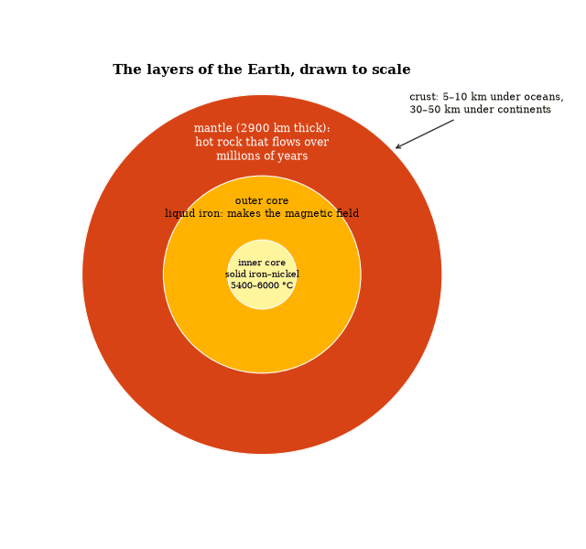
Figure 56. The Earth’s interior drawn to scale. The crust is so thin it is a line at this size. Seismic waves reveal the layers: shear waves do not pass through the liquid outer core, which is how it was found.
The evidence for these layers came first from earthquake waves. P-waves and S-waves travel at different speeds and behave differently at boundaries. S-waves do not travel through liquid. Their absence in certain paths showed that the outer core is liquid. The speeds and reflections mapped the boundaries. Later, the composition was constrained by the density required to match the Earth’s total mass and by the chemistry of meteorites, which sample the material from which the planet formed.
The crust is not fixed: it is broken into plates that move. Alfred Wegener proposed continental drift in detail in 1912, pointing to the fit of the continents, matching fossils and rock formations across oceans, and evidence of past climates, but without a mechanism the idea was resisted. In the 1960s seafloor spreading and plate tectonics supplied one. New crust forms at mid-ocean ridges, old crust sinks at trenches, and the continents are carried along with the plates, so the Atlantic is widening while parts of the Pacific shrink. Earthquakes and volcanoes concentrate at the boundaries (Figure 57).
The Earth’s magnetic field is generated by motion in the liquid outer core. The field reverses at irregular intervals. Those reversals are recorded in the seafloor as it forms, providing a tape of the spreading. The field also shields the surface from much of the solar wind. Without it, the atmosphere would be more vulnerable to stripping.
The age of the Earth is about 4.54 billion years, measured from the oldest meteorites and from the oldest terrestrial minerals. The oldest known crustal rocks are younger, because the surface has been recycled. Zircon crystals from Australia are more than 4.3 billion years old and show that continental crust and liquid water existed early.
Heat inside the Earth comes from leftover heat of formation and from radioactive decay. That heat drives the mantle’s slow convection, which drives the plates, and it supplies the energy for volcanoes and for the magnetic field. The surface we live on is the cool, thin skin of a planet that is still geologically active.

Plate Tectonics
The Earth’s lithosphere is divided into rigid plates that move relative to one another. The motions are driven by mantle convection and by the sinking of cold oceanic lithosphere. Divergent boundaries produce mid-ocean ridges and new oceanic crust. Convergent boundaries produce subduction zones, volcanic arcs and mountain belts. Transform boundaries accommodate lateral slip.
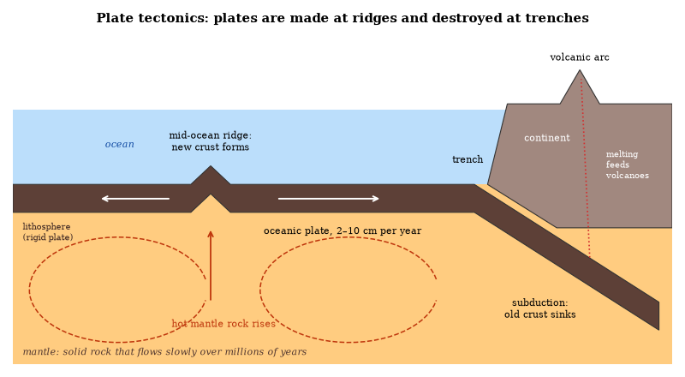
Figure 57. Plate tectonics in cross-section: plates are made at mid-ocean ridges and destroyed at trenches.
The theory unifies continental drift, seafloor spreading and the distribution of earthquakes and volcanoes. Magnetic anomalies symmetric about ridge axes record reversals of the geomagnetic field and demonstrate that oceanic crust is created at ridges and destroyed at trenches. The oldest oceanic crust is about 180 million years old. Continental crust is older and is not systematically recycled.
Plate motions have rearranged the continents repeatedly. The assembly and breakup of supercontinents correlate with changes in sea level, climate and biological diversity. The same processes operate today. GPS measurements confirm the velocities predicted by magnetic anomalies and by earthquake slip vectors. Plate tectonics is the surface expression of the Earth’s internal heat engine.

Geochemistry
Geochemistry is the study of the chemical composition of the Earth and of the processes that control the distribution of the elements. The bulk Earth is dominated by oxygen, silicon, magnesium and iron. Differentiation into core, mantle and crust partitioned the elements according to their chemical affinities. Siderophile elements concentrated in the core. Lithophile elements remained in the silicate Earth.
The long-term carbon cycle, described in the section on the carbon-silicate cycle, regulates atmospheric CO₂ on million-year timescales. Perturbations such as large igneous provinces or changes in weathering rates produce excursions recorded in the isotopic composition of sedimentary rocks.
Isotope systems (Rb–Sr, Sm–Nd, U–Pb, C, O, S) date events and trace sources. Fractionation between isotopes records temperature, biological processing and redox state. The same tools applied to meteorites and to other planets constrain the formation of the Solar System and the evolution of planetary surfaces. Geochemistry therefore links the atomic properties of the elements to the history of the planet.

The Oxygen Cycle and the Rock Archive
The oxygen cycle is tightly linked to the carbon cycle. Photosynthesis produces O₂ and consumes CO₂. Respiration and weathering reverse the reactions. On geological timescales the burial of organic carbon and pyrite leaves a net excess of O₂. The Great Oxidation Event marks the point at which this excess became permanent. Subsequent fluctuations in atmospheric oxygen are recorded by redox-sensitive isotopes and by the presence or absence of particular mineral assemblages.
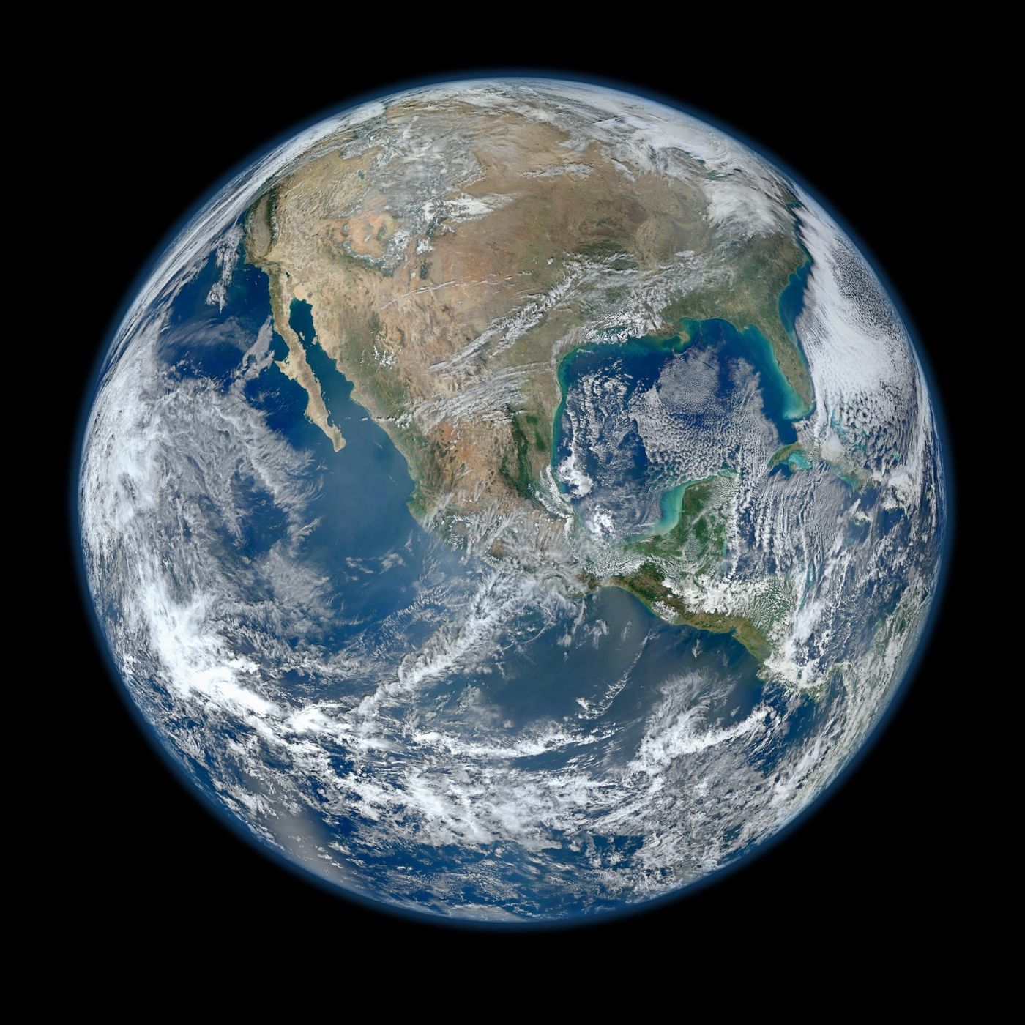
Figure 58. Earth as a single connected system, composited from Suomi NPP satellite data. The oxygen, the water and the white clouds are all products of the planet’s chemistry and its life. Image: NASA Earth Observatory, Robert Simmon, using Suomi NPP data.
Large igneous provinces inject CO₂ faster than weathering can remove it, producing transient warming, while mountain building exposes fresh rock and so increases CO₂ consumption. The isotopic composition of marine carbonates records these imbalances, dates the events and quantifies the size of the perturbations. Geochemical cycles are therefore both regulators and archives of Earth’s surface environment.

The Faint Young Sun Paradox
The early Sun was approximately 30 percent less luminous than today. A planet at 1 AU with Earth’s present atmosphere would have been frozen. Geological evidence shows liquid water as early as 4.4 billion years ago. The paradox is resolved by a stronger greenhouse effect. Higher concentrations of carbon dioxide, methane or both can maintain above-freezing temperatures.
The required concentrations are plausible, and weathering feedbacks regulate them, though the solution is not unique: cloud feedbacks or a lower albedo can contribute. The paradox shows that the habitable zone is not fixed but depends on atmospheric composition. The early Earth stayed habitable because its atmosphere adjusted, through the carbon-silicate cycle and, once life appeared, through biology.

The Carbon-Silicate Cycle
The carbon-silicate cycle is the long-term regulator of Earth’s climate. Volcanism releases CO₂ and the weathering of silicate rocks consumes it, at a rate that rises with temperature and runoff. That negative feedback stabilizes the climate over millions of years. Burial of carbonate and organic carbon removes carbon from the surface reservoirs, and subduction returns it to the mantle.
The cycle has operated for billions of years. It kept the surface temperature within the range that permits liquid water. Perturbations—large igneous provinces, changes in continental configuration—produce excursions that are temporary, and the cycle restores balance. It is the principal reason Earth’s climate has remained habitable despite a brightening Sun and varying volcanic input.
Questions to Keep Asking
How do we know the outer core is liquid? Shear waves from earthquakes cannot pass through liquid, and they are missing on the far side of the Earth.
A shear wave detected passing through the outer core would overturn the model. Why has none been seen?
Try it yourself. Cut out South America and Africa from a printed map of the continents. How well do they fit, and what does the fit not explain?

57. Climate Science
The physics of the greenhouse effect is older than the telephone. Eunice Foote noticed in 1856 that jars of carbon dioxide warmed in sunlight more than jars of air, and the measurements of the past century have confirmed what she saw.
Climate is weather averaged, and the average is moving.
The energy balance can be stated simply. The Earth receives energy from the Sun, mostly in visible light. It emits energy to space as infrared radiation. If the energy in exceeds the energy out, the planet warms until the two balance again. Greenhouse gases intercept part of the outgoing infrared and return some of it downward. More greenhouse gas means a higher surface temperature at the new balance. This is physics measured in the laboratory and observed in the atmosphere. It is not a model. Svante Arrhenius calculated the effect of carbon dioxide in the 1890s, and the calculation has been refined, not repealed. Models are what you build when you want to know how much, how fast, and where.
Carbon dioxide is the dominant control over long periods because it stays in the air for centuries and because the oceans and rocks exchange it slowly. Methane is more potent per molecule and shorter-lived. Nitrous oxide and some industrial gases add smaller amounts. Water vapor is a strong greenhouse gas and a feedback rather than a driver: warmer air holds more of it, amplifying a warming started by the others. Aerosols from pollution cool the planet slightly by reflecting sunlight, and they are a reason the observed warming is not even larger. As aerosols are reduced for the sake of lungs, some masked warming can appear.
The rise in carbon dioxide from about 280 to about 420 parts per million is measured directly, in the modern record, and in ice cores for the preindustrial baseline. The isotopic composition of the added carbon matches fossil carbon, not volcanic carbon. Volcanoes emit carbon dioxide. Human activity currently emits on the order of a hundred times more. The source is not in serious doubt among the people who measure it.
The observed warming of about 1.2 degrees Celsius, with recent years higher, is measured by thermometers, by ocean buoys, and by satellites, after the known corrections for instrument changes and for urban effects. The corrections are a source of public confusion and a normal part of measurement. Independent analyses converge. The ocean’s heat content, which is the largest reservoir, has risen steadily. Ice has lost mass. Sea level has risen through thermal expansion and through the addition of meltwater. These are the fingerprints. They match the greenhouse account. They do not match a change in the Sun, which has not supplied the extra energy, or a rearrangement of heat without a net gain.
Models are tested by their ability to reproduce the past when given the past’s emissions, volcanic eruptions, and solar changes, and by their ability to fail when the human emissions are omitted. They pass the first and fail the second in the expected way. Their projections for the future depend on emissions. Continued high emissions lead to warming well above two degrees by late century. Rapid cuts lead to less. The range within any one emissions path comes mainly from clouds, from aerosols, and from the carbon cycle’s feedbacks. The range is a reason for humility about the exact number. It is not a reason for expecting no further warming.
Impacts are already measured. Heat waves are hotter and more frequent; heavy rainfall is heavier in many regions, because warmer air holds more water; drought risk rises where evaporation increases more than rainfall. Sea-level rise is slowly accelerating, and ecosystems are shifting toward the poles and uphill. None of this needs a model to notice. Attribution studies, which ask whether warming made a particular event more likely, now regularly find that it did, so the science of impacts is no longer only forecast but a mixture of forecast and record.
The policy implication is separate from the physics and follows from it. Because carbon dioxide accumulates, the total emitted over time matters more than the rate in any one year. Because the ocean and the ice are slow, warming and sea level continue after emissions fall. Early reduction costs less total damage than late reduction, on the standard economic comparisons. Disagreement about the pace, the tools, and the fairness of reduction is a political disagreement. It does not reopen the energy balance.
Tipping points are the part of the subject that most exceeds a smooth projection. A tipping point is a threshold beyond which a system moves to a new state and does not easily return. Ice sheets, the Atlantic circulation, the Amazon forest, and permafrost carbon are the systems discussed. Some thresholds are better constrained than others. None is a reason to ignore the smooth projection, which already contains serious impacts. They are a reason to treat the smooth projection as a lower description of risk rather than as a complete one. The existence of thresholds is a property of the systems. Their exact locations are uncertain. Both facts belong in the account.
Carbon budgets translate the physics into a quantity a policy can use. For a given chance of staying below a temperature threshold, there is a remaining amount of carbon dioxide that can be emitted. The budgets are uncertain and usable. They say that continuing at the present rate exhausts a 1.5-degree budget quickly and a 2-degree budget over a longer, still limited, period. The exact year is less important than the direction. A budget is the kind of object this book has favored: a measurement converted into a constraint. Disagreement about how to meet the constraint is expected. Disagreement about whether the constraint exists is a disagreement with the measurement.
Adaptation and mitigation are both required by the lags. Mitigation reduces future warming. Adaptation reduces harm from warming already in train and from warming still to come. Cities, agriculture, and coasts can be adapted, at a cost, up to a point. The point depends on how much warming is allowed. Adaptation without mitigation eventually meets changes that are hard to adapt to. Mitigation without adaptation leaves people exposed to changes already locked in. The two are complements. Treating them as rivals is a rhetorical choice, not a scientific one. The science supplies the lags that make both necessary.

Climate Science: Definitions and Methods
Climate science is the study of the long-term statistics of the atmosphere, ocean, cryosphere and land surface, and of the forcings that change those statistics.
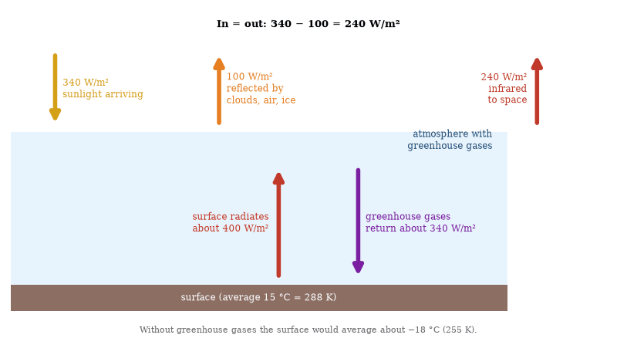
Figure 59. Earth’s energy balance in round numbers (global and annual averages). The planet absorbs about 240 W/m² and must radiate the same to space. Greenhouse gases return part of the surface’s infrared radiation, so the surface is about 33 °C warmer than it would be otherwise. Adding greenhouse gas tips the balance by a few tenths of a watt per square meter at a time.
Observational records include surface temperature series, satellite radiances, ocean heat content, ice-sheet mass balance and paleoclimate proxies. The instrumental record shows a global surface warming of approximately 1.2 °C since the late nineteenth century. The warming is larger over land than over ocean and larger in the Arctic than in the tropics. Attribution studies using climate models and observations assign the majority of the warming since 1950 to the increase in greenhouse gases from fossil-fuel combustion and land-use change.
Models solve the fluid equations on a rotating sphere together with radiation, convection and cloud parameterizations. Equilibrium climate sensitivity to a doubling of CO₂ lies between 2 °C and 5 °C, and regional changes in precipitation, extremes and sea level follow. The physical basis is established; the remaining uncertainties are quantitative.

Paleoclimate, Feedbacks and Sea Level
Paleoclimate records extend the instrumental series. Ice cores provide continuous archives of temperature, greenhouse-gas concentrations and dust for the past 800 000 years. Ocean sediments and corals supply longer but less finely resolved records. These proxies show that CO₂ and temperature have varied together through the glacial cycles, with CO₂ lagging the initial orbital trigger and then amplifying it.
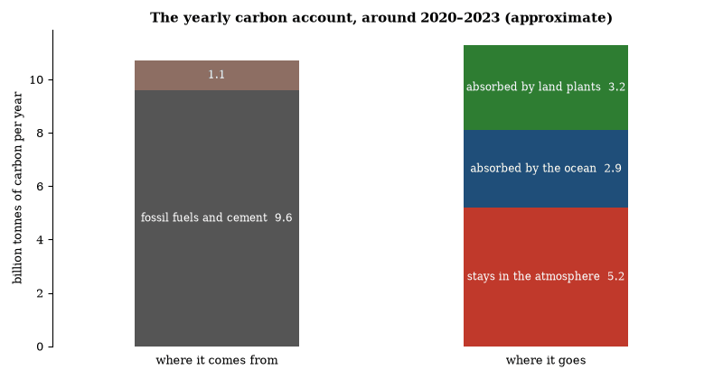
Figure 60. Where the carbon dioxide we emit goes, in round numbers for the early 2020s. Human sources of about 10.7 billion metric tons of carbon a year are matched by sinks: about half stays in the air, raising the concentration, and the rest is absorbed by the ocean and by land plants. The small mismatch is the budget imbalance. Source: Global Carbon Budget estimates, rounded.
The carbon-cycle feedbacks are central. Warmer oceans hold less dissolved CO₂, and thawing permafrost and faster respiration release more carbon; these positive feedbacks are already observable. Negative feedbacks, such as faster rock weathering and possible fertilization of marine productivity, operate on longer timescales, so on century scales the net effect is positive.
Sea-level rise has two components: thermal expansion of seawater and the addition of water from melting glaciers and ice sheets. Both are under way. The Greenland and Antarctic ice sheets contain enough ice to raise sea level by approximately 7 m and 58 m respectively if fully melted. Current mass-loss rates are accelerating. The committed rise from past emissions is already tens of centimeters. Future rise depends on emissions and on the still-uncertain dynamics of ice-sheet collapse.

The Earth’s Atmosphere and Climate
The atmosphere is a thin gaseous envelope whose composition is maintained by geological and biological fluxes. Nitrogen and oxygen dominate. Trace gases—water vapor, carbon dioxide, methane, ozone—control the radiative balance. Incoming solar radiation is partly reflected and partly absorbed. Outgoing long-wave radiation is trapped by greenhouse gases. The resulting surface temperature is approximately 33 K warmer than the effective radiating temperature.
Climate is the long-term statistics of weather. It varies on every timescale. Orbital (Milankovitch) cycles modulate the seasonal distribution of sunlight and pace the Pleistocene ice ages. Volcanic aerosols cool the surface for a few years. Changes in greenhouse-gas concentrations alter the energy budget for decades to millennia. The present rise in carbon dioxide is produced by fossil-fuel combustion and land-use change. It is occurring at a rate unprecedented in the ice-core record.
Feedbacks amplify or damp the response. Water vapor and snow–ice albedo are positive. Clouds and the carbon cycle contain both positive and negative terms. The atmosphere and ocean together redistribute heat. The same physical principles govern the climates of other planets that possess atmospheres.
Questions to Keep Asking
How do we know that the added carbon dioxide comes from fossil fuels? The carbon isotopes in the air have the signature of ancient plants, and the oxygen is falling by the amount burning requires.
What observation would show that the Sun, and not carbon dioxide, is driving recent warming? Satellite measurements show that the Sun’s output has been flat or slightly falling since the 1980s.
Try it yourself. Look up the carbon-dioxide record from Mauna Loa and find the yearly sawtooth in it. What causes it?

58. Ecology and the Living Planet
Take wolves out of a park and the willows along the river may change. Take a bee out of an orchard and the fruit may fail. Ecology is the science of long chains of consequence, in which every link is a living thing.

Ecology
Ecology studies the distribution and abundance of organisms and the interactions that determine them. A population grows exponentially when resources are unlimited. Density-dependent factors—competition, predation, disease—slow growth as numbers rise. The logistic equation is the simplest model that incorporates a carrying capacity. Real populations fluctuate around that capacity under the influence of environmental variation and of interactions with other species.
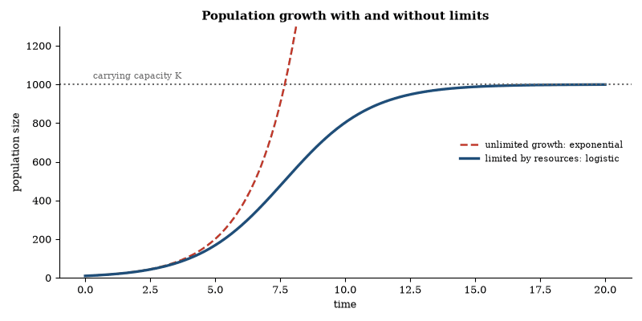
Figure 61. Population growth. With unlimited resources growth is exponential (dashed). Competition, predation and disease slow it as numbers rise, giving the S-shaped logistic curve that levels off at the carrying capacity K.
Communities are sets of interacting populations. Competition, predation, mutualism and parasitism structure the set. Keystone species exert effects larger than their biomass would suggest. Removal of a keystone predator can allow prey to over-exploit primary producers and collapse the community. Energy enters most ecosystems through photosynthesis and is transferred with low efficiency—approximately 10 percent to each successive trophic level. Nutrients cycle. Energy does not.
Ecosystems are open. They exchange gases, water, organisms and energy with their surroundings. Succession follows disturbance. The trajectory depends on the remaining species pool, soil conditions and climate. Human activity now dominates many of these exchanges. The basic constraints of energy degradation, nutrient conservation and density dependence remain those of any ecological system.

Food Webs and Energy Flow
Textbooks draw a food chain, with plants eaten by herbivores and herbivores by carnivores, but real ecosystems form webs. An animal feeds on many species and is eaten by many, and a large share of energy never passes through a living animal at all. In most ecosystems the biggest flow runs through dead material, as bacteria, fungi and invertebrates break down leaves, wood and carcasses and return nutrients to the soil.
The structure of a web decides how disturbance spreads. When sea otters were hunted almost out of existence on the Pacific coast of North America, the sea urchins they ate multiplied and stripped the kelp forests bare, a trophic cascade. When otters returned, the kelp recovered. The effect works from the top down. In other systems the supply of nutrients at the bottom sets the limit, and the effect works from the bottom up.
Energy is lost at each step, mostly as heat, so food chains rarely have more than four or five levels, and the total mass of predators is far smaller than that of the plants that ultimately feed them. This is why large predators are rare and why they are vulnerable to any loss at the foundations of the web.

Biomes: What Decides Where Life Lives
A biome is a large community of plants and animals shaped by climate. Two numbers explain most of the map: average temperature and annual rainfall. Warm and wet gives tropical rainforest, warm and dry gives desert, cool and wet gives temperate forest, and cold gives tundra and the boreal forest. The pattern is so regular that an ecologist can guess the vegetation of a region from a climate chart.
Soil, fire, grazing animals and altitude modify the pattern. Grasslands cover regions that could support forest, because fire and grazing keep trees out. A tall mountain compresses the sequence of biomes into a few kilometers of height, from forest at the base to bare rock at the summit.
The same logic makes the biomes sensitive to climate change. As the pattern of temperature and rainfall shifts, regions that suited one community begin to favor another, and species must move or adapt. Because trees move slowly and habitat is fragmented by roads and farms, the shift may be faster than many ecosystems can follow.

Partnerships: Lichens, Coral and Mycorrhizae
Ecology is often presented as competition, but cooperation is just as common. A lichen is not a single organism. It is a fungus and an alga or cyanobacterium living together, the fungus giving shelter and the partner supplying sugars from photosynthesis, and it can survive on bare rock where neither could live alone. A reef-building coral lives with algae in its tissues that supply most of its energy. When heat makes the algae leave, the coral bleaches.
Beneath the forest floor, most land plants, perhaps 80 percent of species, form partnerships with mycorrhizal fungi. The fungal threads reach far more soil than roots could, delivering water and minerals in return for sugars. Some fungi link several trees at once, and experiments show that carbon can pass through the network between neighboring plants. How much this matters to the plants is still debated, and early claims of a cooperative wood-wide web have been tempered by later studies.
These partnerships show that organisms are not self-contained units. Many of the mitochondria and chloroplasts discussed in the chapter on the cell began as partners, and the boundary between one organism and several partners can be a matter of definition.

Metapopulations, Coevolution and Macroecology
Metapopulations are sets of local populations linked by dispersal. Local extinctions are balanced by recolonization. The persistence of the metapopulation depends on the rates of extinction and colonization and on the spatial arrangement of habitat patches. Habitat fragmentation increases extinction rates and decreases colonization rates. Both effects raise the risk of regional disappearance.
Coevolution is reciprocal evolutionary change in interacting species, seen in predators and prey, parasites and hosts, and mutualists. Arms races produce escalating defenses and counter-defenses, while mutualisms produce matching traits. The interactions are rarely pairwise, since most species interact with many others, and the resulting networks, modular and nested, influence how stable the community is.
Macroecology examines statistical patterns across large spatial and temporal scales. Species-abundance distributions, species-area relationships and latitudinal diversity gradients are among the patterns. Proposed explanations include energetic constraints, historical contingency and neutral processes. No single explanation accounts for all patterns, but the patterns themselves are robust and they constrain the possible dynamics of ecological communities.
Questions to Keep Asking
How do we know that a species is a keystone? Experimental removal, such as Robert Paine’s removal of a starfish from tide pools, showed how many other species depended on it.
What would a food web look like if the keystone idea were wrong?
Try it yourself. Draw a food web for a pond or a garden with at least ten species. Remove one and trace what changes.

59. Biodiversity
About two million species have been named, and the true total may be several times that. Most are insects, microbes and fungi, and most are unnamed, which makes extinction a hard thing to count.
Life has been pruned before. The fossil record holds several mass extinctions, the most famous of which ended the non-bird dinosaurs sixty-six million years ago. The present loss is different in cause and in speed. It is driven by a single species changing habitats, climates, and the movement of other species.
Biodiversity is not only a list of species. It is variation within species, and the workings of communities. A forest is not a set of trees. It is pollination, predation, decay, and soil. Remove a function and the list of remaining names misleads. Fisheries collapse when the large fish are gone even if the water still holds life. Soils fail when the community under them is simplified.
The background rate of extinction, inferred from the fossil record, is low. The documented rate for well-studied groups over the last few centuries is much higher. Amphibians, with their permeable skins and their dependence on both land and water, have suffered especially. Large mammals and birds have suffered where they were hunted or where their habitat was converted. Many invertebrates are declining in monitored places and unmonitored in most places. The phrase “sixth mass extinction” is a warning about trajectory, not a claim that the losses already equal the great fossil die-offs. The trajectory, if continued, points that way. It has not arrived.
Habitat loss is the largest present driver on land: forests are cleared for crops and pasture, wetlands are drained, and grasslands are plowed. Fragmentation leaves patches too small for species that need room. In the sea, fishing pressure and habitat damage from trawling and from coastal development play the corresponding role. Climate change adds a driver that habitat protection alone cannot cancel: a species may lose the climate it requires even inside a park. Exploitation, pollution, and invasive species add further pressure, dominant in some places and secondary in others.
The value of biodiversity is argued in several currencies. One is instrumental: pollination, fisheries, soil, and the chemical library of possible medicines. One is insurance: variety makes a system more likely to contain a member that can handle a new stress. One is scientific: each lineage is a history, and extinction deletes the history. One is ethical, and sits outside science. A guide can note that the first three are empirical claims with evidence behind them, and that the fourth is a judgment societies make. The empirical claims do not require the ethical one to be real. The ethical one does not require the empirical ones to be felt.
Successes show that decline is not a law. Species have recovered where hunting stopped and habitat returned. The bald eagle, the wolf in parts of its range, and various whales are examples, each with caveats. The ozone agreement shows that a global pollutant can be restricted when the science is clear and the substitutes exist. Protected areas work better when they are large, connected, and actually protected. Restoration works better when the driver has been reduced. These are design lessons, not consolations. They say that the outcome is sensitive to what people do.
The deeper tension is land. Food for eight billion people requires land or a large increase in yield per area, or both. Yield increases have spared land relative to what would otherwise have been needed. Further sparing, through yield, diet, and waste reduction, is the arithmetic of having both agriculture and wild habitat. The arithmetic can be done. It is not automatic. Biodiversity science is, at bottom, the measurement of what is being lost and of what the losses do, so that the arithmetic is not done in ignorance.
Extinction debt is a concept the numbers require. A habitat reduced below the size a species needs may still hold the species for a time. The loss appears later, when the remaining population fails to replace itself. Counts of species present today can therefore understate the effect of habitat loss already done. The debt is not a reason for despair about every damaged place. It is a reason to restore and to connect habitats sooner rather than later, while the species are still there to be saved. Lag cuts both ways: damage can be slow to appear, and recovery can be real if the conditions are returned.
Invasive species are a driver that globalization amplified. Organisms moved by trade and travel encounter communities that have not adapted to them. Some fail. Some become problems. Islands have suffered most, because their species evolved without the new arrivals. Prevention is cheaper than removal. Removal works in some cases, especially on islands, and fails in others. The subject is a branch of ecology with a customs office. Treating it as either hopeless or trivial misreads the record, which contains both expensive failures and clear successes.
Genetic diversity within species is the part of biodiversity least visible and most useful. A species with little genetic variety is brittle. A species with a range of variants is more likely to contain one that tolerates a new disease or a new climate. Conservation that saves a species as a few individuals, without regard to variety, saves less than it appears to. Seed banks, captive breeding that manages relatedness, and protection of populations across a species’ range are the responses. The responses are technical. They follow from the same population genetics that explains evolution. Conservation is applied evolution, practiced in reverse, against a loss.
A guide’s job is not to preach but to state the mechanism: extinction is permanent on human timescales. Evolution will fill gaps, over millions of years, with different creatures. The interval between is the interval in which we live. The species and the functions lost in that interval are a choice, in the limited sense that the drivers are human, even when no one intended the loss.
Questions to Keep Asking
How do we know the rate of extinction? Comparisons with the fossil record, careful lists of well-studied groups and models of habitat loss are used, each with wide uncertainty.
What evidence would tell you that a species long unseen is extinct and not just hiding?
Try it yourself. Spend ten minutes counting kinds of life in a square meter of lawn or a hedge. How many can you tell apart?

60. Oceans and Ecosystems
The ocean covers seventy percent of the planet and has absorbed about ninety percent of the extra heat we have trapped. Less of its floor has been mapped at high resolution than the surface of Mars.
Most of the living surface of the planet is ocean. Most of that ocean is poorly visited.
The sea is not a uniform bath but is structured by light, temperature, and nutrients. Photosynthesis happens in the sunlit top, below a few hundred meters food falls or swims, and the deep ocean is cold, dark, and inhabited. Hydrothermal vents support communities that run on chemical energy rather than sunlight, a reminder that life’s energy source is broader than the textbook diagram.
Currents move heat. The overturning circulation carries warm water north in the Atlantic and returns cold deep water south. A slowdown would shift climates around the basin. Whether a slowdown is under way, and how far it might go, is an active measurement problem, not a settled catastrophe. The measurement is worth doing because the circulation is a hinge.
The ocean’s practical importance is easy to understate because it is opaque. It is the largest carbon sink after the geological ones, a source of food for billions of people, and the driver of coastal weather. Studying it used to mean ships and nets. It now also means satellites, autonomous floats, and genetic surveys of seawater. The planet’s dominant habitat is finally being measured at something like the scale it occupies.
The ocean’s layers are set by density, with warm water sitting on cold water and fresh water on salt water. The boundaries between layers limit the upward mixing of nutrients and the downward mixing of oxygen. Most of the ocean’s productivity happens where nutrients reach the sunlit surface: in upwelling zones, in high latitudes in season, and near coasts. The open tropical ocean is often a desert by comparison, blue because it is empty. Productivity is not uniform, and fisheries follow the productive places.
The biological pump is the ocean’s way of moving carbon. Phytoplankton take up carbon dioxide. Some of the resulting organic matter sinks. A fraction reaches the deep sea and stays there for centuries. The pump is a part of the carbon cycle and a part of the climate system. Its strength depends on the plankton community, on nutrients, and on temperature. How it will change as the ocean warms and stratifies is a research question with a large lever attached.
Acidification is the chemical twin of warming. Dissolved carbon dioxide lowers pH and reduces the availability of the carbonate ions that many organisms use to build shells and skeletons. Corals, mollusks, and some plankton are the groups of concern. The effect is measurable in the water and in experiments. It is not uniform, because temperature, nutrients, and the organism’s biology modify it. Reefs under combined heat and acidity are the clearest warning. A reef can recover from a mild bleaching. Repeated severe bleaching, with slower calcification, is a different prospect.
Fisheries are an ecological and an economic system. A stock can be harvested sustainably if the take stays below the stock’s production. Many stocks are managed near that line. Some are past it. The data for good management exist in some fisheries and not in others. Illegal and unreported fishing is a measurement problem as much as a policing problem. Aquaculture supplies a growing share of the fish people eat, with its own issues of feed, waste, and disease. The ocean as a food source is not exhausted. It is unevenly and often poorly governed.
Land ecosystems obey parallel rules. Energy enters through photosynthesis and moves through food webs, nutrients cycle, and disturbance by fire, storm or grazing resets succession. Remove a top predator and the herbivores may increase and the plants decline, or the effect may be weak, depending on the web. The Yellowstone wolves are a real example that was oversold as a simple cascade: real cascades are common, simple ones rarer. The lesson is to measure the connections rather than assume them.
The practical upshot is that the ocean and the land are not backdrops. They are systems with rates. Exceed the rate of renewal and the stock falls. Change the temperature and the chemistry and the rates change. The measurements of those rates, from floats, from satellites, from long-term plots, are the evidence base for every later argument about what can be taken and what has to be left.
Oxygen is the quiet variable. Warming reduces the solubility of oxygen in seawater and can strengthen the stratification that limits mixing. Low-oxygen zones have expanded in some regions. The expansion affects fisheries and the chemistry of the deep. It is less visible than bleaching or than storms, and it is measured. The ocean’s health is not one indicator. Temperature, acidity, oxygen, nutrients, and exploitation move together and separately. Managing one while ignoring the others produces surprises. The system rewards attention to the set.
Coral reefs are where several stresses meet in public. Heat causes bleaching, acidity slows the building of skeletons, and fishing and pollution reduce resilience; a reef under one stress may recover where a reef under several may not. The decline of many reefs is documented, and so is the survival of some, where local stresses are low or the corals are naturally more tolerant. The difference maps what still responds to local protection and what needs the global temperature to stabilize. Both kinds of place exist, and a policy that treats them as one will mistreat one of them.
Long-term ecological research sites are the reason some trends are known rather than guessed. Plots and transects observed for decades show changes that a single survey cannot. The value of the record grows with its length. Interruptions for budget reasons create gaps that cannot be filled later. The infrastructure of observation is part of the science. It is less photogenic than a discovery. It is what makes the discovery of a trend possible. A society that wants to know whether its ecosystems are changing has to keep the measurements going. The knowledge is not a stock. It is a practice.
Questions to Keep Asking
How do we know that the ocean is acidifying? Long series of measurements at Hawaii and Bermuda show its pH falling, by about 0.1 over the past century.
What would show that corals could adapt to warmer water quickly enough to survive?
Try it yourself. Add a little purple cabbage juice to water and blow gently through a straw into it. The color changes because dissolved carbon dioxide has acidified it. What is the same process doing to the sea?

61. Renewable Energy
The sunlight that reaches Earth in an hour is more than humanity uses in a year. The difficulty is not supply but harvest, storage and wires.
Energy is the constraint beneath every civilization. The modern world was built on stored sunlight, coal and oil and gas, burned faster than it was buried. The next energy system, if it is to last, has to live on flows.
The flows are large. Sunlight arriving on Earth exceeds human energy use by many thousands of times. Wind is sunlight converted into motion. The engineering problem is not a shortage of energy. It is collection, conversion, storage, and the materials to do those things.
Other pieces exist at different stages of maturity. Hydroelectric dams are old and effective, and most of the best sites are taken. Geothermal power is local and promising where the crust cooperates. Nuclear power and storage are treated below.
Solar and wind became cheap for ordinary industrial reasons. Manufacturing scale, learning by doing, and competition drove the cost of panels and turbines down by large factors over two decades. In many regions they are now the cheapest source of new electricity. That fact is the foundation of the present transition. It does not, by itself, solve nights, winters, or industrial heat.
Variability is the engineering problem. A grid must balance supply and demand continuously, and wind and sun do not follow demand. Over short periods, batteries, flexible demand, and existing hydro and gas plants can balance them. Over long periods, especially in climates with dark winters, the balancing is harder. Options include long-distance transmission, overbuilding and curtailment, hydrogen or other fuels made from surplus electricity, geothermal where it exists, nuclear, and storage beyond batteries. Each option has a cost and a maturity, so a serious plan uses several, and a plan that relies on one is fragile.
Nuclear fission is the existing low-carbon source that does not depend on weather. Existing plants are valuable for that reason. New plants have been slow and expensive in some countries and faster in others. The difference is largely institutional. Waste is a real issue and a bounded one: the volume is small, the technology for storage exists, and the political path for permanent repositories has been the obstacle. Accident risk is real and, in the record of modern designs, small compared with the air-pollution deaths of fossil generation. These comparisons do not settle policy. They are the factual background of the settlement.
Materials are the hidden schedule. Electrifying transport and expanding wind and solar increases demand for copper, lithium, nickel, rare earths, and steel. The quantities are large and mineable. Opening mines is slow. Recycling will matter more as the stock of batteries and turbines grows. Dependence on a few countries for processing is a strategic fact as well as a geological one. A renewable system is a materials system. Treating it as weightless is a mistake.
Efficiency is the other half. The cheapest energy is the energy not used. Buildings, industry, and vehicles have large remaining efficiency gains, some of them economical already. Electrification helps because electric motors and heat pumps are more efficient than combustion for the same service. Demand will still grow in many places as people gain access to energy they do not now have. The transition is a race between the growth of clean supply and the growth of total demand. Both numbers are measurable. The race is not metaphorical.
The state of the art is that the tools for a largely decarbonized electricity system exist, that the tools for industry, aviation, and shipping are less mature, and that the pace is set by building, by grids, and by policy rather than by a missing invention. Invention would help. It is not the only thing required.
Storage deserves a clearer accounting. Lithium-ion batteries have fallen in cost and dominate short-duration storage. They are a poor fit for storing energy across seasons. Pumped hydro is excellent where the geography exists. Hydrogen, made by electrolysis and stored, can serve long duration and can supply industry, at a cost in efficiency. Thermal storage and other chemistries are in development. The portfolio is the point. A grid with wind, solar, batteries, transmission, and a firm source, whether nuclear, hydro, or gas with capture, is a different engineering object from a grid of any one of these. The object can be built. Its cost and its reliability depend on the mix and on the place.
Transmission is as important as generation. A windy or sunny region far from cities is useful only if the electricity can be moved. Building transmission is slow, because of permits, land, and local opposition. The technology is ordinary. The implementation is the constraint. A transition plan that counts generation and omits wires will underperform. The wires are part of the machine. So are the markets and the operators that balance them. The engineering is socio-technical. Describing only the turbine describes a component.
Industry is the harder decarbonization. Cement, steel, chemicals, and aviation require high temperatures or dense fuels. Electricity and efficiency can do part of the work. Hydrogen, made cleanly, can do part. Carbon capture can do part, where the stream is concentrated. The mix differs by industry. None of these sectors is as far along as electricity generation. Their lag is a reason the electricity transition is not the whole transition. It is also a reason to start with the sectors that are ready while the others are prepared. Sequence is a strategy. Waiting for every sector to be ready is not.
Questions to Keep Asking
How do we know that the costs have fallen? Prices of panels, turbines and batteries have been published for decades, and the declines are among the best-documented learning curves.
What would persuade you that a grid can run on mostly wind and solar? Look at real grids that have reached a high share and what they needed.
Try it yourself. Find your monthly electricity use on a bill. A good panel yields about 0.8 kilowatt-hours per square meter per day. How much panel area would supply it?

62. Sustainability
Sustainability is arithmetic before it is politics: how fast is a stock drawn down, and how fast does it refill? A bank account, an aquifer and a fishery all obey the same rule, and in many cases the numbers are known.
Sustainability is a word asked to do too much. In this book it means a practical question. Can a civilization of billions maintain food, water, energy, and a living biosphere without spending down the conditions that make those things possible?
A sustainable system is not a return to a smaller past. Eight billion people cannot live on medieval yields. It is a set of loops: nutrients returned to fields, materials recycled where recycling saves more than it costs, energy from flows rather than from a single inheritance of fossil carbon, and cities dense enough that land remains for other uses. None of these loops is mysterious, and all of them are incomplete.
Carrying capacity is a useful phrase and a bad number. There is no single headcount the Earth can support, because the count depends on technology, diet, and distribution. A population living on grain and vegetables uses less land than the same population living on grain-fed meat. A population with high yields uses less land than a population with low yields. The useful question is not a magic number. It is whether the particular system in use is within the renewal rates of the resources it draws on.
Several systems are not. Groundwater in major agricultural regions is being depleted. The depletion is measured by wells and by satellites that weigh the water. Topsoil is lost where tillage and bare seasons leave it exposed. Fisheries in many places are harvested at or beyond their production. Nitrogen fixed by industry for fertilizer exceeds natural fixation and ends in rivers and coastal dead zones. These are stock-and-flow problems. They have the same structure as a bank account drawn down faster than the deposits.
Other trends have improved. Air pollution in many rich countries is lower than fifty years ago. Deforestation has slowed in some regions and reversed in a few. The land used per person for food has fallen. Poverty, measured by consumption, has fallen in large parts of the world over the same decades that population rose. The improvements came from technology, from rules, and from wealth. They are evidence that trajectories can bend. They are not evidence that every trajectory bends by itself.
Rebound deserves a clear statement. When a service becomes cheaper in energy or materials, people often use more of it: lighting became so efficient that total lighting grew, and efficient cars can be driven further. The rebound seldom cancels the gain but often reduces it, so the correction is to count the total, not the efficiency alone. A sustainability metric that ignores rebound will overstate progress.
Justice is not a scientific variable and affects every practical plan. The people who have emitted the least are often the most exposed to climate harm and the least able to pay for adaptation. A transition that ignores that fact may be physically possible and politically impossible. A guide can note the constraint without pretending to settle the distribution. The physical constraints remain either way: the carbon budget, the aquifers, the fish stocks, the soil. Negotiation does not enlarge them. It allocates them.
The scientific core of sustainability is therefore unromantic: measure the stocks and the flows, and do not draw the stocks down faster than the flows refill them if you want the stocks later. Technology can improve the flows and reduce the draw, and has done so repeatedly, but it has not repealed the accounting.
Circular economy is a useful aim and a sloppy slogan. Some materials, like aluminum, are recycled profitably and well. Others, like many plastics and mixed electronics, are recycled poorly or not at all, because the physics and the economics do not favor it. Designing products for disassembly, keeping materials in known streams, and accepting that some uses are dissipative and should be minimized, is the practical content. A circle drawn on a slide is not a materials policy. A measured recovery rate is. Sustainability, again, is accounting, and the accounting can include ambition. It cannot include a circle that violates the second law or the market as it actually is, without saying so.
Population is part of the accounting, not the whole of it. In the old identity, impact is population times affluence times technology, and all three terms move. Population growth is slowing in most regions; rising affluence raises impact but also pays for cleaner technology; and technology can raise or lower impact per person. The identity picks no villain. It says that a plan addressing only one term will be surprised by the others: sustainability arithmetic is multiplication, and ignoring a growing factor undoes the gains made on the rest.
Measurement is the unglamorous prerequisite. Aquifers, fish stocks, soil carbon and material flows can be managed only if they are measured, and in many places they are not, or only too coarsely to guide a decision. Investing in measurement is less satisfying than announcing a goal, but it is what makes a goal checkable. A sustainability goal that cannot be checked against a stock and a flow is an aspiration; aspirations have their use, but they do not replace the account, and this book has preferred the account throughout.
Questions to Keep Asking
How do we know that an aquifer is being overdrawn? Wells show falling water levels, and satellites that weigh the water from orbit show the change over regions.
What would count as evidence that a resource is truly renewable at the rate we use it?
Try it yourself. Estimate your household’s yearly use of water, electricity or fuel and compare it with the average for your country.
Further reading for Part IX. Weart’s The Discovery of Global Warming follows the science from the 1800s to now. Ritchie’s Not the End of the World weighs the major environmental problems with data, and Carroll’s The Big Picture reminds us that a living planet is a physical phenomenon too.

Part X: Technology
Information, codes, machines that learn, living technology and spaceflight

63. Information Theory
In 1948 Claude Shannon showed that every message has a size, measured in bits, that no cleverness can beat, and that noise can be defeated by adding the right redundancy. Every phone call, photograph and spacecraft signal obeys the limits he proved.
In 1948 Claude Shannon gave information a unit. A bit is a distinction between two equally likely possibilities. Surprise can be measured. A message can be compressed down to its uncertainty, and sent through a noisy channel up to a calculable rate, with errors driven as low as desired. The theory was about telephones. It turned out to be about much else.
The two answers are the entropy and the channel capacity. Entropy measures uncertainty: a fair coin carries one bit, a biased coin less. On average a message cannot be compressed below its entropy without losing content, and a channel cannot carry information faster than its capacity if errors are to be driven down. These are theorems, and engineering lives inside them.
The theorems explain the shape of the digital world. Error-correcting codes make communication and storage reliable by adding structured redundancy. Compression removes unstructured redundancy. Together they are why a video can cross an ocean and arrive intact, and why a disk can hold what it holds. Cryptography, adjacent to the field, uses related mathematics to make a message unreadable without a key. The limits remain: you cannot get reliable communication above capacity, and you cannot compress below entropy and keep the content.
Biology found the same currency: DNA is a sequence with redundancy and with meaning, and mutations are noise. The genetic code has a structure that reduces the effect of some errors. Evolution can be described as a process that accumulates information about the environment in the genome, in the limited sense that the genome becomes a record of what worked. The description is not a replacement for natural selection. It is a way of measuring one of its results. Cells also process information in real time: signaling pathways are networks that transform inputs into outputs. The analogy with circuits is useful and incomplete. Cells are noisy, slow, and evolved, not designed.
Physics found information at the base of thermodynamics. Entropy, in Boltzmann’s sense, counts the microscopic arrangements consistent with a macroscopic state. Shannon’s entropy and Boltzmann’s entropy are formally the same kind of quantity. The connection became sharper with black holes. A black hole has an entropy proportional to the area of its horizon, not to its volume. The proportionality is a clue that the information content of a region of space may be related to its surface. Arguments about whether information is lost when matter falls into a black hole have driven work in quantum gravity. The arguments are unresolved. They illustrate how far a theory of messages has reached.
The discipline information theory imposes on talk is valuable. A claim that cannot change any probability you assign to an observation carries no information about the world. It may carry other kinds of meaning, but it does not carry empirical content, and science is the practice of preferring claims that do. The preference will not rank every sentence. It will retire the ones that are compatible with anything, and it will force the ones that remain to say what they expect.
The extension of information language to every subject is a fashion that the theory itself can discipline. Not every use of the word “information” refers to Shannon’s quantity. Sometimes it means knowledge, sometimes meaning, sometimes data; the quantity is precise and the metaphors are loose. Where the quantity can be defined and measured, the theory applies and the limits hold. Where it cannot, the word is a resemblance, not an application. A reader who asks whether the entropy has actually been defined will avoid most of the loose uses. The question is the theory’s gift to the rest of thought.
Compression and understanding are related but distinct. A theory compresses observations, and a shorter description that still predicts is a better theory, in a sense Shannon’s successors made precise and that has been used to compare models. That does not make the shortest program the true theory, or human understanding the same as compression. A compressed file is not an explanation; an explanation lets a person see why. Information theory supplies a limit and a measure, not the understanding itself, and confusing the two is a modern error.
Networks are information made structural. The internet, cellular signaling, and ecological food webs are networks that carry or process information in Shannon’s broad sense or in a related one. The structure affects what can be transmitted and what fails when a node is removed. Network science and information theory meet in the study of robustness and of bottlenecks. The meeting is practical. It informs the design of systems that should survive the loss of parts, and the analysis of systems, like power grids or ecosystems, that sometimes do not. Structure is not decoration. It is a constraint on flow.

Information, Channels and Capacity
Information theory quantifies the amount of information in a message and the capacity of a channel to transmit it. The Shannon entropy of a discrete source is H = -∑_{i} p_{i}log ₂ p_{i} bits. It is the average number of bits required to encode the source. No lossless code can compress the source below that average. A noisy channel has a capacity C = max _{p(x)} I(X;Y) where I is the mutual information. Rates below capacity are achievable with arbitrarily low error. Rates above capacity are not.
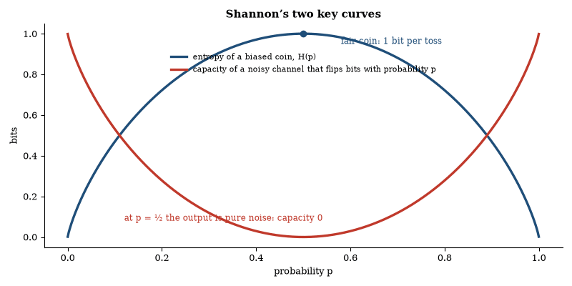
Figure 62. Left to right, the same function seen two ways. H(p) = −p log₂p − (1−p) log₂(1−p) is the information in a biased coin toss, largest when the outcome is most uncertain. Subtracting it from 1 gives the capacity of a channel that flips each bit with probability p; at p = ½ nothing gets through.
The theory is independent of the physical substrate. It applies to telegraph lines, to DNA sequences and to neural spike trains. Compression algorithms approach the entropy limit and error-correcting codes approach the channel capacity, and both are now routine. The same formalism underlies the definition of entanglement entropy in quantum information and the analysis of communication in biological systems.

Coding Theorems and Quantum Extensions
The source coding theorem states that a source of entropy H can be encoded at any rate above H and cannot be encoded at any rate below H. Huffman coding and arithmetic coding approach the bound for known distributions. Lempel–Ziv coding approaches it for unknown stationary sources. The channel coding theorem states that reliable communication is possible at any rate below capacity. Modern codes—turbo codes, LDPC codes, polar codes—come within fractions of a decibel of capacity on standard channels.
Quantum information theory extends the framework. The von Neumann entropy replaces the Shannon entropy. The Holevo bound limits the classical information extractable from a quantum ensemble. Entanglement-assisted capacities can exceed the unassisted Holevo capacity. The classical theorems remain the foundation. The quantum extensions are required once the carriers themselves are quantum.
Questions to Keep Asking
How do we know that the limits are reachable? Codes invented decades after Shannon’s theorem now come within a fraction of a decibel of them.
A compression scheme that claimed to shrink every possible file would break a counting argument. Why?
Try it yourself. Play twenty questions with a friend. How many yes-or-no questions does it take to single out one of a million items? (Answer: about 20.)

64. Secrets and Codes
Each time you see a padlock in a browser, two machines that have never met have agreed a secret in public, using mathematics that was a government secret until the 1970s. The security is a bet that certain problems are hard, and the bet is being tested by quantum computers.

Cryptography
Cryptography is the design of systems that remain secure in the presence of adversaries. Symmetric-key systems use the same secret key for encryption and decryption. Public-key systems use a public key for encryption and a private key for decryption. The security of public-key systems rests on the computational difficulty of certain mathematical problems—integer factorization, discrete logarithms, lattice problems.
Quantum computers threaten the factorization- and discrete-logarithm-based systems. Shor’s algorithm solves both in polynomial time. Post-quantum cryptography replaces those problems with others believed to be hard for quantum computers. Quantum key distribution offers information-theoretic security, resting on the physics described in Chapter 8. It requires an authenticated classical channel. Both approaches are under active development, and the classical public-key infrastructure, whose long-term security against quantum attack is not assured, remains in widespread use.

Hashes, Signatures and Side Channels
Hash functions map inputs of any length to outputs of fixed length. A cryptographic hash is collision-resistant and pre-image-resistant, and it is used for integrity checks and as a building block of digital signatures. Signatures provide authentication and non-repudiation: the signer uses a private key, and anyone can verify the signature with the matching public key.
Side-channel attacks extract information from timing, power consumption or electromagnetic emissions. They bypass the mathematical security of the algorithm by exploiting the implementation. Constant-time code and physical shielding are countermeasures. The attacks demonstrate that security depends on both the algorithm and the device that executes it. Formal verification of implementations remains incomplete. The gap between mathematical security and practical security is persistent.

A Short History of Secrecy
The oldest ciphers shuffle or shift letters. Julius Caesar is said to have shifted each letter of a message three places along the alphabet, a trick a child can undo by trying all 25 shifts. In the ninth century the Arab scholar al-Kindi described a much stronger attack, frequency analysis: in any long text some letters are far commoner than others, and a cipher that replaces each letter by another keeps the pattern. Counting letters breaks it.
Cipher designers answered with machines. The German Enigma machine of the Second World War changed its substitution with every keystroke, and its breaking at Bletchley Park, by Alan Turing and colleagues building on earlier Polish work, was an early triumph of mathematics applied to practice. In 1949 Claude Shannon proved that one system is perfectly secure, the one-time pad, in which the key is as long as the message, truly random and never reused. It is unbreakable and almost impossible to manage, because every message needs a fresh key shared in advance.
That obstacle, the need to share a secret before sharing a secret, defined cryptography until the 1970s. Its removal is the next section.

Public Keys and One-Way Functions
In 1976 Whitfield Diffie and Martin Hellman proposed that two people who have never met could agree on a secret over an open line. A year later Ron Rivest, Adi Shamir and Leonard Adleman published RSA, a system in which anyone can lock a message with a public key, and only the holder of a matching private key can unlock it. British government cryptographers had found similar ideas earlier, in secret.
The mathematics rests on one-way functions, operations that are easy in one direction and hopelessly slow to reverse. Multiplying two large primes takes a moment, while recovering the primes from their product, when each has hundreds of digits, is beyond any known classical method. Elliptic-curve systems use a different problem with the same property and need much shorter keys.
In practice the two kinds of system work together. When a browser connects to a secure site, public-key methods set up a shared secret, and a fast symmetric cipher such as AES then protects the traffic. Digital signatures use the same mathematics in reverse, letting a private key mark a document in a way anyone can check with the public key. All of this stands or falls on the difficulty of a few mathematical problems, and as the chapter on quantum computing explains, Shor’s algorithm would solve the two most widely used ones.

Trust, Certificates and Passwords
A public key is only as good as the knowledge of whose key it is. The web solves this with certificates: a trusted authority signs a statement that a given key belongs to a given site, and browsers carry a list of authorities they trust. The system works well for ordinary use and has been weakened more than once by the compromise of an authority, which is why certificate mistakes are visible and logged.
Passwords raise a related problem. A well-run service never stores your password, only a hash of it, the output of a one-way function. If the hashes leak, an attacker must guess passwords and test each guess, and deliberately slow hash functions make each guess expensive. Length matters more than cleverness. A long random phrase has far more possibilities than a short one full of symbols, and a password reused on two sites is only as safe as the weaker site.
Cryptography protects messages. It cannot protect against a person who is fooled into giving the secret away, nor a device that has been compromised. Most real failures are of that kind, which is a useful reminder that security is a property of a whole system and its people.
Questions to Keep Asking
How do we know a code is secure? Experts attack it in public for years, and for some systems proofs reduce its security to a hard problem.
What announcement would tell you that the mathematics behind the padlock was no longer safe?
Try it yourself. Write a short message with a Caesar shift of three. Then try to break a friend’s shifted message by counting letters, and say why the attack works better on longer text.

65. Artificial Intelligence
A program trained only to predict the next word can write code, explain physics and pass professional exams, and it can state a falsehood in the same confident tone. Understanding what such systems are and are not is now part of scientific literacy.
Machines that perform tasks once called intelligent are no longer a speculation. They are a deployed technology, and an unfinished science.
The revival of neural networks after a long winter is a story of data, hardware, and a few algorithmic ideas. Networks of simple units had been studied for decades. They became dominant when large labeled datasets, fast parallel hardware, and training methods that worked at scale arrived together. Image recognition crossed human-level accuracy on certain benchmarks. Speech recognition became good enough for daily use. Protein structure prediction, in the form of AlphaFold and its successors, solved a problem that had resisted fifty years of other methods and earned a share of the 2024 Nobel Prize in Chemistry. The pattern is that a task with a lot of examples and a clear measure of success can often be learned.
Language models extended the pattern to text. Trained to predict the next token, they acquire abilities that look like knowledge: answering questions, writing code, translating, summarizing. The abilities are real and uneven. A model can produce a correct explanation of a standard topic and a fluent error on a less standard one. It does not have a reliable internal marker for which is which. Users supply the marker, or they do not. Systems that retrieve from a trusted source, or that use tools to check a calculation, reduce the problem. They do not abolish it.
The limits are structural as well as temporary. Models trained on text have no direct contact with the physical tests that correct human belief. They can describe an experiment but cannot run one unless connected to instruments, and long chains of reasoning accumulate errors. Novelty that lies outside the training distribution is handled less well than interpolation inside it. These limits may move. They are the reason current systems are powerful assistants and unreliable authorities.
Learning from human feedback and from other models has been used to make the outputs more helpful and less harmful by ordinary standards. The methods work imperfectly. They can be evaded. They encode the judgments of the people who supplied the feedback. A system aligned with one set of judgments is not aligned with every set. Alignment, in the practical sense, is the problem of keeping a capable system inside the bounds its operators intend. It becomes more important as systems gain tools and act, rather than only reply.
The effect on work is already measurable in some tasks and speculative in others. Programming, drafting, translation, and customer support have seen real productivity changes. Physical trades, care work, and any job whose bottleneck is a body or a relationship have seen less. Forecasts of wholesale replacement have been early before. Forecasts of no effect are already false. The accurate statement is that a class of cognitive tasks has become cheaper, and that the rearrangement of jobs around that fact is underway and unfinished.
The scientific question and the social question should not be fused. The scientific question is what these systems can and cannot do, and what architectures and training methods change the boundary. The social question is how to use, regulate, and distribute a technology that writes and recommends at scale. Both are open. Neither is settled by calling the technology intelligent or by refusing to.
Evaluation is the unglamorous core. A model’s performance on a benchmark is a fact about that benchmark. It is not a general intelligence quotient: benchmarks saturate, models overfit to them, and new benchmarks are written and saturate in turn. The meaningful tests are the ones that resemble the use: a coding task with a real codebase, a medical question checked against a source, a plan executed by a robot. Narrow tests produce narrow claims, and the field has sometimes advertised the narrow test as the general claim. Readers should demand the use case, because the use case is where the limits appear.
Open and closed models are a practical division. Some systems are released with weights that others can run and modify. Some are available only through an interface. The division affects research, safety, and concentration of capability. Open release spreads benefit and spreads the chance of misuse. Closed release concentrates both. Neither is a complete answer. The existence of the division is a fact about the present industry. Regulation that ignores it will misfire. A reader does not need to settle the argument to notice that the argument is about deployment, not only about capability.
Energy and data are the material constraints. Training large models consumes electricity and requires large collections of text, images, or other inputs. The electricity can be supplied more or less cleanly. The data raise questions of consent, of copyright, and of representation. Neither constraint is a reason the technology will stop. Both are reasons its growth has costs that should be counted. A description of capability that omits the electricity and the data describes a software abstraction. The system is a physical and a social object, and its footprint belongs in the chapter.

Definitions and Scope
Artificial intelligence is the construction of systems that perform tasks ordinarily associated with human cognition: recognition, prediction, planning and the generation of language or images. Contemporary systems achieve these tasks by statistical learning from large data sets rather than by explicit symbolic rules.
A deep neural network is a composition of simple functions whose parameters are adjusted to minimize a loss on training examples. When the network is sufficiently large and the data sufficiently rich, the minimization produces internal representations that support accurate classification, translation and synthesis. The same architecture, trained on text, yields language models that predict the next token with high fidelity. Their outputs are samples from a learned distribution, shaped by the training data and by later fine-tuning and conditioned on the prompt.
The performance gains have been empirical. Scaling laws relate loss to the number of parameters, the volume of data and the quantity of computation. The laws hold across many orders of magnitude. They do not yet supply a theory of why particular architectures generalize. Interpretability remains limited. The internal activations can be probed, but no complete mapping from weights to human-readable concepts exists for the largest models.
Applications already include medical imaging, protein-structure prediction, code generation and real-time translation. The systems remain narrow. They are beginning to propose hypotheses and plan experiments under human supervision, but they do not reliably do so unaided, and they do not set their own objectives. Claims of imminent artificial general intelligence are conjectures. The present evidence shows only that statistical models of sufficient scale reproduce many patterns present in human-generated data.

Machine Learning
Machine learning constructs models that improve their performance on a task by exposure to data. Supervised learning minimizes a loss on labeled examples. Unsupervised learning discovers structure in unlabeled data. Reinforcement learning maximizes cumulative reward through interaction with an environment. Deep networks implement all three by composing differentiable functions whose parameters are adjusted by gradient descent.
Generalization is the ability to perform well on unseen data drawn from the same distribution. It is not guaranteed by low training error. Regularization, early stopping and large data sets improve it. The theoretical understanding of why heavily over-parameterized networks generalize remains incomplete. Empirical scaling laws nevertheless predict performance from model size, data volume and compute across many orders of magnitude. The predictions hold. The explanation does not yet.

Why Large Networks Generalize
Over-parameterized networks can interpolate the training data yet still generalize. The phenomenon contradicts classical expectations that more parameters produce more overfitting. Double descent describes the non-monotonic dependence of test error on model size. Error first rises, then falls as the model becomes heavily over-parameterized. The descent is observed across architectures.
Gradient descent on the non-convex loss landscape finds solutions that generalize. The solutions lie in flat regions of the loss, and flatness correlates with generalization, though causal explanations remain incomplete. Adversarial examples—inputs modified by imperceptible perturbations that cause misclassification—demonstrate that the decision boundaries are not those a human would draw. The existence of such examples is a geometric property of high-dimensional classifiers. It limits reliability in safety-critical applications. It does not erase the practical successes on standard benchmarks.
Questions to Keep Asking
How do we know whether a model understands and does not merely repeat? Tests on problems it could not have seen, probing of its internal states and careful comparison with human reasoning all help, and none is conclusive.
What result would persuade you that a system has reasoned and not recalled?
Try it yourself. Ask a chat system something whose answer you know very well, and then something you can check. Compare how sure it sounds with how right it is.

66. Robotics
A factory arm repeats a weld ten thousand times without error, but a home robot that folds laundry reliably is still a research goal. The gap between the factory and the kitchen is the whole problem of robotics.
A robot is a machine that senses and acts in the physical world. The definition is plain. The execution is where intelligence meets friction, lighting, and a floor that is not the floor in the diagram.
The gap is instructive. Reasoning about a photograph leapt forward. Reasoning about a cabinet door, a cable, and a slightly wrong belief about where the door is, remains expensive and brittle. The physical world does not offer a clean next-token prediction. It offers contact.
Industrial robotics is the existence proof that machines can do physical work reliably. In automotive plants and electronics factories, arms weld, paint, and place parts with repeatability a person cannot match. The conditions are the secret: the workspace is controlled, the parts are fixtured, and the exceptions are rare. Move the same arm into a kitchen, and the exceptions become the job.
The unstructured world is hard for reasons that are easy to underestimate. Objects vary. Lighting varies. A grasp that works on a rigid box fails on a soft bag. A door that is slightly ajar is a different problem from a door that is latched. Small errors in position compound. A robot that is ninety-nine percent reliable at each step of a ten-step task fails often. Human environments were built for human hands and human tolerance of variation. They are not neutral test tracks.
Progress has come from learning and from better sensors. Cameras became cheap and good, depth sensors became ordinary, simulation let robots practice millions of grasps, and imitation learning let them copy human demonstrations. Warehouses now use mobile robots to move shelves, and increasingly to pick items. The picking is narrower than a person’s, and it is deployed. Surgical robots translate a surgeon’s movements to smaller, steadier ones. They do not operate alone. Autonomous vehicles have operated in limited domains and have struggled at the edge cases that driving contains in abundance. Legs have improved enough for impressive recovery from disturbance. Hands remain behind.
Humanoid form is a choice, not a requirement. A humanoid can use spaces and tools designed for people, an advantage if the goal is to enter those spaces without rebuilding them, but a specialized machine is usually better at any single task, and most successful robots have been specialized. Whether general humanoids become economical depends on whether their generality is worth their complexity. The answer is not yet in, and demonstrations will not supply it; cost per reliable task will.
The near future is more likely to be a proliferation of narrow robots than a sudden population of general ones. Inspection drones, warehouse movers, agricultural machines, delivery vehicles in constrained areas, and laboratory automation are the present growth. Each extends the domain of reliable physical automation a step. The steps are the story. A guide that describes only the video of a humanoid folding a shirt, and not the machines already running a shift, has the proportions backward.
Safety in robotics is physical. A software error in a chatbot produces a bad paragraph. A software error in a moving machine can produce an injury. The standards for industrial robots, for surgical robots, and for autonomous vehicles are accordingly stricter, and the deployment is accordingly slower. The slowness is not only technical caution. It is the correct matching of speed to consequence. A guide that celebrates laboratory agility and omits the safety case has described a demonstration, not a technology that shares a room with people.
Warehouses are the clearest present success outside the classic factory. Mobile robots move goods. Picking robots, narrower than people, handle a growing fraction of items. The environment was built to suit the machines, with barcoded bins and flat floors. Suiting the environment is a legitimate strategy. It is how factories have always worked. The home, which cannot be rebuilt for the robot, remains harder. Success in structured spaces and difficulty in unstructured ones is the pattern. The pattern tells you where the next deployments will be.
Maintenance is the hidden labor. Robots in real environments need supervision, repair, and the handling of exceptions the design did not cover. The labor is less than the labor replaced, in the successful deployments, and it is not zero. Automation changes work as much as it removes it. The change can be toward higher-skill supervision or toward more fragmented tasks. The outcome depends on how the work is organized, not only on the machine. A forecast that counts only the machine will miscount the jobs. The jobs are the machine plus the people who keep it running and who handle what it cannot.

Sensing, Thinking, Acting
Every robot runs a loop. Sensors report the state of the world, software decides what to do, and motors act, and then the loop repeats many times a second. The oldest and still most common control rule is feedback: measure the error between where you are and where you want to be, and push in proportion to it. A thermostat does this slowly; a robot arm does it a thousand times a second, adding terms that anticipate overshoot and correct for a steady drift. Most of the smoothness of industrial motion comes from this unglamorous mathematics.
Sensors are never exact, so robots combine several. A wheel encoder counts rotations but slips on dust, a gyroscope gives rotation rate but drifts, and a camera sees landmarks but is fooled by shadows. A filter, of which the Kalman filter is the classic example, weighs each source by how far it can be trusted and produces a better estimate than any one alone. The same idea guided the Apollo spacecraft to the Moon. It is why a self-driving car can track a pedestrian even when a lamp post briefly hides them.

Why the Hand Is Hard
The roboticist Hans Moravec noticed in the 1980s that the things people find hard, like chess or algebra, were easier for machines than the things a toddler does effortlessly, like walking across a cluttered room or picking up a grape. Evolution spent hundreds of millions of years perfecting perception and movement and only the last instant on abstract reasoning, so the old skills are deeply optimized while the new ones are shallow and, as it turns out, easy to program.
The human hand shows how deep the optimization runs. It has about twenty-seven degrees of freedom, many hundreds of touch receptors in each fingertip, and a nervous system that adjusts grip within a few hundredths of a second when an object slips. A typical industrial robot arm has six or seven joints and, until recently, almost no sense of touch. Engineers now build hands with many joints and tactile skins, and learning methods can improve their use. In 2019 researchers at OpenAI trained a robot hand, in simulation, to rotate a Rubik’s cube and then transferred the skill to a real hand. It worked, though it failed often on hard scrambles, and the gap between simulation and reality was exactly the difficulty that this chapter describes.

Where Robots Already Work
Surgical systems controlled by a surgeon at a console have been in use since 2000 and have been used in millions of operations. They do not decide anything; they translate the surgeon’s hand movements into smaller, steadier ones and filter out tremor. Farm robots milk cows on their own schedule, and newer machines identify weeds with cameras and spray only them. Warehouses run fleets numbering in the hundreds of thousands of mobile robots. Mars has been explored by rovers that must plan their own route because a radio message takes minutes each way.
The pattern across these examples is that robots succeed where someone has simplified the problem: a bounded task, a known environment, a human who handles the exceptions. After the 2011 accident at Fukushima, robots sent into the damaged reactors struggled with rubble and stairs, and radiation disabled their electronics. The lesson drawn then still holds: in the places where we most want robots, the world is least prepared for them.
Questions to Keep Asking
How do we know a robot demonstration is ready to be a product? Look at the success rate over thousands of trials, the cost per task and whether it works away from the lab.
What failure rate per step would make a ten-step household task practical?
Try it yourself. List ten steps in making a cup of tea. If each step has a 99 percent chance of success, what is the chance that all ten succeed? (Answer: about 90 percent.)

67. Biotechnology
Insulin for people with diabetes was once extracted from the pancreases of cattle and pigs. Since 1982 it has been made by bacteria carrying the human gene, and most of modern medicine’s newest drugs now come from living cells in steel tanks.
Biotechnology is the use of living systems, or their parts, as technology. Fermentation is the old version. The new version reads and writes cells.
Biotechnology’s pace is set by a fortunate fact. Cells already solve problems of manufacture that factories find difficult. Persuading a cell to solve the problem you have, and only that problem, is the craft. The craft has become reliable enough to be an industry. It has not become so reliable that nature can be treated as a subroutine. A released organism still faces evolution, and evolution does not sign the design document.
Recombinant DNA was the first writing. In the 1970s, genes were cut and pasted into bacteria, and the bacteria made the protein. Human insulin followed. The pattern, a cell as a factory for a chosen protein, is now ordinary. Monoclonal antibodies extended it. An antibody is selected or designed, produced in cultured cells, and used as a drug. More than a hundred such drugs treat cancer, autoimmune disease, and other conditions. They are expensive to manufacture and precise in target. They are what a large part of modern therapeutics looks like.
Sequencing turned outbreaks into genetic events. A pathogen can be identified and tracked by its sequence. Variants can be watched as they arise. The COVID-19 pandemic was the public demonstration: the virus was sequenced within weeks of recognition, and its subsequent evolution was followed in public databases. The same methods apply to foodborne outbreaks, to antibiotic resistance, and to the background surveillance that makes a new threat visible sooner. Surveillance is infrastructure. It works when it is funded between emergencies.
Gene drives and ecological interventions are the point where biotechnology leaves the lab and the patient and enters a wild population. A gene drive biases inheritance so that a trait spreads even if it confers no advantage. In mosquitoes, a drive that reduces fertility or that blocks a parasite could, in principle, reduce disease. The spread is the feature and the hazard, since once released a drive can be hard to recall. Trials have been cautious, local, and reversible where possible, and the caution is proportionate to the irreversibility.
Organoids and cell therapies sit at the edge of replacement. Organoids are small, self-organized tissues grown from stem cells. They model organs for research and, increasingly, for testing drugs. They are not transplantable organs. Growing full organs for transplant is a further goal, pursued through scaffolding, printing, and developmental biology. Cell therapies that replace or repair a patient’s cells are further along in blood and in some other tissues. The direction is the same. Cells are being asked to do therapeutic work that chemistry alone could not.
Containment is the standing discipline. Laboratory organisms are kept in by physical barriers, by dependence on nutrients they cannot find outside, and by the simple fact that a pampered strain often loses to wild competitors. None of these is absolute. The history of invasive species is a reminder that organisms sometimes thrive where they were not expected. Biotechnology adds designed organisms to the list of things that have to be kept where they are intended. The record so far is manageable. It stays manageable by continuing the discipline as the organisms become more capable.
The summary for a guide is that biotechnology has become an industry of reading and writing cells, with products in pharmacies, in fields, and in factories. It has not become a permission to redesign ecosystems casually. The tools are ahead of the wisdom in some areas and behind the need in others. Both statements can be true.
Cost is the filter. A therapy that works and costs more than a health system can pay does not change outcomes at scale. Monoclonal antibodies and cell therapies have faced this filter. Some have been brought within reach by production improvements and by policy. Some remain rare in practice. The science can succeed and the delivery can fail. A chapter on biotechnology that lists capabilities without prices describes a possible medicine. The actual medicine is the capabilities that survive the price.
Antibiotics are a warning inside the success. They are among the most effective biotechnologies ever deployed. Their effectiveness is eroded by evolution whenever they are used. Stewardship, new drugs, and diagnostics that distinguish viral from bacterial illness are the responses. The warning is general. A biological technology that creates a selective pressure will meet an evolutionary reply. The reply can be slowed but cannot be forbidden by the original design. Biotechnology that forgets evolution will be surprised by it, and the surprise is avoidable.
Dual use is the standing ethical fact. A technique that can make a vaccine can, in principle, be misused on a pathogen. The overlap is not a reason to stop the technique. It is a reason to screen, to train, and to maintain the norm that some experiments are not done without oversight. The norm has held imperfectly, and maintaining it is cheaper than the alternative. Biotechnology’s benefit is large enough to justify the field, but the benefit does not erase the overlap. Living with the overlap, deliberately, is the adult version of the subject.

From Gene to Tank
A modern biological drug begins as a gene, which is built chemically, inserted into a host cell, and checked. Bacteria such as E. coli are cheap and fast and are used for simpler proteins like insulin. Yeast can add some of the sugar decorations that larger proteins need. Complex proteins, including most antibodies, are made in cultured mammalian cells, usually from Chinese hamster ovary lines that have been used for decades. The cells grow in stainless steel or single-use bioreactors, fed a measured broth, and held at a constant temperature, acidity, and oxygen level.
The numbers show why this is an industry. A good antibody process yields several grams of product per liter of culture. A bioreactor of 10,000 liters at 5 grams per liter therefore delivers about 50 kilograms in a run. At a dose of 200 milligrams, that is about 250,000 doses from one tank. Purification takes most of the effort and cost: the product has to be separated from the host’s own proteins and DNA, and tested to show that every batch matches the last. The cost of a biologic is largely the cost of that sameness.

Crops and Food
Genetic engineering of crops began in the 1980s and 1990s. Insect-resistant crops carry a gene from a soil bacterium that produces a protein toxic to certain caterpillars and harmless to people, which reduces the need to spray insecticides. Papaya in Hawaii was rescued in the 1990s by a variety engineered to resist the ringspot virus that had been destroying the harvest. A 2016 review by the US National Academies found no substantiated evidence that approved engineered crops carry greater risk to health than conventionally bred ones, while noting that each new product needs its own assessment, and that effects on farms and ecosystems depend on how a crop is used.
Some of the oldest products of biotechnology are in the grocery store without being noticed. Much of the cheese in the United States is made with chymosin, the milk-curdling enzyme, produced by engineered microbes since 1990 rather than extracted from calf stomachs. Newer gene-editing techniques make small, precise changes, such as a mushroom that does not brown or a tomato with more of a nutrient, and regulators in different countries are still deciding whether to treat them like conventional breeding. The scientific question, what exactly changed in the plant, has an answer. The legal and cultural question, how that change should be labeled, has several.

Enzymes, Fuels and Industrial Chemistry
Laundry detergents contain enzymes that break down proteins, starches, and fats, and have for decades, letting clothes be cleaned in cooler water. Bread, beer, and cheese depend on microbes, and so do many vitamins and flavors. Industrial biology extends the older craft by redesigning the enzymes themselves; in 2018 Frances Arnold shared the Nobel Prize in Chemistry for directed evolution, a method that mutates an enzyme at random and keeps the variant that works better, repeating the cycle until the enzyme does something new.
The arguments over fuels are a lesson in accounting. Ethanol from corn is a mature product, but it uses more than a third of the US corn harvest, and the net greenhouse gas saving compared with petrol is modest and disputed. Sugar cane in Brazil gives a better balance. Artemisinin, the most effective antimalarial drug, was long extracted from sweet wormwood plants whose supply swung with farm prices; a yeast engineered by Jay Keasling’s group made the precursor chemical in tanks, and commercial production began in 2013. Plant prices then fell, and the engineered route struggled to compete. Biology can make a molecule. Whether it makes it cheaply enough depends on the price of the alternative.
Questions to Keep Asking
How do we know a biological medicine is safe and works? Trials test it in people, and manufacturing is controlled so that every batch is the same.
What would you want to see before accepting a gene drive release in the wild?
Try it yourself. Find the active ingredient of a medicine in your home. Does it come from a plant, a microbe or a chemical factory?

68. Space Exploration
Voyager 1, launched in 1977, is now more than 24 billion kilometers from Earth and still sends data home using a transmitter weaker than a refrigerator lamp.
Spaceflight began as a political contest and became a scientific instrument. Both descriptions remain true.
Robotic exploration has been the productive core. Orbiters and landers have rewritten the history of Mars, revealing ancient water and a cold desert that may still hide subsurface ice. Probes have sampled asteroids and returned the samples, a lander reached Titan, and the Voyagers left the heliosphere. Telescopes in space, free of the atmosphere, have seen in infrared, ultraviolet, and X-rays, and have measured the microwave background and the expansion. The scientific yield per dollar has been highest where people did not go.
Human spaceflight has different yields. It is harder, more expensive, and more inspiring to many. It has produced engineering knowledge, a continuous presence in low orbit, and a political demonstration that a state could do a difficult thing. It has not, so far, produced a scientific return comparable to the robotic program, because a person is a costly and fragile instrument. The argument for sending people is only partly scientific. It includes the possibility that people will eventually live off Earth, and the judgment that this is worth doing. The judgment is not a measurement. The costs and the risks are.
The Moon is the near object. It is three days away. It has water ice in shadowed craters, which could supply drinking water, oxygen, and propellant if the ice can be extracted economically. It is a place to practice living off-world before attempting Mars. Programs to return are underway. A sustained presence is a further step, not guaranteed by a few landings. Mars is months away, with radiation, dust, and a thin cold atmosphere. A round trip with chemical rockets is possible and long. The physiological and psychological costs of the duration are part of the engineering. No one has gone. The timeline is a function of money and persistence more than of unknown physics.
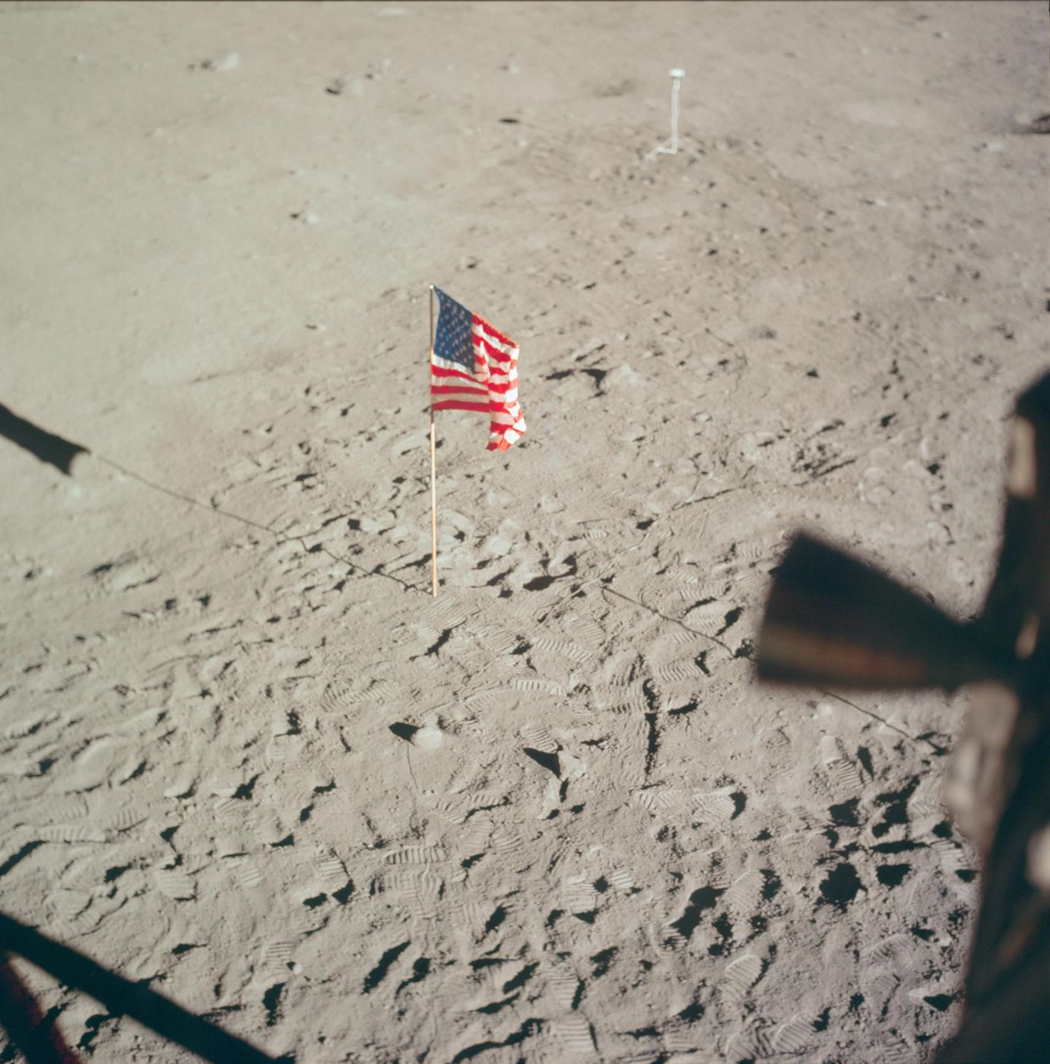
Figure 63. The American flag on the Moon during Apollo 11, in July 1969. Twelve people have walked on the surface; no one has been back since December 1972. Image: NASA, Apollo 11 mission.
Reusable rockets changed the economics of reaching orbit. A stage that flies back and flies again costs less per launch than a stage that is thrown away. The change has increased the number of launches and enabled large satellite constellations. Whether it enables a space economy beyond communications, navigation, and observation depends on finding activities whose value exceeds the remaining cost. Tourism is a niche. Manufacturing in microgravity is a niche. Extraction of materials from the Moon or asteroids is a possibility that has not yet beaten the cost of extraction on Earth. The barrier is economic. It may move. It has not moved enough to make space a place of ordinary industry.
The scientific questions that justify the expense are concrete. Was there life on Mars, and is there any now? What is in the oceans of Europa and Enceladus? How do planetary systems form, in detail the samples and the close observations can answer? What is the inventory of near-Earth asteroids, and which of them are hazards? These questions have missions aimed at them. A guide should keep the questions ahead of the rhetoric. Space is not an escape from the problems of the previous chapter. It is an extension of the reach of measurement, and, perhaps, eventually, of settlement. The extension of measurement is already a success. The settlement is a project.
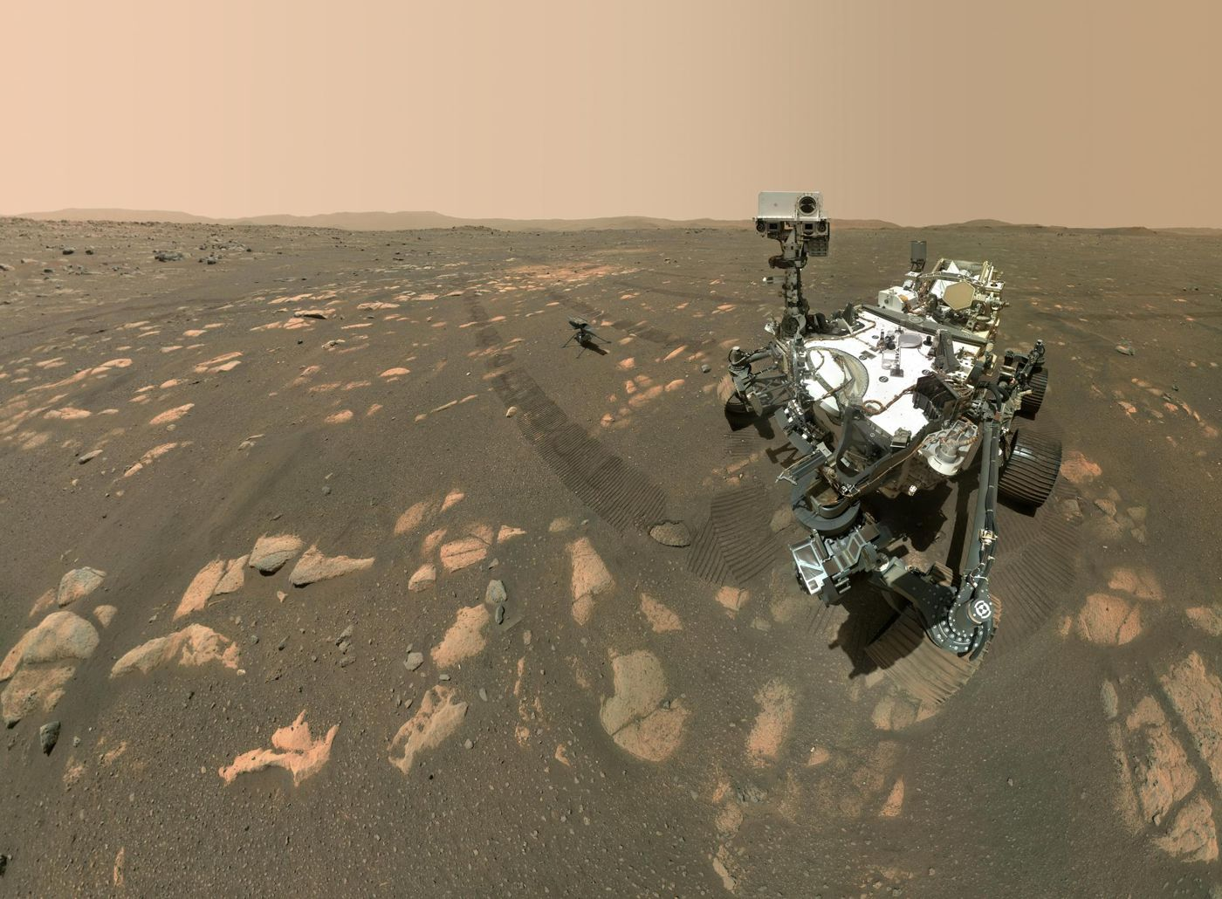
Figure 64. The Perseverance rover and the Ingenuity helicopter on Mars, assembled from many images by the rover’s own camera arm. Image: NASA/JPL-Caltech/MSSS.
Debris and regulation are the mundane frontier. Low orbit is increasingly crowded, and collisions produce debris that can cause further collisions. Tracking, avoidance, and rules for deorbiting are now part of operating in space. The romance of exploration sits on top of a traffic problem that is solvable and not solved. It is a reminder that access to a new domain creates ordinary problems of crowding and external cost, and that those problems arrive before the domain is fully used.
Sample return is the method that joins remote sensing to the laboratory. Rocks from the Moon, from asteroids, and, in proposed missions, from Mars can be analyzed with instruments that no spacecraft can carry. The analyses date surfaces, measure compositions, and look for traces that orbiters cannot confirm. Sample return is slow and expensive. It is how uncertain remote detections become certain laboratory facts. The certainty is worth the wait for the questions that matter enough.
International cooperation and competition both shape the program. Shared missions reduce cost and build redundancy, while competition accelerates schedules and duplicates effort, and the mix has produced the present rate of flight. A reader can prefer one mode, but the record contains both: science missions have often been the cooperative ones and human flight has often been the competitive one. The division is not a law but a history. Future missions to Mars or to the outer moons will test which mode can sustain a long, expensive effort. The test is ahead.

The Tyranny of the Rocket Equation
A rocket moves by throwing mass backward, and the arithmetic of that was worked out by Konstantin Tsiolkovsky in 1903. The speed a rocket can add to itself is its exhaust velocity multiplied by the natural logarithm of the ratio of its starting mass to its final mass. The logarithm is the cruel part. To double the speed gained, a rocket must square its mass ratio, not double it.
Here is the problem in numbers. Reaching low Earth orbit takes about 9.4 kilometers per second once the speed of the orbit itself (7.8 kilometers per second) is added to the losses from gravity and air drag. Burning kerosene with oxygen gives an exhaust speed of about 3.3 kilometers per second. The mass ratio is then e raised to 9.4/3.3, which is about 17, so a single-stage rocket would have to be about 94 percent propellant, leaving 6 percent of the launch mass for the tanks, the engines, and everything it carries. That cannot be built. Hydrogen with oxygen has an exhaust speed of about 4.4 kilometers per second and a ratio near 8.5, which still leaves little for a payload.
The practical answer is staging. A rocket drops its empty tanks and engines as it climbs, so that the next stage does not have to lift them, and the logarithm is applied several times in turn. Reusable first stages add a new trick: they save the most expensive part of the vehicle and return it to be used again. The rocket equation has not been defeated by any of this, only negotiated with, and it explains why so much of a launch vehicle is fuel and why so small a share arrives at the destination.

Trajectories: Falling Toward Other Worlds
Spacecraft traveling between planets do not fly straight. They coast along orbits around the Sun, and the cheapest route to Mars, a transfer ellipse first described by Walter Hohmann in 1925, takes about eight and a half months. Because Earth and Mars both keep moving, the planets line up well for such a transfer only once about every 26 months, and the launch windows are fixed by that celestial clockwork. Missions that miss a window wait over two years.
Gravity can also give a spacecraft a push. A probe that swings past a moving planet takes a small share of the planet’s orbital momentum, and the planet’s change in speed is far too small to notice. The Voyager probes used this repeatedly. Voyager 2, launched in 1977, passed Jupiter, Saturn, Uranus, and Neptune in turn because the outer planets had arranged themselves along a path that comes around about once every 175 years. It remains the only spacecraft to have visited Uranus and Neptune.
Distance imposes a delay that cannot be engineered away. A radio signal takes between about three and twenty-two minutes to cross between Earth and Mars, depending on where the planets are, and 22 hours or more to reach Voyager 1. A rover therefore cannot be driven with a joystick. It has to plan its own movements, and a crewed mission to Mars would have to be run by people who cannot count on advice from home within an hour.

Telescopes That Left the Planet
The atmosphere blocks most ultraviolet, X-ray, and infrared light, and blurs what remains, so some of the most productive spacecraft are observatories. The Hubble Space Telescope, launched in 1990, has a mirror 2.4 meters across, and after a servicing mission corrected a flaw in its optics it has produced the images and measurements behind tens of thousands of scientific papers. Its successor, the James Webb Space Telescope, was launched on Christmas Day 2021 and sits about 1.5 million kilometers from Earth in the shadow of a sunshield the size of a tennis court. Its 6.5-meter mirror of 18 gold-coated beryllium segments works in the infrared, which is needed to see galaxies whose light has been stretched by cosmic expansion.
These instruments illustrate the advantage that the scientific case for exploration rests on. They do not carry people. They are tuned to measure one thing very well, they can be left alone for years, and they do not need life support. The same logic applies to the Kepler and TESS missions that counted planets around other stars (Chapter 27) and to the Planck satellite that measured the afterglow of the Big Bang (Chapter 32).

What Space Does to a Body
In weightlessness the body behaves as if it had been told the load has gone. Bones lose mineral at about one percent a month in the hips and spine, muscles shrink, and fluid shifts upward, which swells the face and can change the shape of the eyeball and the pressure behind it. Exercise of about two hours a day on the International Space Station slows the changes without stopping them. In 2015–16 the astronaut Scott Kelly spent 340 days in orbit while his identical twin stayed on Earth, and the comparison showed a long list of small changes, most of which reversed within months of his return.
Radiation is the harder limit. On Earth, natural background radiation gives an average person about 2.4 millisieverts a year. Crew aboard the International Space Station, protected by Earth’s magnetic field, receive roughly 0.5 millisievert per day. In deep space the field no longer helps, and an instrument on the Mars Science Laboratory measured about 1.8 millisieverts per day on the way to Mars. Six months out and six months back would add roughly 650 millisieverts, about the whole 600-millisievert career limit that NASA now applies to its astronauts. Better shielding, faster propulsion, and careful timing around solar storms are the ways around the problem, and none has been shown in a real mission.
Questions to Keep Asking
How do we know what is on other worlds? Spacecraft carry instruments that measure what no telescope can, and returned samples can be tested in laboratories.
What single measurement from a spacecraft would most change our view of whether Mars once had life?
Try it yourself. Find out when the International Space Station will next pass over your town, and watch it cross the sky.
Further reading for Part X. Shannon and Weaver’s The Mathematical Theory of Communication is where information theory began. Singh’s The Code Book tells the history of secret writing, Russell’s Human Compatible asks what it means to build machines whose goals match ours, and Hofstadter’s Gödel, Escher, Bach is the great playful book about minds, machines and meaning.

Part XI: How We Know, and What Comes Next
How people came to know, count and doubt, and where that might lead

69. A History of Scientific Thought
Aristotle held that heavy things fall faster, and for nearly two thousand years almost no one tried dropping two weights. Science is not a body of facts but a habit that took a long time to form: ask what would count as evidence, and then look.
Science is a method that emerged slowly and then changed everything it touched.
The ancient world had observation, mathematics, and engineering. Babylonians tracked planets. Greeks argued that nature was lawful and, in some schools, that it was made of atoms. Archimedes did physics. The limitation was not intelligence. It was the absence of a settled habit of letting experiment overrule a beautiful system, and of institutions that would reward the overruling.
The method that emerged can be stated without romance: prefer explanations that make predictions, and compare the predictions to measurement. Keep the explanations that survive, and say how sure you are. Publish the measurement so someone else can try to break it. The last step is the social one. Science is individual curiosity organized so that individual error can be caught.
The history is worth telling because it warns against two errors. One error is that science is a modern opinion, replaceable by an older story that feels better. The other is that science is a finished authority. It is a way of being wrong in public, with measurement attached, so that the next wrongness is smaller.
The method did not arrive on a single date. Aristotle collected observations and built systems. He also trusted the systems past the point where new observations should have corrected them. The Islamic golden age preserved Greek work, advanced algebra and optics, and insisted in its best practitioners on testing. Medieval European universities taught logic and natural philosophy and, at their best, disputed rather than only recited. The ingredients were old. The sustained habit of letting a measurement kill a beautiful idea was rarer.
The seventeenth century made the habit institutional. Scientific societies published results so that others could repeat them. Instruments, the telescope, the microscope, the air pump, the precise clock, extended the senses. Newton’s Principia showed that a mathematical law could cover heaven and Earth and could be used to predict. Prediction was the new prestige. An idea that predicted a return, a position, or a measurement earned a kind of trust that an idea which only explained the past did not.
Later centuries extended the habit into chemistry, geology, and biology. Chemistry became quantitative. Geology accepted deep time because the rocks required it. Biology accepted evolution because the pattern of life required it, and later found the mechanism. The nineteenth century also saw the beginning of statistical thinking, which allowed science to deal with variation rather than only with clean laws. The twentieth century saw the habit applied to the very small and the very large, and saw it fail, temporarily, where ideology overrode measurement. The failures are part of the history. They are why the social structure of criticism matters as much as the intelligence of the practitioners.
Fraud, error, and fashion exist: results are withdrawn, and fields have pursued dead ends with confidence. The correction mechanism is slow and real: replication, peer criticism, and the eventual demand that a claim meet the world. The mechanism is imperfect. It is better than the alternatives that have been tried, which include authority, revelation, and the uncriticized intuition of clever people. A reader should trust the method more than any one result, and should trust a result more when independent lines of evidence agree.
The history also shows that science is done by people in societies. Funding, war, institutions, and accident shape what gets studied. They do not, in the long run, decide what is true. The expansion of the universe was not a political outcome. The structure of DNA was not a national one. Remembering the human setting prevents a false purity. Remembering the constraint of measurement prevents a false reduction of science to power. Both errors are available. The record supports neither.
Replication is the part of the method that readers hear about when it fails. In several fields, a fraction of published results do not replicate. The causes include small samples, flexible analysis, publication bias toward positive results, and occasional fraud. The response has been more preregistration, larger samples, open data, and a cultural shift toward treating replication as contribution. The existence of a replication problem in some fields does not infect every result in every science. Particle physics and molecular biology have different standards and different failure modes. The lesson is local vigilance, not global cynicism: the method includes the correction, and using the correction is the ongoing work.
Instruments are the forgotten half of the method. The telescope, the microscope, the balance, the spectroscope, the cloud chamber, the sequencer, and the gravitational-wave interferometer each opened a domain that argument alone could not reach. A history of science that follows only ideas understates the dependence on tools. Ideas suggested where to look. Tools decided what could be seen. The present frontiers are frontiers in part because the tools to cross them are new or do not yet exist. Building the tool is often the scientific act.
Openness is a design choice with a scientific effect. Results that are published in full, with data, can be checked. Results that are withheld cannot. The choice to publish was part of the method’s success. It allowed strangers to find errors. It also allowed the method to scale beyond a circle of acquaintances. Current arguments about open access, about preprints, and about data sharing are arguments about how to keep that property as the volume of science grows. The property is not automatic. It is maintained by norms and by infrastructure. Letting it erode would change the method, not only the business model of journals.

The Philosophy of Science
The philosophy of science examines the methods, foundations and implications of scientific knowledge. It asks what distinguishes science from non-science, how theories are confirmed or refuted, and what scientific claims mean.
Falsifiability, associated with Popper, holds that a theory is scientific only if it can in principle be contradicted by observation. Confirmation is never final and refutation is decisive. The criterion is clear but not always easy to apply, because auxiliary hypotheses can protect a theory from apparent refutation. The Duhem–Quine thesis notes that theories are tested in bundles. A failed prediction can be blamed on an auxiliary assumption rather than on the core theory.
Kuhn described science as alternating between normal science, conducted within a paradigm, and revolutionary science, in which the paradigm is replaced. The description captures historical episodes. It does not supply a normative rule for when replacement is required. Lakatos offered research programs with hard cores and protective belts. Progress is the prediction of novel facts. Degeneration is the accommodation of known facts by ad hoc adjustments.
Realism holds that successful theories are approximately true descriptions of an independent world. Anti-realism holds that success is empirical adequacy, not truth. Both positions are compatible with the same evidence, so the choice is philosophical, and the practice of science continues under either interpretation. The practice is the comparison of precise claims with observation. The comparison is public, repeatable and corrigible. Those features distinguish it from other forms of inquiry. They do not guarantee that the current claims are final.

Reichenbach on Probability, Time and Space
Hans Reichenbach developed a frequency interpretation of probability, a causal theory of time, and a relational account of space-time. The frequency interpretation identifies probability with the limit of relative frequency in a long series of trials. The identification is operational. It avoids reference to single-case propensities. It requires that the series be infinite or that the limit be treated as an idealization. Both requirements are explicit.
The causal theory of time defines the direction of time by the direction of causal processes and by the increase of entropy. The definition is not circular: causal processes are those that can transmit marks, and the mark method distinguishes causal from non-causal sequences. The thermodynamic arrow supplies the global direction, and the two accounts are coordinated without either being reduced to the other.
The relational theory of space-time treats geometry as a system of relations among events rather than as a container. The treatment is consistent with general relativity. It emphasizes that simultaneity is conventional within the limits set by the causal structure.
Reichenbach’s principle of the common cause states that if two events are correlated and neither causes the other, a common cause in their past screens off the correlation. Classical correlations obey it: two thermometers in one room agree because the room’s temperature is their common cause. The correlations of entangled particles do not, since no local common cause can screen them off; that is the content of Bell’s theorem (Chapter 7). The principle remains the default assumption, and its failure is the signature of quantum non-locality.
Reichenbach distinguished between axioms, which are the formal relations, and coordinative definitions, which link the formal terms to physical operations. The distinction reappears whenever a theory is applied. The proper time of a clock, the length of a rod, and the simultaneity of distant events are fixed by coordinative definitions. The definitions are conventional within limits set by the causal structure, and the limits are not conventional. The same distinction organizes the relation between the mathematical formalism of relativity and the operations that measure its quantities.
Reichenbach showed that the simultaneity of distant events is fixed by a coordinative definition. The standard definition (Einstein synchronization) sets the one-way speed of light equal in both directions. Other definitions are possible. They differ by a parameter ε between 0 and 1. The choice of ε does not affect observable round-trip times. It affects only the description of one-way processes. The freedom is limited by the causal structure. No choice permits a signal to travel outside the light cone. The limited freedom is the content of the relativity of simultaneity. It is conventional within the limits. It is not conventional outside them.
Reichenbach treated induction as a procedure that converges to the correct relative frequency if a limit exists. The procedure does not guarantee success in any finite time. It guarantees that if a limit exists, continued application will find it. The guarantee is asymptotic. It is the strongest guarantee available for empirical generalization. The same asymptotic character appears in the frequency interpretation of quantum probabilities and in the convergence of relative frequencies in statistical mechanics. The interpretation does not supply certainty. It supplies a method that succeeds if success is possible.
Reichenbach introduced the notion of genidentity—the identity of a thing through time. For classical particles the notion is unproblematic, but for quantum particles it is not: indistinguishable particles lack trajectories that can be followed. The absence is a consequence of the symmetrization postulate, which replaces genidentity with permutation symmetry, and the replacement is required by the statistics. It is the reason identical particles are not individuals in the classical sense. The point reappears whenever the book discusses fermions, bosons or the failure of classical particle labels.
These positions appear, in different language, throughout the present book. The frequency interpretation underlies the statistical reading of the Born rule and of thermodynamic probability. The causal theory of time reappears in the discussion of the thermodynamic arrow and of the impossibility of signaling outside the light cone. The relational view of space-time is the background of the chapters on special and general relativity. The influence is not doctrinal. It is the shared insistence that claims about probability, time and geometry must be cashed out in terms of observable relations and operations.
Questions to Keep Asking
How do we know when one theory should replace another? When it predicts new facts, explains the old ones and survives tests the old theory fails.
Pick a theory in this book. What evidence would make you abandon it?
Try it yourself. Choose a belief once held by experts and since overturned. What evidence overturned it, and how long did that take?

70. Four Maxes
Planck, Born, von Laue and Tegmark share a first name and an interest in what mathematics says about reality. Between them they stand for the quantum, probability, the first view of atoms in crystals and the idea that the universe is mathematics all the way down.

Max Planck
Planck introduced the quantum of action in 1900. To fit the spectrum of black-body radiation he assumed that the energy of an oscillator of frequency ν is an integer multiple of hν. The constant h is Planck’s constant. The assumption was empirical. It reproduced the observed spectrum, including the high-frequency fall-off that classical theory could not explain.
The same constant sets the scale of quantum phenomena. A photon of frequency ν carries energy hν. The angular momentum of an electron orbit is quantized in units of ħ = h/2π. The uncertainty principle is written with ħ, and every confirmed quantum calculation contains h, whose measured value is 6.626 × 10⁻³⁴ joule-seconds.
Planck also defined the natural units constructed from h, G, and c. The Planck length is √(ħ G/c³) ≈ 1.6 × 10⁻³⁵ m. The Planck time and Planck mass follow similarly. These units mark the scale at which quantum gravity is expected to become important. No experiment has reached them. They remain the characteristic scales of any theory that unites quantum mechanics and general relativity.
The introduction of h was the first step of quantum theory. The subsequent development replaced the original oscillators with the operators and amplitudes of modern quantum mechanics. The constant itself is unchanged.

Max Born
Born gave the statistical interpretation of the wave function. The quantity |ψ|² is the probability density for finding the particle. The interpretation was proposed in 1926. It turned the Schrödinger equation from a classical wave equation into a probabilistic theory. Every subsequent calculation of cross-sections, decay rates, and spectra uses the rule.
Born also developed the theory of ionic crystals and, with Heisenberg and Jordan, the matrix formulation of quantum mechanics. The matrix formulation and the wave formulation were shown to be equivalent. Both are in use. With Oppenheimer he also supplied the approximation that separates electronic from nuclear motion, still the foundation of molecular quantum chemistry. The probabilistic reading of the wave function remains the link between the formalism and laboratory counts.
The rule does not say what happens in a single run; it gives the distribution of outcomes over many runs. That is what has been tested, to high precision, and every alternative reading has to reproduce it.

Max von Laue
Von Laue predicted that X-rays would diffract from the regular lattice of a crystal. The experiment, performed in 1912, confirmed the prediction. The diffraction pattern established both the wave nature of X-rays and the atomic periodicity of crystals. The wavelengths of X-rays were thereby measured. The spacing of atomic planes was determined.
The same technique, extended to electrons and neutrons, maps the structure of solids, proteins, and viruses. The phase problem—the loss of phase information in the intensity pattern—is solved by direct methods, by isomorphous replacement, or by anomalous dispersion. More than two hundred thousand structures of biological molecules are now on file. The method remains the principal source of atomic-resolution models of large molecules.
Von Laue’s demonstration converted crystallography from a macroscopic description of faces into a quantitative determination of atomic positions. Von Laue also wrote the first systematic textbook on special relativity and contributed to the electrodynamics of moving media.

Max Tegmark
Tegmark has argued that the mathematical structure of physical law is not a description of reality but is reality itself. The hypothesis is called the mathematical universe: every consistent mathematical structure exists, and the physical world we inhabit is one such structure. Observers arise inside those structures that are complex enough to contain self-aware subsystems.
The proposal implies a form of multiverse. Structures that differ in their equations or in their solutions are equally real. The anthropic selection of our particular laws is then a selection among existing structures rather than a selection among possibilities. The hypothesis is metaphysical. It is not contradicted by existing data. It makes no unique empirical prediction that distinguishes it from ordinary physics inside our structure.
Tegmark has also classified multiverse proposals into four levels: regions beyond our horizon, universes with different constants, the many-worlds branches of quantum mechanics, and the ensemble of mathematical structures. The classification organizes existing ideas. It does not establish that any level beyond the first is realized. The first level is already implied by standard inflationary cosmology if the inflationary volume is infinite.
The mathematical-universe hypothesis and the multiverse taxonomy are therefore frameworks for organizing questions. They are not established theories. They remain options for interpreting the relation between mathematics and the physical world.

Planck: An Act of Desperation
Planck was a conservative man who did not set out to start a revolution. In 1900 he was trying to explain why a hot object radiates the colors it does, and experimenters in Berlin had just measured the infrared end of the spectrum with new precision. He first guessed a formula that fit the data. Then he searched for a physical explanation of his guess, and the only one he could find required that energy be exchanged in discrete packets. Years afterward he called this assumption an act of desperation, adopted because nothing else would give the right answer.
His 1900 paper also did something practical. Matching the formula to the measured curve gave him numerical values for the new constant h and for Boltzmann’s constant, and from those he calculated the number of molecules in a mole and the charge on the electron. His electron charge came within about 3 percent of the modern value, long before the electron’s charge had been measured with real precision. In 1905 Einstein took the idea literally and showed that light itself comes in quanta, and Planck, who was not convinced, spent several years trying to fit the quantum into classical physics before accepting that it would not go.
The constant has had a long career. Since 2019 the kilogram has been defined by fixing the exact value of Planck’s constant, 6.62607015 × 10⁻³⁴ joule-seconds, and weighing by balancing electromagnetic forces against gravity. A century and a quarter after an act of desperation, the quantum sits at the foundation of the world’s system of units.

Born: A Rule for Turning Waves into Odds
Born’s rule says that the probability of finding a particle at a place is the square of the size of its wave function there. The strangeness shows up in two-slit experiments. If each slit alone would give an amplitude of 1 at a certain point on the screen, then a classical sum of probabilities would give 1 + 1 = 2. The quantum rule adds the amplitudes first and squares afterward. If the two waves arrive in step, the result is (1 + 1)² = 4, twice the classical figure; if they arrive out of step, it is (1 − 1)² = 0, a place where particles never land even though each slit alone would send them there.
The rule was published in 1926, in a paper about collisions, almost as a footnote. Einstein disliked its consequence that the theory could only give odds, and wrote to Born in December that year that he was convinced that God does not play dice. Born replied politely and kept working. In 1954 he shared the Nobel Prize in Physics for the statistical interpretation, nearly thirty years after it had been proposed. He had been forced out of his professorship in Göttingen in 1933 because he was Jewish, and he did much of his later work in Edinburgh. His granddaughter was the singer Olivia Newton-John.

Von Laue: Seeing the Atoms in a Crystal
Von Laue reasoned in 1912 that if X-rays were waves with a wavelength like the spacing between atoms, a crystal would act like a three-dimensional diffraction grating. His colleagues Walter Friedrich and Paul Knipping tried it on a crystal of copper sulfate and found a pattern of spots on the photographic plate, as predicted. A single experiment had shown that X-rays are waves and that crystals are regular arrays of atoms. Von Laue received the Nobel Prize in 1914.
The young William Lawrence Bragg, working with his father William Henry Bragg, found a simpler way to think about it. Reflections from successive planes of atoms reinforce one another only when the path difference is a whole number of wavelengths, which gives the Bragg condition nλ = 2d sin θ. For X-rays of wavelength 0.154 nanometers, the line copper emits, falling on planes 0.20 nanometers apart, sin θ = 0.154/(2 × 0.20) = 0.385, so the first reflection appears at an angle of about 22.6 degrees. By measuring such angles, researchers worked out first the structure of salt and diamond, then of metals, and in time of DNA, whose double-helix pattern in the 1950s came from an X-ray photograph.
Von Laue was also one of the few prominent German physicists to speak out against the dismissal of Jewish colleagues after 1933 and to defend the physics of Einstein, which the regime called Jewish science. He stayed in Germany, kept his post for a time, and helped rebuild German science after the war.

Tegmark: Weighing an Idea You Cannot Test
Tegmark’s proposal raises a question every scientist meets sooner or later: what should we make of an idea that cannot yet be tested? His book Our Mathematical Universe (2014) is open about the speculation, and he has also done conventional work in cosmology, including analyses of the cosmic microwave background and of galaxy surveys. He co-founded the Future of Life Institute in 2014 to study the risks of powerful technologies, which shows that the philosopher and the practical scientist coexist in one person.
A few questions help when weighing a speculative idea. Does it predict anything that could, even in principle, come out differently from the alternatives? Does it explain something that the simpler account cannot? Does it fit everything already known? And what does it cost in assumptions? Tegmark argues that his hypothesis is the cheapest, since it needs no rule beyond mathematics itself, though critics answer that the price is paid in another currency, an infinity of unobservable worlds. A second objection is the measure problem: if every possible structure exists, then there are infinitely many observers of every kind, and there is no agreed way to say what a typical one should expect to see.
Neither objection settles the matter, and an honest guide leaves it unsettled. It is enough to notice the difference in status between the four Maxes. Planck’s constant is measured to nine digits, Born’s rule is tested in every quantum experiment, and von Laue’s method reveals new structures every day. Tegmark’s hypothesis is a proposal about what all of that adds up to, and the proper response is interest and patience.
Questions to Keep Asking
How do we know the value of Planck’s constant? It can be found from the black-body curve, the photoelectric effect and the quantum Hall effect, which agree.
What kind of result would show that the mathematical-universe idea is wrong, or that it cannot be tested?
Try it yourself. Find the energy of a green photon, with frequency 5.5 × 10¹⁴ hertz, from E = hf. (Answer: about 3.6 × 10⁻¹⁹ joules, or 2.3 electron-volts.)

71. The Scientific Method
A coin lands heads five times in a row, and nobody is surprised. It lands heads fifty times and everyone is. The difference between the two reactions is statistics, which is how science decides what to believe.
The scientific method is the systematic comparison of hypotheses with observation. A hypothesis is scientific if it is falsifiable in principle. Observations that contradict the hypothesis require its modification or abandonment. Observations that agree increase its credibility but do not prove it. The method is iterative. Theories are refined, extended or replaced as new data arrive.
Controlled experiments isolate variables. When experiments are impossible, as in much of astronomy and geology, multiple independent lines of evidence are required. Reproducibility is essential. Results that cannot be reproduced by others are discarded. Peer review and open data accelerate the detection of error. The method does not guarantee truth. It guarantees that persistent error is eventually exposed. The exposure is slower than the appearance of new claims. It is nevertheless more reliable than any alternative so far devised.

Replication and Its Safeguards
Replication is the repetition of an experiment by an independent group. It tests whether the original result was an artifact of a particular apparatus, sample or analysis. Failure to replicate does not prove the original claim false. It proves that the claim is not yet robust. Meta-analysis combines results across studies. It can reveal small effects that no single study detects. It can also propagate systematic errors if the studies share the same bias.
Pre-registration of hypotheses and analysis plans reduces the opportunity to adjust the question after the data are seen. Open data and open code allow others to check the calculations. None of these practices guarantees correctness; they raise the cost of undetected error, and the method remains fallible. Its advantage is that the fallibility is public and correctable.

Updating Belief: Bayes’ Theorem
Falsification says that a theory is tested by evidence that could contradict it. A complementary view, named for the eighteenth-century minister Thomas Bayes, says how strongly any piece of evidence should change our belief. Before the evidence we hold a prior probability. The evidence is more or less likely under each hypothesis. Bayes’ theorem combines the two into a posterior probability, and it tells us that surprising evidence moves us more than expected evidence.
The theorem is best understood through a case that fools many doctors. Suppose a disease affects one person in a hundred, and a test catches 90 percent of true cases but also gives a false positive for 9 percent of healthy people. A patient tests positive, and most people say that the chance of disease is about 90 percent. The true answer is about 9 percent, because in 1,000 people there are about 9 true positives and about 89 false ones. The prior, the rarity of the disease, matters as much as the accuracy of the test.
Scientists use the same logic when they judge whether an extraordinary claim is credible. A result that contradicts a great body of earlier evidence has a low prior and needs strong evidence in return. That is not stubbornness. It is arithmetic.

Statistics and the Meaning of a p-value
A p-value is the probability of seeing data at least as extreme as those observed if there were really no effect. It is not the probability that the hypothesis is false, and it is not the size of the effect. A very small effect can have a tiny p-value in a huge sample, while a large and important effect can fail to reach significance in a small one. Reporting the effect and its uncertainty is more informative than a verdict.
A second hazard is multiple comparison. A researcher who tests twenty unrelated hypotheses at the usual 5 percent threshold should expect one false positive by chance alone. The remedy is to state in advance what will be tested, correct for the number of tests, and replicate the result in new data. Fields differ in how strict they are. Particle physicists demand five standard deviations, about one chance in three and a half million, before announcing a discovery, because they look in so many places.
The deeper point is that a number cannot replace a judgment about design. A well-designed study of a plausible effect, with its protocol fixed beforehand, is worth more than a clever analysis of an accident.

Cause and Effect: From Cholera to Trials
In 1854 a cholera outbreak struck the Soho district of London. The physician John Snow mapped the cases, found that they clustered around one water pump on Broad Street, and persuaded the authorities to remove its handle. The outbreak waned, though it was already declining, and later work confirmed that the pump’s water had been contaminated. Snow’s great contribution was the method: comparing groups that differ in one exposure, here the water supply.
The central difficulty is confounding. People who take a vitamin may also exercise and eat well, so any difference in health may have nothing to do with the vitamin. The most powerful solution is the randomized controlled trial, in which a coin toss decides who receives a treatment, so that other differences balance out on average. Blinding, so that neither patient nor doctor knows who received what, guards against expectation.
When trials are impossible, as in astronomy, geology or the study of climate, scientists look for natural experiments and for many independent lines of evidence that all point the same way. Causes are established by the convergence of different kinds of evidence, not by a single decisive test.
Questions to Keep Asking
How do we know a result will replicate? We cannot be sure, but pre-registered plans, large samples and independent repetition raise the odds.
What would persuade you that a study’s finding had come from chance?
Try it yourself. Flip a coin 100 times. If you got 60 heads, how surprising is that? Look up or compute the probability of 60 or more. (Answer: about 3 percent.)

72. Mathematics, Humanity’s Language
Eugene Wigner called the usefulness of mathematics in physics “unreasonable.” The same mathematics that lets us count apples also shows that some true statements about numbers can never be proved.
Mathematics is not only a tool science uses. It is the language in which the most reliable descriptions of nature are written.
A falling apple and an orbiting Moon are the same equation. A vibrating string and a quantum wave function share a structure. The usefulness of mathematics in physics has been called unreasonable. It may be less mysterious than it sounds. We keep the mathematics that matches the world and discard the rest. The match is still striking. Imaginary numbers, invented for algebra, became the natural language of quantum mechanics. Geometries invented for their own interest became candidates for the shape of space.
Mathematics is also where certainty has a different meaning. A proof, once checked, does not expire. The infinitude of primes is not waiting on the next survey. This certainty is bought by talking about defined objects rather than about rocks. The application to rocks is a further step, and it can fail even when the proof stands.
Computation changed the subject without ending it. Proofs can be formalized and checked by machines. Conjectures can be tested to vast numbers, which is evidence and not proof. Mathematical biology, climate models, and cryptographic protocols are mathematics applied where the older guides had only physics in mind. Statistics is the mathematics of uncertainty, and much of what this book reports, from genomes to galaxies, arrives as a statistical claim. Knowing what a confidence interval is has become part of literacy.
None of this makes mathematics identical to the world. The map can be perfect and the terrain different. It does explain why a book about reality keeps becoming a book about equations, and why the equations, when they are right, outlast the words around them.

Gödel’s Incompleteness Theorems
Gödel’s first incompleteness theorem states that any consistent formal system capable of expressing elementary arithmetic contains true statements that are unprovable within the system. The second theorem states that such a system cannot prove its own consistency.
The theorems apply to any sufficiently strong, recursively axiomatisable theory. They do not imply that mathematical truth is arbitrary. They imply that no single formal system captures all arithmetic truths. Stronger systems can prove the undecidable sentences of weaker systems, but they in turn possess their own undecidable sentences. Consistency of the stronger system remains unprovable within itself.
The results limit the ambitions of Hilbert’s program. They do not limit the everyday practice of mathematics, which moves freely among systems of different strength. They establish a precise boundary between what can be proved inside a given formal system and what is true of the natural numbers.

How Gödel’s Proof Works
The self-referential sentence constructed in the proof of the first incompleteness theorem is obtained by diagonalization. A formula that expresses “the sentence with Gödel number x is unprovable” is applied to its own Gödel number. The resulting sentence G asserts its own unprovability. Consistency of the system implies that G is true and unprovable. The argument requires that the system be able to represent the provability predicate and that it be consistent.
The second theorem follows by formalizing the first inside the system. If the system could prove its own consistency, it could prove G, contradicting the first theorem. The theorems therefore link consistency and incompleteness. Extensions of the system that add G as an axiom remain incomplete. They possess new undecidable sentences, the hierarchy of consistency strength is strict, and no finitely axiomatisable extension that includes arithmetic escapes incompleteness.
The results are specific to formal systems. They do not apply directly to informal mathematical practice, which is not bound by a fixed axiom set. They do establish that any mechanical proof procedure for arithmetic will leave some truths unproved.

Strange Loops and Self-Reference
A strange loop is a hierarchical system that closes upon itself so that movement up or down the levels returns one to the starting point. The concept is illustrated by Gödel’s self-referential sentence, by Escher’s drawings of hands drawing each other, and by the self-referential structure of conscious thought. In each case a level of description refers to the system of which it is a part.
Self-reference is not paradoxical by itself. It becomes paradoxical only when combined with negation in unrestricted ways, as in the liar paradox. Formal systems avoid contradiction by restricting the formation rules or by stratifying the language. Natural language and mental representation do not obey the same restrictions. They permit the formation of self-referential statements and of models that include the modeler.
Hofstadter proposed that the self—the sense of “I”—is a strange loop realized in the brain’s symbolic activity. The proposal is a philosophical hypothesis, not a neuroscientific theory. It identifies a structural feature common to formal incompleteness, visual paradox and subjective experience. Whether that feature is explanatory of consciousness remains open. The formal and artistic examples themselves are well-defined.

Analogy: The Fuel and Fire of Thinking
In Surfaces and Essences, Douglas Hofstadter and Emmanuel Sander argue that analogy is not an occasional trick of reasoning but its core. A child who calls a pony a big dog, or a man who uses the word mother for the second wife of his father, is stretching an old category to fit a new case. Every word, they say, is a bundle of such stretches, and thinking is the continual finding of likenesses beneath different surfaces.
Science supplies many examples. Rutherford’s picture of the atom as a miniature solar system, Kekulé’s dream of a snake biting its tail that gave him the benzene ring, and Einstein’s image of a person in a falling elevator all work by analogy. Their value lies in what they let a mind do next, and also in where they stop working: electrons do not follow planetary orbits, and the analogy has to be dropped at the right moment.
The thesis is a bold one, and cognitive scientists do not all accept its strongest form. It does fit a lesson that runs through this book. The strongest results in science are those whose analogy holds in detail, and the clearest explanations are those that say where the likeness ends.

Formal Systems and Meaning
A formal system consists of a finite alphabet, a set of formation rules, a set of axioms and a set of inference rules. Theorems are the strings generated from the axioms by the rules. The system is purely syntactic. Meaning is assigned by an interpretation that maps strings to statements about some domain.
Gödel numbering shows that the syntax of a sufficiently rich system can be represented inside arithmetic. The system can therefore talk about its own proofs. Completeness holds for first-order logic: every logically valid formula is provable. It fails for arithmetic, as the incompleteness theorems demonstrate. Consistency and completeness cannot be simultaneously achieved for any system that includes elementary number theory.
The distinction between syntax and semantics is sharp inside the formal system. It is less sharp in natural language and in mental representation, where the same symbols carry both formal roles and interpreted content. The study of formal systems supplies the precise tools with which the limits of mechanical proof and the possibilities of self-reference are established. Those limits and possibilities are mathematical facts.

A Puzzle in Meaningless Symbols
Douglas Hofstadter introduced a small game in Gödel, Escher, Bach to show how meaning relates to form. Strings are made from the letters M, I and U. You start with MI, and you may apply four rules: add a U to the end of a string that ends in I; double everything after the M; replace any III with U; delete any UU. Can you reach MU?
Try it, and you will wander through many strings and never arrive. The reason is found by stepping back from the rules to a property of every string. The number of I’s starts at one. Doubling changes it from n to 2n, and replacing III by U lowers it by three. Neither operation can turn a number that is not divisible by three into one that is, so zero I’s, as MU requires, is out of reach. The proof is outside the system, and that is its point.
The game is a miniature of a theme in the previous sections. A formal system is a set of rules on symbols, and it has no meaning until an interpretation is assigned. When the symbols are given the meaning of arithmetic, the rules acquire a content. The incompleteness theorems rest on this, and so does the question of how a mind, which is also a system of rules acting on symbols, can mean anything at all.

Superrationality and the Prisoner’s Dilemma
Two prisoners are held apart. Each may stay silent or betray the other. Whatever the other does, betrayal pays better for the individual, yet if both betray they do worse than if both stay silent. This is the prisoner’s dilemma, the standard model of a situation in which the best choice for each person is bad for both. Many real tensions, between rivals, nations and herders sharing a pasture, have the same shape.
In 1980 Robert Axelrod invited experts to submit programs for a tournament of repeated dilemmas. The winner was the simplest entry, Tit for Tat: cooperate first, then do what the other did last time. It succeeded because it was nice, firm, forgiving and easy to understand. Axelrod’s later work showed how such strategies can arise in an evolving population, an idea that fits the biology of reciprocal cooperation.
Douglas Hofstadter, in a column collected in Metamagical Themas, proposed a stronger argument. If rational players are truly alike, each should realize that whatever it decides the other will decide too, so both should cooperate. He called this superrationality. Most theorists find the reasoning too slippery, since the players are not guaranteed to be copies, but the column showed readers how a puzzle about choices becomes a puzzle about identity.
Questions to Keep Asking
How do we know that a proof is correct? Experts check it, and for some proofs a computer verifies every step against the rules.
What would an inconsistency in arithmetic mean, and why do mathematicians think we would find out?
Try it yourself. Draw squares to show that the sum of the first n odd numbers is n squared.

73. Knowing, Doubting and Correcting
The most reliable theories in physics have each been replaced by something better, and each is still used. Learning to hold a result firmly and loosely at the same time is the central skill of living with science.

On the Usefulness of Being Wrong
Science advances by being wrong in public and then correcting the error. The phlogiston theory of combustion was wrong. It nevertheless organized a large body of chemical observations and was replaced by a better account only after careful weighing showed that metals gain mass when they burn. The luminiferous aether was wrong. It nevertheless supplied the conceptual frame in which the Michelson–Morley experiment became decisive.
The pattern is general. A theory that is precise enough to be tested will eventually be tested. If it fails, the failure is informative; if it succeeds, the success is provisional, and the provisional successes accumulate. They are the reason aircraft remain aloft, antibiotics cure infections, and GPS receivers know where they are. Each of those technologies rests on theories that have been wrong in detail and right enough in practice to be useful.
The same process applies to the chapters of this book. Some statements will be superseded. The supersession will not erase the parts that were already correct. It will merely draw the boundary between the two more accurately. Being wrong, provided the error is detectable, is a method. It is slower than being right, but it has the advantage of working.

A Note on Certainty
The laws of physics are the most reliable statements human beings have so far managed to write down. They are still provisional. Newton’s law of gravitation was reliable enough to send men to the Moon and inaccurate enough to require replacement by general relativity. General relativity is reliable enough to operate the GPS network and incomplete enough to fail at the center of a black hole. The pattern is familiar. Each improvement removes an error and reveals a new boundary.
The practical response is not despair. It is the continued use of the best available description while noting where it ceases to apply. Aircraft do not fall out of the sky because quantum gravity is unfinished. Antibiotics do not stop working because the origin of life is unknown. The unfinished parts are interesting. They are not a reason to discard the finished ones. Certainty, in science, is a matter of degree and of domain. Both are larger than they were a century ago and smaller than a complete theory would make them.

Many Levels of Description
A cup of coffee can be described as a collection of quantum fields, as a liquid with a temperature and a viscosity, or as something to drink before a meeting. Each description is correct in its own terms, and none is a rival to the others. Sean Carroll, in The Big Picture, calls this attitude poetic naturalism: the world is made of one set of physical things, and there are many useful stories about them, each with its own vocabulary.
The levels are linked by what physicists call emergence. Temperature is not a property of a single molecule, yet it is perfectly real, because it summarizes the average motion of an enormous number of them. A table, a species, a market and a person are similar. They are patterns that are stable enough to be spoken of in their own right, though they consist of nothing but their parts.
Two cautions apply. The existence of a higher-level description does not break the laws below it. And a pattern being real at its own level does not make every story about it true. The test of a level is the same test used throughout this book: whether it lets us predict something and survives checking.

On Experts
An expert is someone who has already made the mistakes you are about to make and has written them down. The writing is usually technical but is nevertheless the shortest route past the mistakes, and the alternative is to repeat them. Repeating them is slower and, in some fields, more expensive.
Expertise is not infallibility. Experts disagree and they update, both in public, which is preferable to the unanimity of people who have not examined the evidence. A consensus that has survived repeated attempts to overturn it is the least bad guide available. It can still be wrong, but it is less likely to be wrong than an opinion formed without the same examination.
The chapters of this book rely on that consensus where it exists and note the disagreements where they remain. The reliance is provisional. It is also the reason the book can be shorter than the literature it summarizes.

On the Persistence of Error
Error is not eliminated by the discovery that it is error. It is eliminated by the slower process of replacing the practices that embody it. The practice of bleeding patients survived the demonstration that it was harmful. The practice of denying continental drift survived the evidence that continents move. In both cases the evidence was available for decades before the practice changed.
The delay is not mysterious. Institutions, textbooks and habits have inertia, and individuals have reputations; both resist revision until the cost of keeping the error exceeds the cost of abandoning it. The change is rarely graceful, but it is more reliable than hoping an error will vanish the moment it is pointed out. Pointing out is necessary. Replacement finishes the job.

A Note on Progress
Progress in science is the replacement of a vague idea by a precise one, followed by the discovery that the precise idea is wrong in a smaller way. The smaller wrongness is an improvement, and it is not a reason for celebration but a reason to continue.
The pattern is reliable and slow. The slowness is not a defect of the method but a consequence of requiring every new idea to survive contact with observation, which is often inconvenient. The inconvenience is the point. Ideas that cannot be inconvenienced are not scientific; they may be comforting, but they are not progress.

On the Retention of Obsolete Theories
Obsolete theories are not retained because they are true. They are retained because they are useful within a restricted domain, or because the cost of replacing them exceeds the cost of keeping them. Newtonian gravity is obsolete, and it is also the reason spacecraft reach their destinations: the obsolescence is real and the usefulness is also real.
The retention is therefore not an error but a calculation, and calculations can be wrong. When this one is, the theory is eventually discarded, though rarely at once: it goes when a better calculation is available and the institutions that teach the old one have been persuaded to teach the new. The persuasion takes time, measurable in textbooks.
Questions to Keep Asking
How do we know whom to trust? Look at track record, whether claims can be checked and whether an expert’s incentives line up with the truth.
What would you want to see before changing your mind about something you believe strongly?
Try it yourself. Take a news headline announcing a scientific breakthrough and find the original paper’s abstract. What did the paper actually claim?

74. Future Challenges
Every era’s open problems read, a century later, like a list of what was about to be solved or about to be misunderstood. The present list is long because the answers of the last hundred years raised sharper questions.
The unfinished list is not a secret. It is the table of contents of the journals.
A challenge is not a reason for gloom. The list of a century ago included the nature of the stars, the structure of the gene, and the cause of infection. Those items moved from mystery to mechanism. The present list is what remains after that success. It is a larger list only because the horizon moved.
The challenges in fundamental physics are specific. Dark matter has been weighed but not identified, and dark energy measured but not explained. Quantum gravity has candidates and no experimental confirmation; the matter-antimatter imbalance has a size and no established mechanism; neutrino masses have a range and an unsettled origin. Each is a place where a measurement could change the framework, which has survived a great many measurements but is not immune to the next one.
In biology the challenges are just as specific. The origin of life lacks a demonstrated pathway. The cell is not fully mapped: many genes have partial or unknown functions, and their interactions are incompletely known. Development, which builds a body from an egg, is understood in outline in model organisms but nowhere near in full circuit detail. Consciousness is unsolved in the sense already discussed, aging is a set of processes with partial interventions, and cancer is many diseases, some now treatable. Pandemic risk is permanent, because evolution is, and preparedness is a choice. These are not vague frontiers but jobs with tools assigned to them.
Earth science faces a different kind of challenge: a system that can be measured and that is being changed while it is measured. The rate of ice-sheet loss, the stability of major circulations, the response of clouds, and the capacity of ecosystems to adapt or to fail are the uncertainties that dominate practical risk. They will be better known in twenty years. The emissions of those twenty years will already have been added. The challenge is scientific and temporal at once.
Technology’s challenges include the alignment and reliability of increasingly capable automated systems, the safe and equitable use of gene editing, the governance of surveillance that cheap computation makes possible, and the management of biological tools that are spreading as they cheapen. These are not purely technical. They have technical components. A system that cannot be understood by its operators, or a genetic change that cannot be confined, is a technical problem before it is a political one. The political one remains after the technical one is addressed.
The list is longer than a list from 1900 because the horizon moved. It is not longer because knowledge failed. The successes of the last century created new questions at a higher resolution. That is the ordinary progress of a science that works. A reader who finds the list daunting can equally find it a map of the interesting jobs. Both reactions fit the same facts.
Coordination is the meta-challenge. Several of the problems, climate, pandemic surveillance, the governance of powerful technologies, are shared. Shared problems require shared measurement and some degree of shared rule. The measurement is the scientific part. The rule is the political part. Science can supply the measurement and cannot supply the agreement. Pretending that the measurement settles the agreement leads to backlash. Pretending that disagreement about the agreement undermines the measurement leads to confusion. The two should be kept in their own columns. This book has tried to keep them so.
Some challenges are chosen and some are imposed. Dark matter is imposed: the measurements require an answer. A particular design of a technology is chosen: societies decide whether to build it. Treating chosen challenges as if they were laws of nature removes the responsibility for the choice. Treating imposed challenges as if they were optional delays the measurement. The list in this chapter mixes the two. Marking which is which is a useful habit. It keeps the sciences from being blamed for choices and keeps choices from being disguised as science.
Time scales differ, and the difference matters for action. A particle-physics experiment may take decades to build and run. A pandemic response has weeks. Climate policy has years to affect a trajectory that plays out over centuries. Treating every challenge as if it had the same urgency, or the same patience, misallocates effort. The sciences can say something about the time scales. They cannot rank the moral urgency. A reader who separates the time scale from the urgency will read both the science and the politics more clearly. The separation is a tool. It belongs with the other tools this book has offered.

Open Numbers in the Cosmos
Some of the sharpest unsolved problems come with numbers attached. The cosmological constant is the clearest. Quantum field theory says that empty space should carry energy, and a rough estimate of its size comes out larger than the observed dark energy by between 55 and 120 orders of magnitude, depending on where the calculation is cut off. It is the worst disagreement between a prediction and an observation in all of physics, and nobody agrees on the reason.
The expansion rate of the universe has a quarrel of its own. Measurements of the cosmic microwave background, interpreted with the standard model, give a Hubble constant of about 67 kilometers per second per megaparsec. Measurements built up from nearby stars and supernovae give about 73. The gap is several times larger than the stated errors and has persisted through years of checks, so either something is wrong in one of the methods or the model is missing a piece. Observations of the expansion by the Dark Energy Spectroscopic Instrument in 2024 and 2025 have also hinted, at a few standard deviations and without yet being conclusive, that dark energy may change with time rather than staying constant.
A third number concerns why we exist. For every particle of ordinary matter there are about 1.6 billion photons left over from the early universe, a ratio of about six in ten billion. The laws we know treat matter and antimatter almost symmetrically, so that nearly all of both should have annihilated. Something tilted the balance by roughly one part in a billion at the start, and the Standard Model’s known sources of asymmetry are too weak by a very large factor.

Open Numbers in the Living World
In 2016 a team at the J. Craig Venter Institute built a bacterium that could replicate itself with only 473 genes, the smallest genome of any such cell they could make. About a third of them, 149, had no known function. A cell stripped to its essentials still has a large part that no one can explain, which is an honest measure of how much biology has yet to be read.
Protein structure shows how quickly a problem can change. For fifty years predicting a protein’s three-dimensional shape from its sequence was among the great unsolved problems. In 2020 the AlphaFold program of DeepMind reached an accuracy comparable to experiment on many proteins, and the 2024 Nobel Prize in Chemistry went to Demis Hassabis and John Jumper for that work and to David Baker for designing new proteins. Shapes are not the whole answer, though. How proteins move, how they interact in crowded cells, and how to design drugs from a shape remain open.
Brains give another measure of scale. In 2024 researchers completed the wiring diagram of a whole fruit-fly brain, about 139,000 neurons joined by roughly 50 million connections. A human brain has about 86 billion neurons, some 600,000 times as many, and on the order of a hundred trillion connections. Antibiotic resistance gives a measure on the practical side: a 2022 analysis in The Lancet estimated that drug-resistant bacterial infections caused about 1.27 million deaths in 2019 and contributed to nearly 5 million.

How Long Problems Take
The history of solved problems is a useful corrective to impatience. Pauli proposed the neutrino in 1930 and it was detected in 1956, 26 years later. Alfred Wegener put forward continental drift in 1912 and the idea became standard after the seafloor was mapped in the 1960s, about fifty years on. Peter Higgs and others predicted the Higgs boson in 1964, and it was found at CERN in 2012. Einstein predicted gravitational waves in 1916 and they were detected in 2015, after four decades of instrument development. Fermat’s last theorem stood unproved for 358 years, from 1637 to Andrew Wiles’s proof in 1995.
No rule of thumb connects the difficulty of a problem with the time its solution takes. Some questions wait for a tool, as gravitational waves waited for lasers and vibration isolation of unprecedented quality. Some wait for an idea, as Fermat’s theorem waited for the mathematics of elliptic curves. Some are settled quickly once the right measurement is made. The practical consequence is that the way to prepare for the answers is to keep building better instruments and to keep training people to ask careful questions. A forecast of which question will fall next is almost always wrong, and a refusal to fund the slow questions is almost always regretted.
Questions to Keep Asking
How do we know that a problem is open and not merely unfamiliar? It appears in the current literature and has no accepted answer.
Pick one problem on the list. What observation would count against your favorite answer?
Try it yourself. Choose an open question from this chapter and write down an experiment or observation that would help settle it.

75. Possible Futures
Forecasts of the future fail on dates and succeed on trends. This chapter keeps to what present measurements make likely, separates it from hope, and marks where the choices are ours.
Prediction is the weakest chapter in any science guide. It is included because readers will make one anyway, and a disciplined guess is better than a mood.
Some branches depend on choices. A world that builds nuclear plants, transmission lines, and renewable capacity looks different from a world that argues about them for another generation. A world that treats pandemic surveillance as infrastructure looks different from a world that rebuilds it after each outbreak. A world that develops machine intelligence inside serious constraints looks different from a world that does not.
Some forecasts are constrained by demographics and by physics. Population growth is slowing. Several large countries have fertility below replacement and will shrink unless offset by migration. Aging populations change the economics of health and of work. Climate warming will continue until net emissions are near zero, and sea level will continue longer. These are not speculations in the free sense. They are consequences of present measurements and of inertia.
Energy and computation have trajectories that are sturdy and not infinite. The cost of solar and wind electricity has fallen for decades and will meet limits of materials, land, and grid before it meets a limit of sunlight. The cost of computation has fallen for decades and will meet limits of energy and of the physics of switches. Both can continue to improve in usefulness after the raw curves flatten, through better design. Neither will improve without bound on the old curve. Plans that assume the old curve forever are plans that will be revised.
Biotechnology’s trajectory is toward cheaper reading and writing of genomes and toward more precise cell therapies. The consequences depend on regulation and on what is done with the tools. A world that uses them for therapies and for more productive crops looks different from a world that uses them for unconstrained ecological release or for enhancement that only the wealthy can buy. The tools do not select the world. Decisions do.
Machine intelligence is the forecast with the widest error bar. Current systems are capable and unreliable. Future systems may be more capable and more reliable, or the present limits may prove stubborn. The social effects of even the present systems are still being absorbed. A forecast that treats a particular level of capability as inevitable by a particular year is not a scientific claim. A forecast that the cheapening of cognitive tasks will matter is already confirmed.
Settlement beyond Earth, contact with another civilization, and radical extension of human lifespan are possible in the sense that no known law forbids them. They are not baseline, and contact in particular is a blank: the search has produced no confirmed signal. The silence constrains the density and the loudness of technological civilizations within our listening range. It does not decide whether any exist. The correct statement is ignorance, bounded by the search so far.
The useful attitude toward the future is the one this book has taken toward the present: prefer the measurement, name the uncertainty, and update when the measurement changes. Scenarios are tools for thinking, not findings. The laws in the earlier chapters will hold; the choices people make will determine which of the lawful futures they inhabit.
Histories of prediction are humbling. Forecasts of flight, of nuclear power, of computing, and of space have been early, late, and wrong in detail even when right in outline. The outline that survives is usually the one tied to a cost curve or to a demographic fact. The detail that fails is usually a date or a social assumption. A reader can take the constrained outlines in this chapter more seriously than the speculative branches, and can take both less seriously than the measurements in the earlier chapters. The order of trust is the order of contact with evidence.
Branching is the honest picture. Wherever a cost curve, a regulation or a discovery can go more than one way, the future forks; some forks rejoin, because physics constrains them, and some diverge. A single narrative future is a storytelling convenience, not what the evidence supports. The evidence supports a set of trajectories, weighted by what is already in motion and open where decisions have not been made, and holding the whole set, rather than adopting a favorite member of it, is the discipline this chapter recommends.
Agency is unevenly distributed and real. Most people cannot choose the outcome of a research program. Collectively, through institutions, people choose funding, regulation, and infrastructure, and those choices select among the lawful futures. The selection is not fine-grained, but it is enough to bend trajectories. A passive reading of the future, in which technology arrives and society adapts, understates the selection. An inflated reading, in which any future can be chosen, understates the constraints. The middle is the accurate place: constraints bind and choices select. The future chapters of a later guide will record which selections were made.
Questions to Keep Asking
How do we know which forecasts to trust? Those tied to measured rates and to physical limits do better than those that depend on a single invention arriving on time.
What development would make you revise the forecasts in this chapter most?
Try it yourself. Find a forecast made in 1990 about a technology and score how it did.

76. What Would Change in the Guides
Every guide to science dates itself within a decade. The final chapter lists what a successor would have to add, replace or retire, and so tells you which parts of this one to hold most loosely.
The great one-volume guides to science of the twentieth century did a particular job. They told an educated reader what the sciences had established, in prose that did not sneer and did not flatter, and they separated fact from guess. A guide with the same job today would keep most of their structure. Mechanics, chemistry, the cell, evolution and the Solar System have not been repealed. It would replace chapters, and add chapters, where the world has changed under the book.
It would add chapters on subjects that had no stable form in the older books. CRISPR, because gene editing became cheap and specific. mRNA medicine, because a platform vaccine was designed from a sequence and deployed at global scale. The microbiome, because the microbial communities in and on the body moved from curiosity to organ. Gravitational waves, because they were detected and became a branch of astronomy. Exoplanets, because the census went from zero to thousands. Dark energy, because the acceleration was measured. Quantum information, because entanglement became a technology as well as a puzzle. Artificial intelligence, because learned systems became general tools. Climate science, because the warming and its cause became a detailed measurement. Synthetic biology, because genomes became files that can be ordered.
It would also rewrite chapters the older books already had. The universe chapter would gain a standard model, a precise age, and named tensions. The atom chapter would gain quarks, the Higgs boson, and a completed inventory of the Standard Model, with a clear statement of what the model does not contain. The gene, once a molecular discovery, is now a sequence that can be ordered, edited and interpreted in the clinic. The brain, once described anatomically, is now a system that can be recorded in large parts and perturbed cell by cell in animals, and the correlates of consciousness are separated from the unsolved hard problem. The periodic table is intact, and nanomaterials have been added to what the elements can be made to do.
The tone would change in places. Forecasts in the older books were sometimes early and sometimes late, so a later book would take more care with dates, and would say that a capability exists without saying when its consequences will arrive. Computers would be treated as scientific instruments, not curiosities. The unknown would be given more room, because the unknowns are sharper. Dark matter is a better mystery than the old question of whether other galaxies existed, because it is required by measurements already in hand. A sharp mystery is a sign that the subject has moved.
One more change is worth naming. The older guides were written by a single person who had read across the sciences and could present them in one voice. The sciences have since grown further apart in their techniques. A single voice is harder and more necessary: harder, because no one can be current at the frontier of every field, and more necessary, because the educated reader still needs the picture in one place, with the joints between fields visible. This book is an attempt at that place. It will be wrong in particulars. It will have succeeded if a reader finishes it knowing what is established, what is open, and how the two are told apart.
Updating is part of the form. A guide that cannot be revised is a monument; a guide revised whenever a result changes is a tool. The present book is dated by its figures, by its account of tensions, and by the state of technologies that move quickly. The dates are a feature. They tell a later reader what was known when the book was written, and they invite correction. A book about science that feared correction would have misunderstood its subject.
The aim is the aim of those guides: a single account, readable without a laboratory, of what an educated person should know about the world as the sciences currently describe it. Not a monument of certainty. A picture, dated, and open to correction. Actually.

What Remains Open
The map is detailed and still unfinished. The identity of dark matter is unknown. We do not know why the cosmological constant is small. We do not know how the classical world emerges from the quantum wave function, or why there is a wave function at all. How life began, and whether it has begun elsewhere, is unknown. We do not know how the brain produces experience, or whether experience can be produced by anything other than a brain.
These are not small gaps but the places where the present theories stop. Filling any one of them would change the picture, and filling several would change it beyond recognition; the possibility is open. So is the possibility that some of the gaps are permanent, either because the information is lost or because the questions are malformed.
The practical consequence is modest. The parts of the map that are already drawn are sufficient to cure diseases, to build machines, to warn of asteroid impacts, and to measure the damage being done to the only biosphere we have yet found. They are also sufficient to show that those capabilities can be used in more than one way. The open questions are intellectually central and the closed ones are already consequential, so both deserve attention.

A Final Observation
The universe has been expanding for 13.8 billion years. It will continue to expand for a period that is, on present evidence, much longer. During a brief interval near the beginning of that history, a small number of its atoms became organized into readers of books about atoms. The organization is temporary. The books are optional. The fact that both exist at the same moment is the only reason this sentence can be written or read.
Nothing in the preceding chapters alters that contingency. They merely describe, as accurately as present knowledge allows, the conditions under which the contingency arose and the constraints it continues to face. The description is incomplete. It is still the best description we have. Whether it remains the best description depends on whether the temporary organization of atoms continues to prefer accurate maps to comforting ones. The preference is not guaranteed. It is, for the moment, observable.

A Note on the Reader
The reader who has reached this point has already performed a non-trivial act. Several hundred pages of compressed technical prose have been traversed. Some of it will have been clear and some of it will have required re-reading, and both outcomes are normal. Clarity in these subjects is usually the product of prior familiarity. The first encounter is rarely the clearest.
A re-reading, if undertaken, will be shorter. The map and the territory will be the same; only the reader’s location on the map will have shifted, and that shift is the whole practical effect of the book. The atoms continue their arrangements regardless. For a short interval the reader holds a slightly more accurate description of them, finite and provisional, and both limits are acknowledged.

A Remark on the Reader’s Patience
The reader who has continued to this point has demonstrated a tolerance for sentences that contain both numbers and qualifications. The tolerance is not universal. It is also not permanent. It can be exhausted by repetition, by obscurity, or by the suspicion that the author is enjoying the sound of his own caveats.
The suspicion is sometimes justified. The caveats are nevertheless required. The universe does not become simpler because a clearer sentence would be more agreeable. It becomes clearer when the sentence matches the evidence. The matching is the only service the book can offer. The service is limited. It is still the service that was requested.
Questions to Keep Asking
How do we know which statements will last? Those that rest on repeated measurements and on several lines of evidence tend to.
Which statement in this book would you most like to see tested again?
Try it yourself. Mark three statements in this book that you find least convincing and look each one up in a primary source.
Further reading for Part XI. Kuhn’s The Structure of Scientific Revolutions and Popper’s The Logic of Scientific Discovery are the two classic arguments about how science changes. Hofstadter’s Metamagical Themas and Surfaces and Essences show how analogy drives thinking, Axelrod’s The Evolution of Cooperation is a model of testing an idea by simulation, and Greene’s Until the End of Time places the whole story in cosmic time.

Epilogue: Actually
The child who asks why the sky is blue deserves a real answer.
The sky is blue because molecules in the air scatter short wavelengths of sunlight more than long ones. The explanation uses electromagnetism, the size of atoms, and the spectrum of the Sun. It can be checked. It connects a glance upward to the same physics that runs in a laboratory.
That is the pattern of this book. A question that looks local becomes a question about laws. The laws turn out to be few, old in their operation, and still incomplete in our statement of them. The incompleteness is not a flaw in the telling. It is the present edge of the subject.
We know the age of the observable universe to a precision our ancestors could not have defined. We do not know what most of it is made of. We know the code of life and can edit it. We do not know how the code started. We can detect the collision of black holes across a billion light-years. We do not know how a brain produces a point of view. We can light a city with a panel of silicon. We have not yet arranged to do so without spending the climate we inherited.
None of these sentences cancels another. Holding established results and open problems in the same mind is the skill the sciences teach, more durable than any single result. The age of the universe and the identity of dark matter belong in the same head. So do the genetic code and the unsolved origin of life, and so do the detection of gravitational waves and the absence of a quantum theory of gravity. None of these pairs is a contradiction. Each is a measurement beside a gap. Prefer the measurement. Name the uncertainty. Update the book.
The child who asks why people age, or whether we are alone, deserves the same treatment the sciences try to give one another: a real answer where a real answer exists, a clear statement of the limit where it does not, and the willingness to replace the answer when the measurement requires it. That is the whole method. It has carried the picture this far, and it is the reason the picture can still change.
The method has a cost: it withholds comfort and refuses to fill gaps with preferred stories. It asks the reader to carry uncertainty without treating uncertainty as a reason to discard what is known. The cost is the price of a picture that can be improved. Pictures that cannot be improved are not pictures of the world. They are decorations.
The world, as far as the picture reaches, is lawful, old, large, and incompletely mapped. We are a recent species on a small planet, able to read a surprising fraction of the map, and unable, so far, to read the rest. The fraction is the achievement. The rest is the work. Both are real.
The invitation at the end is the invitation at the beginning. Ask the question. Prefer the answer that meets the measurement. Keep the uncertainty that the measurement does not resolve. Replace the answer when a better measurement arrives. Nothing in the method requires a particular politics or a particular metaphysics beyond the willingness to let measurement correct belief, so people who disagree about everything else can share it in a laboratory, and the picture in this book can be taught across boundaries. The picture will be revised; the method of revision is the inheritance. A reader who keeps the method can do without this book. A reader who keeps the book and loses the method has kept the less important thing. Actually.

A Note on Sources
This book is an original account in the tradition of the classic one-volume science guides. Readers who want those predecessors will find them listed in the bibliography below.
Figures given here are the working values of current science, rounded for a general reader: a universe about 13.8 billion years old; ordinary matter near five percent of the cosmic budget, dark matter near twenty-seven, dark energy near sixty-eight; a human genome of about three billion base pairs; atmospheric carbon dioxide above 420 parts per million, against about 280 before industrial burning. Where a result is disputed, including the Hubble tension and the causes of aging, the dispute is named.
Photographs. The photographs in this book come from NASA and its partner agencies’ public image libraries (the NASA Image and Video Library at images.nasa.gov and the Planetary Photojournal), and are in the public domain. Each caption names the mission and the team that made the image. Where an image is shown in false color or enhanced color, or combined from several exposures, the caption says so. The diagrams are the author’s own, drawn from the equations and values in the text.

Bibliography
Anthony, David W. The Horse, the Wheel, and Language. Princeton University Press, 2007.
Asimov, Isaac. A Short History of Biology. Natural History Press, 1964.
Asimov, Isaac. A Short History of Chemistry. Doubleday, 1965.
Asimov, Isaac. Asimov’s New Guide to Science. Penguin, 1984.
Asimov, Isaac. The Human Brain. Houghton Mifflin, 1964.
Asimov, Isaac. Understanding Physics. Barnes & Noble, 1966.
Axelrod, Robert. The Evolution of Cooperation. Basic Books, 1984.
Barbour, Julian. The End of Time. Oxford University Press, 1999.
Barrow, John D. The Origin of the Universe. Weidenfeld & Nicolson, 1994.
Barrow, John D., and Frank J. Tipler. The Anthropic Cosmological Principle. Oxford University Press, 1986.
Carroll, Sean. Something Deeply Hidden. Dutton, 2019.
Carroll, Sean. The Big Picture: On the Origins of Life, Meaning, and the Universe Itself. Dutton, 2016.
Dawkins, Richard. The Blind Watchmaker. W. W. Norton, 1986.
Epstein, Lewis Carroll. Relativity Visualized. Insight Press, 1985.
Everett, Hugh. “Relative State Formulation of Quantum Mechanics.” Reviews of Modern Physics 29 (1957): 454–462.
Feynman, Richard P. QED: The Strange Theory of Light and Matter. Princeton University Press, 1985.
Feynman, Richard P. Quantum Electrodynamics. W. A. Benjamin, 1961.
Feynman, Richard P., Robert B. Leighton, and Matthew Sands. The Feynman Lectures on Physics. Addison-Wesley, 1963–1965; online edition.
Graeber, David, and David Wengrow. The Dawn of Everything: A New History of Humanity. Farrar, Straus and Giroux, 2021.
Greene, Brian. The Fabric of the Cosmos. Alfred A. Knopf, 2004.
Greene, Brian. Until the End of Time. Alfred A. Knopf, 2020.
Harari, Yuval Noah. Sapiens: A Brief History of Humankind. Harper, 2015.
Hawking, Stephen W. A Brief History of Time. Bantam, 1988.
Hawking, Stephen W., and Roger Penrose. The Nature of Space and Time. Princeton University Press, 1996.
Hofstadter, Douglas R. Gödel, Escher, Bach: An Eternal Golden Braid. Basic Books, 1979.
Hofstadter, Douglas R. I Am a Strange Loop. Basic Books, 2007.
Hofstadter, Douglas R. Metamagical Themas. Basic Books, 1985.
Hofstadter, Douglas R., and Daniel C. Dennett, eds. The Mind’s I. Basic Books, 1981.
Hofstadter, Douglas R., and Emmanuel Sander. Surfaces and Essences: Analogy as the Fuel and Fire of Thinking. Basic Books, 2013.
Kuhn, Thomas S. The Structure of Scientific Revolutions. University of Chicago Press, 1962.
Lane, Nick. The Vital Question: Energy, Evolution, and the Origins of Complex Life. W. W. Norton, 2015.
Lewis-Williams, David. The Mind in the Cave. Thames & Hudson, 2002.
McFadden, Johnjoe, and Jim Al-Khalili. Life on the Edge: The Coming of Age of Quantum Biology. Crown, 2014.
McFadden, Johnjoe. Quantum Evolution. HarperCollins, 2000.
Mead, Carver A. Collective Electrodynamics: Quantum Foundations of Electromagnetism. MIT Press, 2000.
Mithen, Steven. After the Ice: A Global Human History, 20,000–5000 BC. Weidenfeld & Nicolson, 2003.
Musiol, Lothar J. Foundations of Electronics. Independently published, 2026.
Musiol, Lothar J. Physics, Actually. Volumes 1–3. Independently published, 2026.
Musiol, Lothar J. Quantum, Actually. Volumes 1–2. Independently published, 2026.
Musiol, Lothar J. Science Sparks. Independently published, 2026.
Penrose, Roger. Cycles of Time. Bodley Head, 2010.
Popper, Karl R. The Logic of Scientific Discovery. Hutchinson, 1959.
Ritchie, Hannah. Not the End of the World: How We Can Be the First Generation to Build a Sustainable Planet. Chatto & Windus, 2024.
Russell, Stuart. Human Compatible: Artificial Intelligence and the Problem of Control. Viking, 2019.
Sagan, Carl. Cosmos. Random House, 1980.
Scarre, Chris, ed. The Human Past: World Prehistory and the Development of Human Societies. Thames & Hudson.
Schiller, Christoph. Motion Mountain: The Adventure of Physics. Free online textbook.
Seth, Anil. Being You: A New Science of Consciousness. Faber & Faber, 2021.
Shannon, Claude E., and Warren Weaver. The Mathematical Theory of Communication. University of Illinois Press, 1949.
Singh, Simon. The Code Book: The Science of Secrecy from Ancient Egypt to Quantum Cryptography. Fourth Estate, 1999.
Tattersall, Ian. Masters of the Planet: The Search for Our Human Origins. Palgrave Macmillan, 2012.
Tipler, Frank J. The Physics of Immortality. Doubleday, 1994.
Tyson, Neil deGrasse, and Donald Goldsmith. Origins: Fourteen Billion Years of Cosmic Evolution. W. W. Norton, 2004.
Watson, James D. The Double Helix. Atheneum, 1968.
Watson, James D., and Francis H. C. Crick. “Molecular Structure of Nucleic Acids.” Nature 171 (1953): 737–738.
Weart, Spencer R. The Discovery of Global Warming. Harvard University Press, 2003.
Weinberg, Steven. The First Three Minutes. Basic Books, 1977.
Wheeler, John Archibald, and Kenneth Ford. Geons, Black Holes, and Quantum Foam. W. W. Norton, 1998.
Wheeler, John Archibald. “Information, Physics, Quantum: The Search for Links.” In Complexity, Entropy and the Physics of Information, edited by W. H. Zurek. Addison-Wesley, 1990.
Wragg Sykes, Rebecca. Kindred: Neanderthal Life, Love, Death and Art. Bloomsbury Sigma, 2020.
Particle Data Group. Review of Particle Physics. Progress of Theoretical and Experimental Physics (biennial).

External Resources
The links below point to reliable outside material for the main subjects of each part. They are starting points, not endorsements of every claim on the pages they lead to. Entries marked with a source name lead to that organization; the others lead to the Wikipedia article of that name.
Part I · Motion and Energy: Newton’s laws · Least action · Laws of thermodynamics · Statistical mechanics · Entropy · Chaos theory · Maxwell’s equations · Optics
Part II · The Quantum World: Quantum mechanics · Stanford video lecture (Leonard Susskind) · MIT OpenCourseWare · Superconductivity · Topological insulator · Quantum information · Quantum computing · TED talk: A beginner’s guide to quantum computing · Qiskit (IBM quantum computing)
Part III · Particles, Nuclei and Atoms: Standard Model · CERN · Higgs boson · CERN: the Higgs boson · Neutrino oscillation · Nuclear physics · Nuclear fusion · Periodic table · Chemical bond · Materials science
Part IV · Space, Time and Gravity: Special relativity · General relativity · Einstein Online · Gravitational wave · LIGO (Caltech) · Black hole · Black hole information paradox
Part V · Planets, Stars and Galaxies: Solar System · NASA Solar System Exploration · Exoplanet · NASA Exoplanet Exploration · Stellar evolution · Galaxies
Part VI · The Universe as a Whole: Big Bang · NASA · Inflation · Arrow of time
Part VII · Life: Evolution · Understanding Evolution (Berkeley) · DNA · CRISPR · Great Oxidation Event · Cambrian explosion · Mass extinctions · Astrobiology · NASA Astrobiology · Habitable zone · Human evolution
Part VIII · The Human Body and Mind: Human microbiome · Neuroscience · Consciousness · Hard problem of consciousness
Part IX · Earth, the Living Planet: Climate change · IPCC · Ecology
Part X · Technology: Information theory · Machine learning · 3Blue1Brown video: But what is a neural network?
Part XI · How We Know: Gödel’s incompleteness theorems
If this book gave you something, a laugh, an idea, or a better question, I’d love to hear about it. A short review on Amazon, even a sentence or two, helps other curious readers find it, and I read every one.

About the Author
Lothar J. Musiol is a graduate of Munich University of Applied Sciences who spent more than forty years in the semiconductor industry, first at Germany’s largest company in the field, then at a string of American start-ups. He studied physics alongside all of it, seriously enough to know exactly how much he is simplifying. Dual citizenship, put to its most sensible use, lets him split his time between San Clemente, California, and Passau, Bavaria, where Austria begins at the garden fence. The household includes one married daughter, one grumpy Teacup Pomeranian named Gucci, and eleven chickens, listed in order of seniority rather than volume.
He writes to make complex ideas clearer and more engaging than most treatments manage, without ever pretending they are simpler than they actually are.

Also by Lothar J. Musiol
Physics, Actually · Physics, Actually, Volume 1: Motion, Forces, Time, and Relativity · Physics, Actually, Volume 2: Gravity, Cosmology, and the Limits of Spacetime · Physics, Actually, Volume 3: The Standard Model, Chaos, and the Edge of Knowledge · Life, Actually: From the First Cell to the Edited Genome and the Search for Life Elsewhere
More Actually Books · Gravity, Actually: Einstein’s Relativity in Plain Words: Falling, Time, Black Holes, and the Waves We Finally Heard
Math, Actually · Math, Actually, Volume 1: From Arithmetic to Calculus · Math, Actually, Volume 2: From Multivariable Calculus to Set Theory & Logic · Math, Actually, Volume 3: From Differential Equations to Abstract Algebra · Math, Actually, Volume 4: From Category Theory to the Frontier
Quantum, Actually · Quantum, Actually, Volume 1: Questions and Answers from the Double Slit to the Superconducting Wire · Quantum, Actually, Volume 2: A QED Course
Science Sparks · Science Sparks: Physics, Life, and Mathematics — The Same Few Rules, Told in Highlights
Look First · Look First, Volume 1: The Universe Has No Now · Look First, Volume 2: A Trip Is Not a New Life
Electrical Engineering Series · Foundations of Electronics (Book 1) · Circuits, Components, and Control (Book 2) · Semiconductor Physics and Devices (Book 3) · RF, Microwave, and Transceivers (Book 4) · Communications, Wireless, and SDR (Book 5) · Power and Energy (Book 6) · Packaging, Layout, EMC, and Test (Book 7)
History · The Dolphins’ View of History
Fiction · The Murder That Hadn’t Happened Yet (The Relativistic Investigation Bureau, Book 1), Lothar J. Musiol writing as Spezala Genara Relavi (S.G.R.) · The Warning That Was Sent Too Late (The Relativistic Investigation Bureau, Book 2), Lothar J. Musiol writing as Spezala Genara Relavi (S.G.R.) · Schrödinger’s Paperwork (Lolly Wren’s Curious Science Adventures, Book 1), Lothar J. Musiol writing as Quentin Edmund Darling (Q.E.D.) · The Permitted Options (Lolly Wren’s Curious Science Adventures, Book 2), Lothar J. Musiol writing as Quentin Edmund Darling (Q.E.D.) · Protocol Flamingo (The Invasion Storybooks, Book 1), Lothar J. Musiol writing as George Herbert Fontaine · In Love with Murder, Actually: A Derailed Mystery in Provence, Lothar J. Musiol writing as Romuald Livingston
In German · Auswandern – Ab in die USA, Kanada, Australien oder Neuseeland?

